1. **To find Armstrong number**

**package** lasya;

**import** java.util.Scanner;

**public** **class** Armstrong {

**private** **static** Scanner *sc*;

**public** **static** **void** main(String[] args) {

**int** Number, Temp, Reminder, Times = 0;

**double** Sum = 0;

*sc* = **new** Scanner(System.***in***);

System.***out***.println("\n Please Enter number to Check : ");

Number = *sc*.nextInt();

Temp = Number;

**while** (Temp != 0) {

Times = Times + 1;

Temp = Temp / 10;

}

Temp = Number;

**while**( Temp > 0) {

Reminder = Temp %10;

Sum = Sum + Math.*pow*(Reminder, Times);

Temp = Temp /10;

}

System.***out***.format("\n Sum of entered is = %.2f", Sum);

**if** (Sum == Number) {

System.***out***.format("\n% d is a Armstrong", Number);

}

**else** {

System.***out***.format("\n% d is NOT", Number);

}

}

}

Output:

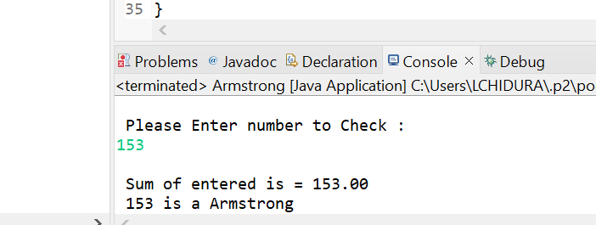

1. **To find Armstrong number from 100 to 999**

**package** lasya;

**public** **class** Armstrong100

{

**public** **static** **void** main (String [] args)

{

**for** (**int** k = 100 ; k <= 1000 ; k++)

{

**int** n = k;

**int** d = 0;

**int** s = 0;

**while** (n > 0)

{

d = n % 10;

s = s + (d * d * d);

n = n / 10;

}

**if** (k == s)

{

System.***out***.println (k + " is Armstrong number");

}

}

}

}

Output:

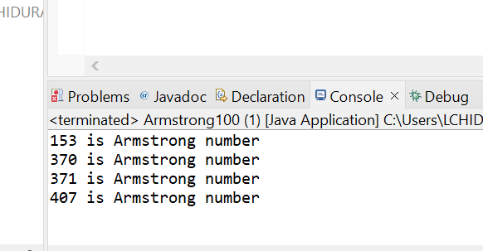

1. **To find compound interest**

**package** lasya;

**import** java.util.Scanner;

**class** Main1 {

**public** **static** **void** main(String[] args) {

Scanner input = **new** Scanner(System.***in***);

System.***out***.print("Enter the principal: ");

**double** principal = input.nextDouble();

System.***out***.print("Enter the rate: ");

**double** rate = input.nextDouble();

System.***out***.print("Enter the time: ");

**double** time = input.nextDouble();

System.***out***.print("Enter number of times interest is compounded: ");

**int** number = input.nextInt();

**double** interest = principal * (Math.*pow*((1 + rate/100), (time * number))) - principal;

System.***out***.println("Principal: " + principal);

System.***out***.println("Interest Rate: " + rate);

System.***out***.println("Time Duration: " + time);

System.***out***.println("Number of Time interest Compounded: " + number);

System.***out***.println("Compound Interest: " + interest);

input.close();

}

}

Output:

