Developer Onboarding & Collaboration Guide
Christchurch Rental Market Analysis
University of Canterbury DATA422

Team :
Pooja Chiduruppala (Repository Manager)
Sahil Mann
Robbie Jarman
Prasanthi Sooriyakumar
Table of Contents
- 1. Introduction
- 2. Software Requirements
- 3. Repository Access & Cloning
- 4. Opening the Project
- 5. Understanding the RStudio Interface
- 6. Git Workflow in RStudio
- 7. Branch Strategy
- 8. Branch Protection
- 9. Project Standards & Naming Conventions
- 10. Repository Structure
- 11. Pull Request Workflow
- 12. Merge Conflicts
- 13. Troubleshooting
- 14. Frequently Asked Questions
- 15. Appendix – Useful Git Commands

1. Introduction
Purpose
• Introduce new team members to the project.
• Explain the development workflow.
• Standardise coding and Git practices.
• Reduce merge conflicts.
Project Technologies
• R
• RStudio
• Git
• GitHub
• Quarto

2. Software Requirements
Install:
• Git
• R
• RStudio Desktop
• Quarto
• GitHub Account

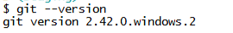
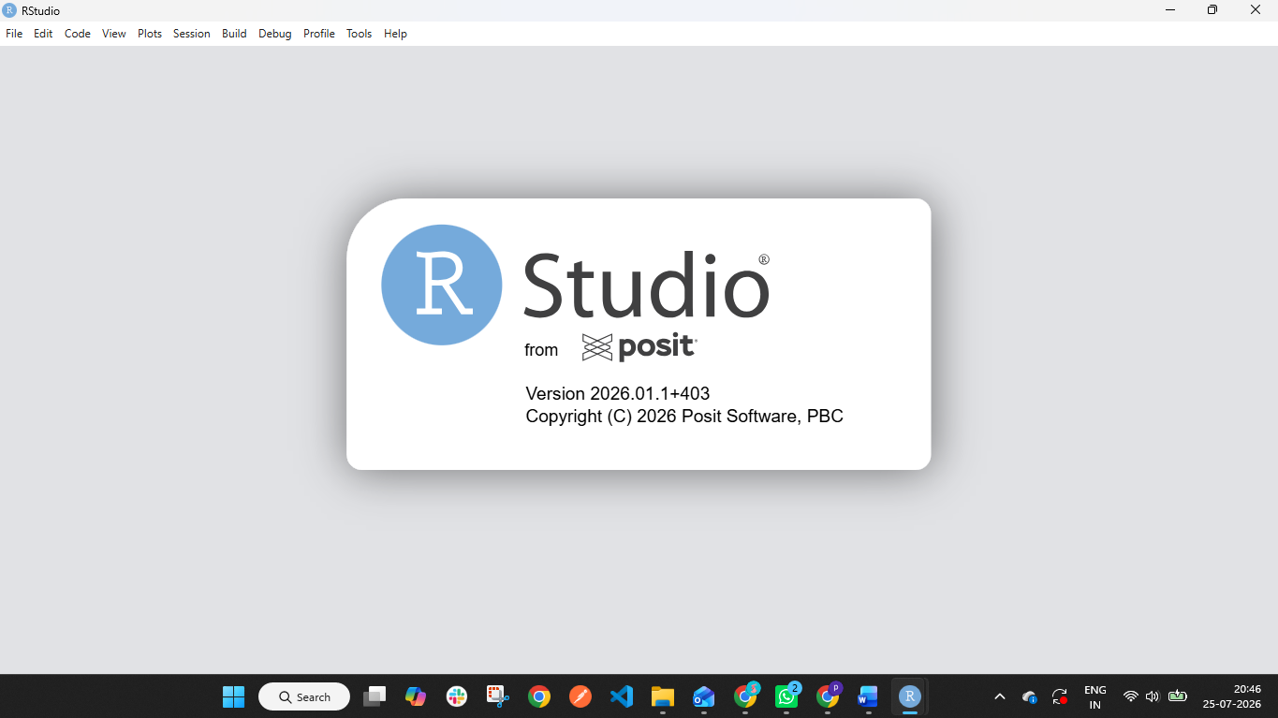

3. Repository Access & Cloning
Steps
1. Accept GitHub invitation.
2. Open repository.
3. Click Code → HTTPS.
4. Copy repository URL.
5. Open RStudio.
6. File → New Project → Version Control → Git.
7. Paste URL and create project.
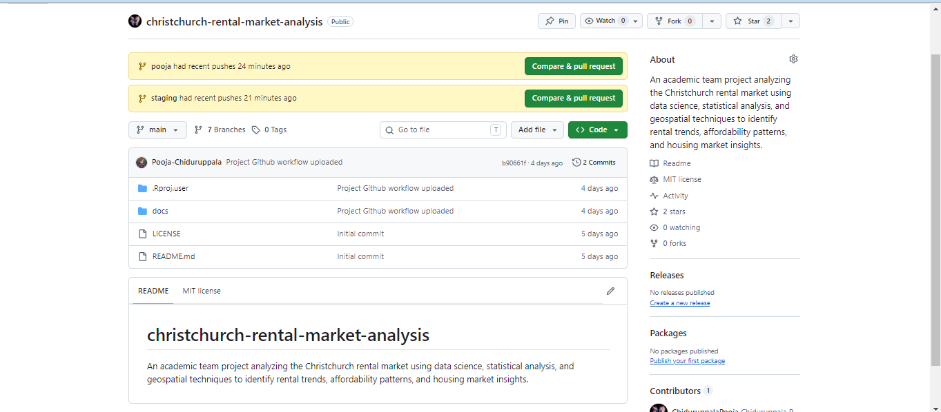

4. Opening the Project
Always open the project using the .Rproj file.
Project Environment (renv)
What is renv?
renv is R's project-specific package management system. It ensures that every team member uses the same package versions, improving reproducibility and preventing issues caused by different package installations.
Benefits
- Consistent package versions across all team members.
- Reproducible analyses.
- Simplified onboarding for new contributors.
- Easy restoration of the project environment.

Initial Setup
Step 1 – Install renv
Run the following command in the R Console:
install.packages("renv")
Note: This step only needs to be completed once on your computer.

Step 2 – Restore the Project Environment
After cloning the repository and opening the .Rproj file, restore the project's packages by running:
renv::restore()
This will automatically install all required packages specified in the project's renv.lock file.
Note: This process may take several minutes the first time.
📸 Screenshot: Running renv::restore() successfully in the R Console.

Installing New Packages
If your task requires an additional package that is not already included:
install.packages("packageName")
Example:
install.packages("plotly")

Updating the Project Environment
After installing any new package that should be available to the whole team, update the lock file:
renv::snapshot()
This records the current package versions in renv.lock.
Important: Always commit the updated renv.lock file.
Example:
git add renv.lock
git commit -m "Add plotly dependency"
git push

Restoring After Pulling Changes
If another team member updates the project's dependencies and you pull the latest changes, run:
renv::restore()
This synchronises your local package library with the updated renv.lock.

Project Files
The following files are part of the project's environment management.
File | Purpose
renv.lock | Stores the project's package versions.
renv/ | Contains the project environment and bootstrap files.
Do not delete or rename these files.

Team Responsibilities
All team members must follow these guidelines:
- Use the project through the .Rproj file.
- Run renv::restore() after cloning the repository.
- Run renv::restore() whenever renv.lock changes.
- Run renv::snapshot() after adding or updating project dependencies.
- Commit the updated renv.lock file whenever dependencies change.
- Do not manually edit renv.lock.

Common Commands
Task | Command
Install renv | install.packages("renv")
Restore packages | renv::restore()
Save current package versions | renv::snapshot()
Check project status | renv::status()

Workflow
Clone Repository
│
▼
Open .Rproj
│
▼
Run renv::restore()
│
▼
Start Development
│
▼
Install New Package (if required)
│
▼
renv::snapshot()
│
▼
Commit updated renv.lock
│
▼
Push changes

5. Understanding the RStudio Interface
• Source Editor
• Console
• Terminal
• Environment
• Git Pane
• Files Pane
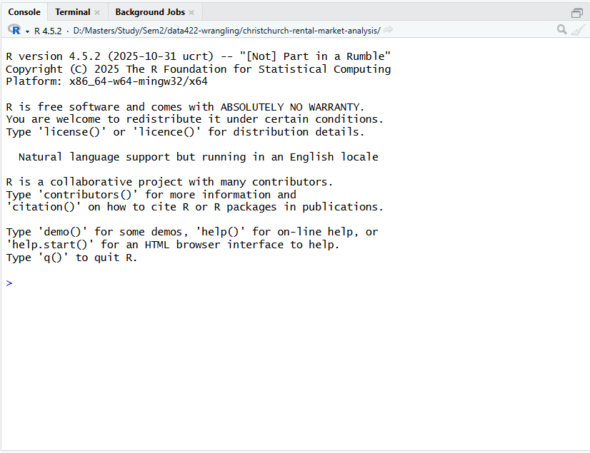

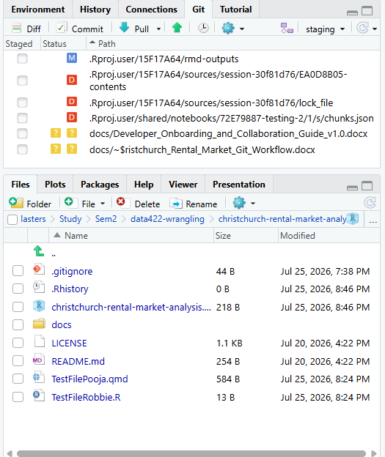

6. Git Workflow in RStudio
Workflow
Pull
↓
Switch Branch
↓
Develop
↓
Review Diff
↓
Stage Files
↓
Commit
↓
Push
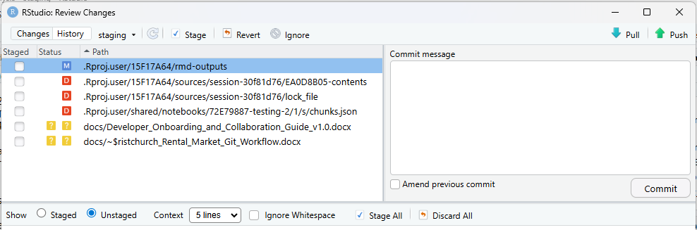

7. Branch Strategy
main (Protected)
↑
pre-prod (Protected)
↑
staging
↑
Personal branches
Responsibilities
• main – Final submission.
• pre-prod – Stable reviewed version.
• staging – Shared integration branch.
• Personal branches – Individual development.

8. Branch Protection
Protected branches:
• main
• pre-prod
Rules
• Pull Request required.
• Repository Manager approval required.
• Direct pushes prohibited.
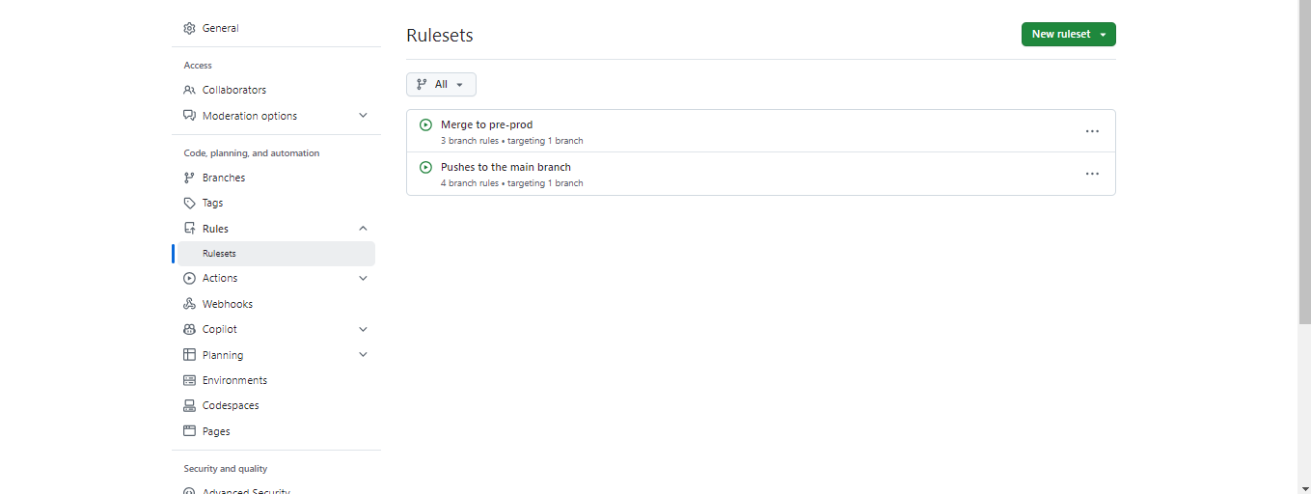

9. Project Standards & Naming Conventions
General
• No spaces in file names.
• Use descriptive names.
• English only.
File Naming
• R Scripts → camelCase (dataCleaning.R)
• Quarto → PascalCase (ExploratoryAnalysis.qmd)
• R Markdown → PascalCase (WeeklyReport.Rmd)
• CSV → snake_case (cleaned_dataset.csv)
• Images → snake_case (price_distribution.png)
• Documentation → PascalCase (GitWorkflow.docx)
Folders
• Documentation
• Data
• Scripts
• Reports
• Figures
• Models
Variables → camelCase
Examples:
rentalData
cleanedData
averagePrice
Functions → camelCase (verb+noun)
loadData()
cleanDataset()
generateSummary()
trainModel()
Constants → UPPER_CASE
RANDOM_SEED
MAX_ITERATIONS
Commit Messages
Good:
• Add rental price visualisation
• Fix missing values
• Update documentation
Avoid:
• update
• changes
• test
• final

10. Repository Structure
ChristchurchRentalMarketAnalysis/
│
├── Documentation/
├── Data/
│ ├── raw/
│ ├── processed/
│ └── external/
├── Scripts/
├── Reports/
├── Figures/
├── Models/
├── README.md
└── .gitignore

11. Pull Request Workflow
Personal Branch
↓
Push
↓
Open Pull Request
↓
Review
↓
Merge into staging
↓
Repository Manager promotes to pre-prod
↓
Repository Manager promotes to main

12. Merge Conflicts
• Resolve conflicts locally.
• Test code.
• Commit resolution.
• Push updated branch.

13. Troubleshooting
Common Issues
• Git tab missing
• Wrong branch
• Push rejected
• Merge conflict
• Authentication failed
• Nothing to commit

14. Frequently Asked Questions
Suggested FAQs
• Why can't I push? You can but only to Personal branch and staging
• Should I pull every day? Yes
• How do I stash changes? Use git stash -m “your message”
• Can I merge another member's branch? No

15. Appendix – Useful Git Commands
git status
git pull
git add .
git commit -m "Meaningful message"
git push
git switch
git merge
git stash
git log

