INSTITUTO SUPERIOR PRIVADO - CIBERTEC

DIRECCIÓN ACADÉMICA

CARRERA PROFESIONALES

NOTA
CURSO : 2411-Ingles 2
PROFESOR :
SEMESTRE : 2020-II
SECCIÓN :
FECHA :
DURACIÓN :

ALUMNO (A) :Cesar Chira

CASO TEÓRICO 1 – CT1

Unidad de Logro de la Aprendizaje Nº 1

- Al finalizar la unidad, el estudiante es capaz de describir con precisión los diferentes tipos de climas, así como hablar de deportes y ejercicios utilizando el tiempo presente continuo en preguntas y respuestas.
- Al término de la unidad, el alumno habla con seguridad acerca de las prendas de vestir, así como preguntar y opinar acerca de los precios y de sus hábitos para comprar ropa y regalos, utilizando los verbos Like to, Have to, ¿Want to y need to + otros verbos y la palabra interrogativa “How much…?”

Writing Production.

- These days we are spending more at home. Using the present continuous tense, write about how you and your family are organizing to get through this situation. Are you working? Are you attending classes online? What are you doing these days during this state emergency over coronavirus? (10 sentences) (10 ptos.)

My family and me are organizing to get through this situation like this :
My dad and me go to the grocery store while my sisters are cleaning the house and my grandmother is cooking.
I am not working at the moment, but I am helping a friend with some projects and he is paying me for them.
I am assisting to my online classes every day to learn as much as I can.

During the state of emergency I am going jogging every morning, and using my abs machine to work out.

I am reading some books from time to time too.

I am practicing my english by listening to music and watching series in english.
My friend is teaching how to drive too.

Rubrics
Marks | Excellent:  10 marks | Good:  9-7 marks | Satisfactory:  6-5 mark | Needs improvement:  4-1 marks | Below expectations:  0 marks
10 | Writes all sentences using the correct structure according to the context. | Minor errors on writing correctly. | Some mistakes in using certain grammar structures in some sentences but still acceptable. | Confuses the use of structures matching them with the given context. | More mistakes than expected.

- Look for 5 pictures on the internet of people wearing different outfits. Then describe what they’re wearing.

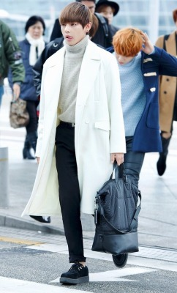
For example :

He is wearing a white coat, a gray sweater, black pants, a black bag and black shoes.


He is wearing a white shirt, black jeans , black glasses and light yellow shoes.

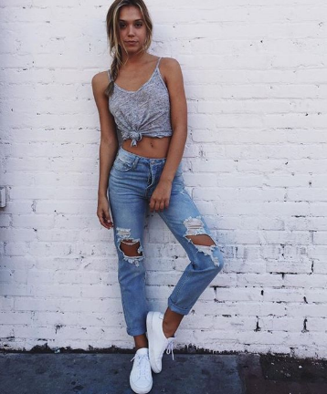
She is wearing a grey t-shirt, blue jeans and white sneakers.

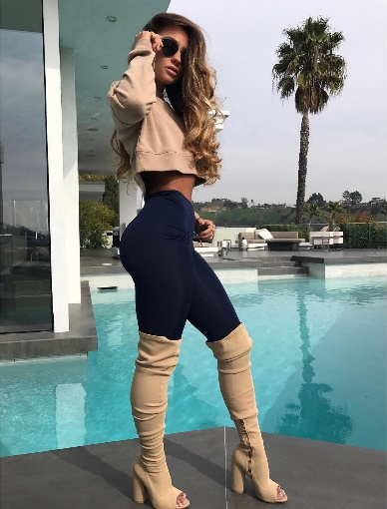
She is wearing a beige t-shirt , black leggings,black glasses and beige boots .

She is wearing a black dress, a black purse and black sneakers.


He is wearing black glasses , blue jean jacket , green t-shirt, black sweatpants and black sneakers.

Rubrics
Marks | Excellent:  10 marks | Good:  9-7 marks | Satisfactory:  6-5 mark | Needs improvement:  4-1 marks | Below expectations:  0 marks
10 | Writes all sentences using the correct structure according to the context. | Minor errors on writing correctly. | Some mistakes in using certain grammar structures in some sentences but still acceptable. | Confuses the use of structures matching them with the given context. | More mistakes than expected.

