Document Ranking Scoring Functions:
Okapi BM25 and the Language Model with Jelinek-Mercer Smoothing
Information Retrieval
Week 4 Assignment

Introduction
Ranking documents by relevance is the central problem an information retrieval (IR) system must solve once candidate documents have been retrieved. A scoring function assigns each document a numeric value for a query so the most relevant documents can be presented first. This report examines two scoring functions from different theoretical families: Okapi BM25, a probabilistic relevance model, and a unigram Language Model (LM) with Jelinek-Mercer (JM) smoothing, a statistical language-modeling approach. Both were implemented from first principles in Python and applied to a shared eight-document corpus so their practical behavior could be compared directly.

Corpus and Setup
The evaluation corpus consists of eight public Wikipedia documents (artificial intelligence, machine learning, large language models, NASA, Mars, association football, basketball, and climate change), the same corpus used in the Week 3 vector space model assignment. Text was lowercased, tokenized with the regular expression [a-z]+, and filtered through a stopword list, yielding a vocabulary of 601 terms and an average document length of 123.8 tokens. Figure 1 shows the program's corpus summary.
Figure 1
Corpus Statistics Reported by scoring.py
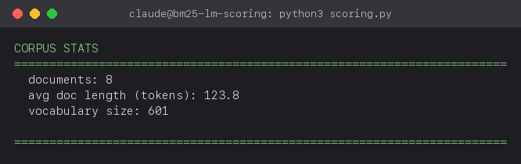

Okapi BM25
BM25 (Robertson & Zaragon, 2009) scores a document d against a query q as a sum, over query terms t, of an inverse document frequency (IDF) weight multiplied by a saturating term-frequency component:
score(q, d) = sum_t IDF(t) * [ f(t,d)*(k1+1) ] / [ f(t,d) + k1*(1 - b + b*|d|/avgdl) ]
IDF(t) = ln[ (N - df(t) + 0.5) / (df(t) + 0.5) + 1 ] down-weights terms that occur in most documents. f(t,d) is the raw frequency of term t in document d, k1 controls how quickly additional occurrences of a term stop adding to the score (term-frequency saturation), and b controls how strongly document length is normalized against the average document length (avgdl). This implementation uses the standard defaults k1 = 1.5 and b = 0.75.
Two properties of BM25 are important in practice. First, term frequency saturates: a term appearing 10 times contributes far less than 10 times the score of a single occurrence, which prevents keyword stuffing from dominating the ranking. Second, a document that shares no vocabulary with the query scores exactly 0, since every summed term contributes nothing -- BM25 has no mechanism to distinguish between two completely non-matching documents.

Language Model with Jelinek-Mercer Smoothing
The language-modeling approach (Zhai & Lafferty, 2001; Ponte & Croft, 1998) treats each document as having generated a probability distribution over words, and ranks documents by the likelihood that their language model would generate the query. The raw maximum-likelihood estimate P(w|d) = c(w,d)/|d| assigns zero probability to any query term absent from d, which would make the whole query probability zero the moment a single term is missing. Jelinek-Mercer smoothing fixes this by linearly interpolating the document model with the collection model:
P(w|d) = (1 - lambda) * c(w,d)/|d| + lambda * c(w,C)/|C|
score(q, d) = sum_w log P(w|d)
c(w,C)/|C| is the term's relative frequency across the whole collection C, and lambda in [0,1] controls the smoothing strength. Following Zhai and Lafferty's (2001) finding that short, keyword-style queries perform best with light smoothing, this implementation uses lambda = 0.1: document evidence dominates the score, and the collection model only prevents a missing term from producing an undefined log(0).

Implementation
def bm25_score(corpus, query_terms, doc_name, k1=1.5, b=0.75):
for term in query_terms:
f = corpus.counts[doc_name].get(term, 0)
if f == 0: continue
idf = bm25_idf(corpus, term)
num = f * (k1 + 1)
den = f + k1 * (1 - b + b * corpus.doc_len[doc_name] / corpus.avg_dl)
score += idf * (num / den)
def lm_jm_score(corpus, query_terms, doc_name, lam=0.1):
for term in query_terms:
p_doc = corpus.counts[doc_name].get(term, 0) / corpus.doc_len[doc_name]
p_coll = corpus.collection_counts.get(term, 0) / corpus.collection_len
p = (1 - lam) * p_doc + lam * p_coll
score += math.log(p) if p > 0 else math.log(1e-12)
The full implementation, including corpus loading and the ranking helper, is provided in scoring.py.

Results
Three test queries were run against the corpus to probe different topic clusters: a machine-learning query, a space-exploration query, and a team-sports query. Each was scored with both BM25 and LM-JM and the top-ranked documents compared.
Figure 2
Ranking for the Query "machine learning neural network"
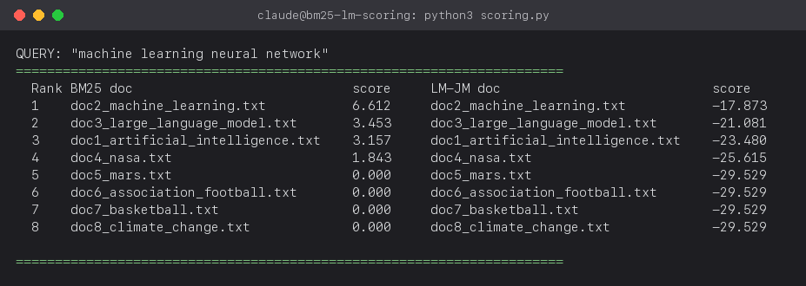
Figure 3
Ranking for the Query "space exploration mars mission"
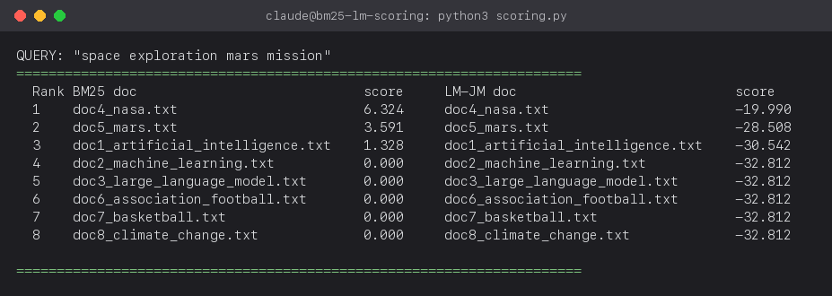
Figure 4
Ranking for the Query "football basketball team player"
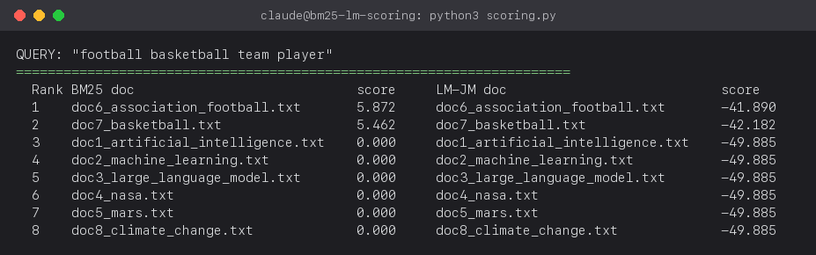

Analysis
Across all three queries, BM25 and LM-JM agree on document ordering: doc2 (Machine Learning) tops the ML query, doc4 (NASA) tops the space query, and doc6/doc7 (football/basketball) top the sports query, in the same relative order under both functions. This agreement is expected -- both functions grow with how often query terms occur in a document relative to the collection -- but the two scores are not interchangeable.
The clearest difference is how each function treats non-matching documents. BM25 assigns exactly 0.000 to every document that shares no term with the query (ranks 4-8 in Figure 3), so it cannot rank them relative to each other; ties must be broken arbitrarily. LM-JM instead falls back to the collection-wide probability of each query term (-32.812 for those same documents), which keeps the score finite and, in corpora where non-matching documents differ in how much they otherwise share with near-miss query terms, still lets LM-JM discriminate where BM25's flat zero cannot.
Scale also differs. BM25 scores are additive, unbounded above, and directly readable as relative match strength (6.612 vs. 3.453 for the ML query shows doc2 matching nearly twice as strongly as doc3). LM-JM scores are log-probabilities that shrink toward negative infinity as query length grows, since each extra query term multiplies in another probability below 1, making raw scores harder to compare across queries of different lengths.
The functions normalize document length differently as well. BM25 applies an explicit, tunable factor (1 - b + b*|d|/avgdl) that penalizes long documents unless their term frequency is proportionally high. LM-JM normalizes only implicitly, through the ratio c(w,d)/|d|; its one parameter, lambda, instead controls collection-versus-document weighting. With document lengths fairly close in this corpus (avg. 123.8 tokens), the effect was small here but would matter more with wide length variance.
In short, BM25 suits keyword-style retrieval where a tunable, interpretable saturation curve is useful, while LM-JM's smoothing gives it a principled probability distribution that composes well with other probabilistic techniques, such as relevance models or query expansion.

Conclusion
This assignment implemented Okapi BM25 and a Jelinek-Mercer smoothed language model from first principles and applied both to an eight-document corpus across three queries. Both functions produced the same top-ranked document for every query, confirming that they are both valid relevance signals, but they diverge in how they treat non-matching documents, in the interpretability and scale of their scores, and in how they normalize for document length. Understanding these differences is important when choosing a scoring function for a real system: BM25 remains a strong, tunable default for general-purpose search, while LM-JM's probabilistic foundation makes it preferable when scores need to compose with other probabilistic components.

How to Reproduce
pip install -r requirements.txt
python3 scoring.py # corpus stats + BM25/LM-JM rankings
python3 make_screenshots.py # re-renders terminal-style PNGs

References
Ponte, J. M., & Croft, W. B. (1998). A language modeling approach to information retrieval. Proceedings of the 21st Annual International ACM SIGIR Conference on Research and Development in Information Retrieval, 275-281.
Robertson, S., & Zaragoza, H. (2009). The probabilistic relevance framework: BM25 and beyond. Foundations and Trends in Information Retrieval, 3(4), 333-389.
Zhai, C., & Lafferty, J. (2001). A study of smoothing methods for language models applied to ad hoc information retrieval. Proceedings of the 24th Annual International ACM SIGIR Conference on Research and Development in Information Retrieval, 334-342.
Manning, C. D., Raghavan, P., & Schutze, H. (2008). Introduction to information retrieval. Cambridge University Press. (Chapters 11-12: probabilistic IR and language models for IR.)
Wikipedia contributors. Articles used as the evaluation corpus: Artificial intelligence, Machine learning, Large language model, NASA, Mars, Association football, Basketball, Climate change. Wikipedia, The Free Encyclopedia. Licensed under CC BY-SA 4.0.

