

**DOCUTRACKER: A Web Based Document Management Information System for Davao Oriental State University**

**Ivan Dawang**

**Patrick Gerald Heyres**

**Cleo Khaye Marie Marohom**

**A Final Capstone Project Submitted to the Faculty of Computing, Data Sciences, Engineering, and Technology of the Davao Oriental State University in Partial Fulfillment of the Requirements for the Degree**

**BACHELOR OF SCIENCE IN INFORMATION TECHNOLOGY**

**JANUARY 2024**

**TABLE OF CONTENTS**

**TITLE PAGE**

**CHAPTER I INTRODUCTION**

1.1 Rationale of the Study…………………..…………………………………………………..1

1.2 Purpose and Project Description…………………………………………………………..2

1.3 Objectives of the Study……………………………………………………………………..2

1.4 Significance of the Study…………………………………………………………………...3

1.5 Scope and Limitation………………………………………………………………………..4

1.5.1 Scope………….………………………………………………………………….4

1.5.2 Limitation…….…………………………………………………………………...6

1.6 Conceptual Framework……………………………………………………………………..6

1.7 Definition of Terms…………………………………………………………………………..7

**CHAPTER II REVIEW OF RELATED LITERATURE**

2.1 Technical Background……………………………………………………….…………...…9

2.1.1 Svelte…….…………………………………………………………..……...……9

2.1.2 MySQL……...……………………………………………………………….…..10

2.1.3 Flask……………..………………………………………………………………11

2.2 Related Literature………………………………………………………………………….11

2.3 Related Systems……………………………………………………………….…………..15

2.3.1 University of the Philippines Document Tracking System…….…………..15

2.3.2 M-Files: Digital Document Management……….……………………………16

2.3.3 Globodox Document Management Software…..…………………………...17

2.3.4 Folderit Cloud Document Management System………..…..……………..18

2.3.5 Gigatrak Document Tracking System………………..………..…………….19

2.4 Synthesis……………………………………………………………………………………20

**CHAPTER III MATERIALS AND METHODS**

3.1 Software Methodology…………………………………………………………………….22

3.2 Requirements Analysis…..………………………………………………………………..24

3.3 Requirements Documentation…...……………………………………………………….25

3.3.1 System Architecture………………………………………….………………..25

3.4 Requirements Specifications……………………………………………………………..25

3.4.1 Product Perspective..…………….……………………………………………26

3.4.2 Product Features……………………………………………………………….26

3.4.3 User Class and Characteristics….…………………………………………...26

3.4.4 Opening Environments……………..………………………………………….27

3.4.5 Design and Implementation Constraints…….………………………………27

3.4.6 User Documentation..………………………………………………………….28

3.4.7 Other Non-Functional Requirements…….…………………………………..28

3.4.8 Software Quality Requirements…………………..…………………………..29

3.5 Design……………………………………………………………………………………….31

3.5.1 Use Case Diagram………………………………..……………………………31

3.5.2 Entity Relationship Diagram……………………..……………………………35

3.5.3 Data Dictionary………..………………………………………………………..35

3.5.4 Graphical User Interface Design…….……………………………………….39

3.6 Development and Testing………………………………………………………………...52

3.6.1 Development…………………….……………………………………………..52

3.6.2 Data Analysis Plan……………………..………………………………………52

**CHAPTER IV RESULT AND DISCUSSION**

4.1 Achievement per Objective……………………………………………………………….54

4.2 Evaluation of the system…………………………………………………………………..55

4.3 Implementation Plan……………………………………………………………………….55

**CHAPTER V SUMMARY, CONCLUSION, AND RECOMMENDATION**

5.1 Summary……………………………………………………………………………………56

5.2 Conclusion………………………………………………………………………………….56

5.3 Recommendation……………………….………………………………………………….56

**LITERATURE CITED…………………………….…...……………………………………….57**

**CHAPTER I**

**INTRODUCTION**

**1.1 Rationale of the Study**

DOCUTRACKER is a Web-based document tracking system that offers Davao Oriental State University (DORSU) a seamless tracking solution. This system has the potential to reduce time and effort spent locating documents, provide awareness of the whereabouts of documents, and guarantee efficient and secure tracking. Implementing a document tracking system like DOCUTRACKER can lead to improved efficiency, enhanced security, reduced errors and misplaced documents, better collaboration of routes that documents need to go through, and reduced cost (Q. Techopedia, n.d. 2019).

Here is a related global study about document tracking, Publuu Interactive Online Flipbook. Publuu is a cloud-based platform for modern companies that enables them to produce, organize, and monitor all of their business documents in one location through Flipbook PDFs. It is one of the document tracking systems in real-time and enables you to share multiple trackable links for each recipient or group you wish to track. This is one of the useful things that differentiates Publuu from other document-tracking technologies on the market. (MD. Carolina Monntoya, 2023)

The Department of Social Welfare and Development Field Office V is implementing a web-based electronic document tracking management system to streamline document transactions. The system, which includes identifying, classifying, storing, securing, retrieving, tracking, and preserving documents, is designed to improve communication between clients and staff, enhance document tracking, and make information more accessible. The system is fully functional and is expected to improve the processes of the DSWD Field Office V, enhancing overall efficiency and effectiveness. (K. Smith Shoen, 2016)

Another document tracking management system that is related to DOCUTRACKER is the IBM Sterling B2B Integrator. This Document Tracking service enables you to define correlation name-value pairs to gather additional tracking data about documents. When you create or edit a business process, you can include the Document Tracking service at appropriate points in the process to define additional tracking data that Sterling B2B Integrator gathers about a document (or a family of documents). The additional tracking data is defined using any number of correlation name-value pairs that are associated with the specified primary document. These correlation name-value pairs provide Sterling B2B Integrator with more pieces of information about which you can query for document data.(C. Andrew; J. Floyd; 2022)

The study of DOCUTRACKER, a web-based document management information system for Davao Oriental State University, is driven by the need for an efficient and organized document management system within the university. The current manual document tracking processes at DOrSU are prone to errors, delays, and inefficiencies, leading to challenges in maintaining accurate records and ensuring timely access to information. The implementation of DOCUTRACKER aims to address these issues by leveraging web-based technology to streamline document tracking, enhance collaboration among university departments, and improve overall administrative efficiency. The system is designed to automate document creation, tracking, and retrieval, providing a centralized platform for users to monitor the status of documents in real-time. The study seeks to evaluate the impact of DOCUTRACKER on reducing administrative bottlenecks, enhancing workflow efficiency, and ultimately contributing to the overall effectiveness of document management at Davao Oriental State University.

**1.2 Purpose and Project Description**

The main goal of this project is to provide Davao Oriental State University (DOrSU) with a comprehensive document management information system that tracks documents. The system simplifies the procedure and boosts the overall workflow.

**1.3 Objectives of the Study**

The objective of this project is to design and implement a Full Stack Document Management Information System that aims the following:

1. To design and develop a system that is capable of:
2. Generating QR code when registering a document.
3. Document monitoring in real-time.
4. Visualizing the time data of each route
5. Providing data of the time taken each route and overall process time lifecycle of the document.
6. To enhance the system with the following features:
7. Implementing a user-friendly interface for document registration.
8. Providing downloadable data for offline viewing and reports.
9. Ensuring the system is scalable to handle increasing volumes of documents.

**1.4 Significance of the Study**

The DOCUTRACKER system, which aims to develop a web-based platform document information management system for easy access and processing of documents, that is significant for providing easy way of document process with these beneficiaries:

**Users.** The users will benefit in using the DOCUTRACKER system since it provides a secure, seamless, and organized way of tracking of documents and it also reduced their time in processing of documents with the help of web platform DOCUTRACKER system.

**Faculties.** Selected faculty departments in Davao Oriental State University will benefit in using the DOCUTRACKER system hence, the processing of documents is all the same within faculties and it also eliminates the risk of misplacing or losing documents which is the most common drawback in the absence of document tracking.

**Admin.** The admin which is the one who keeps the records and history of tracked documents can benefit in using the DOCUTRACKER system as it offers a range of features that is designed to enhance the document-related processes and improve the overall functionality and the admin also ensures the processing of document will be done in designated time.

**Future Researchers.** The data collected about the document tracking system in DORSU can help the future researchers to understand on what document tracking is all about and, the future researchers can use the data about this system if they are willing to enhance the system based on what ideas they have in the future.

**1.5 Scope and Limitation**

* + 1. **Scope**
* The document management information system has its main features which are the Manage registered accounts, manage documents and view document status for admin interface, while the Register Document, View Document Status and User’s profile is for user’s interface and the Document register approval and view document status for receiver’s interface.
* The main focus of the system is in every faculty in Davao Oriental State University (DorSU) that includes the following which is the Faculty of Computing, Data Sciences, Engineering and Technology (FCDSET), Faculty of Nursing and Allied Health Science (FNAHS), Faculty of Teacher Education (FTED), Faculty of Agriculture and Life Sciences (FALS), and Faculty of Governance, Business and Management (FGBM).
* The process of document tracking has its different processes and receiver flow in every document. There are some documents that are from faculty, and there is a document that is outside of faculty process.
* For the process of “Faculty Loading”, it will undergo to program head, Dean and to the academic VP.
* For the process of “Requested Subject”, it will undergo to program head, dean, and to the VP.
* For the process of “Endorsement Form”, it will undergo to communication, faculty program head, faculty dean, VP, and to the OP, once it is done, it will be approved.

**1.5.2 Limitation**

* This system will be implemented only at Davao Oriental State University main campus.
* The system only tracks selected documents, (Faculty Loading, Requested Subject, Endorsement Form).
* Only the selected users can use DOCUTRACKER, (Program Head, Dean Office, Academic VP, OP, Secretary).
* The system needs internet connection in order to be accessible.

**1.6 Conceptual Framework**

**OUTPUT**

DOCUTRACKER: A Web Based Document Management Information System for Davao Oriental State University

**PROCESS**

**Requirement Gathering and Analysis**

* Planning
* Design
* Development
* Testing
* Evaluation

**INPUT**

**Knowledge Requirements:**

* Web-based platform
* Responsive UI design
* User-friendly interface

**Software Requirements:**

* Svelte
* Flask
* MySQL

**Hardware Requirements:**

* Desktop (PC)
* Laptop

Figure 1.1: Conceptual Framework

**1.7 Definition of Terms**

**User Interface/UI:** is a visual system that permits communication between people and machines, computers, or other digital devices. It has interactive elements such menus, forms, buttons, icons, and displays that make input, feedback, and navigation easier.

**User Requirement/Specification:** The user requirement document or user requirement specification is a document usually used in software engineering that specifies what the user expects the software to be able to do.

**Data Collection/Gathering:** is the process of gathering and measuring information on targeted variables in an established system, which then enables one to answer relevant questions and evaluate outcomes.

**MySQL:** MySQL is a relational database management system (RDBMS) that is open source and extensively used for managing and organizing structured data. It uses the client-server approach, in which a client connects with the MySQL server to conduct database activities including querying, updating, and managing data.

**Access:** is the privilege or assigned permission to use computer data or resources in some manner.

**ISO:** The International Organization for Standardization produces ISO standards, which are standardized publications, to offer precise rules, specifications, and best practices for numerous sectors, technologies, and processes. They go through things like quality control, environmental regulations, data security, and safety procedures.

**CHAPTER II**

**REVIEW OF RELATED LITERATURE**

* 1. **Technical Background**

For the development of the system entitled DOCUTRACKER: A Web Based Document Management Information System for Davao Oriental State University. The researchers indicate the following programming language and libraries that is going to be used that is stated below:

* + 1. **Svelte**

Is an innovative tool for building user interfaces. Unlike traditional frameworks that do most of their work in the browser, Svelte shifts that work into a compile step that happens when you build your app. This results in highly efficient code that updates the DOM at incredible speed. Svelte is a compiler, you can't just add a script tag to your page and import it into your app. You'll have to set up your development environment to let the compiler do its job. Components are the building blocks of Svelte applications. They are written into. svelte files using a superset of HTML. The Svelte compiler converts your components to JavaScript that can render the HTML for the page and to CSS that styles the page.

In DOCUTRACKER, Svelte is used to build the user interface of the application. Svelte is a front-end framework that's designed to build interactive user interfaces running in a browser. It doesn't use a virtual DOM, instead, it compiles code into optimized vanilla JavaScript, which minimizes overhead at runtime and boosts application performance (Nakajima, 2021).

Svelte components, which are written into svelte files using a superset of HTML, are the building blocks of Svelte applications (Anonymous, 2016). These components encompass the logic, style, and markup of a part of the user interface. For instance, in a DOCUTRACKER, there might be Svelte components for displaying a list of documents, a detailed view of a selected document, a form for creating new documents, and so on.

* + 1. **MySQL**

MySQL, an acronym for "My Structured Query Language," is an open-source relational database management system (RDBMS) renowned for its efficiency and versatility. Developed by MySQL AB and now owned by Oracle Corporation, it forms an integral part of the widely adopted LAMP stack, alongside Linux, Apache, and PHP/Python/Perl. Operating across various platforms such as Linux, Windows, and macOS, MySQL organizes data into structured tables with rows and columns, facilitating efficient management and retrieval of information.

With its robust performance, scalability options, and advanced security features, MySQL is a popular choice for diverse applications, ranging from web development to data-driven software solutions. Its open-source nature fosters an active community of developers, contributing to ongoing improvements and support. MySQL's ability to handle large datasets, execute complex queries swiftly, and seamlessly integrate into various environments underscores its significance as a reliable and widely used relational database management system in the realm of modern computing.

**2.1.3 Flask**

is a small and lightweight Python web framework that provides useful tools and features that make creating web applications in Python easier. It gives developers flexibility and is a more accessible framework for new developers since you can build a web application quickly using only a single Python file. Flask is also extensible and doesn’t force a particular directory structure or require complicated boilerplate code before getting started. Flask takes a radically different approach to creating web apps. It’s a micro framework, equipped only with the web app development essentials. Its strength lies in its customizability. Flask is flexible, allowing you to experiment and switch directions easily.

**2.2 Related Literature**

The study entitled “A Data Centre Configurable Data Mining Document Management Information System, 2021” conducted by Gurusubramani, S., Mouleeswaran, S. K., Srinivas, P., & Aruna, R., it states that Electronic information development in many aspects of human practices, from research to industry, has been rising rapidly over the past two years. Every day very large data sets are manufactured from cameras, instruments, handheld devices and computers. Effective technologies are also needed to incorporate flexible data collection workflows through the use of cloud-based storage platforms, where data is stored even more regularly. The paper attempts to show how cloud infrastructure is implemented to introduce an optimized framework in which scalable data analyzation workflows can be planned and performed. We explain how the Data Mining Cloud Architecture is built and applied and a data analytics method that incorporates visual workflow vocabulary, parallel to the Virtualized environment. DMCF is developed with a view to simplifying the creation of applications for data mining associated with generic system monitoring schemes that are not created especially for this area, in view of the specifications of actual data mining applications.

According to (Bentech, 2022) most common problem faced by most organizations when it comes to Physical Document papers is (Document loss: 75% of all corporate 12 documents are misplaced and never discovered. The time spent looking, as well as the privilege of replacing a lost document, is a huge loss of time and resources). The loss of documents can be a major problem for organizations. When documents are lost, it can lead to wasted time and resources, as well as potential legal and financial consequences.

The study entitled “Electronic Document Management Information System for Universities, 2018” conducted by Costoiu M., Plesu V., Isopescu R., Soriga S., Alesincu S., Arsene I., it states that Efficient administration of funds and thorough correlation of diverse activities are required in the management of Higher Education institutions. The electronic document management information system implemented in the University is continuously up-graded in order to provide a tool for an efficient management. A preliminary identification was performed to take into account all the aspects referring to the numerous documents in circulation in the University and the problems raised by the necessity that some supported documents should be digitized. They also mentioned that while using the document management system, the documents may be created by an author or introduced in the system by means of scanning, automatic import from file systems or other applications, by e-mail or by automatic generation based on forms.

In addition, the study entitled “Interrelationship between document management, information management and knowledge management, 2017” conducted by N. Sewdass, it states that the Documents are the natural by-products of the activities of an organization. Information and knowledge are perceived as very important assets for organizations. Managing documents, information and knowledge can contribute to business efficiency and effectiveness for organizational competitiveness. The three concepts document management, information management and knowledge management are becoming increasingly prevalent in academic and vocational literature. Although these concepts have been used and discussed over and over, there remains ambiguity about them, confusion between them, and little consensus on how to perform them.

This study “System Development for Document Management System, 2018” conducted by Kiplie, Yatin, Angutim, & Hamid, it states that Digitization systems should always support the sharing of views or movement of data from other systems, regardless of the level of integration selected. System development is a formal set of process to define, design, testing and implementing a new software application or program. This includes the process of internal development in order to customize the systems, and creating the database system as well. Digitization system offers to organization in capturing important materials that can be treat as an important information and knowledge for users either for business, study, or research purposes. According to Kroenke (2015), Information system is an organized system of information that functions it collect, organized, store, and communicate the information. Specifically, information system is a group of connected people and organization to collect, filter received information or data, process, create and distribute the date to specific users. So, information system can be concluded as a group of components that interact together to create, produce and disseminate information.

A study entitled “Electronic Document Management System: Malaysian Experience, 2021” conducted by Yatin, S. F. M., Ramli, A. a. M., Shuhaimi, H., & Kadir, M. R. A., it states that Document management systems have long been touted as the answer to many paper-related problems. They seem to offer the opportunity to exercise a high degree of control over the ways in which paper documents are handled. The latter are sometimes referred to as “enterprise or electronic document management systems”. It is important to realize that document management systems do just that they manage documents, not the information or knowledge contained within the documents. Thus, their impact on a business is in the efficiency they provide in document storage and retrieval and also information access. The time has never seemed to be right to opt for this system, there has always seemed to be such ongoing development that the “ideal” system must be just around the corner. As the awareness of computers as a tool for data processing increased, more organizations and institutions began to acquire computers for their record keeping. One of the seven flagships in Vision 2020 focuses on the area of record keeping and document management is Generic Office Environment-Electronic Government Document Management System (GOE-EGDMS). This study is designed to investigate the usage and effectiveness of the implementation of GOE-EGDMS adopting the IS Effectiveness Model from DeLone and McLean.

A study entitled “eGovernment Document Management System: A case analysis of risk and reward, 2016” conducted by Jones, S, it states that The effective deployment of an electronic document management system (EDMS) is an important element in establishing a virtual workplace environment and transforming the capabilities of a modern organization and its workforce (Adam, 2007). EDMS can empower users to streamline business processes via workflow and information sharing, which can also improve information management (Hammer & Hershman, 2010). Read (2009) highlights that operational efficiency can be transformed through the deployment of IT in back office functions. This is especially the case with EDMS implementations (Wilkins, Swatman, & Holt, 2009). There is also increasing recognition that efficiencies will come from common IT systems and common business processes in the public sector (Gershon, 2004). With the growing need for the public sector to embrace more technology and be more innovative, organizations are increasingly implementing IT systems in an attempt to transform service delivery, both internally to the organization and externally for the citizen. This case analysis investigates how the EDMS was initiated and implemented. It draws upon the literature and case study findings to propose a good practice framework to help assess the value, benefit and risk of an electronic document management system to help ensure it meets the desired outcomes.

**2.3 Related Systems**

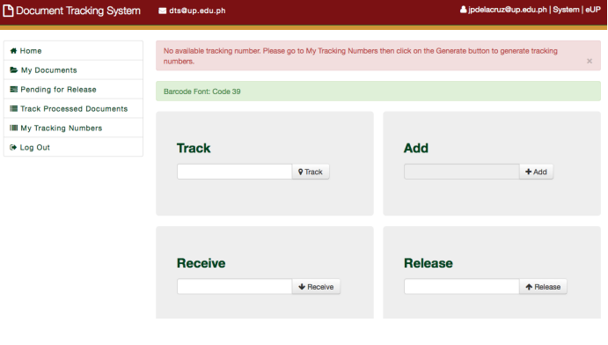**2.3.1 THE UNIVERSITY OF THE PHILIPPINES DOCUMENT TRACKING SYSTEM**

Figure 2.1 University of the Philippines Document Tracking System Interface (UPITDC, 2022)

The Document Tracking System (DTS) at the University of the Philippines (UP) is an information system designed to monitor the flow of paper documents across UP offices. It captures details such as the origin and destination offices, personnel involved, and the time taken for documents to move between offices, units, or departments. The DTS also provides support for document attachments, revisions, updates, and remarks, enhancing its functionality and usability.

In today's rapidly advancing technological landscape and the growing importance of efficient information management, the emergence of document tracking systems has provided a solution to enhance the accessibility of documents online, whenever needed. Given the common tendency of document workers to lose track of document paths, it is imperative for these systems to effectively trace the movement of documents from their origin to their intended destinations. Although some corporate and educational institutions may believe that transitioning from paper-based processes is unnecessary, the significance of adopting such practices has never been more critical. However, determining the appropriate timing and method for transitioning from paper to digital documents can be a challenging task.

**2.3.2 M-FILES: DIGITAL DOCUMENT MANAGEMENT**

Figure 2.2 M-Files: Digital Document Management Interface (M-FILES, 2018)

The next-generation intelligent information management platform M-Files provides answers to all the problems associated with managing digital documents. M-Files offers a fundamentally different approach to document management in addition to a set of effective enterprise content management technologies, completely altering how businesses organize information. M-Files prioritizes metadata labeling to make documents easy to identify, find, and incorporate into operations rather than classifying them based on where they are stored. A document's metadata can include everything from the name of a client or project to the person who developed it, the format of the information it contains, the people who need to see it and in what sequence, invoice and project numbers, due dates, and any other information. (M-Files, 2021)

**2.3.3 GLOBODOX DOCUMENT MANAGEMENT SOFTWARE**

Figure 2.3 Globodox Document Management Software Interface (GLOBODOX, 2023)

GLOBODOX document management system solutions let you organize, manage, share, and communicate business-critical information. It can meet the needs of organizations of any size. GLOBODOX comes with modules such as workflow, document retention policy, customer portal, etc, GLOBODOX DMS is easy to install, easy to configure, and easy to use the system. GLOBODOX DMS is affordable for small, medium, and large organizations. GLOBODOX is used by SMB and large enterprises in Government, Banking, Financial Services, Insurance, Healthcare, Legal, Education, Service, Manufacturing, Technology, Real Estate and Consultancy industries. It features an integrated set of tools that let you scan, index, search, secure and share documents and keep an audit trail. Using workflow, GLOBODOX helps you route documents electronically to help you automate your business processes.

**2.3.4 FOLDERIT CLOUD DOCUMENT MANAGEMENT SYSTEM**

Figure 2.4 Folderit Cloud Document Management System Interface (FOLDERIT, 2023)

Folderit provides an easy to use document management system software where you can store, manage, share, and gain better control of all digital documents. But don’t take just our own word for it — Folderit was named the most user-friendly document management system in the world! Folderit provides a secure offsite cloud-based DMS to keep your important data safe from risks of fire, hardware failure, criminals, floods and other natural disasters. It’s the best DMS for both small and medium businesses.

**2.3.5 GIGATRAK DOCUMENT TRACKING SYSTEM**

Figure 2.5 Gigatrak Document Tracking System (Gigatrak, 2018)

The GigaTrak Document Tracking System is a flexible solution for nearly any organization that needs to track documents and materials assigned to a person or location. GigaTrak Document Tracking System uses barcodes to identify employees, locations, and material items, keeping costs low yet accuracy high. The user simply scans the employee or location barcode using a handheld Android device and then each document barcode being assigned. Documents can then be located quickly with a full chain of custody report available. Simple, effective, and quick to implement. With the use of existing cell phone cameras for individual barcode scans or a dedicated Android PDA with an integrated barcode scanner for rapid scanning of multiple documents.

The GigaTrak Document Tracking System can help you track where your documents and material items are quickly and easily. Every organization has documents and materials that must be tracked until you no longer need the items.

**2.4 Synthesis**

DOCUTRACKER is a web-based Document Management Information System developed as a capstone project for Davao Oriental State University. It addresses the university's need for an efficient document management system that can handle both physical and electronic documents. The system will be developed through a comprehensive needs analysis involving surveys, interviews, and focus groups, which identified the university's specific requirements and challenges in document management.

This system, namely “DOCUTRACKER” will be built with Svelte and Firebase, that offers tracking services, robust security features, and a user-friendly interface. It utilizes cloud storage to securely store, manage, and maintain all university documents. Advanced search capabilities and tagging systems allow users to quickly retrieve needed documents.

The related literature of the study emphasizes the relevance and importance of document management information systems and how they can be helpful in every organization. Based on these articles, different perspectives and objectives emerge regarding the assessment of document tracking systems, even though they share the same intention for implementing document tracking.

Implementing a Document Tracking System can make it simple for DORSU to keep track of all its documents where the system's main goal is to provide secure tracking of documents. The system's user-friendly interface may minimize the need for extensive training or technical support, further streamlining the document management process.

|  |  |  |  |  |  |  |
| --- | --- | --- | --- | --- | --- | --- |
| Features | Proposed study | Existing Document Management System/Document Tracking System | | | | |
| DOCUTRACKER: Web Based Document Management Information System | The University of the Philippines Document Tracking System | M-FILES Digital Document Management | GLODOBOX  Document Management Software | FOLDERIT  Cloud Document Management System | GIGATRAK  Document Tracking System |
| Web based platform | YES | YES | NO | NO | YES | NO |
| Request Document | YES | YES | YES | NO | NO | NO |
| View Request Status | YES | YES | NO | NO | NO | NO |
| Able to track document request by entering track code | YES | YES | NO | NO | NO | YES |
| Able to generate QR with tracking code | YES | YES | NO | NO | NO | NO |

Table 2.1: Tabulated Comparison of the System’s Feature

**CHAPTER III**

**MATERIALS AND METHODS**

**3.1 Software Methodology**

The system uses Agile methodology, is a collaborative, iterative approach to software development that emphasizes user input, cooperation, and continual improvement. Its concepts were first developed for software development, but they are now used in many different disciplines and sectors. A few key concepts include incremental delivery, cross-functional teams, face-to-face communication, functioning software over documentation, self-organizing teams, regular reflection and improvement, and transparency.

Implementing the Agile methodology in DOCUTRACKER can result in better transparency, faster value delivery, more user happiness, and the flexibility to meet changing requirements efficiently. Agile methodology is a structured way for creating efficient and adaptive tracking management systems by embracing iterative development, visual tracking, constant feedback, and empowered teams.

Figure 3.1. Agile Methodology Model (MEDIUM, 2020)

Here are the 6 step by step of Agile methodology:

**Requirements:**

In this process the researchers built a plan on how the document information management system would be developed. This was accomplished by defining the purpose and goal of the system and determining and documenting the user requirements and system needs.

**Design:**

In this process, the researchers constructed and finalized the design of the system and the user interface. This was achieved by using a prototype and wire framing tools for the implementation of the design.

**Development:**

In this process, the proposed system was developed based on the plans made by the researchers. It was done by using a programming language for the back end of the system, and the design was constructed through a prototype for the front end of the system.

**Testing:**

Once the development of the system is done, it undergoes a testing process in which the researchers perform tests to check for errors or mistakes in the coding and to ensure that it functions properly, meeting all the objectives outlined in the plan.

**Deployment:**

In this process, the system is ready for the deployment or implementation of the document information management system since the testing process had been completed, and this system will be implemented at DORSU. Also, the system was ready to assist the users with their documents.

**Review:**

In this process, the researchers will provide some maintenance for the future development and needs for the system. It will also base on the feedback of the users.

* 1. **Requirements Analysis**

The researchers analyzed the requirements and information needed to ensure that the system will work perfectly and to provide services to the users, and ensures the user-friendly interface of the system. In order to develop the system, the researchers gathered the requirements needed for its development and discussed the system’s structure and design that is needed based on the information gathered.

* 1. **Requirements Documentation**
     1. 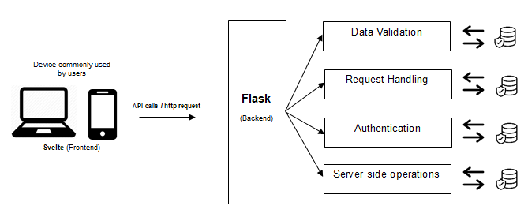**System Architecture**

Figure 3.1: Micro-Service Architecture

When the frontend needs data, it sends an HTTP request to the Flask server. The server processes this request and sends back a response, which the Svelte app then processes and uses to update the UI. This separation of concerns allows for better code organization, easier debugging, and the potential for each part to scale independently.

* 1. **Requirements Specifications**

This document management system or “DOCUTRACKER”, is a web-based system for Davao Oriental State University (DORSU), that helps the user to reduce the time of effort of processing their documents. The system is able to notify the user on the progress of their tracked and ensures the smooth flow and secure tracking of documents.

* + 1. **Product Perspective**

This web based DOCUTRACKER system allows user to add a document to be tracked whether that user is in the campus or not since it can be accessible wherever they are as long as it is connected in the internet. Once the user is done adding a document, they can be able to see the progress of the document.

* + 1. **Product Features**

DOCUTRACKER is designed to manage documents, and within the area of processing documents, the system provides information and data such as status, time visualization, etc. in which can be absorbed by the end user, the system also notifies the user about every piece of process in their document.

**User Class and Characteristics**

**3.4.2.1 User**

Users can add document in which the system can process, Users can see the status and progress of documents, Users cannot manage other user’s credentials.

**3.4.2.2 Receiver**

Receivers receives documents such as approves/rejects them and they opt for the system to process documents, the data of the process will be thrown back to the end user, they can only process documents that it is meant for them, Receiver cannot view data of documents and can't see others receiver’s processes.

**3.4.2.3 Admin**

Admin is the one who is responsible for managing the “DOCUTRACKER” system and has all the access on the user’s section, Admin manages users and receiver, it has the control over users’ data and other credentials of registered accounts.

**3.4.3 Opening Environments**

**3.4.3.1 Software Components**

The developers used “Visual studio code” for developing and designing the system. For the frontend, the developers used HTML, CSS and svelte.js library, we use several modules that comes alongside svelte to help in the overall development process of the frontend, in the backend the developers used python flask for database integration, data processing and other server side operations which exposes a rest API/endpoint which the frontend can grab into.

* + 1. **Design and Implementation Constraints**

There are several implementation constraints, but the major internal implementation constraint the comes along during the development process, due to the separation of concern of the front end and backend is CORS (Cross Origin Resource Sharing), CORS is a security feature in the browser, which no frontend code can access the backend endpoint which gives the developers a hard time getting around it.

* + 1. **User Documentation**

The developers ensure that the user manual will be applied for the user to be able to know once they’ve accessed the DOCUTRACKER system for its first use. Developers ensure a smooth and more user-friendly experience when accessing the DOCUTRACKER system with the help of user manual for each function and navigation in the system.

* + 1. **Other Non-functional Requirements**

The system comes with a range of Non-functional Requirements that is required and common in developing software such as Security, Usability and Availability, etc. These system attributes makes DOCUTRACKER more reliable and capable that ensures safety at the same time

**3.4.7.1 Safety requirements**

DOCUTRACKER comes with common security features that can be found in most software such as real time validation of entries, password hashing, email verification, CORS (Cross Origin Resource Sharing) ensures that only our frontend can access the backend endpoint, DOCUTRACKER uses JWT (JSON Web Tokens) to authenticate the user, admin also verifies the user accounts, etc. DOCUTRACKER ensures that the users and data are safe under its supervision.

**3.4.7.2 Security Requirements**

In order to maintain the security of the system, DOCUTRACKER is supervised by the admin which has control over the users which is called administrative Security, after users creating/signing up their account, the admin needs to verify the newly registered account first. When the user logs in for the first time and if their account is still under verification by the admin, they can’t use DOCUTRACKER which leaves them to patiently wait until their account is verified, admin also supervised users in real time this ensures that DOCUTRACKER is secure.

* + 1. **Software Quality Requirements**

The DOCUTRACKER: A Web Based Document Management Information System for Davao Oriental offers the following features that indicate high software quality:

**3.4.8.1 Usability**

The developers will implement a user-centered design which provides the user-friendly interface that allows users, secretaries and admin to effortlessly interact within the system. The system's well-organized and visually appealing design enhances the user experience.

**3.4.8.2 Reliability**

The system is properly tested by the developers in the time of development before being implemented. It places on dependability through rigorous testing, quality assurance measures, robust error-handling and data integrity that assure constant performance and good process flow of tracking documents.

**3.4.8.3 Functionality**

The system allows the users to request not only one, but multiple documents in one place and they will be notified to the progress of their requested document with the help of the system’s “real-time notification”. Users can check and update their information in the “user profile” feature once they have access to the system and it is also required for the verification process of user’s credentials.

**3.4.8.4 Portability**

The system and its components can be transferred from one operational organization to another that is relevant to document management.

**3.4.8.5 Maintainability**

The system ensures long-term sustainability and adaptability through regular updates, coding methods, and software development principles ensuring the reliability and relevance throughout development and, to adapt in the present environment and requirements.

**3.4.8.6 Efficiency**

The system optimizes document-related operations, increasing productivity through streamlined process flow, user-friendly interface, batch processing, real-time collaboration, and load testing. These methods are essential for managing documents within faculties at Davao Oriental State University (DorSU).

**3.5 Design**

**3.5.1 Use case Diagram**

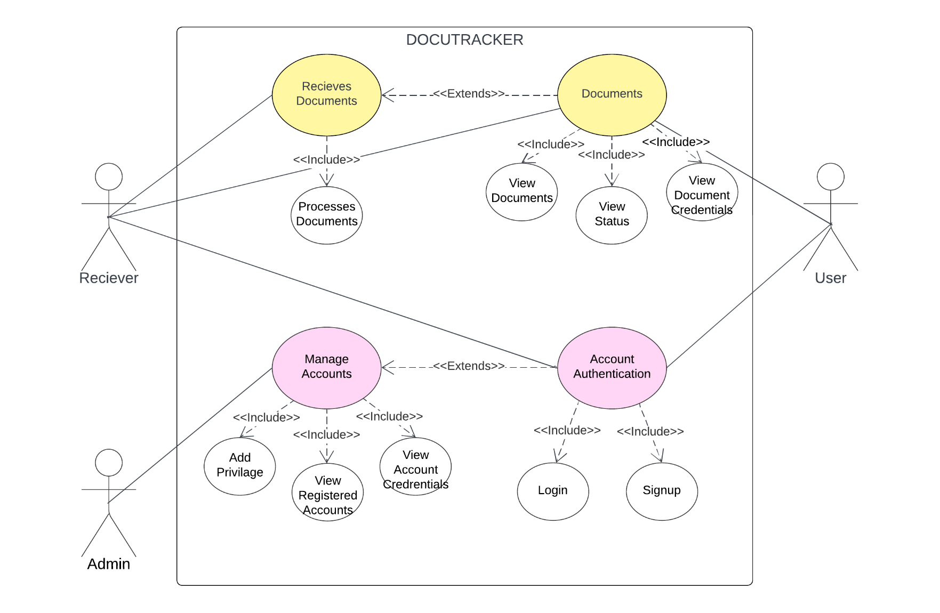

Figure 3.3: DOCUTRACKER Use Case Diagram

**3.5.1.1 Use Case Description**

The explanations of the Use Case Diagram that the developers were using were supplied in this, enabling the users to manage different aspects of the DOCUTRACKER: A Web Based Document Management System for Davao Oriental State University.

Table 3.1: Login

|  |  |
| --- | --- |
| **DOCUTRACKER: Login** | |
| Actors | Admin/Users/Secretary |
| Description | Admin, registered user and secretary can log in their account by providing the account’s credentials like username and password. |
| Data | Users/Secretary/Admins’ username and password |
| Stimulus | By clicking the login button. |
| Response | The Dashboard page will appear. |

Table 3.2: Register

|  |  |
| --- | --- |
| **DOCUTRACKER: Register** | |
| Actors | User/Receiver |
| Description | Users and Receivers can create an account first by providing the necessary information and credentials before can get access to the system. |
| Data | User and secretary’s credentials like name, address, email, password, etc. |
| Stimulus | By clicking the “Sign–up” button. |
| Response | The login page will appear. |

Table 3.3: Add Document

|  |  |
| --- | --- |
| **DOCUTRACKER: Document Registration** | |
| Actors | User |
| Description | The users can add document for the tracking process. Users are able to add not only one, but multiple of documents. |
| Data | User’s full name, designation, id, name/type of document, description. |
| Stimulus | By clicking the “Add Document” in homepage |
| Response | The Add document page will appear. |

Table 3.4: View Request Status

|  |  |
| --- | --- |
| **DOCUTRACKER: View Document Status** | |
| Actors | Users |
| Description | The users can view the status of their requested document once they are done in adding document. |
| Data | User’s information, document status |
| Stimulus | By clicking the “Expand dropdown” in homepage |
| Response | The Document Status page will expand. |

Table 3.5: Manage Accounts

|  |  |
| --- | --- |
| **DOCUTRACKER: Manage Accounts** | |
| Actors | Admin |
| Description | The admin is able to view the list of registered account and their information. |
| Data | List of registered user and receivers accounts |
| Stimulus | By clicking an account in admin homepage |
| Response | The “Manage account modal” page will appear. |

Table 3.7: Document Approval

|  |  |
| --- | --- |
| **DOCUTRACKER: Document Approval** | |
| Actors | Receiver |
| Description | The receiver’s role is to receive the document of users. Receiver can also dismiss the document if there’s a mistake or lacking of document attachment. |
| Data | Document credentials |
| Stimulus | By clicking the “Approve button” in Document modal. |
| Response | The “Document Approval” message will appear. |

**3.5.2 Entity Relationship Diagram**

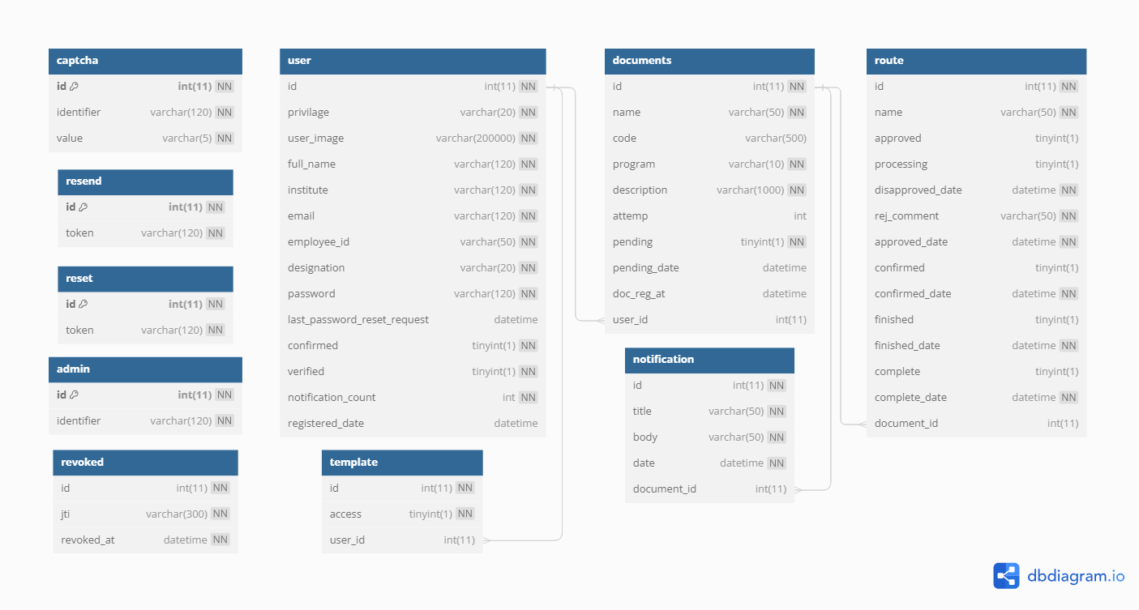Figure 3.4: DOCUTRACKER Entity Relationship Diagram

**3.5.3 Data Dictionary**

|  |  |  |  |  |
| --- | --- | --- | --- | --- |
| **Table Name** | **Attribute_Name** | **Type** | **Content** | **Format** |
| **Captcha** | id | Int (11) | Captcha Id | PK, not null |
| identifier | Varchar (120) | Captcha Identifier | Not null |
| capt_value | Varchat (5) | Captcha value | Not null |
| **Documents** | docu_id | Int (11) | Id | PK, not null |
| name | Varchar (50) | Document Name | Not null |
| code | Varchar (50) | Document QR Code | Null |
| program | Varchar (10) | Program Associated with the Document | Null |
| description | Varchar (200) | Document Description | Null |
| institute | Varchar(10) | Institute Associated with the Document | Null |
| attemp | Int(11) | Document Resubmit attemps | [default: 0] |
| pending | Tinyint(1) | Document Pending State | [default: true] |
| pending_date | datetime | Document Registered Date | datetime |
| user_id | Int(11) | User id | FK, Not null |
| **Notifications** | id | Int (11) | Notification id | PK, not null |
| title | Varchar (50) | Notification Title | Not null |
| body | Varchar(50) | Notification Content | Not null |
| date | datetime | Notification Date | Not null |
| document_id | Int(11) | Document Id | FK, not null |
| **Resend** | id | Int (11) | Resend Id | PK, not null |
| token | Varchar (120) | Token | Not null |
| **Reset** | id | Int (11) | Reset Id | PK, not null (000) |
| token | Varchar (120) | Reset Token | Not null |
| **Revoked** | id | Int (11) | Id | Not null |
| jti | Varchar (50) | Revoked Token Value | Not null |
| revoked_at | datetime | Revoke time | Not null |
| **Route** | id | Int (11) | Route Id | PK, not null |
| name | Varchar (50) | Name | Not null |
| approved | Tinyint (1) | Approved State | [default: 0] |
| disapproved_date | datetime | Disapprove Date | Null |
| rej_comment | Varchar (50) | Comment of rejection | Null |
| approved_date | datetime | Approve Date | Null |
| confirmed | Tinyint (1) | Confirmed State | [default: 0] |
| confirmed_date | datetime | Confirmed Date | Null |
| finished | Tinyint(1) | Finished State | [default: 0] |
| finished_date | datetime | Finished Date | null |
| complete | Tinyint(1) | Complete State | [default: 0] |
| complete_date | datetime | Complete Date | null |
| document_id | Int (11) | Document Id | FK, not null |
| **Template** | id | Int (11) | Template Id | Not null |
| access | Tinyint (1) | Access State | Not null |
| user_id | Int (11) | User id | FK, not null |
| **User** | id | Int(11) | User Id | PK, Not null |
| privilage | Varchar (20) | User privilage | Not null |
| user_img | Varchar (120) | User Image | Not null |
| full_name | Varchar (50) | User full name | Not null |
| institute | Varchar (120) | User Institute | Not null |
| email | Varchar (120) | User Email | Not null |
| Employee_id | Varchar (50) | User Employee Id | Not null |
| designation | Varchar (20) | User Designation | Not null |
| program | Varchar (20) | User Program | Not null |
| password | Varchar (120) | User password | Not null |
| last_password_reset_request | datetime | Last request date | [default: null] |
| confirmed | Tinyint(0) | User confirmed State | [default: 0] |
| verified | Tinyint(0) | User verified State | [default: 0] |
| notification_count | Int (11) | Notification Count | Not null |
| registered_date | datetime | User Registered Date | Not null |

**3.5.4 Graphical User interface Design**

This would display a potential mock-up of the web-based application that the developers intended to create.

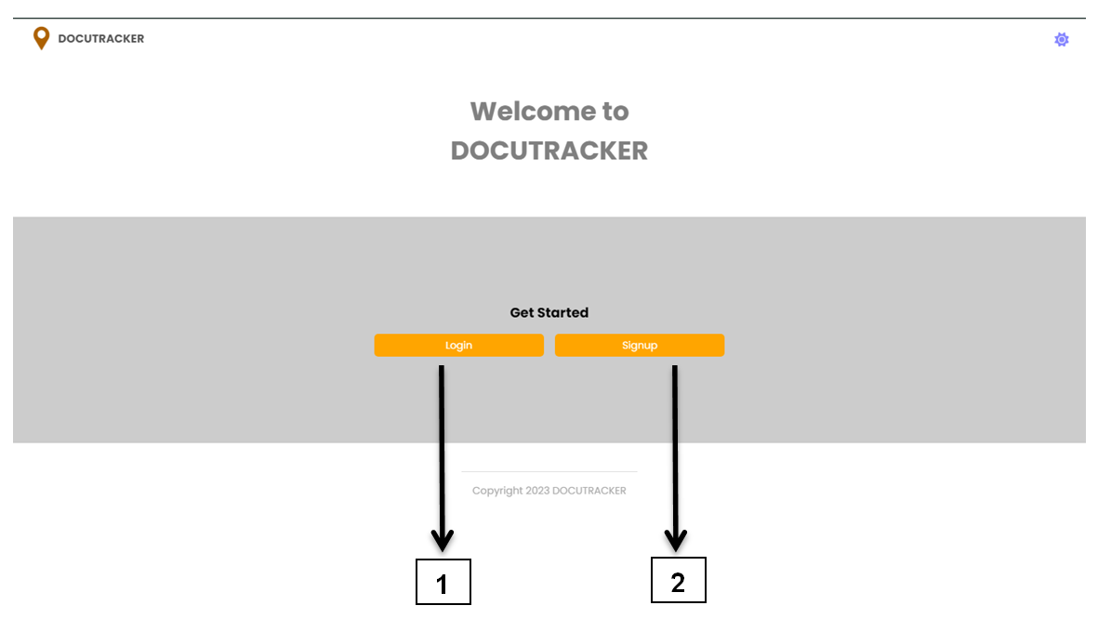

Figure 3.5: User and Secretary interface of DOCUTRACKER

|  |  |
| --- | --- |
| **Name** | **Function** |
| 1. Login button | Allows the user to access the login form once it is clicked. |
| 1. Register button | Allows the user to access the signup form if the user doesn’t have an account. |

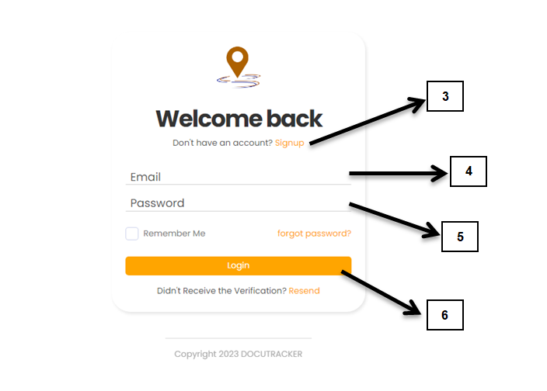

Figure 3.6: Login Form

|  |  |
| --- | --- |
| **Name** | **Functions** |
| 1. Signup hyperlink | Directs the user to access the signup form |
| 1. Email | Allows the user/secretary to enter a email |
| 1. Password | Allows the user/secretary to enter a password |
| 1. Login Button | Directs the user/secretary to dashboard page |

Figure 3.7: Sign up form

|  |  |
| --- | --- |
| **Name** | **Functions** |
| 1. Registration credentials | Allows the user to enter his/her credentials for account. |
| 1. User/Secretary option | Allows the user to select his/her designation and institute on where assigned. |
| 1. I’m not a robot | Directs the user to “captcha” for verification |
| 1. Upload profile | Allows the user to upload his/her profile picture. |
| 1. Submit button | Directs the user/receiver to login form. |

**User Interface**

Figure 3.8: User Dashboard

|  |  |
| --- | --- |
| **Name** | **Functions** |
| 1. Sidebar Navigation | Contains a group of navigations |
| 1. Add/Register Document | Directs the user to request document |
| 1. Scan Document | Directs the user for scanning of documents. |
| 1. Registration status | Provides information details for the status of document registration. |
| 1. Registration status widget | Displays the quantity of registered document based on its status whether it is to be forwarded, approved, for waiting, complete, and rejected. |
| 1. Document registration details | Displays the table list of registered documents which includes document name, description, ID, and registered date |

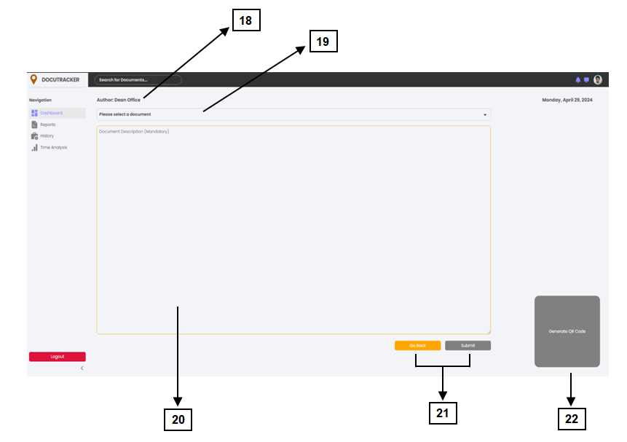

Figure 3.9: User Dashboard/Register Document

|  |  |
| --- | --- |
| **Name** | **Functions** |
| 1. Designation | Displays the work designation of the user |
| 1. Select Document | Allows the user to select a document to be registered |
| 1. Document Description | User is required to include an description that is associated to the selected document |
| 1. Back and Submit Button | Once the user is done, clicking submit will able to send his/her request to be processed. Pressing back button will directs back to dashboard. |
| 1. Generate QR code | Allows the user to generate a QR code that will be used for the identification of selected document |

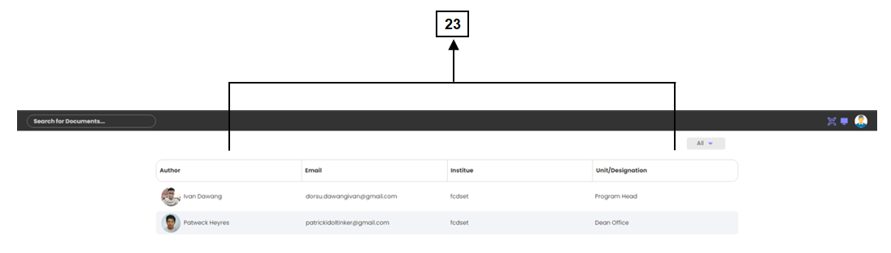**Secretary Interface**

Figure 3.10: Secretary Dashboard

|  |  |
| --- | --- |
| **Name** | **Functions** |
| 1. User account details | Displays the table list of users who requests a document. |

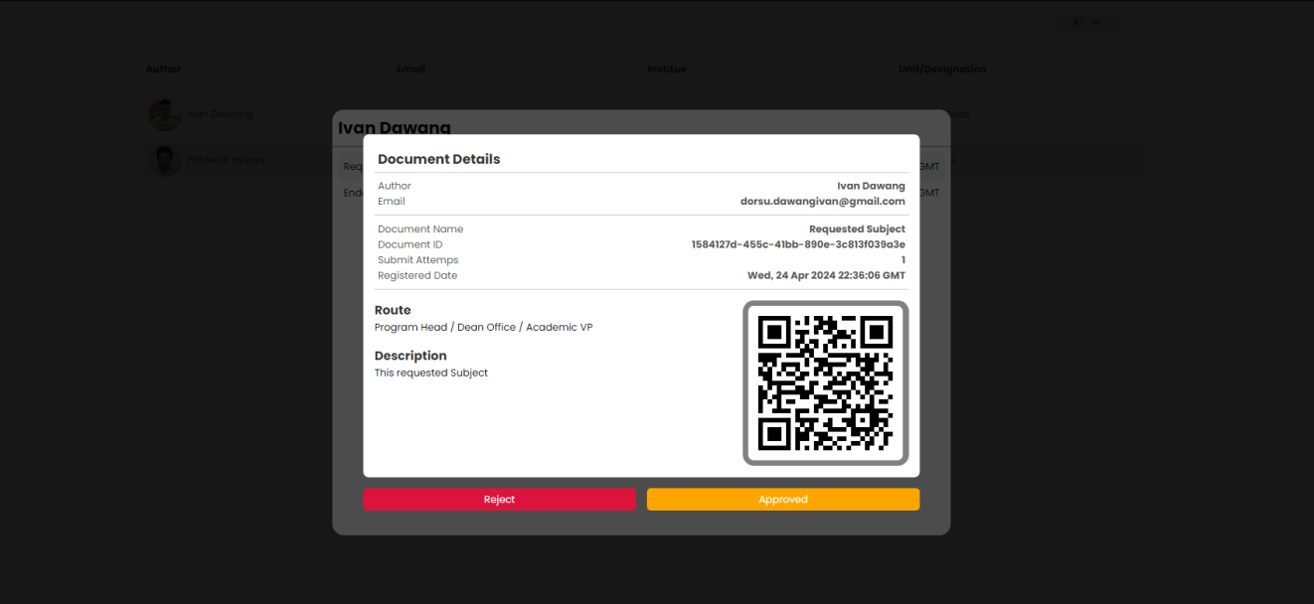

Figure 3.11: Document registration details

Figure 3.18: Registered Account List

This figure shows the details of the registered document (once clicked the user’s info shown in figure 3.10) that is made by the user. It contains the name, email, document name, ID, registered date, document description and its route.

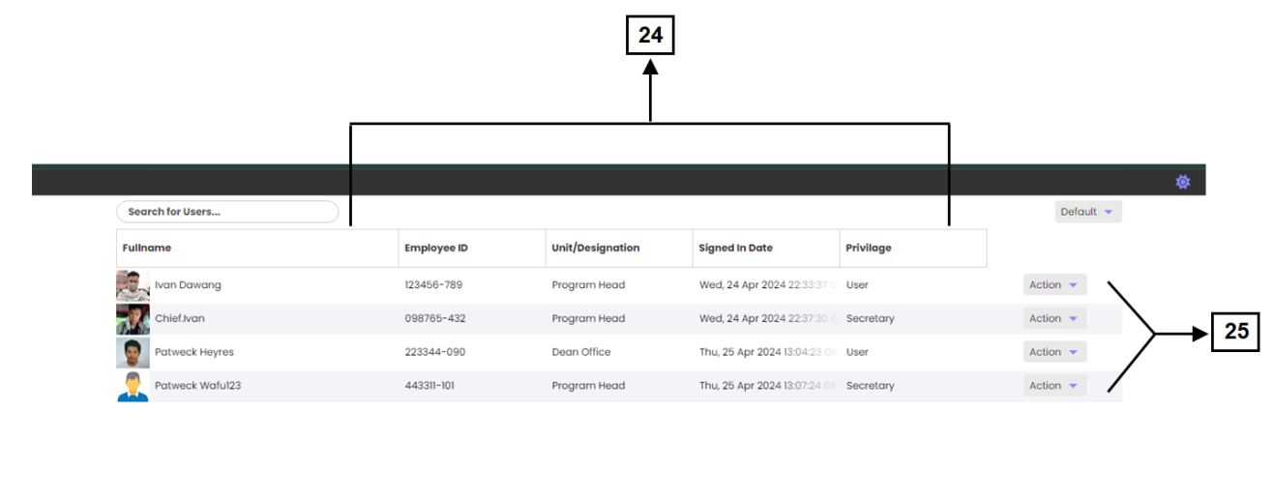**Admin Interface**

Figure 3.12: Secretary Dashboard

|  |  |
| --- | --- |
| **Name** | **Functions** |
| 1. User account details | Displays the user’s information and its privilege to the system. |
| 1. Privilege selection | Allows the admin to set a privilege to the users after they’ve register account. Has two privilege which is user or document receiver. |

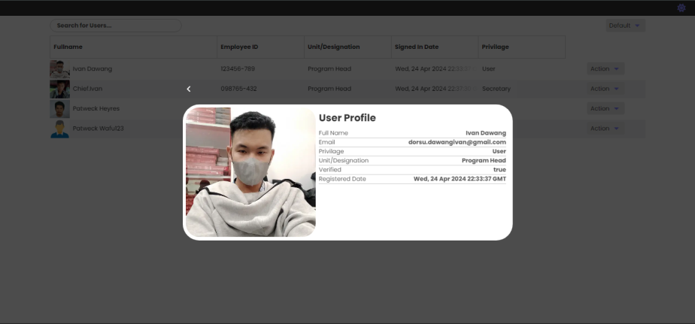

Figure 3.13: Secretary Dashboard/User Profile

This figure shows the credentials of the user. It contains the name of the user, email, privilege to the system, designation, and date of registration.

**3.6 Development and Testing**

* + 1. **Development**

During the DOCUTRACKER development phase, the developers used a combination of HTML/CSS, svelte and flask to create the user interface, creating an engaging and responsive design for the website. Front-end development was carried out utilizing these web technologies in order to provide consumers with a visually pleasing experience. The developers used PHP in combination with XAMPP as the server environment and MySQL as the database management system for the backend.

Visual Studio Code was the primary coding environment utilized throughout the development process. The compatibility, performance, and adaptability of these technologies influenced their selection, which contributed to the overall development of the DOCUTRACKER website.

* + 1. **Data Analysis plan**

The DOCUTRACKER project, a web-based document tracker for Davao Oriental State University, will be reviewed in accordance with the ISO 25010:2011 standard to see if it fits the criteria. This assessment will be based on the evaluation of each user. DOCUTRACKER was evaluated using a questionnaire based on the ISO25010:2011 paradigm. Indicators for functional appropriateness, performance efficiency, usability, dependability, security, maintainability, and portability are included in the questionnaire.

The data will be analyzed using Weighted Arithmetic Mean for the evaluation. The respondents' answers on the survey may produce the Likert scale. Each assessment item will be graded on a scale of 1 to 5, with 5 indicating strong agreement and 1 indicating strong disagreement. The weighted arithmetic mean will be obtained for each item, and the overall score of evaluation will be generated by averaging the responses of every item.

The weighted arithmetic mean will be interpreted using the scale below:

|  |  |
| --- | --- |
| Weighted arithmetic mean range | Interpretation |
| 4.50 – 5.0 | Strongly Agree |
| 3.50 – 4.50 | Agree |
| 2.50 – 3.50 | Undecided/Fair |
| 1.50 – 2.50 | Disagree |
| 1.50 and below | Strongly Disagree |

**CHAPTER IV**

**RESULTS AND DISCUSSION**

**4.1 Achievements per objective**

The system uses QR code to identify each file easily, the system has an interface to generate QR code and to register a requested document.

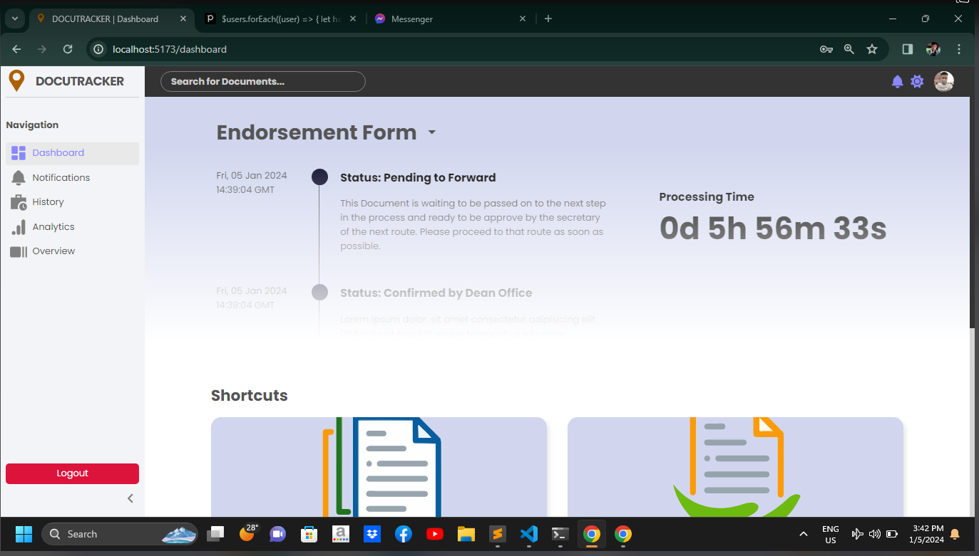Provides data of the time taken by each processing of document and number of times of the same document that processed in every use of system.

**4.2 Evaluation of the system**

The evaluation of the system is not implemented yet, and we are unable to present any results since our system is in the development stage, working on progress.

**4.3 Implementation Plan**

Researchers cannot conclude yet information, working on progress.

**CHAPTER V**

**SUMMARY, CONCLUSIONS AND RECCOMENDATIONS**

**5.1 Summary**

The purpose of the researchers in this study was to develop, design, and implement a web based document management information system for Davao Oriental State University that is capable of adapting the manual processing method of documents within faculties in DorSU in order to reduce given time and effort of those who process and manages the documents. The researchers gathered information of mainly processed document and its routes in order to be applied in the system. For the system development, the researchers developed a plan for design which focuses on user-friendly interface, and using some of programming language for the overall functionality of the system.

**5.2 Conclusion**

In conclusion, the developers of DOCUTRACKER a web-based document management information system established at Davao Oriental State University, is an essential solution for managing and organizing the university's huge array of papers. This system has an easy-to-use interface that streamlines the document lifecycle, from creation to retrieval. Its extensive features, such as version control, access rights, and document classification, let university workers collaborate more effectively. DOCUTRACKER not only encourages openness and accountability, but it also greatly lowers the time and effort required to handle documents. The system's safe and accessible platform guarantees a smooth flow of information between departments, resulting in a more simplified and responsive administrative procedure for Davao Oriental State University.

**5.3 Recommendation**

Researchers cannot conclude yet information, working on progress.

**Literature Cited**

Aiim. (n.d.). What is Document Management (DMS)? https://www.aiim.org/What-Is Document-Imaging

Corporation, D. (n.d.). What is Document Management (DMS)? | DocuWare. https://start.docuware.com/document-management

Hawthorne, J. (2023). The benefits of a centralized document management system for global enterprises. Document Management System Folderit. https://www.folderit.com/blog/the-benefits-of-a-centralized-document management-system-for-global-enterprises/

Ontra. (2023). 7 benefits of a document management system. Ontra. https://www.ontra.ai/blog/benefits-modern-document-management-systems-dms/

M-Files. (2021, October 5). Document management system | M-Files. M-Files | the Smarter Way to Work. https://www.m-files.com/supplemental/document management-system/

Techopedia. (2022, August 9). What is an Electronic Document Management System (EDMS)? - Definition from Techopedia. https://www.techopedia.com/definition/12769/electronic-document-management system-edms

Labis, X. (2023b, July 26). What are Document Tracking Systems? Syntactics Inc. https://www.syntacticsinc.com/news-articles-cat/document-tracking-systems/

Ducker, T. (2022, December 16). Document Management in Salesforce: The Ultimate Guide | Salesforce Ben. Salesforce Ben. https://www.salesforceben.com/document-management-salesforce/

Lori. (2018, November 14). Records Management Literature: the language of collaboration - Lori Birrell. Lori Birrell. http://lori.birrell.us/2010/11/14/records management-literature-the-language-of-collaboration/

Han, J. W., Wang, C., Miao, J., Lu, M., Wang, Y., & Shi, J. (2021). Research on Electronic Document Management System based on Cloud Computing. Computers, Materials & Continua, 66(3), 2645–2654. https://doi.org/10.32604/cmc.2021.014371

Haryawan, C., & Iswanti, S. (2021). IMPLEMENTASI PIECES FRAMEWORK DALAM PERANCANGAN E-DOCUMENT MANAGEMENT SYSTEM WEBSITE PUSAT JAMINAN MUTU. Jurnal Teknik Informasi Dan Komputer, 4(2), 137. https://doi.org/10.37600/tekinkom.v4i2.344

Luna-Reyes, L. F., & Gil-Garcia, J. R. (2019). Digital government transformation and internet portals: The co-evolution of technology, organizations, and institutions. Government Information Quarterly, 31(4), 545–555. https://doi.org/10.1016/j.giq.2014.08.001

Team, M. (2023). 11 Benefits and Advantages of document management systems. MHC Automation. https://www.mhcautomation.com/blog/11-benefits-and-advantages of-document-management-systems/

BenTech. (n.d.). Common Document Management Problems & how to avoid them? www.linkedin.com. https://www.linkedin.com/pulse/common-document management-problems-how-avoid-them-venkat-bentech

Xiao, X. (2022). Research and application of Cloud Platform-Oriented Intelligent Information Management System. Wireless Communications and Mobile Computing, 2022, 1–8. https://doi.org/10.1155/2022/8397780

Inc, T. (2023). What is Agile [Guide] | Trundl. Trundl | Atlassian Solution Platinum Partner. https://trundl.com/resources/guides/what-is-agile/#What_is_Agile

Bestaieva, D., & Altynpara, E. (2023, August 8). The full guide on Agile SDLC for 2023. Cleveroad Inc. - Web and App development company. https://www.cleveroad.com/blog/agile-sdlc/

Emralino, J. B. (2019). PROJECT DOTS (DOCUMENT TRACKING SYSTEM): ITS EFFECTS IN THE INTER-OFFICES IN THE SCHOOLS DIVISION OF PARAÑAQUE CITY. https://ejournals.ph/article.php?id=14080

Côrtes, P. L., & De Paula Côrtes, E. G. (2020). Hospital information systems: a study of electronic patient records. Jistem Journal of Information Systems and Technology Management, 8(1), 131–154. https://doi.org/10.1590/s1807 17752011000100008

The UP Document Tracking System (DTS) | University of the Philippines Information Technology Development Center. (n.d.). https://itdc.up.edu.ph/news/the-up document-tracking-system-dts

Abba, I. V. (2022). What is an ORM – The Meaning of Object Relational Mapping Database Tools. freeCodeCamp.org. https://www.freecodecamp.org/news/what is-an-orm-the-meaning-of-object-relational-mapping-database-tools/

Murphy, D. (2022). The importance of information systems security. https://iticollege.edu/blog/the-importance-of-information-systems-security/

Chehab, G., & Chehab, G. (2023). What is an ORM? how does it work? How should we use one? | Baeldung on Computer Science. Baeldung on Computer Science. https://www.baeldung.com/cs/object-relational-mapping

ORM or SQL in large, scalable and MAINTAINABLE web application? (n.d.). Stack Overflow. https://stackoverflow.com/questions/2637259/orm-or-sql-in-large scalable-and-maintainable-web-application

Ian. (2021, June 20). What does ACID mean in Database Systems? https://database.guide/what-is-acid-in-databases/

Paikroy, P. (2023, July 9). Understanding MVC architecture: Building robust and maintainable applications. Piyush Paikroy. http s://piyushpaikroy.hashnode.dev/understanding-mvc-architecture-building-robust and-maintainable-applications

iNetTutor.com. (2022, November 15). Document Control System Conceptual Framework - iNetTutor.com. iNetTutor.com. https://www.inettutor.com/diagrams/document control-ipo-conceptual/

Clark, J. (2023). Top 10 advantages of Firebase. Back4App Blog https://blog.back4app.com/advantages-of-firebase/

Kiplie, F. H., Yatin, S. F. M., Angutim, M., & Hamid, N. H. A. (2018). System development for Document Management system. International Journal of Academic Research in Business & Social Sciences. https://doi.org/10.6007/ijarbss/v8-i9/4652

Costoiu, M., Plesu, V., Isopescu, R., Soriga, S. G., Alesincu, S. H., & Arsene, I. C. (2019). Electronic Document Management Information System for Universities. Chemical Engineering Transactions, 29, 1639–1644. https://doi.org/10.3303/cet1229274

Chen, X. (2005). The Interrelationship between Document Management, Information Management and Knowledge Management. https://uir.unisa.ac.za/handle/10500/13666

Nakajima, S. M. (2021). Beginner’s guide to Svelte - From basics to state management and animation. Twilio Blog. https://www.twilio.com/blog/all-you-need-to-know svelte

Uzondu, D. (2023). What is Svelte Framework and how do you use it? MUO. https://www.makeuseof.com/what-is-svelte-framework-and-how-do-you-use-it/

Getting started with Svelte - Learn web development | MDN. (2023). https://developer.mozilla.org/en-US/docs/Learn/Tools_and_testing/Client side_JavaScript_frameworks/Svelte_getting_started

Omisola, I. (2021). What is Google Firebase and why should you use it? MUO. https://www.makeuseof.com/what-is-google-firebase-why-use-it/

Hanna, K. T., & Rosencrance, L. (2023). Google Firebase. Mobile Computing. https://www.techtarget.com/searchmobilecomputing/definition/Google-Firebase

GeeksforGeeks. (2021). Firebase Introduction. GeeksforGeeks. https://www.geeksforgeeks.org/firebase-introduction/

Labis, X. (2023). What are Document Tracking Systems? Syntactics Inc. https://www.syntacticsinc.com/news-articles-cat/document-tracking-systems/

Team, M. (2023). 11 Benefits and Advantages of document management syste s. MHC Automation. https://www.mhcautomation.com/blog/11-benefits-and advantages-of-document-management-systems/

What is a document tracking service? (n.d.). business.com. https://www.business.com/articles/document-tracking/

Document Tracking System | Document Management Software. (2022). GigaTrak. https://www.gigatrak.com/software/document-tracking-system/

GLOBODOX. (2023). Document Management System (DMS) - GLOBODOX. https://www.globodox.com/

Zammit, I. (2023). Document Management System Definition. Document Management System Folderit. https://www.folderit.com/blog/document-management-system definition/

Canva Graphic Design Company 2023 | Agile Methodology https://www.canva.com/design/DAFr6Vgwt9Y/6dScH0kXTAgmpWyvn0s-dw/edit

University of the Philippines Document Tracking System Interface (January 01, 2022) https://itdc.up.edu.ph/news/the-up-document-tracking-system-dts

M-Files: Digital Document Management (2022) https://www.google.com/url?sa=i&url=https%3A%2F%2Fwww.m-files.com%2Fm filesplatform

GLODOBOX Document Management Software (2023) globodox-https://www.globodox.com/globodox-features/use-with-ease/

Folderit Document Management System Software (2023) , https://www.folderit.com/?gclid

Gigatrak Document Tracking System (2022) https://www.gigatrak.com/software/document-tracking-system/

About SQLite. (n.d.). https://www.sqlite.org/about.html

S, R. A. (2023). What is SQLite? Everything You Need to Know. Simplilearn.com. https://www.simplilearn.com/tutorials/sql-tutorial/what-is-sqlite

Dyouri, A. (2022). How To Make a Web Application Using Flask in Python 3. *DigitalOcean*. https://www.digitalocean.com/community/tutorials/how-to-make-a-web-application-using-flask-in-python-3

Mieczkowski, O. (2023, June 9). Flask vs. Django in 2023 – Which Python Framework To Choose and When? *f*. https://www.monterail.com/blog/flask-vs-django