LocoSwap manual

# Introduction

Hello there! Thank you for downloading LocoSwap. Please read this short manual and follow the instructions in order to use the program smoothly. I hope that you will enjoy LocoSwap!

# What is LocoSwap?

LocoSwap is a small utility that lets you to edit TS Classic scenarios by swapping the rolling stock.

If you don’t own a piece of stock, then editing the scenario within the TS editor is not an option, as TS will just completely discard all the consists with missing stocks.

Swapping stocks is useful in situations like:

* You bought a vehicle on Steam but it is located in another folder than the version sold by other vendors
* The scenario creator used a reskin of a stock you own, but you don’t want to bother installing it, or it is no longer available
* You own a better version of a stock the scenario uses
* You just don’t own the stock at all because DLCs are expensive 😉

# Installation

The system requirements are:

* Windows 10/11 64bit (if you have an older version of Windows, please check that you have .NET Framework 4.8 and then it should also run without problem)
* Train Simulator Classic

To install LocoSwap, simply extract the files to a location of your choice and launch LocoSwap.exe.

# First launch

When the program starts for the first time, it will ask you about the location of Train Simulator, so that the program can find all your routes, scenarios and vehicles. Please go to the folder that contains RailWorks.exe and click “Select Folder.”



# Program usage

### Main window

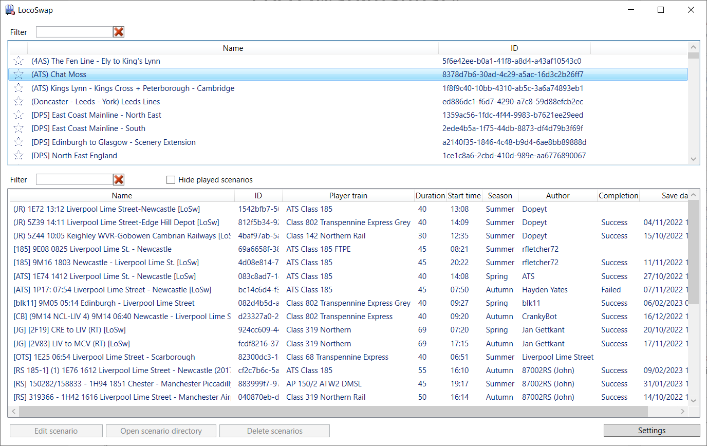

### Routes list

In the first window, you will see a list of routes installed.

Routes can be filtered by name with the text field on top.

You can pin a route to the top of the list by clicking the star to the left of the route name.

Click on a route and the scenarios under this route will be listed on the lower list.

### Scenarios list

On the lower part of the main window is the scenarios list of the selected route.

These can be filtered with the “Filter” text field.

Filtering criteria include:

* Scenario name
* Scenario ID
* Player train
* Author
* Description

You can hide played scenario, so that only scenarios that have never been failed or succeeded will show.

Scenario showing in italic are scenarios packed in an .ap file (these are mostly default scenarios coming with routes, as opposed to workshop or other third-party scenarios).

*ℹ These scenarios cannot be deleted, or their directory opened.*

These scenarios can be edited “normally”, LocoSwap taking care of extracting the scenario from the .ap on save. Not that you may encounter an error in TS stating “Cannot read Scenario.bin file”. Simply discard the error by hitting F2, then “Cancel”.

Various scenario details can be viewed.

Among these:

* “Save date” is the date of the game save for that scenario.
* “Completion” is the scenario status in the TS database. “Success” is like the green tick in TS, “Failed” means you failed the scenario. Note that in the TS interface, failed and never played scenarios cannot be distinguished!
* Scenario description: can be seen as you hover on the scenarios list.

Once you have selected the scenario to edit, click on the “Edit Scenario” button, and the editor window will show up.

### Scenario edition window

### 

The first step is to select the consist from the left list, and then select the vehicle to be replaced on the second list. With Ctrl or Shift button you can select more than one vehicle in a consist.

The icons on the consist and vehicles lists mean:

 The consist is driven by player

* Vehicle is found

 Vehicle is not found, but a replacement rule is known for it (see *Replacement rules* below)

* Vehicle is not found and no replacement rule is known

Vehicle is replaced



 Vehicle is involved in a couple or uncouple instruction (see *Vehicle numbering* below)

Then you will need to choose the new vehicle you want.

To do this, first on the top right side navigate to the folder that contains that vehicle and click on the “Look up vehicles” button. It will then search for the available vehicles under the folder and its subfolders. The result will be shown on the bottom right-side list. You can filter this list by using the “filter” text box.

After you have chosen your new vehicle just click on the “Replace” button. To replace all identical vehicle in the scenario please click on the “Replace identical” button. If you leave “and add as rule” ticked, a replacement rule will be added (see next chapter).

### Vehicle length

Keeping the consists’ lengths roughly constant is key to avoiding pathing errors, collisions, or Out of Memory errors on load.

To assist you with that, LocoSwap will:

* Show the length of all available vehicles
* Try to guess the length of all vehicles, even missing ones

Note that for some vehicles, the computed length may be obviously wrong. Please ignore these erroneous values which are due to a TS limitation.

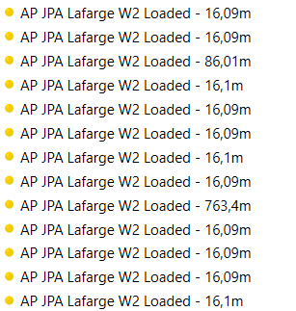

*These JPA wagons are obviously around 16,10 meters long, and not 86 or 763 😉*

When replacing a vehicle with that of another type, you can use these figures to avoid increasing the length of the resulting consist. Just aim at vehicles which lengths are slightly less than these of the original consist.

*Note that all lengths are expressed in meters.*

### Adding/flipping vehicles

You can also click on the “Insert” button to add the selected vehicle on the right side into the consist, before or after the selected position. With the “Remove” button you can remove the selected vehicle(s).

You can flip the vehicle by click on the “Flip vehicle” button.

### Vehicle numbering

When swapping, LocoSwap will pick a vehicle number at random among those provided by the creator, except if the vehicle is targeted by a couple or uncouple instruction, so as to not break the ability to complete the scenario.

You can always change the number of the vehicle by clicking the “Change number” button.

You can pick a number in the list, or enter one manually (this is useful for stocks enabling some degree of customization through the use of parameters).



*The numbering change window*

# Replacement rules

You can define a set of rules to have a particular vehicle always replaced by the same other vehicle.

Rules can be created by:

* simply selecting the vehicle to be replaced and the new vehicle you want, then click the “Add to rules” button.
* clicking “Replace all” while leaving “and add as rule” ticked. Note that any existing rule for that vehicle will be overwritten.

Rules can be applied by:

* opening the Replacement rules window, ticking rules, and applying them with the “Apply” button.
* applying all the rules to the current scenario by the use of the “apply all rules” button. You have the opportunity to only replace the yellow stocks, or apply all the rules even to green stocks.

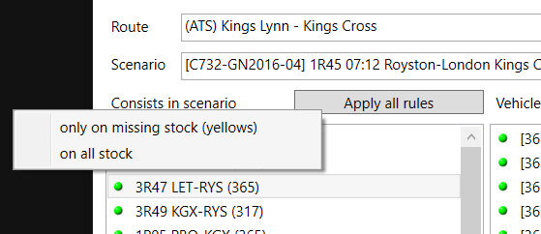

*“Apply all rules” button*

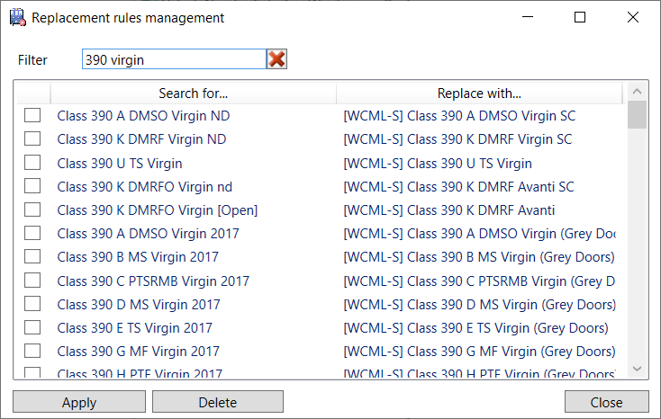

*The Replacement rules management window*

# Saving your changes

### Saving/restoring

When you are finished editing the scenario don’t forget to click on the “Save” button, located on the top right side of the editor window. That’s all and have fun with driving!

Should you run into problems with the edited scenario, don’t worry! We have created a backup for you. Just select the scenario on the main window, click on the “Open scenario directory” button. Rename “ScenarioBackup-{Date}-{Time}.bin” and “ScenarioPropertiesBackup-{Date}-{Time}.xml” back to “Scenario.bin” and “ScenarioProperties.xml”. That’s all and you have your old working copy back.

### Scenario name suffix

The scenario you modified with LocoSwap will be saved with a **[LoSw]** suffix appended to its name. This serves as a reminder you that you edited the scenario and that it’s ready to be played.

You can modify this suffix under the Settings screen. Leave the field blank to disable the suffix addition.

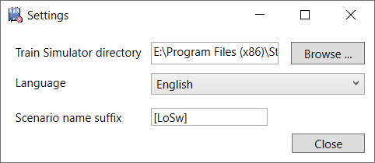

# FAQ

## All consists show as green in LocoSwap but I still have a black box error at scenario start stating that some stock couldn’t load.

The likely cause is that you installed a reskin or enhancement of a stock for which you do not have the base requirement. Search every consist for the possible culprit.

This message has also been seen while in fact no vehicle had loaded incorrectly.

## I have an Out of Memory error at the launch of a swapped scenario.

OOM’s have many possible causes in TSC, but one that is swap-related and very common is that what you did confuses the TS dispatcher.

A golden rule: **the length of consists should vary as little as possible**. It’s also always better if you reduce the length of a consist than if you increase it. Very often, the scenario will have AI trains next to buffers. In such a case, even the slightest increase in size can make the train overlap the track limits, and you’re almost certainly going for an OOM! Same goes if a train is supposed to spawn at a signal: making it longer can make the train overlap the next signal block, which is cause for trouble.

So:

* try to swap for similar types
* avoid changing between stock categories (electric/diesel/steam, passenger/freight)
* pay attention to the length of vehicles as you do your swapping, see the ***Vehicle length*** section of this manual
* if in doubt about the resulting length of your new consist, remove some wagons/carriages preemptively

## Why is it not possible to completely remove a consist with LocoSwap?

This choice is very deliberate. Removing an entire consist, especially if not a loose one, will make the scenario behave differently compared to what the creator intended (an AI train may be scheduled to wait at a signal for another AI to pass…). This can very easily lead to AI collisions or various pathing issues.

If you want to not bother with a train, simply replace it with a dummy stock (a stock that will not show in the simulation but still be computed as a train).

*ℹ If you have Armstrong Powerhouse products, you will find the “AP Blocker Engine” under AP/Common for instance. If you have at least one JustTrains route, you will find an equivalent under JustTrains/CommonLibrary.*

*Still keeping in mind that these engines have a non-zero length! (see previous question)*

## I swapped a diesel/steam engine and TS is saying I ran out of fuel right at the start of the scenario.

Go to the scenario editor, double-click on the player train’s engine and set the fuel slider at its maximum. If it’s a multiple unit train, you may have to do this on every car of the train.

# Uninstallation

Since LocoSwap does not use an installation program to install itself, you can simply delete the LocoSwap folder to uninstall it. The user settings are located at C:\Users\{Username}\AppData\Local\LocoSwap. This directory can also be safely removed.

# Credits & thanks

* dodo0822 – original developer up to version 1.1
* vanlueckn – contributor
* Frankoi1337 – developer
* Andrea Luigi Gobber (TrainSimItalia) – Italian translation
* [Architecture et ville icônes créées par Freepik - Flaticon](https://www.flaticon.com/fr/icones-gratuites/architecture-et-ville)