**Computer Vision HW1: Basic Image Manipulation**

**R10741015 鄭傑鴻**

**Sept. 7, 2022**

**Original Picture:**

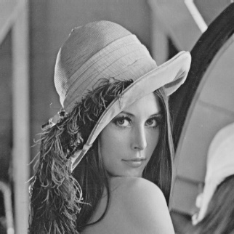

(With shape (512, 512))

**Part 1:**

1. Upside down

* Description:

For every element (pixel) in the new picture, denoted as $pic_new[i][j]$, assign pixel of the original picture $pic\left[511-i\right][j]$ to it. (The height of the picture is 512, i & j from 0 to 511)

* Code:

def upsideDown(self, save=True):  
 pic_new = np.zeros_like(self.pic)  
 rownum = self.pic.shape[0]  
 colnum = self.pic.shape[1]  
 for i in range(rownum-1):  
 for j in range(colnum-1):  
 pic_new[i][j] = self.pic[rownum-1-i][j]  
 showImg(pic_new)  
 if save: cv2.imwrite('lena_upsideDown.bmp', pic_new)

* Resulting Image:

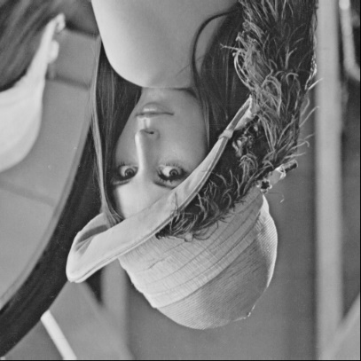

1. Right-side Left

* Description:

For every element (pixel) in the new picture, denoted as $pic_new[i][j]$, assign pixel on the original picture $pic\left[i\right][511-j]$ to it. (The width of the picture is 512, i & j from 0 to 511)

* Code:

def rightsideLeft(self, save=True):  
 pic_new = np.zeros_like(self.pic)  
 rownum = self.pic.shape[0]  
 colnum = self.pic.shape[1]  
 for i in range(rownum-1):  
 for j in range(colnum-1):  
 pic_new[i][j] = self.pic[i][colnum-1-j]  
 showImg(pic_new)  
 if save: cv2.imwrite('lena_rightsideLeft.bmp', pic_new)

* Resulting Image:

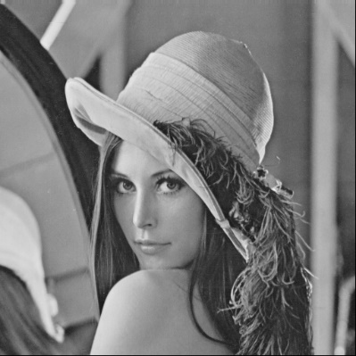

1. Diagonally Flip

* Description:

For every element (pixel) in the new picture, denoted as $pic_new[i][j]$, assign pixel on the original picture $pic\left[511-i\right][511-j]$ to it. (The width and height of the picture are both 512, i & j from 0 to 511)

* Code:

def diagonalFilp(self, save=True):  
 pic_new = np.zeros_like(self.pic)  
 rownum = self.pic.shape[0]  
 colnum = self.pic.shape[1]  
 for i in range(rownum-1):  
 for j in range(colnum-1):  
 pic_new[i][j] = self.pic[rownum-1-i][colnum-1-j]  
 showImg(pic_new)  
 if save: cv2.imwrite('lena_diagonalFlip.bmp', pic_new)

* Resulting Image:

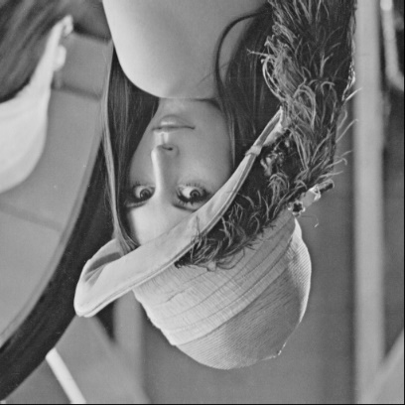

**Part 2:**

1. Rotate 45 degrees clockwise

* Description:

Since part 2 has no restrictions regarding using libraries, I use the *imutils.rotate()* method, with a negative 45 degrees counter-clockwise.

* Code:

def rotate45(self, save=True):  
 pic_new = imutils.rotate(self.pic, -45)  
 showImg(pic_new)  
 if save: cv2.imwrite('lena_rotate45.bmp', pic_new)

* Resulting Image:

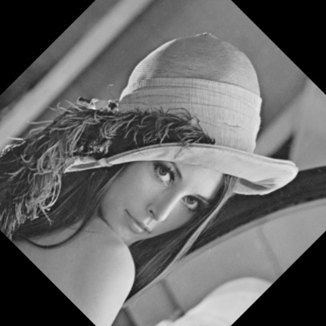

1. Shrink height and width in half

* Description:

Since part 2 has no restrictions regarding using libraries, I use the *cv2.resize()* method, with a new shape (256, 256).

* Code:

def shrinkHalf(self, save=True):  
 h_new = int(self.pic.shape[0]/2)  
 w_new = int(self.pic.shape[1]/2)  
 pic_new = cv2.resize(self.pic, (h_new, w_new), cv2.INTER_AREA)  
 showImg(pic_new)  
 if save: cv2.imwrite('lena_shrinkHalf.bmp', pic_new)  
 print('Shape for the new picture: ', pic_new.shape)

* Resulting Image:

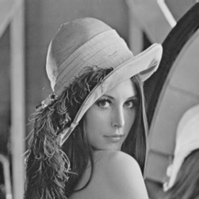



1. Binarize at 128 to get a binary image

* Description:
* For every element (pixel) in the new picture, denoted as $pic_new[i][j]$, if the correspondent pixel in the original picture $pic\left[i\right]\left[j\right]$ is greater than 128, assign value 255 to $pic_new[i][j]$, else assign 0 to $pic_new[i][j]$. (Value 255 resulting in white pixel, and value 0 result in black pixel. i & j from 0 to 511)
* Code:

def binarize(self, save=True):  
 pic_new = np.zeros_like(self.pic)  
 rownum = self.pic.shape[0]  
 colnum = self.pic.shape[1]  
 for i in range(rownum-1):  
 pic_new[i] = (self.pic[i] > 128)*255  
 showImg(pic_new)  
 if save: cv2.imwrite('lena_binarize.bmp', pic_new)

* Resulting Image:

