**Computer Vision HW3: Histogram Equalization**

**R10741015 鄭傑鴻**

**Sept. 20, 2022**

1. Original image and its histogram

* Description:
  1. Initiate a new array $count_array$ with shape (256, 1), where $count_array[i]$ stores the number of pixels with intensity *i*.
  2. Iterate over the original picture and accumulate numbers for different intensities in $count_array$.
  3. Visualize the result using matplotlib
* Code:

def generateHistogram(self, img, filename, graphname, ret=False):  
 def plotHistogram(ys, title='', save=True):  
 plt.bar(range(256), ys)  
 plt.title(graphname)  
 plt.xlabel('Intensity')  
 plt.ylabel('Number of Pixels')  
 plt.savefig('histogram_{}.png'.format(filename))  
 plt.clf()  
  
 count_array = np.zeros((256,), dtype=np.uint32)  
 for i in range(512):  
 for j in range(512):  
 count_array[img[i][j]] += 1  
 plotHistogram(count_array, title=filename)  
 if ret:  
 return count_array

* Resulting Image:

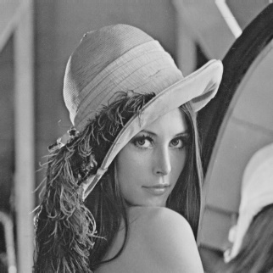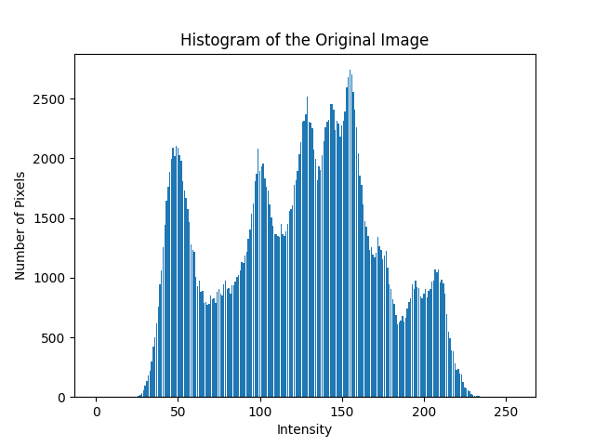

1. Image with intensity divided by 3 and its histogram

* Description
  1. Initiate a new zero array $pic_new$, with the same shape as the original picture (512, 512), to store the new picture.
  2. Iterate over the original picture $pic$, assign pixel intensity divided by three, i.e. $int(pic\left[i\right]\left[j\right]/3)$, to $pic_new[i][j]$ (*i* and *j* both from 0 to 511)
  3. Show the image with 1/3 intensity.
  4. Reuse the code from part (a) above to generate histogram, and return an $count_array$ filled with numbers for each pixel intensity.
* Code

def divideByThree(self):  
 pic_new = np.zeros(self.pic.shape, np.uint8)  
 for i in range(512):  
 for j in range(512):  
 pic_new[i][j] = int(self.pic[i][j]/3)  
 return pic_new

* Result

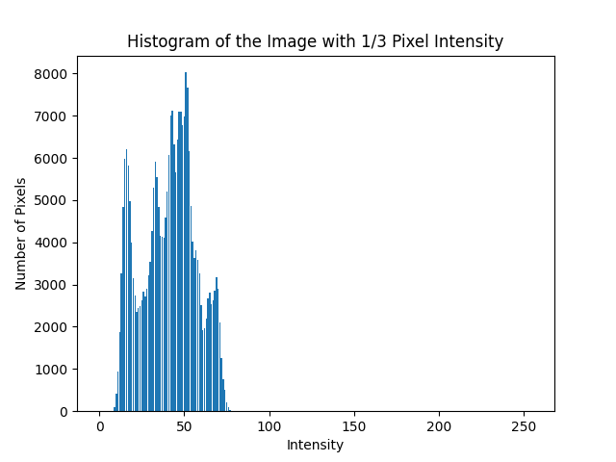

1. Image after applying histogram equalization to (b) and its histogram

* Description

Consider the relationship:

* 1. Set up a new zero array $s_array$, with shape (256, 1), to store information about $s_{k}, k from 0 to 255$
  2. Utilize the $count_array$ from part (b). With index *k* from 0 to 255, calculate the corresponding $s_{k}$ by the formula above.
  3. Initiate a new zero array $pic_new$, with shape (512, 512), to store the new picture.
  4. Iterate over the picture with 1/3 intensity, and translate each pixel intensity $pic_div[i][j]$ to the corresponding new intensity using the $s_array$
  5. Show the picture with equalized intensity
  6. Reuse code from part (a) to generate histogram
* Code

def equalization(self, pic_div3, histo_array):  
 s_array = np.zeros((256,), dtype=float)  
  
 cumulate = 0  
 for k in range(256):  
 cumulate += 255 * histo_array[k] / (512**2)  
 s_array[k] = cumulate  
  
 pic_new = np.zeros(self.pic.shape, np.uint8)  
 for i in range(512):  
 for j in range(512):  
 pic_new[i][j] = int(s_array[pic_div3[i][j]])  
 return pic_new

* Result

