**Computer Vision HW4: Mathematical Morphology – Binary Morphology**

**R10741015 鄭傑鴻**

**Oct. 08, 2022**

**Original Binary Image:**

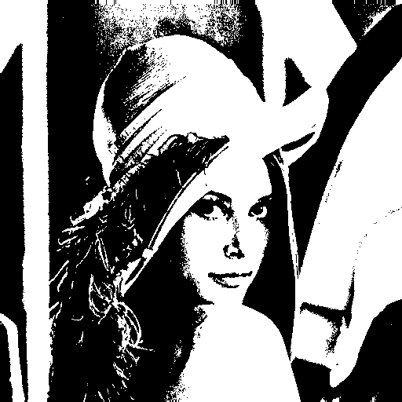

**Mutual Parameters:**

* **Binary Image: 0 for intensity<128, 1 for intensity>=128**
* **Kernel: (3,5,5,5,3): Disk shaped kernel for dilation/erosion/closing/opening**
* **Kernel_hit, Kernel_miss: L-shaped kernel for hit & miss**

**Write programs which do binary morphology on a binary image:**

1. Dilation

* Description:

Using the (3,5,5,5,3) kernel to perform dilation on the binary image, spreading the white points outward.

* Algorithm:

*For every pixel in the binary image with Boolean value 1(White pixel):*

*Spread white pixels using the kernel*

* Code:

def spread(self, array, row, col):  
 for point in self.kernel:  
 if self.inRange(row+point[0], col+point[1]):  
 array[row+point[0]][col+point[1]] = 1  
  
  
def dilation(self, tgtpic):  
 dilation_pic = np.copy(tgtpic)  
 for i in range(dilation_pic.shape[0]):  
 for j in range(dilation_pic.shape[1]):  
 if tgtpic[i][j] == True:  
 self.spread(dilation_pic, i, j)  
 return dilation_pic

def sequential(self):  
 # Dilation  
 dilation_pic = self.dilation(self.binary)  
 cv2.imwrite('lena_dilation.bmp', dilation_pic * 255)

……

* Resulting Image:

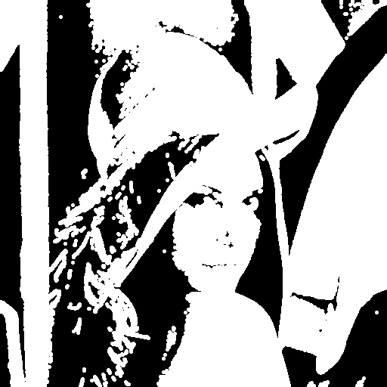

1. Erosion

* Description

Using the (3,5,5,5,3) kernel to perform erosion on the binary image, checking whether the kernel can fit in each pixel location.

* Algorithm

*For every pixel in the binary image with Boolean value 1(White pixel):*

*If the kernel can fit:*

*Assign 1 to the corresponding pixel in the erosion picture*

*Else if the kernel cannot fit:*

*Assign 0 to the corresponding pixel in the erosion picture*

* Code:

def checkFit(self, array, refer, row, col):  
 ret_bool = True  
 for point in self.kernel:  
 if self.inRange(row+point[0], col+point[1]):  
 if not refer[row+point[0]][col+point[1]] == True:  
 ret_bool = False  
 break  
 array[row][col] = ret_bool  
  
def erosion(self, tgtpic):  
 erosion_pic = np.copy(tgtpic)  
 for i in range(erosion_pic.shape[0]):  
 for j in range(erosion_pic.shape[1]):  
 if tgtpic[i][j] == True:  
 self.checkFit(erosion_pic, tgtpic, i, j)  
 return erosion_pic

def sequential(self):

……

# Erosion  
erosion_pic = self.erosion(self.binary)  
cv2.imwrite('lena_erosion.bmp', erosion_pic * 255)

……

* Resulting Image:

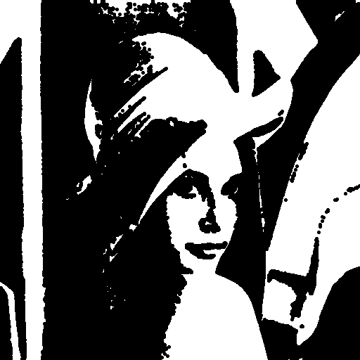

1. Opening

* Description/Algorithm:

Perform erosion first, then apply dilation. In practice, call the erosion function in part (b), then call the dilation function in part (a)

* Code:

def opening(self, tgtpic):  
 opening_pic = self.erosion(tgtpic)  
 opening_pic = self.dilation(opening_pic)  
 return opening_pic

def sequential(self):

……

# Opening  
opening_pic = self.opening(self.binary)  
cv2.imwrite('lena_opening.bmp', opening_pic * 255)

……

* Resulting Image:

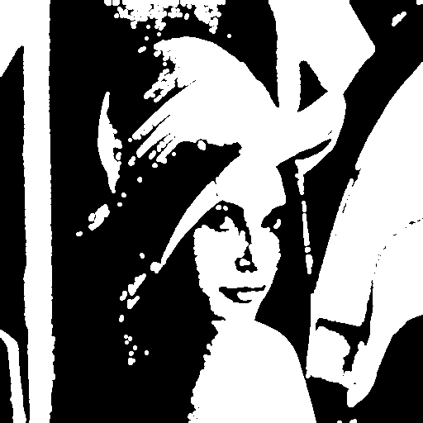

1. Closing

* Description/Algorithm:

Perform dilation first, then apply erosion. In practice, call the dilation function in part (a), then call the erosion function in part (b)

* Code:

def closing(self, tgtpic):  
 # Dilation -> Erosion  
 closing_pic = self.dilation(tgtpic)  
 closing_pic = self.erosion(closing_pic)  
 return closing_pic

def sequential(self):

……

# Closing  
closing_pic = self.closing(self.binary)  
cv2.imwrite('lena_closing.bmp', closing_pic * 255)

……

* Resulting Image

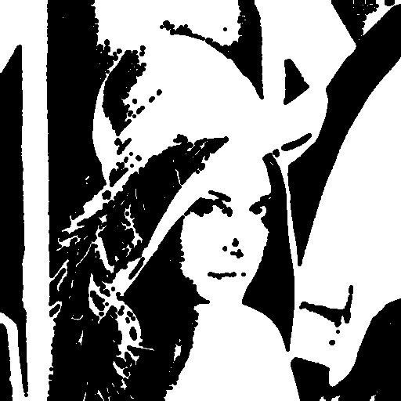

1. Hit-and-miss Transformation

* Description:

Using the L shaped kernel to detect upper-right edges in the binary picture.

* Algorithm

*For every pixel in the binary image with Boolean value 1(White pixel):*

*If the kernel_hit cannot fully fit in this pixel:*

*Assign 0 to the corresponding pixel in the hit&miss picture*

*Else if the kernel_miss can fit in any position:*

*Assign 0 to the corresponding pixel in the hit&miss picture*

*Else:*

*Assign 1 to the corresponding pixel in the hit&miss picture*

* Code:

def match(self, row, col):  
 ret_bool = True  
 for point in self.kernel_hit:  
 if self.inRange(row + point[0], col + point[1]):  
 if not self.binary[row + point[0]][col + point[1]] == True:  
 ret_bool = False  
 break  
 for point in self.kernel_miss:  
 if self.inRange(row + point[0], col + point[1]):  
 if self.binary[row + point[0]][col + point[1]] == True:  
 ret_bool = False  
 break  
 return ret_bool  
  
def hit_miss(self):  
 hitmiss_pic = np.copy(self.binary)  
 for i in range(self.binary.shape[0]):  
 for j in range(self.binary.shape[1]):  
 if self.binary[i][j] == True:  
 hitmiss_pic[i][j] = self.match(i, j)  
 return hitmiss_pic

def sequential(self):

……

# Hit & Miss  
hitmiss_pic = self.hit_miss()  
cv2.imwrite('lena_hitmiss.bmp', hitmiss_pic * 255)

* Resulting Image

