3. (V) Simulate and Verify (i), (ii), (iv)

Verify (i): Average System Size & Average Waiting Time

**Average System Size: Number of customers simulated as 0.7343**

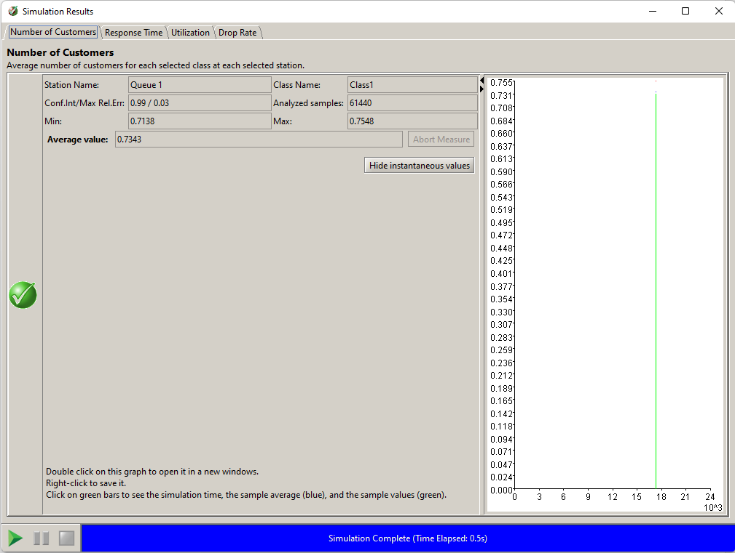

**Average Waiting time: (System) Response Time simulated as 0.4697**

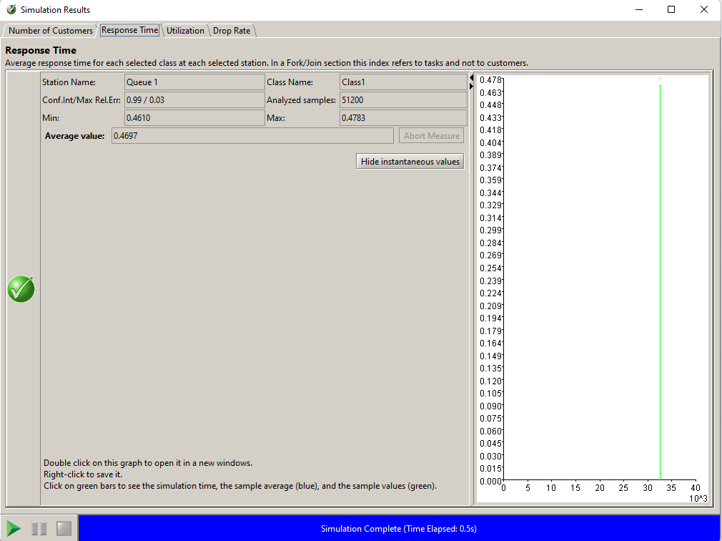

Verify (ii): Block Rate

**Block Rate: System Drop Rate simulated as 0.4248**

**Since $Drop Rate=0.4248=λP_{b}=2×P_{b}→P_{b}=0.2124$**

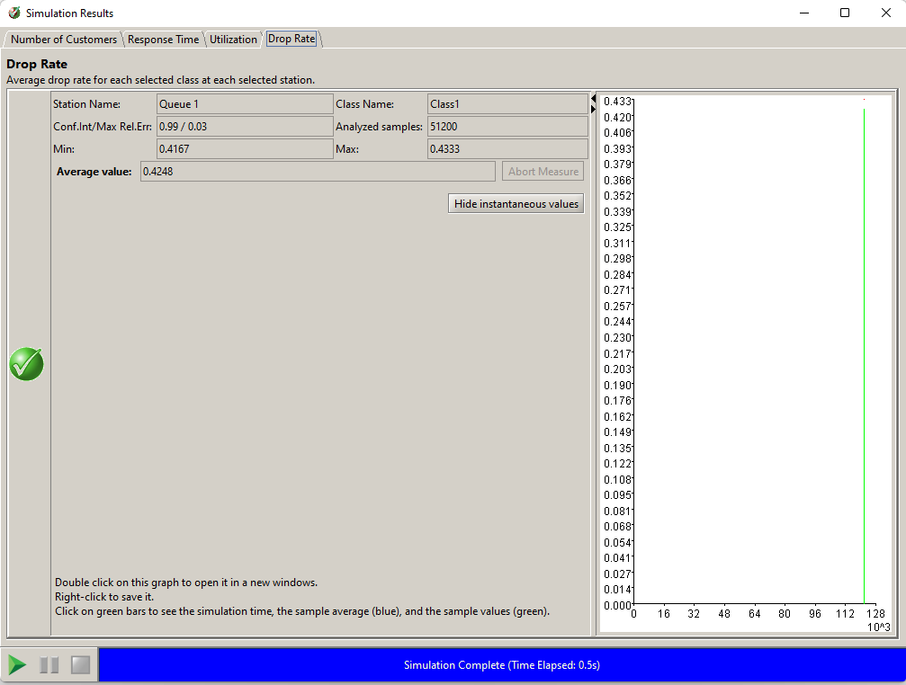

Verify (iv): Utilization

**Utilization simulated as 0.5250**

