2. Construct the queueing network:

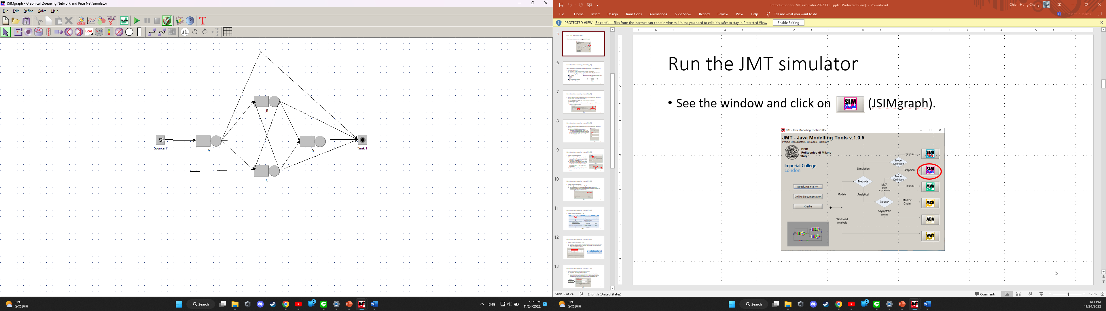

Run the simulation:

* Simulated system number of customers (L): 13.5416 (Calculated: 13.357)
* Reference: Second trial 13.471

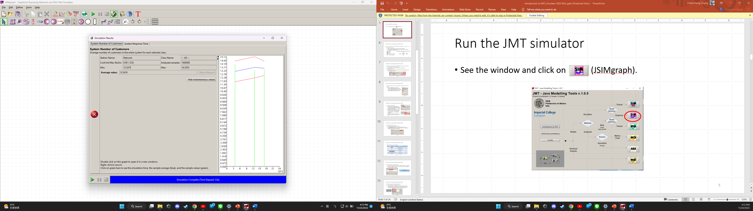

* Simulated system response time (W): 0.4377 (Calculated: 0.445)
* Reference: Second Trial: 0.486

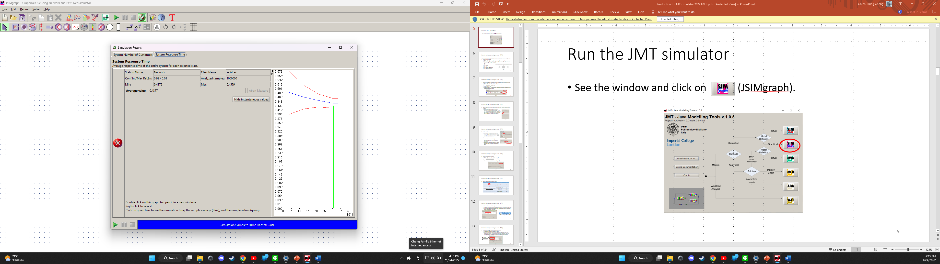

3. (ii)

Construct the model:

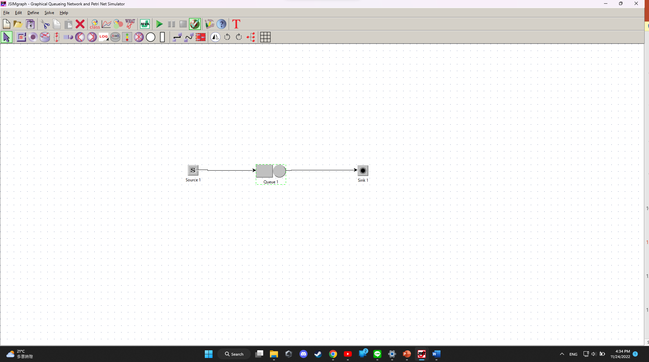

For M/M/1:

* Simulated system number of customers (L): 3.9804 (Calculated: 4)
* Simulated system response time (W): 5.0344 (Calculated: 5)

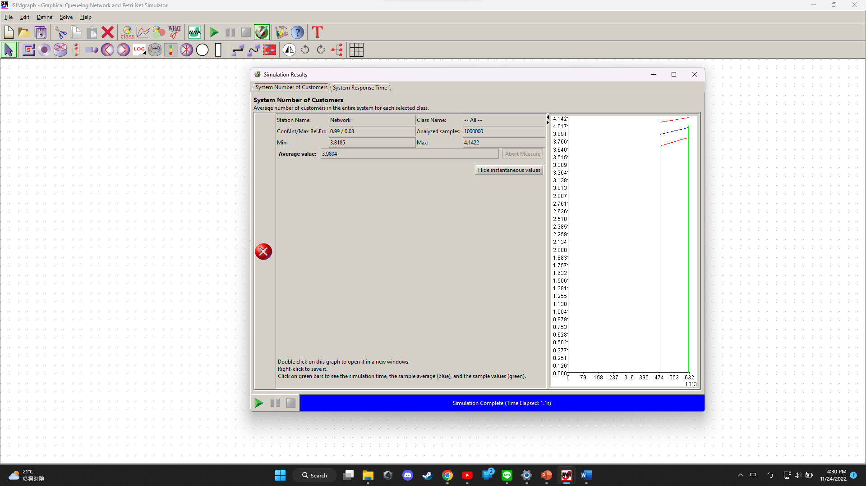

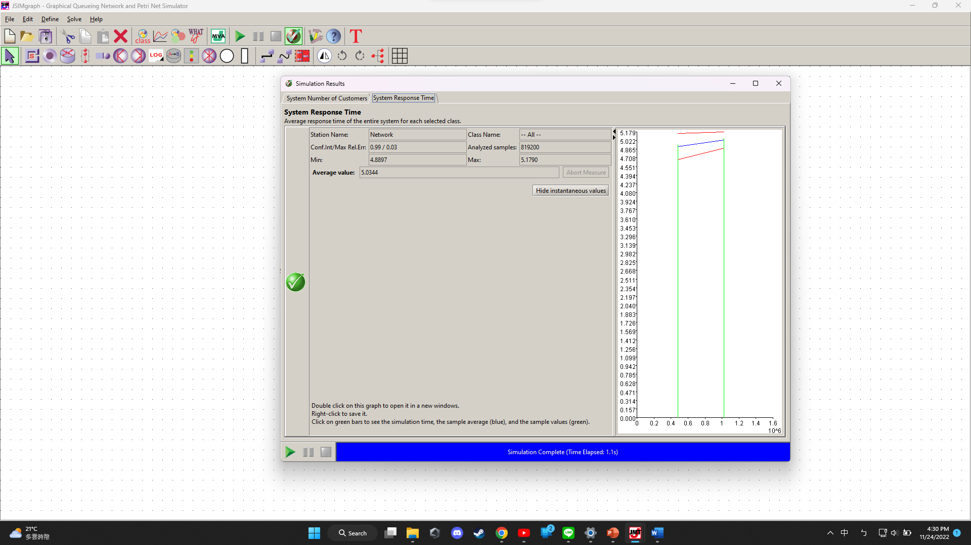

For M/E2/1:

* Set the service time distribution to Erlang-k: λ(each stage)=2, k=2, such that mean service rate µ=1
* Simulated system number of customers (L): 3.1724 (Calculated: 3.2)
* Simulated system response time (W): 3.9691 (Calculated: 4)

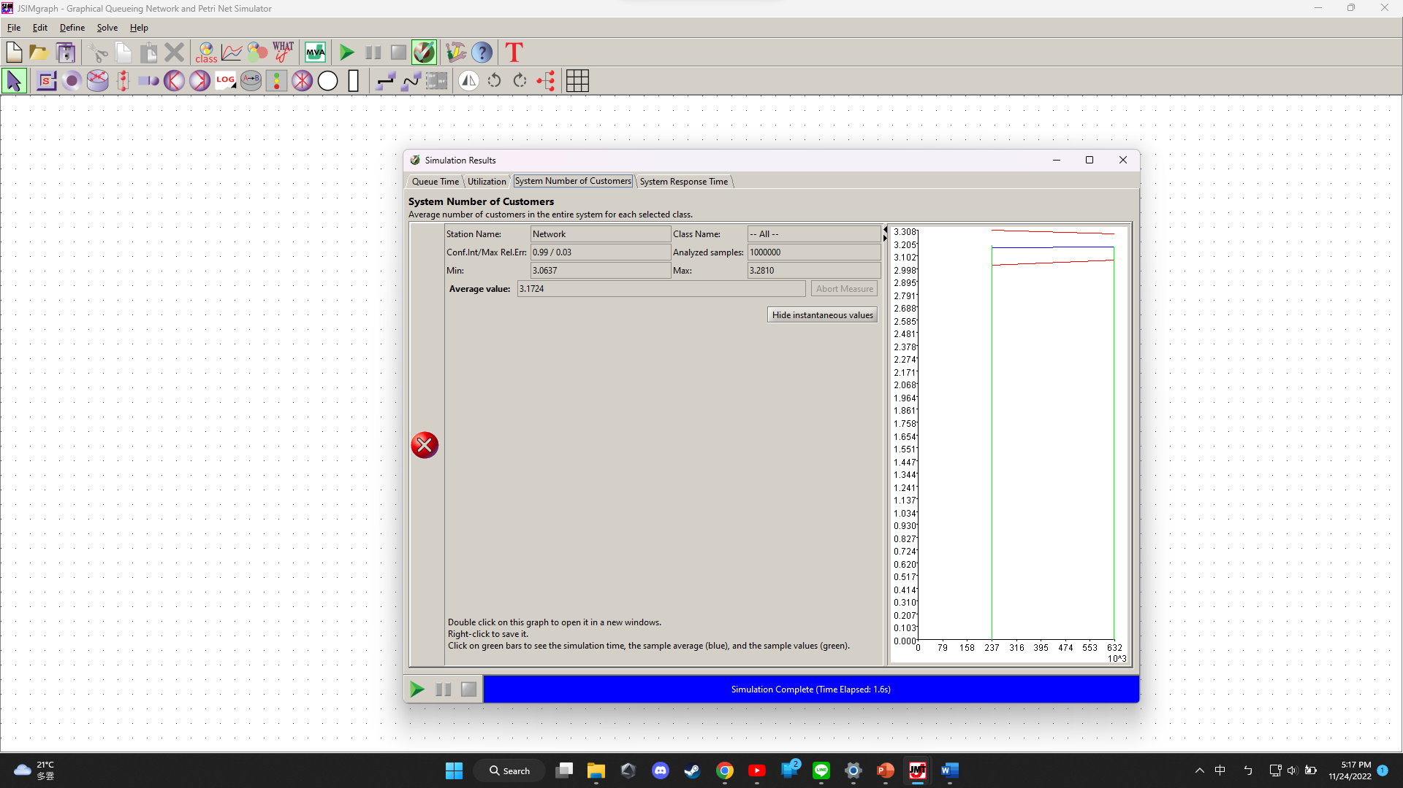

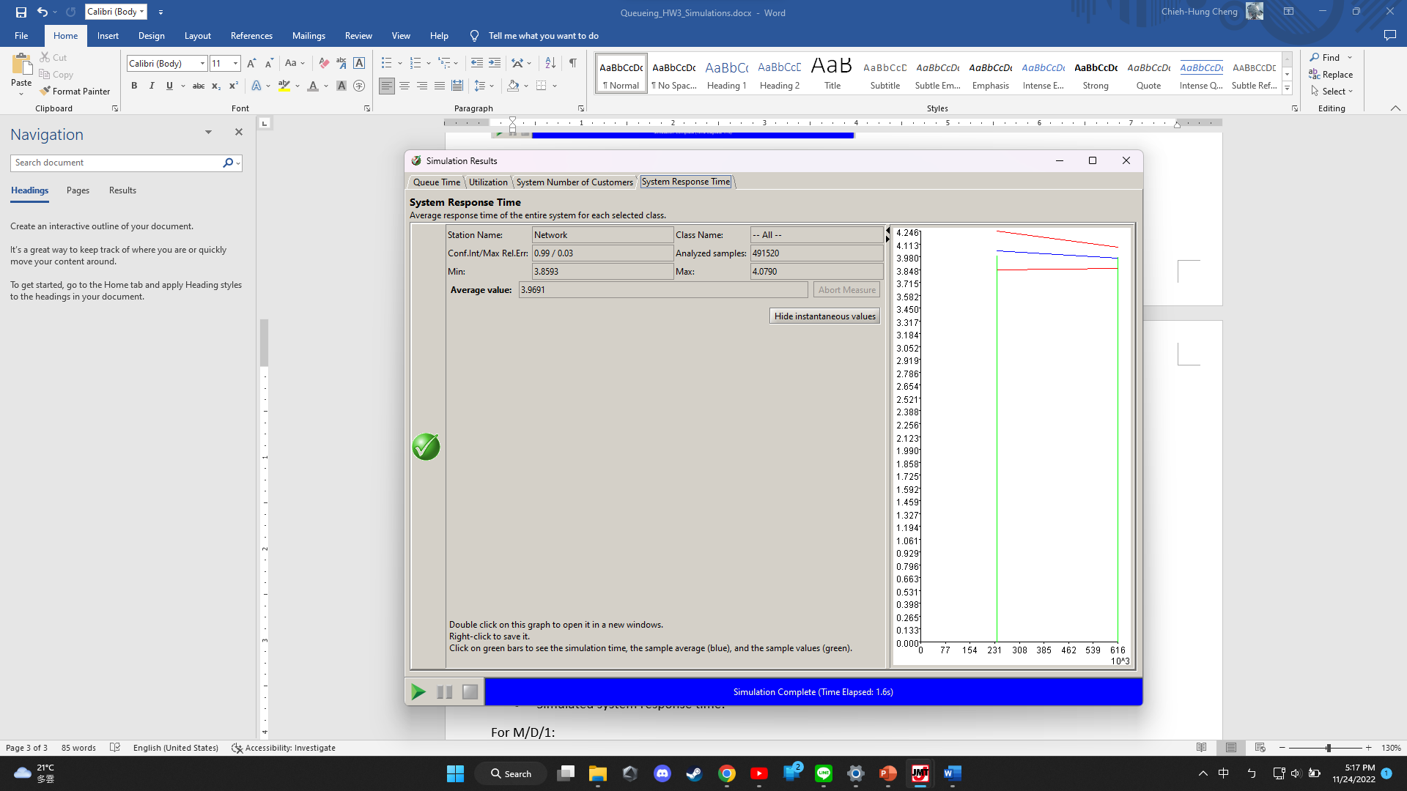

For M/ E10/1:

* Set the service time distribution to Erlang-k: λ(each stage)=10, k=10, such that mean service rate µ=1
* Simulated system number of customers (L): 2.5432 (Calculated: 2.56)
* Simulated system response time (W): 3.1635 (Calculated: 3.2)

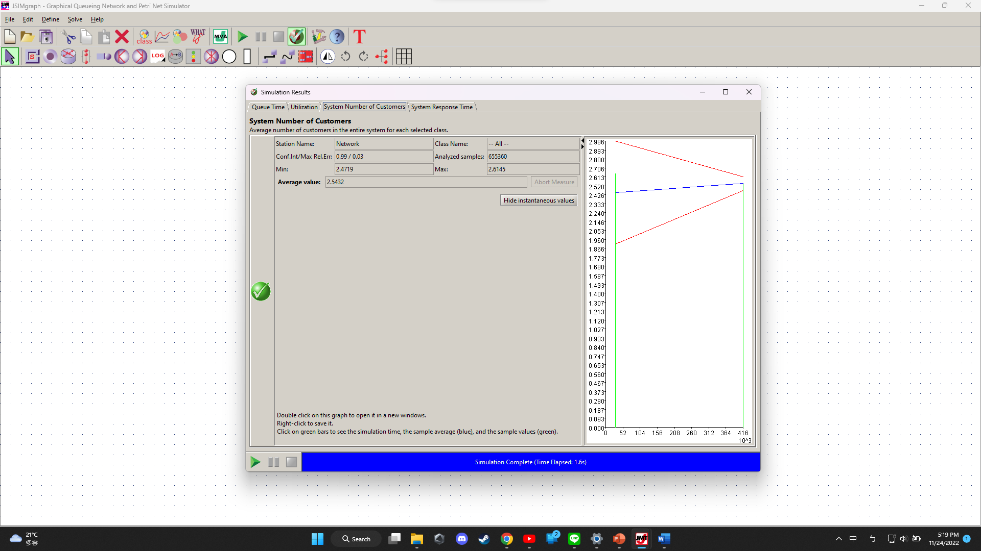

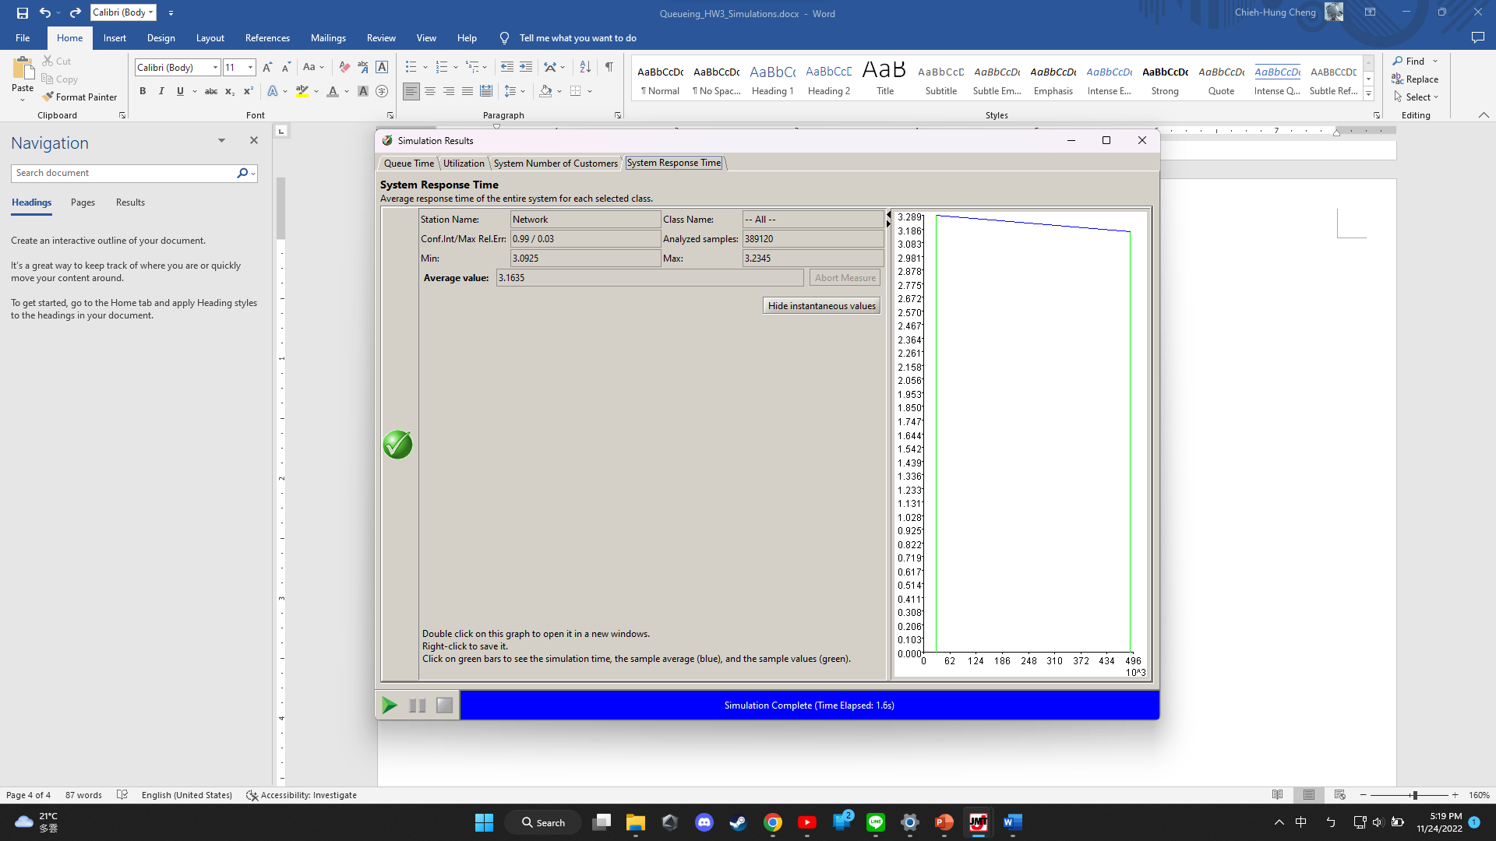

For M/D/1:

* Set the service distribution to deterministic with service rate µ=1
* Simulated system number of customers (L): 2.4471 (Calculated: 2.4)
* Simulated system response time (W): 3.0371 (Calculated: 3)

