- In a binary tree, the height of it is counted from the bottom to the top, starting from 0. The depth is counted from the top to the bottom and from 0. The level is counted the same as the depth but starting from 1.
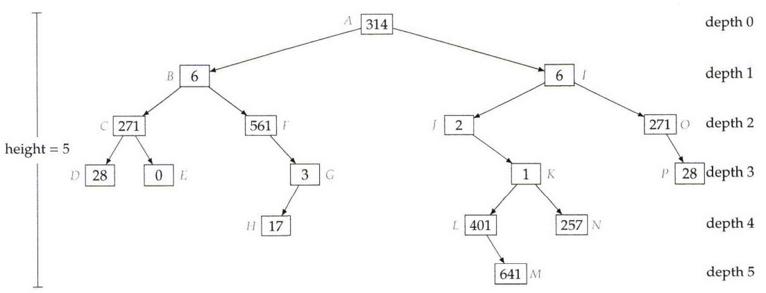
- A tree with n node has height .
- A perfect binary tree of height h has 2^{h+1} - 1 nodes and 2^{h} leaves.

