Algorithm A* : 最短路徑問題

Main method: Ai_hw1_M10509109.java

Path

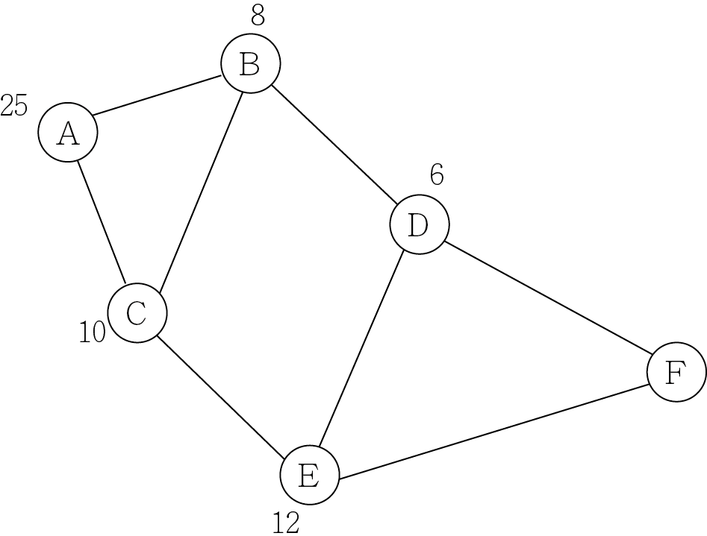

Path Matrix

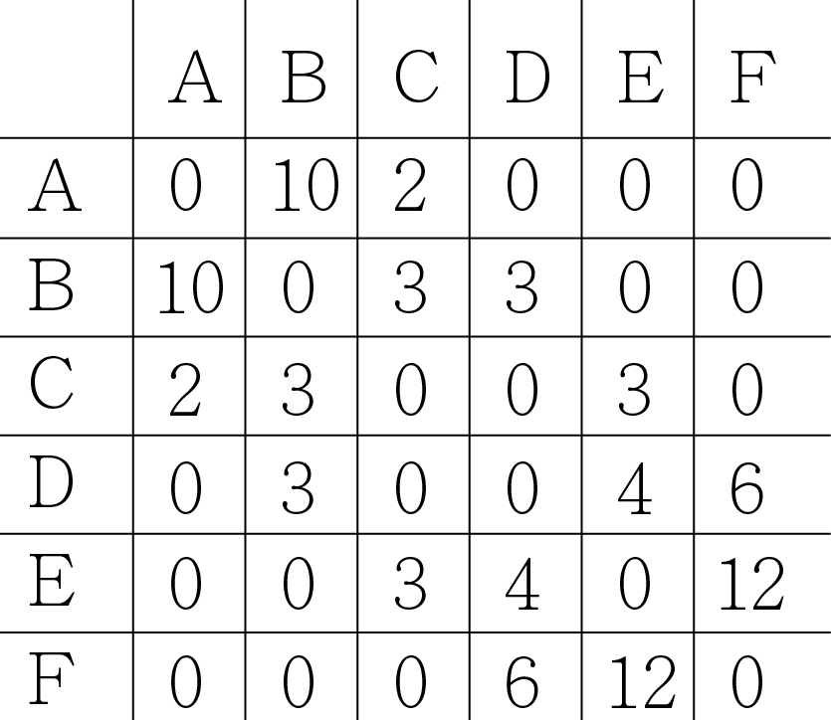

Heuristic

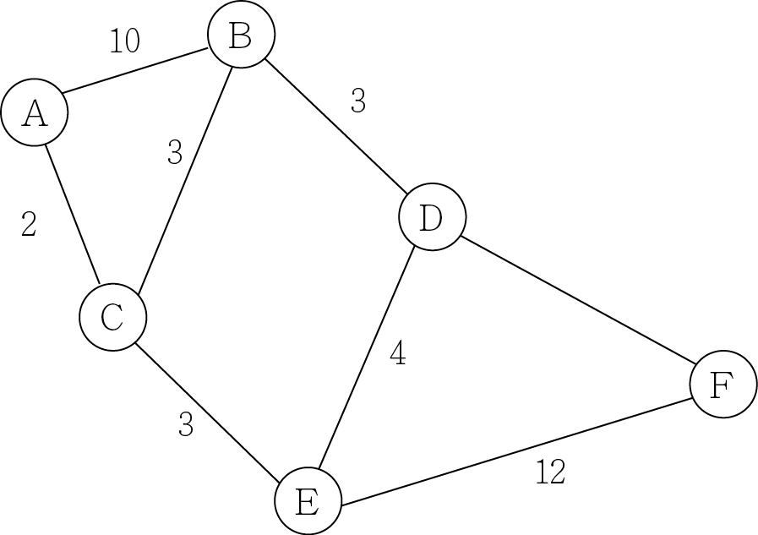

Heuristic Matrix

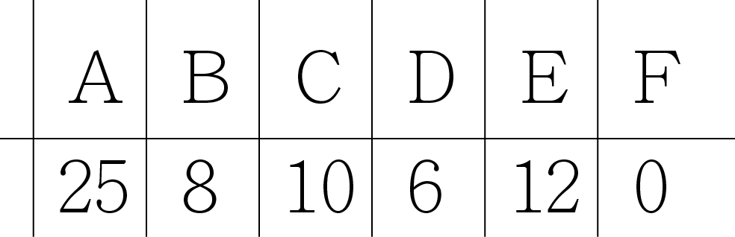

Path tree

