**Homework2**

Use gradient descent to find the minimum point on the line $f\left(x\right)=1-xe^{-x}$

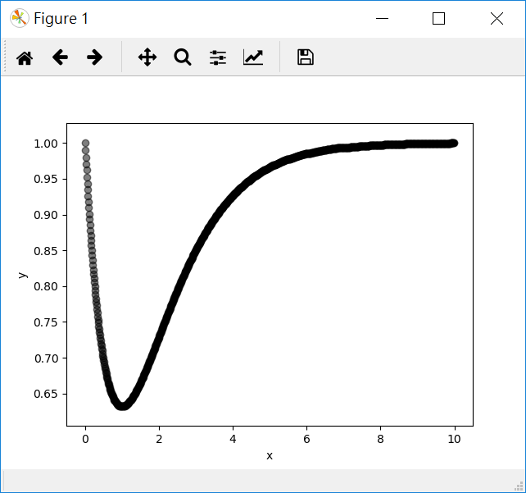

**Basic Requirement**

1. Choose an arbitrary point $\left(x,y\right)$.
2. Find the minimum point $\left(x^{*},y^{*}\right)$.
3. You must use gradient descent.

**Tip**

1. Set an arbitrary point $x=8$.
2. At each iteration, update the position until you arrive the minimum point.
$$dx=-ε\frac{∂f}{∂x}$$

$$x^{'}=x+dx$$

3. The $ε$ is the learning rate which is a very small positive real number $ε=0.02$.
$$0<ε<1$$

4. Set the max number of iterations to 30000. If the iteration is bigger than the max iteration number, stop program and get the point as the minimum point $\left(x^{*},y^{*}\right)$.

$f^{'}\left(x\right)=-e^{-x}+xe^{-x}$

**Program Requirement**

1. If you use some program libraries which contain the algorithm logic about the homework, your score will be a lower than others.
2. Please attaching a readme.doc file which describes the progam langauge you used, e.g. the name, the version, the enviroment, the IDE etc.

**Attaching .zip file**

1. The program file (if more than one, put them in a folder).
2. A readme.doc file which describes the progam langauge you used.
3. A homework2.doc file which must contain the program execution screenshot and a simple description of your implementation.
4. Compress above 3 items into a ZIP file using the same name as your student NO. Upload this compressed file to Moodle.

**Notice**

The score is based on the degree of your program implementation which written by yourself.