**Homework3**

Give the training set $T=\left\{\left(x_{i},y_{i}\right)\right\}$, $0≤i≤999$. Please use k-means clustering to cluster these points into 5 clusters.

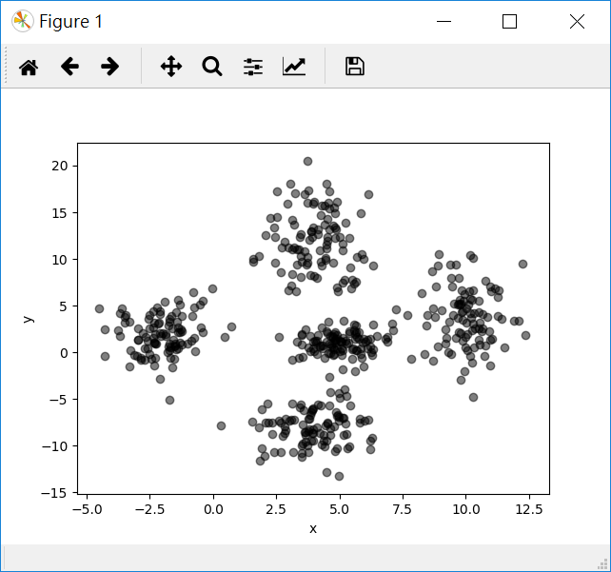

**Basic Requirement**

1. You must use **k-means clustering** to cluster these points into 5 clusters.
2. **Draw different clusters with different color.**

**Program Requirement**

1. If you use some program libraries which contain the algorithm logic about the homework, your score will be a lower than others.
2. Please attaching a readme.doc file which describes the progam langauge you used, e.g. the name, the version, the enviroment, the IDE etc.

**Attaching .zip file**

1. The program file (if more than one, put them in a folder).
2. A readme.doc file which describes the progam langauge you used.
3. A homework3.doc file which must contain the program execution screenshot and a simple description of your implementation.
4. A picture with the training set points with different colors which represent different clusters.
5. Compress above 4 items into a ZIP file using the same name as your student NO. Upload this compressed file to Moodle.

**Resource**

The training set is attached on moodle. Its file name is **hw3_data.csv**. The first column represents $x_{i}$. The second column represents $y_{i}$. The first row is the name of each column.

**Notice**

The score is based on the degree of your program implementation which written by yourself.