資管碩一 陸建綱 M10509109

**Part 1 (Bezier Curve)**

**OS:** Windows7

**PROGRAM LANGUAG:** JAVA

**JAVA IDE:** ECLIPSE

**JRE:** 1.8.0_65

**SCREEN SHOT:**

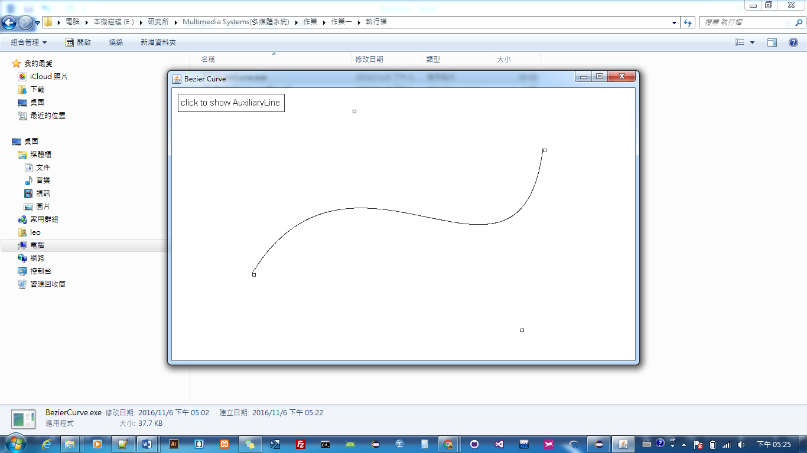

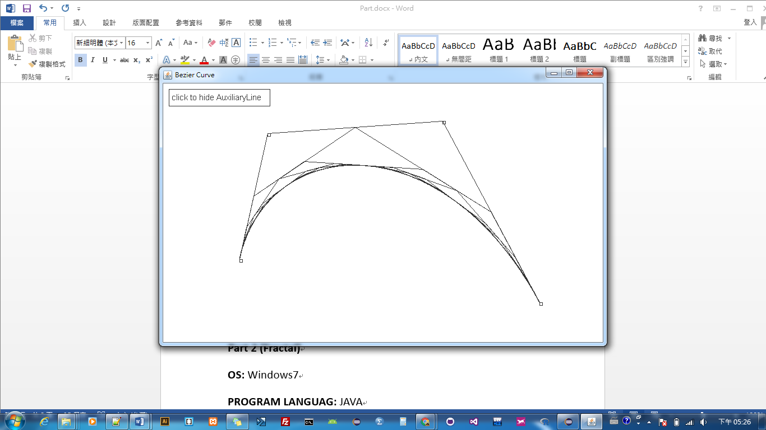

**Part 2 (Fractal)**

**OS:** Windows7

**PROGRAM LANGUAG:** JAVA

**JAVA IDE:** ECLIPSE

**JRE:** 1.8.0_65

**SCREEN SHOT:**

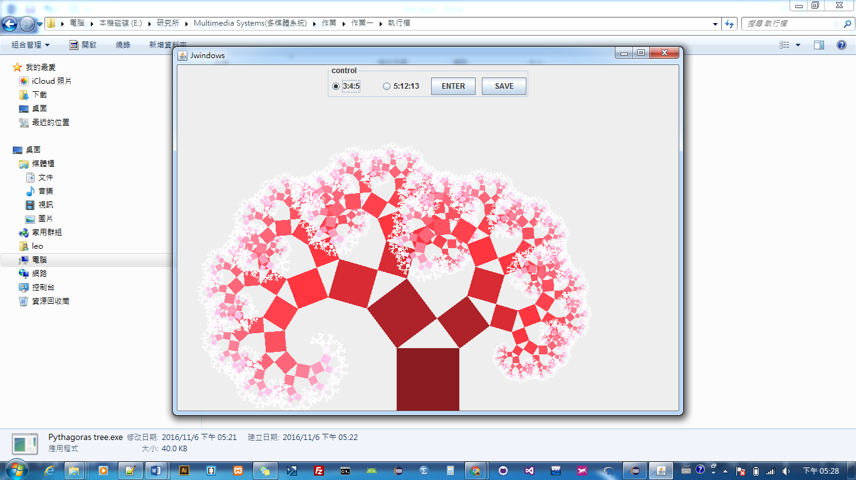

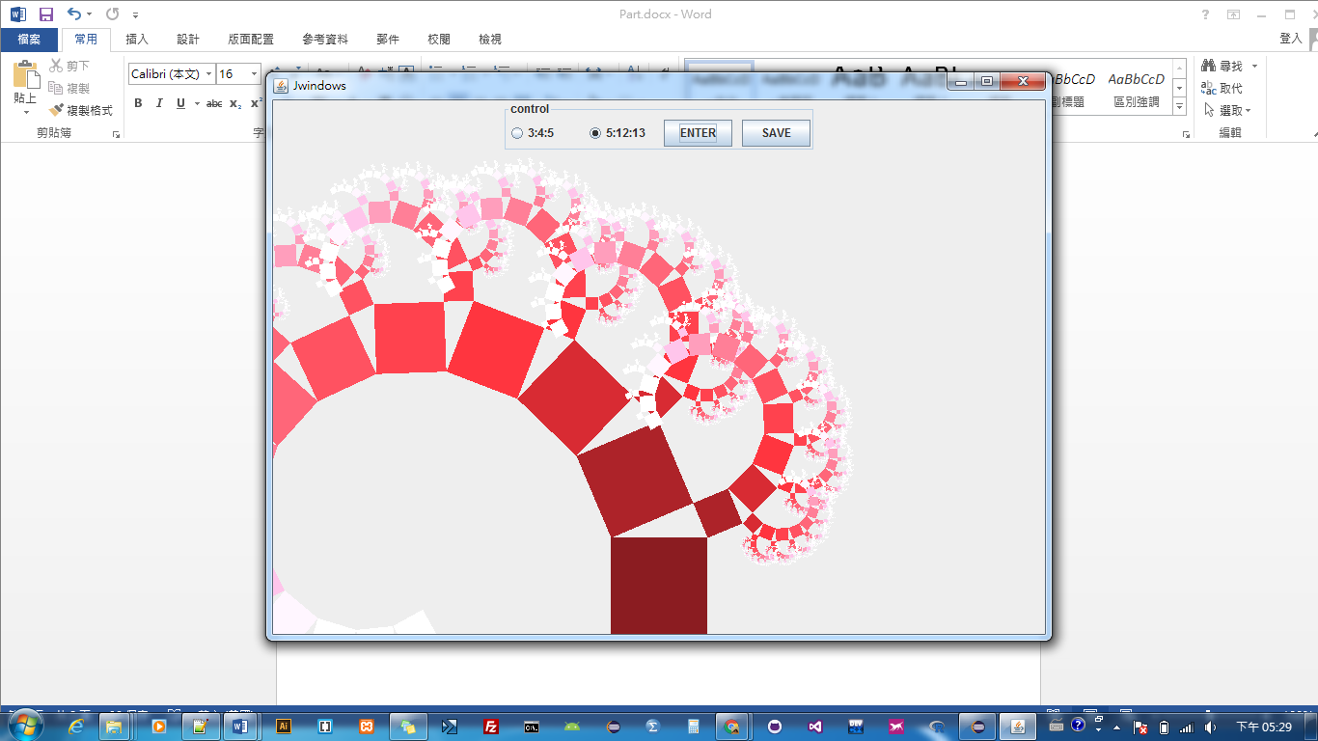

**Part 3 (Final Project & Team member list)**

1. Information of team members and this should include: Student No., Class, Name, and Email.

M10509109 陸建綱 資管碩一 [gon01156109@gmail.com](mailto:gon01156109@gmail.com)

1. Topic of the final project.

Morphing

1. A simple description of your final project this should include: your purpose, input, and output (less than 500 words).

Morphing是一種動態影像特效技術，用來產生從一張影像以向量無縫轉換變成另一張影像的中間過程

把兩張影像都Warping (彎曲轉換)到中間影像，不過並不會改變pixel的值，而是將原圖的每個pixel填到不同位置

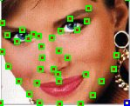

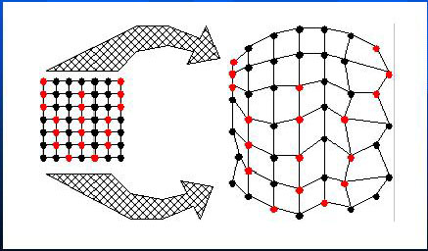

* 中間影像

更改特徵位置

