309551055 萬芊伶

1.Why coverage rate can’t reach 100% in problem 1(with coverage rate pictures)

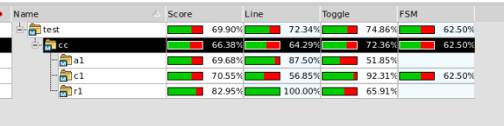

因為random生指令可能有部分指令沒有被產生，且也有可能是cup.v檔本身有bug導致部分line接錯無法被修改

2. Analyze problem 2 results (with coverage rate pictures)

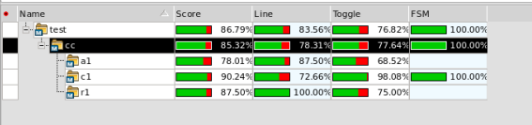

先根據cup的instruct code任意給部分指令，再根據verdi line與toggle顯示的缺漏，再補上其他指令。因為是對應verdi結果產生相應的test檔，所以結果較problem 1佳。

3. Where is the bug in cpu_bug.v and how you correct it

else if (sel == MEM_OUT)//MEM_OUT=3

write_data = mem_out;

always@(posedge clk)begin

if (!reset)

current_state = next_state;

else

current_state = ST_0;

end

4'b0000: next_state=ST_0;

4'b0100: w_reg_c=1;

4'b0101: w_reg_c=1;

4'b0101: w_reg_c=1;

4'b0110: w_out=1;

4'b1000: next_state=ST_2;

4'b1010: w_reg_c=1; sel=MEM_OUT; next_state=ST_3;

4'b1011: next_state=ST_0;

4'b1100: w_out=1; sel=DATA_IN;

4'b1101: next_state=ST_0;

ST_1 : next_state = ST_0;

ST_2 : next_state = ST_0;

ST_3 : next_state = ST_0;

4. What did you do to increase the coverage rate (with 100% coverage rate pictures)

verdi缺甚麼就加甚麼。

5. What did you learn in this project

使用verdi debug，看波形圖。