|  |  |
| --- | --- |
| **Pseudo-code:**  **Cách 1:**  BEGIN  INPUT a, b, c  IF a > b THEN  IF a > c  OUTPUT a  ELSE  OUTPUT c  END IF  ELSE  IF b > c THEN  OUTPUT b  ELSE  OUTPUT c  END IF  END IF  END  **Flowchart:**  **Cách 1:** | **Cách 2:**  BEGIN  INPUT a, b, c  IF a > b&c (a > b and a > c) THEN  OUTPUT a  ELSE  IF b > c THEN  OUTPUT b  ELSE OUTPUT c  END IF  END IF  END |

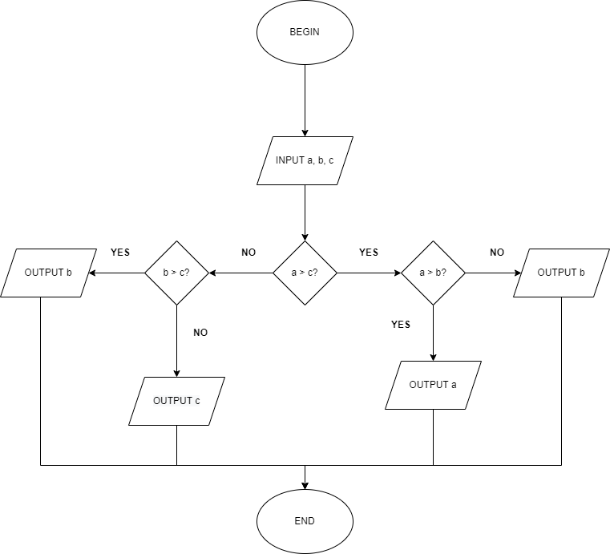

**Cách 2:**

