|  |
| --- |
| CHIEZE FRANKLIN IKENNA |
| Curriculum Vitae |
| Official Document |

|  |
| --- |
| Prepared  20/07/2016 (dd/mm/yyyy) |

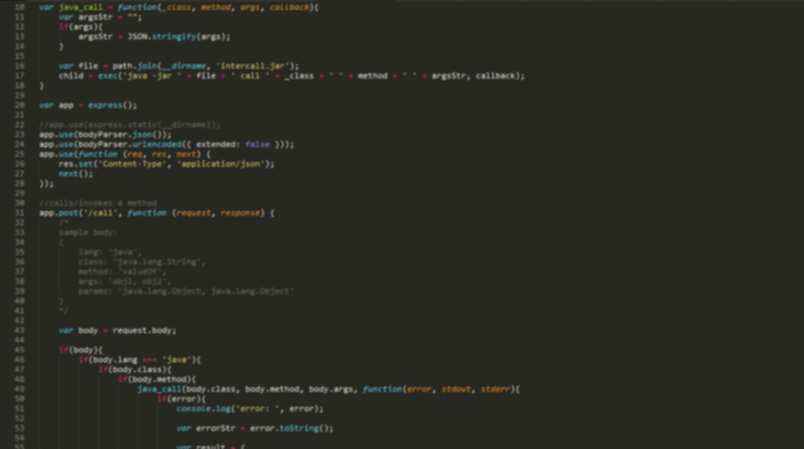

# Career Goal

With my deep understanding of computer science and software development, I intend to help future computer scientists and software developers (especially those in this part of the world) have a solid grasp on fundamental concepts in the field, and also help them get started in some of the most advanced topics in the industry.

# Professional History

|  |  |  |
| --- | --- | --- |
| December, 2014- October, 2016 | **Karabow** | L4 Ahmadu Bello Way, Kaduna State. |

## Software Developer

* Helped kick-start the company
* Helped train IT students in Small Basic and Java
* Helped with the company’s flagship product, a school management system, **Unifyedu.com**

|  |
| --- |
|  |

|  |  |  |
| --- | --- | --- |
| October 14, 2016-date | **Campus Technologies Ltd.** | EK house 5d Kanta road, behind 10 storey building, Kaduna State. |

## Consultant

* Employed as a consultant, involved in the development of number of software projects.
* A part-time trainer in NIIT Kaduna, which is managed by Campus Technologies.
* the standard of document preparation requires using word processing or spreadsheet packages (Preferably Microsoft Word and Excel respectively), for easy reading editing and presentation. All official documents should follow the following format guidelines.

|  |
| --- |
|  |

# Professional Skills

My strong technical skills include (starting from the strongest):

* Windows app development (with C# on the .NET Framework)
* Android app development (Java)
* Web, UI (JavaScript, HTML, CSS, ASP.NET)
* Web, API (Node.js, ASP.NET, PHP)
* Game development (Unity3D)
* Microcontrollers (Arduino, Raspberry Pi)

My soft skills include:

* **Teamwork**. I am very comfortable working within the context of a team. I play my part to the best of my ability, and have no problem asking for help (or giving help) where appropriate. An example of a project I worked on as a team member is the school management system for Campus Technologies.
* **Leadership**. I am very good at project management, excelling at skills like task sharing and working within budgets. Although I had a supervisor to whom I reported, I largely led the developers that worked on the school management system for Campus Technologies.
* **Organization**. I am good at making very clear plans, and organising people to follow them.

# Professional Accomplishments

* As a member of a software development team in Covenant University, I finished as a runner-up at Microsoft Imagine Cup Nigeria, 2011.
* I have had a number of my technical articles approved and published on popular peer-review sites like [CodeProject](http://www.codeproject.com). This most popular of such articles is [C# Compiler Implementation of the new C# 6.0 Features](http://www.codeproject.com/Articles/1119847/Csharp-Compiler-Implementation-of-Csharp-Features).
* I always rank high on [GitHub](http://github-awards.com/users/chieze-franklin) (at least in Nigeria).

# Education

|  |  |  |
| --- | --- | --- |
| 2007-2012 | Tertiary Education | Covenant University, Ogun State |
| 2001-2007 | Secondary Education | Faith Academy, Ogun State |
| 1993-2001 | Nursery & Primary Education | Wilson Group of Schools, Kaduna State |

# Activities/Interests

* I am active member of [StartupKaduna](http://startupkaduna.com.ng/), a group with the long term goal of turning Kaduna state into a thriving startup hub.
* On Sundays I relax with a session of fine art (drawing, painting).
* I also relax by playing chess.
* I love watching and playing football (soccer).

# References

Available on request.