Karabow profile



Karabow

**Company Profile**

**URL:** www.karabow.com

**Industry:** Technology

**Employees: 19**

**Founded:** 2013

**Email:** [info@karabow.com](mailto:info@karabow.com)

**Contact:**

Wisdom Kwati

wisdom.kwati@karabow.com

Work:+234-8169-652-531

**Additional Information**

**Board of Directors**

**Mr. Wisdom Kwati**

**Engr. Lubba Lwachem**

**Mr. Tosin Komolafe**

**Management**

Mr. Tosin Komolafe, Co-Founder,

CEO

Mr. Wisdom Kwati, Co-Founder,

COO

Mr. Adaikwu Fidelis,

Head of Product

Mr. Chieze Franklin,

Head of Engineering

**Advisors**

**Lawyer:** Danjuma Garba and Kantoma Tanko Esq.**Acc**

**Mr. Thompson Amaefule and Mr.** Marcin Mark

**Investors**

Friends

Family

**Who We Are**

Karabow (www.karabow.com, facebook and twitter page) is a technology startup that has the long term goal of pushing back the frontiers of technology in Africa. We are a group of young *dreamers* who believe nothing is beyond the ability of an African. As a continent we have produced great statesmen, great athletes, great musicians, and great writers. Why can't we also add great scientists and engineers to that list? This is the core mindset that drives us at Karabow.

**Vision**

To become the most admirable brand in the technology industry by focusing on customer satisfaction through innovative hardware, software and internet offerings, with superior quality and services.

**Mission**

Developing innovative technology to improve everyone's life.

**History**

* April 4, 2012 - Company idea is conceived by co-founder Wisdom Kwati.
* Karabow is conceived to be a company that deals both in hardware and software products.
* One such hardware product is Fundy tablet for kids.



* One such software is Unify school management system.

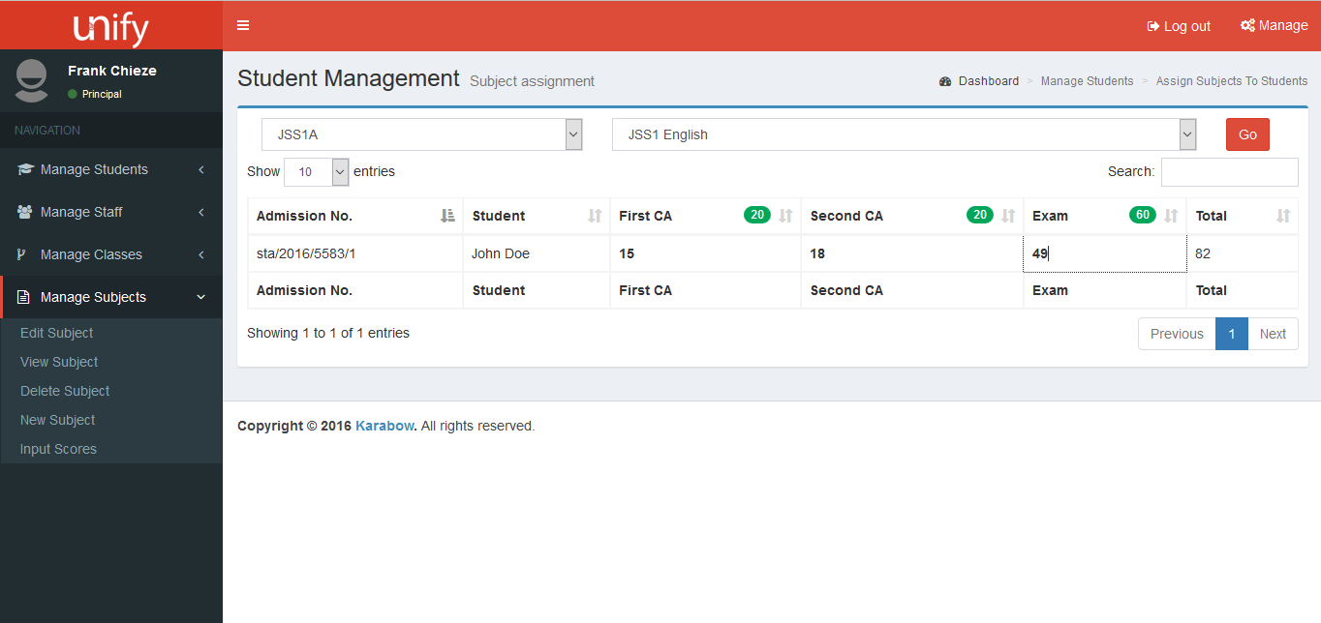

* January 15, 013 - First prototype of a hardware device is unveiled.
* April 15, 2013 - Karabow is officially incorporated, having been registered by the Corporate Affairs Commission (CAC).
* June 2014 - The company receives its first major seed investment (~~N~~4.5m).
* December 1, 2014 - The company gets its first office space.

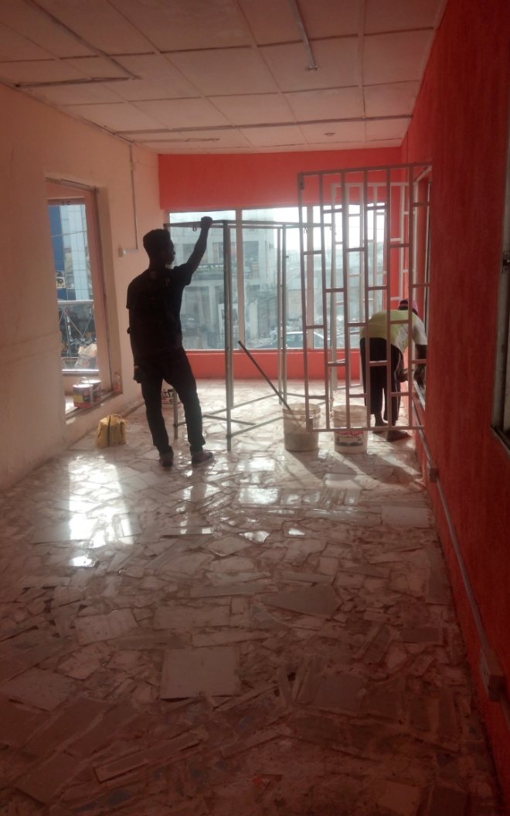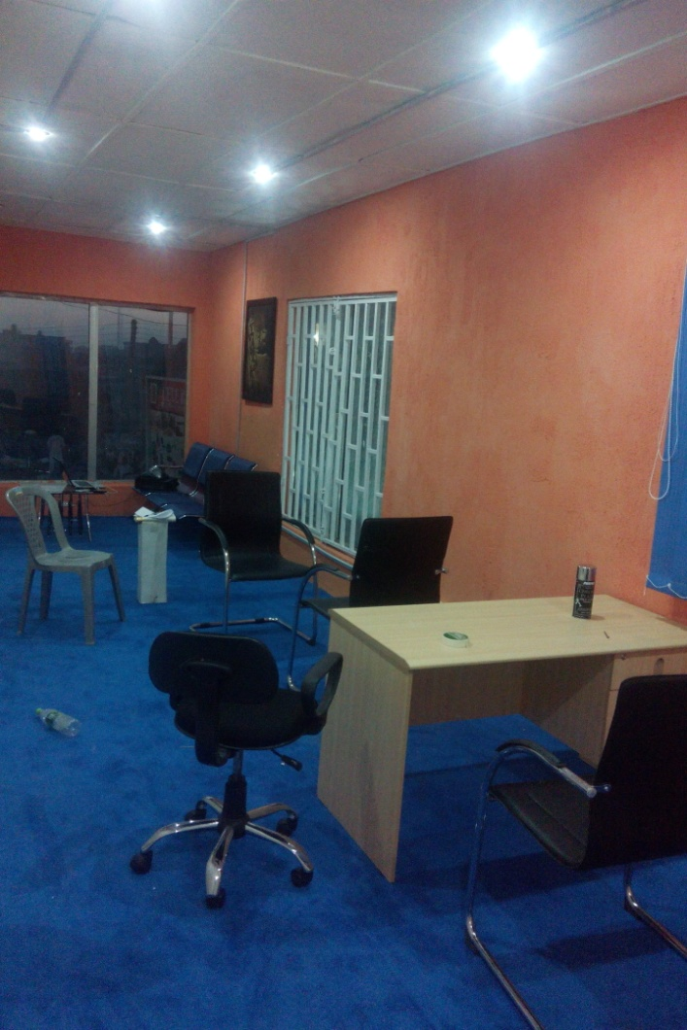

* 2015 - The year is spent developing both hardware and software products that will enter the market as the company's first commercial products.
* February 2016 - Karabow sold its first product - a Fundy kids tablet.
* March 2016 - Installed our school management system - Unify - for a number of schools to test-run.
* March 2016 - Had made ~~N~~235,000 from sales of Fundy by the end of the first quarter of 2016.

**Organizational Structure**

Karabow has 19 staff members spread largely across 3 operations departments.

1. Engineering
2. Marketing
3. Finance

The organogram is as shown below.

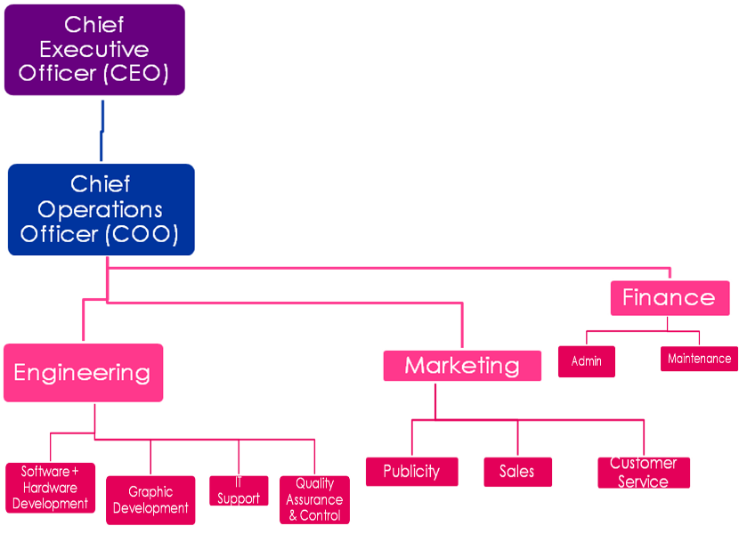

The roles of the department are given below.