**ESP8266飛控板程式積木安裝教學**

1. 先至<https://sites.google.com/jes.mlc.edu.tw/ljj/linkit7697/%E5%A6%82%E4%BD%95%E5%AE%89%E8%A3%9D%E5%90%89%E5%93%A5%E8%87%AA%E8%A3%BD%E7%A9%8D%E6%9C%A8>下載並安裝吉哥積木。
2. 將extension_file目錄copy至吉哥積木 BlocklyduinoF2的目錄下。

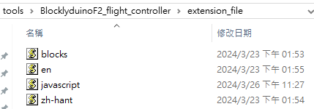

1. 將BlocklyduinoF2\package.nw\main.html打開，如下圖將extension_file引入，其中zh-hant.js是字串定義檔、blocks.js是積木方塊定義檔、javascript.js是積木程式定義檔。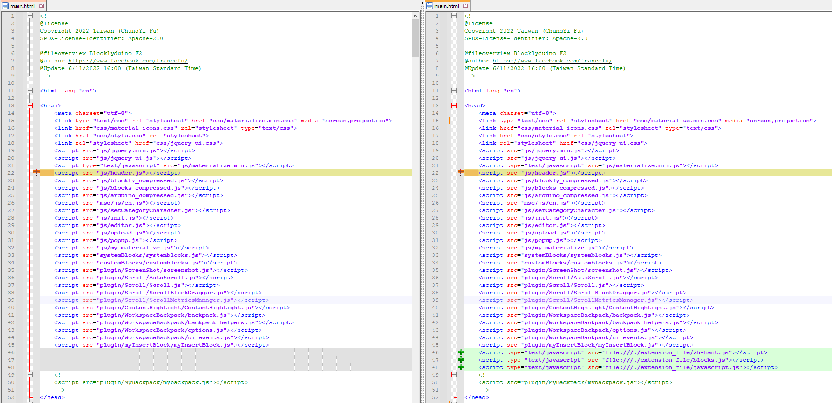

<script type="text/javascript" src="file:///./extension_file/zh-hant.js"></script>

<script type="text/javascript" src="file:///./extension_file/blocks.js"></script>

<script type="text/javascript" src="file:///./extension_file/javascript.js"></script>

1. 將BlocklyduinoF2\package.nw\js\init.js打開，如下圖於function init()的var base結尾處新增積木方塊類別category_flightcontroller。

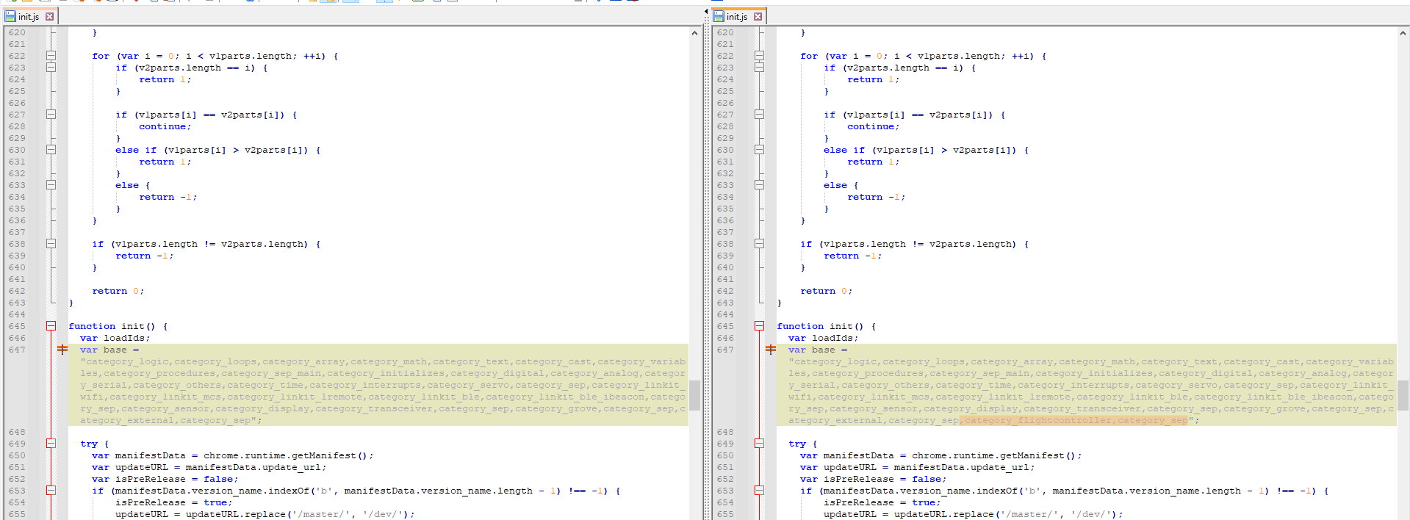

,category_flightcontroller,category_sep

1. 將BlocklyduinoF2\package.nw\category\category_F2.xml打開，如下圖插入積木方塊定義。

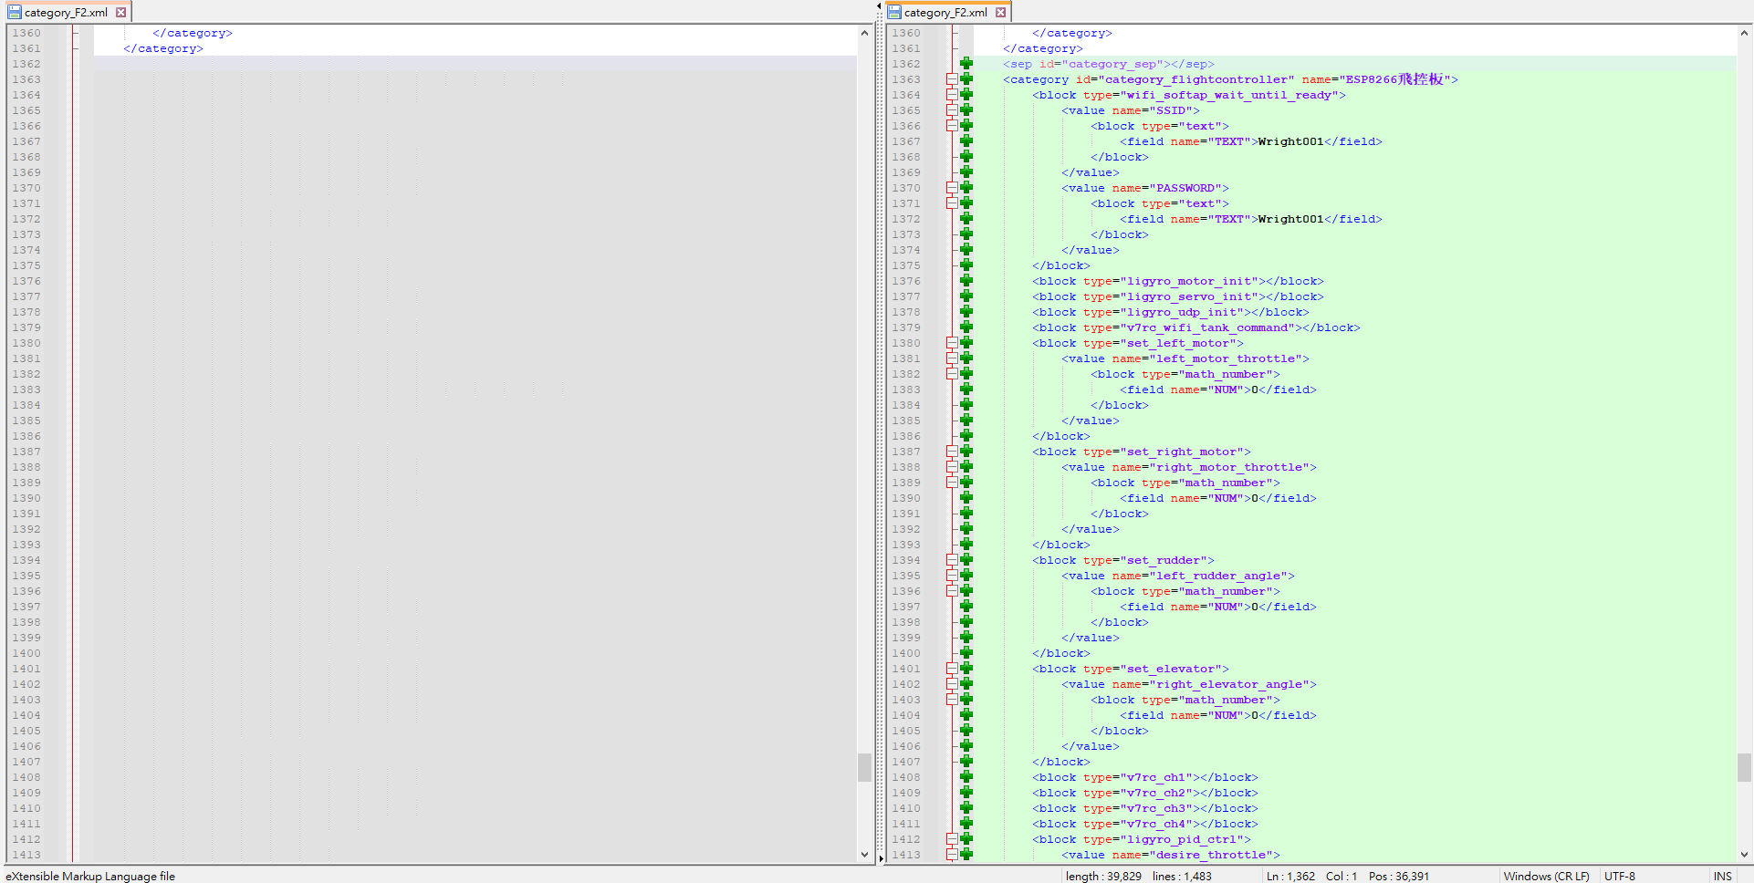

<sep id="category_sep"></sep>

<category id="category_flightcontroller" name="ESP8266飛控板">

<block type="wifi_softap_wait_until_ready">

<value name="SSID">

<block type="text">

<field name="TEXT">Wright001</field>

</block>

</value>

<value name="PASSWORD">

<block type="text">

<field name="TEXT">Wright001</field>

</block>

</value>

</block>

<block type="ligyro_motor_init"></block>

<block type="ligyro_servo_init"></block>

<block type="ligyro_udp_init"></block>

<block type="v7rc_wifi_tank_command"></block>

<block type="set_left_motor">

<value name="left_motor_throttle">

<block type="math_number">

<field name="NUM">0</field>

</block>

</value>

</block>

<block type="set_right_motor">

<value name="right_motor_throttle">

<block type="math_number">

<field name="NUM">0</field>

</block>

</value>

</block>

<block type="set_rudder">

<value name="left_rudder_angle">

<block type="math_number">

<field name="NUM">0</field>

</block>

</value>

</block>

<block type="set_elevator">

<value name="right_elevator_angle">

<block type="math_number">

<field name="NUM">0</field>

</block>

</value>

</block>

<block type="v7rc_ch1"></block>

<block type="v7rc_ch2"></block>

<block type="v7rc_ch3"></block>

<block type="v7rc_ch4"></block>

<block type="ligyro_pid_ctrl">

<value name="desire_throttle">

<block type="math_number">

<field name="NUM">0</field>

</block>

</value>

<value name="desire_yaw">

<block type="math_number">

<field name="NUM">0</field>

</block>

</value>

<value name="wright_yaw">

<block type="math_number">

<field name="NUM">0</field>

</block>

</value>

<value name="yaw_p">

<block type="math_number">

<field name="NUM">0</field>

</block>

</value>

<value name="yaw_i">

<block type="math_number">

<field name="NUM">0</field>

</block>

</value>

<value name="yaw_d">

<block type="math_number">

<field name="NUM">0</field>

</block>

</value>

</block>

<block type="ligyro_hover_pid_ctrl">

<value name="desire_throttle">

<block type="math_number">

<field name="NUM">0</field>

</block>

</value>

<value name="desire_forward_backward">

<block type="math_number">

<field name="NUM">0</field>

</block>

</value>

<value name="desire_direction">

<block type="math_number">

<field name="NUM">0</field>

</block>

</value>

<value name="wright_yaw">

<block type="math_number">

<field name="NUM">0</field>

</block>

</value>

<value name="yaw_p">

<block type="math_number">

<field name="NUM">0</field>

</block>

</value>

<value name="yaw_i">

<block type="math_number">

<field name="NUM">0</field>

</block>

</value>

<value name="yaw_d">

<block type="math_number">

<field name="NUM">0</field>

</block>

</value>

</block>

</category>

<sep id="category_sep"></sep>

1. 點擊BlocklyduinoF2目錄下的BlocklyDuino.exe執行檔，即可開始編寫ESP8266飛控板程式。

