# Overview

DiscountShop is a mobile platform for Retailers and Individual Consumer to share and find discounted items respectively. It is developed by the motivation that many a times Individual Consumers look for items which are at price discount for various reasons from affordability to budgeting constraints. Even though it is motivating enough install every retailer's app, it is inconvenient for the individual Consumer to keep track and go look at the all retailers app for available discounts and also there are retailers/small and medium sized business owners who don't have a mobile app of their own. DiscountShop aims at solving this particular problem by acting as a platform for retailers to market their discounted products and for individual consumers a way to know all discounts at one single place.

# Design Overview:

DiscountShop has been designed by keeping the MVC model in mind. Since the platform involves a mobile application as well as the backend Model and Control logic is shared across the mobile and backend.

## Model

Model involves the persona in the mobile application which represents the consumer , retailer and Login. In the Webservice it is primarily the Consumer, Retailer and Items. Consumer represents Individual users looking for information regarding the products on discount. Retailer represents individual users who want to market the discounted items on the platform. Items model in our backend represent the items that retailers to market through the DiscountShop platform.

In our Android application a class diagram for the model would be as shown below

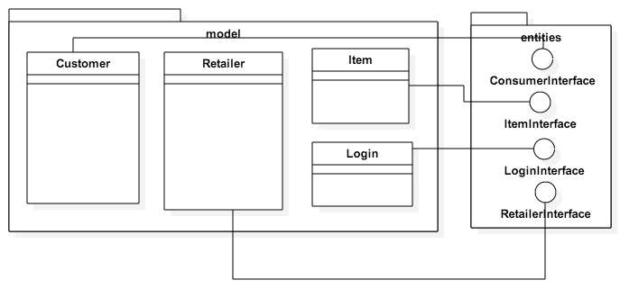

Model Representation in Android

In the web service our model would be as shown below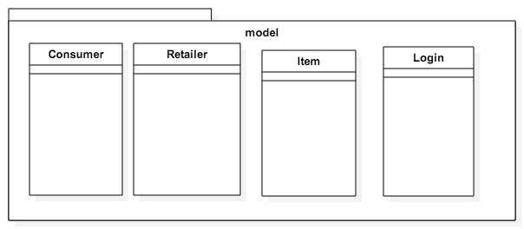

Model Representaion in WebService

## View

Primarily what users(Consumers/Retailers) see is the all Activities from the mobile Application. Views represents the activity with UI elements that application users see and use. All activities that are functionally different(features) are separated. Our class Diagram for the UI would be.

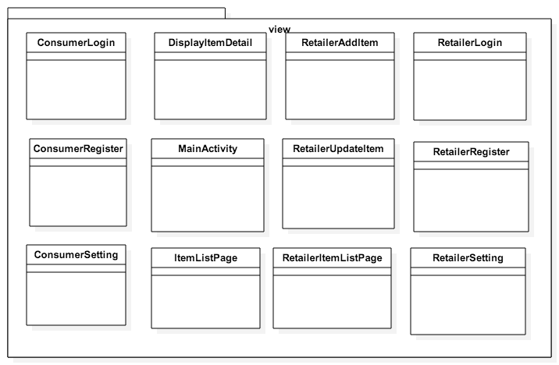

View Representation Android

## Control

Control logic is divided into three parts, ie Android, Web Service and communication between them.

Control logic on Android handles all the activities that users begins that is mostly initiated from the click of a button in the mobile application. This includes initiating authentication when login is clicked , registration at the webserver when register button is clicked, see individual items which are available on discount, add details to their profile etc. ClickInterface is where all the control logic begins.

On Android the control logic would be

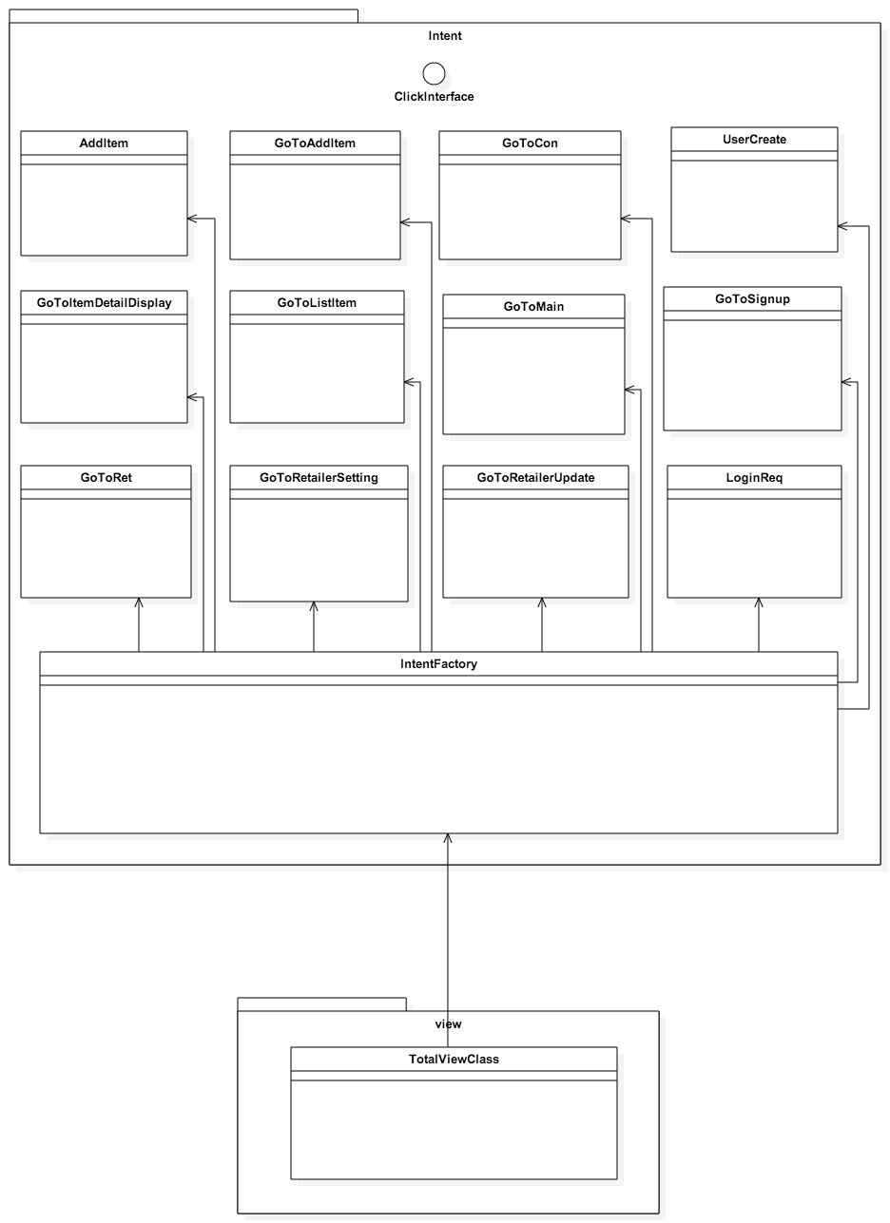

Control logic on the webserver is initiated from the requests that it receives from the mobile application. It handles register, login and retrieve items for display in the mobile app. All the communication is done using JSONs.

Control logic on the server would be as below.

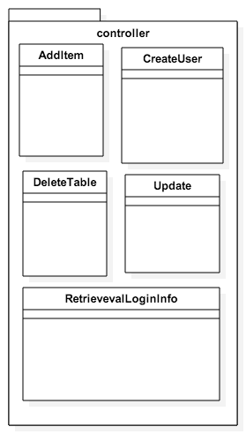

Third part of the control logic is the communication between the mobile application and Webservice which is responsible for all transactions.

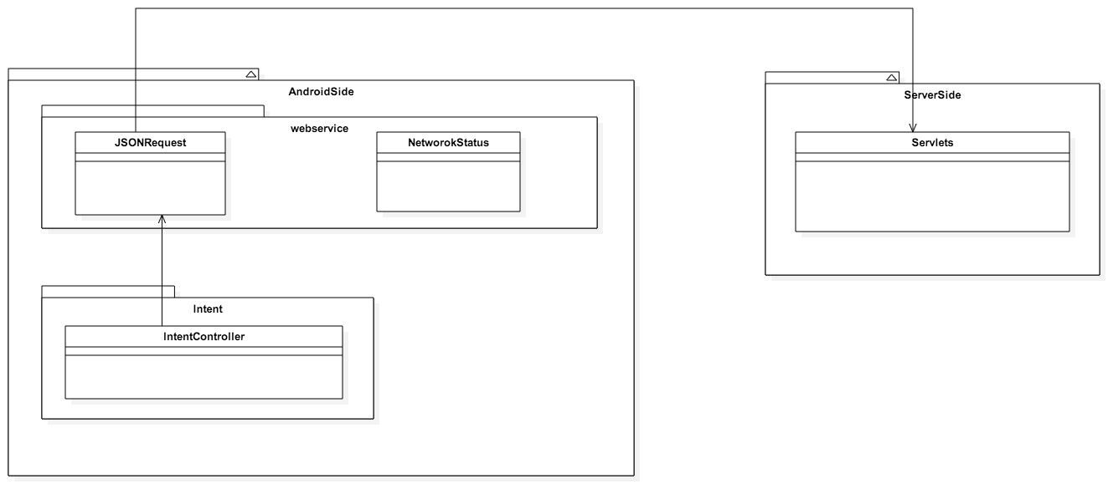

# DiscountShop Class Diagram

The integrated class diagram would be as shown below.

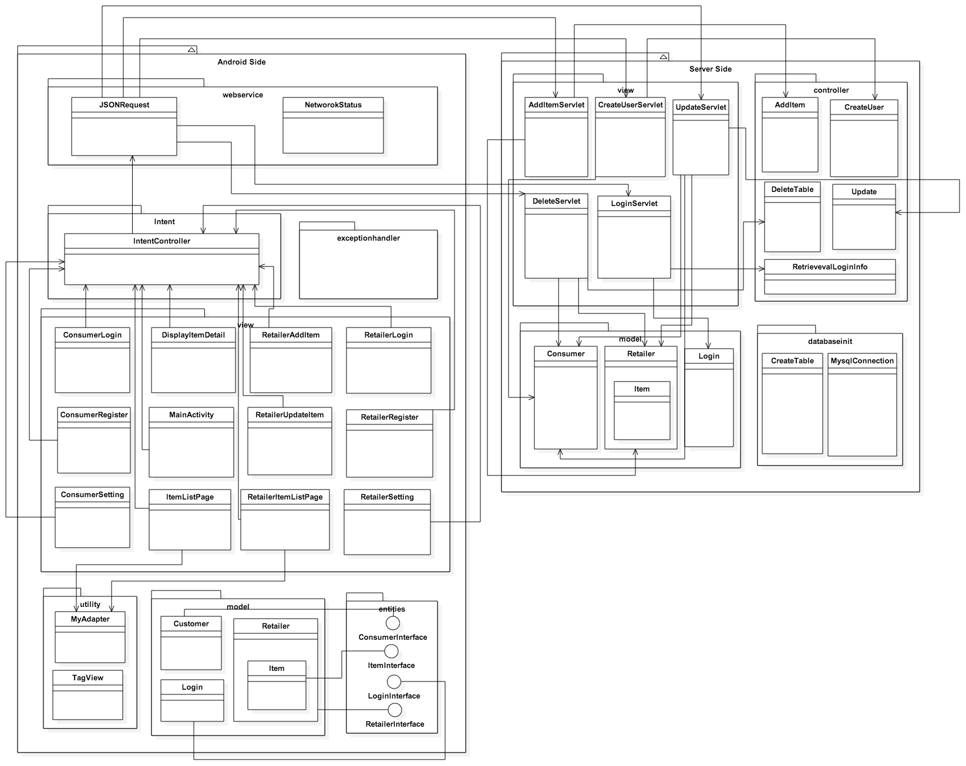

# PageFlow

## Consumer

### Register

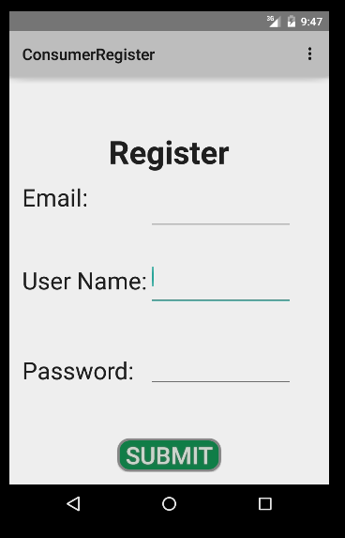

### Login

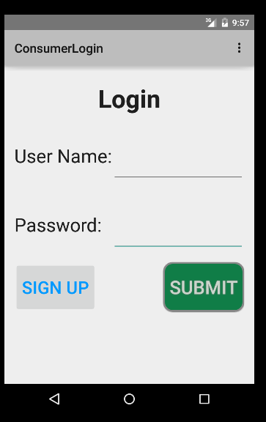

### ItemList Page

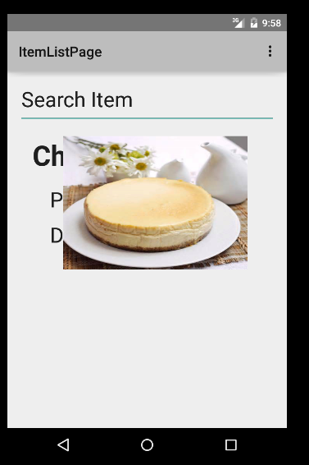

### ItemDisplayDetail

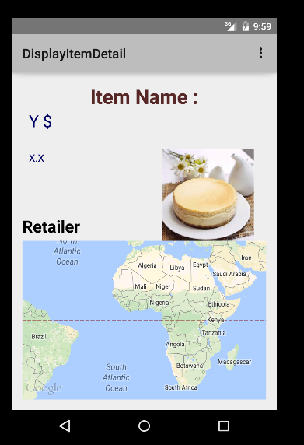

### Profile Setting

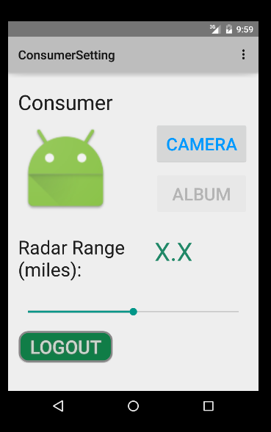

## Retailer

### Register

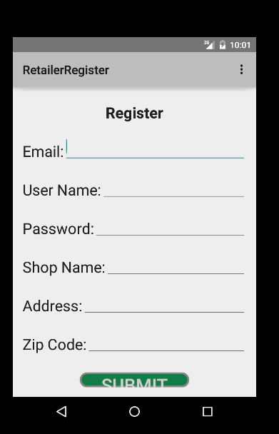

### Retailer Login

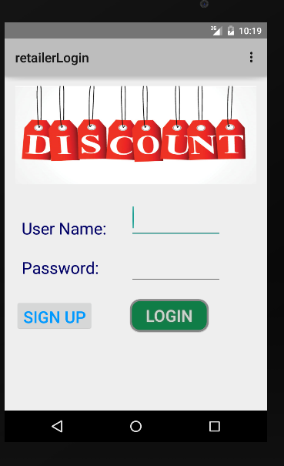

### Retailer Item List

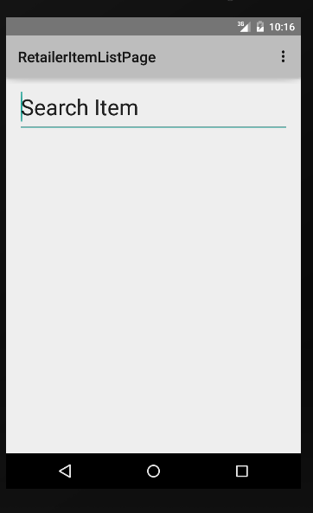

### Retailer Settings

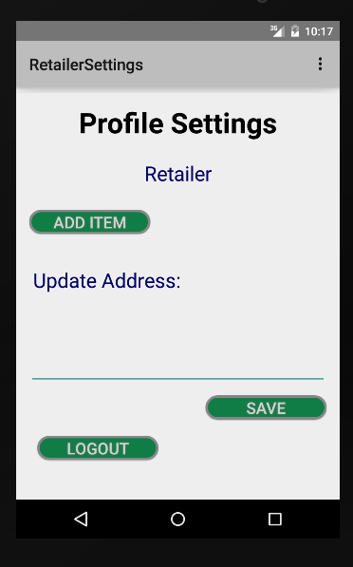

### Retailer Add Item

