<script>

setTimeout(

function(){

document.write("hi");

},1000);

</script>

setTimeout(sayHi,1000);

function sayHi(){

document.write("hi");

}

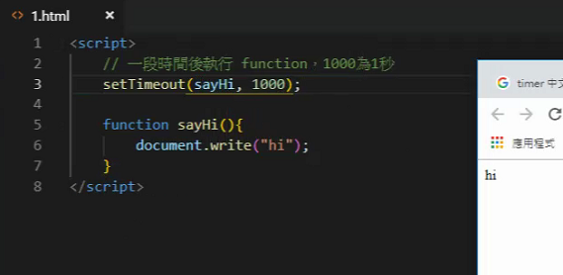

function sayHi(){

document.write("hi");

}

setInterval(sayHi, 1000);

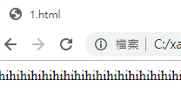

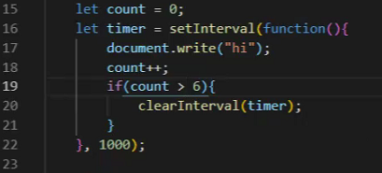

let count =1;

let timer = setInterval(function(){

document.write("hi");

count++;

if(count >6){

clearInterval(timer);

}

},1000);



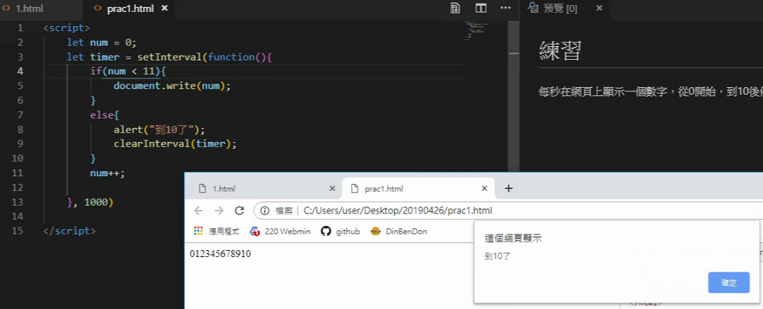

<script>

let count =0;

let timer = setInterval(function(){

if(count <11){

document.write(count);

}else{

clearInterval(timer);

alert("timeout");

}

count++;

},1000);

</script>

<script>

//Math 是Javascript的數學物件

//.PI 是圓周率

document.write(Math.PI+"<br>");

//.round() 四捨五入

document.write("四捨五入"+ Math.round(4.7)+"<br>");

// .ceil()無條件進位

document.write("無條件進位"+ Math.ceil(4.7)+"<br>");

// .floor() 無條件捨去

document.write("無條件進位"+ Math.floor(4.7)+"<br>");

</script>

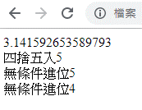

<script>

//Math 是Javascript的數學物件

//.PI 是圓周率

document.write(Math.PI+"<br>");

//.round() 四捨五入

document.write("四捨五入"+ Math.round(4.7)+"<br>");

// .ceil()無條件進位

document.write("無條件進位"+ Math.ceil(4.7)+"<br>");

// .floor() 無條件捨去

document.write("無條件進位"+ Math.floor(4.7)+"<br>");

// .pow() 次方

document.write("次方"+ Math.pow(6,3)+"<br>");

// .sqrt 平方根

document.write("平方根"+ Math.sqrt(64)+"<br>");

// .min() 取最小值

document.write("取最小值"+ Math.min(64,82,67,-100)+"<br>");

// .max() 取最大值

document.write("取最大值"+ Math.max(64,500,72,80,-100)+"<br>");

// .random() 從0到1隨機取一個數字

document.write("從0到1隨機取一個數字"+ Math.random()+"<br>");

</script>

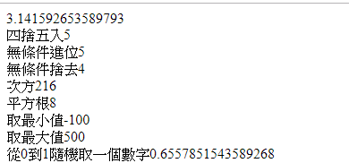



let num = Math.round(Math.random()*50);

let num = Math.floor(Math.random()*100);

document.write(num+"<br>");

if(num>50){

num = num-50;

document.write(num+"<br>");

}else{

document.write(num+"<br>");

}

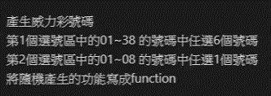

這個方式會取到0

function num1(number){

let result = Math.round(Math.random()*number);

return result;

}

for(let i=1;i<=6;i++){

document.write(num1(38)+"<br>");

}

document.write(num1(8)+"<br>");

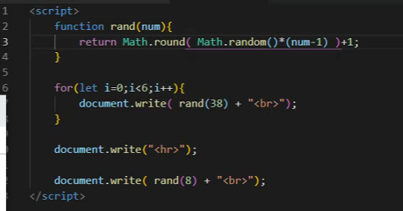

要把

let result = Math.round(Math.random()*number);

改為

let result = Math.round(Math.random()*(number-1)+1);

這樣取值時才不會取到0

// .random() 從0到1隨機取一個數字

//.round() 四捨五入

<h1 id="myh1"></h1>

<script>

console.log(document.getElementById("myh1") );

</script>

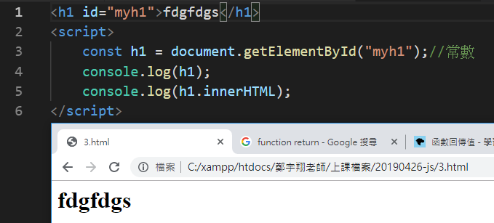

<h1 id="myh1">fdgfdgs</h1>

<script>

const h1 = document.getElementById("myh1");//常數

console.log(h1);

//innerHTML 裡面的HTML

//innerText 裡面的文字

console.log(h1.innerHTML);

//h1.innerHTML = "今天天氣真好";

h1.innerHTML = '<a href="https://www.google.com" >今天天氣真好</a>';

</script>

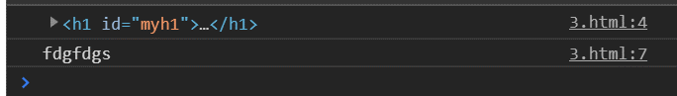

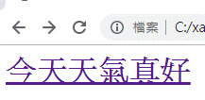

//innerHTML 裡面的HTML

//innerText 裡面的文字



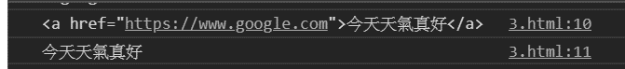

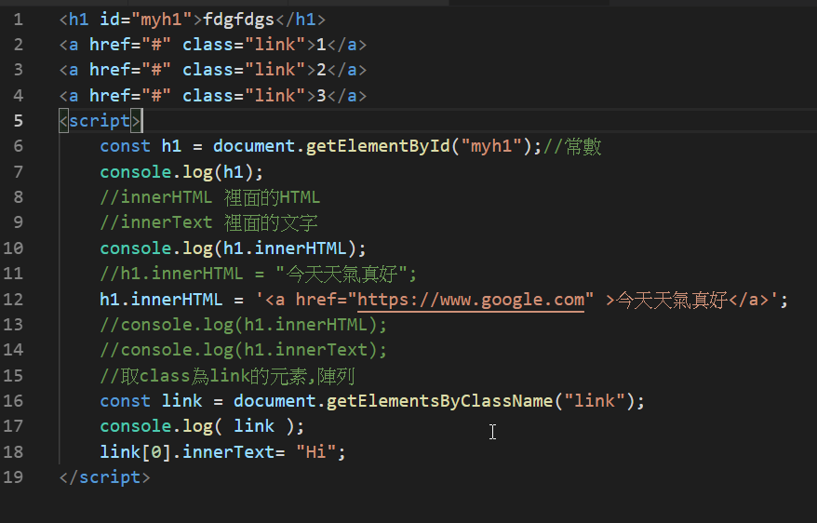

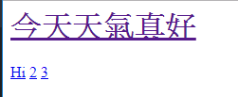

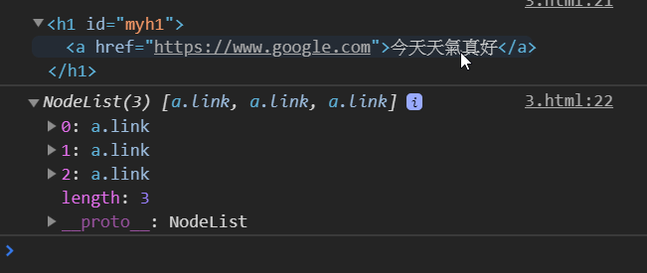

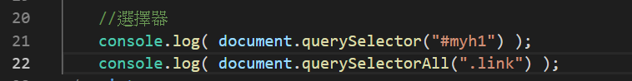

<h1 id="myh1">fdgfdgs</h1>

<a href="#" class="link">1</a>

<a href="#" class="link">2</a>

<a href="#" class="link">3</a>

<script>

const link = document.getElementsByClassName("link");

console.log( link );

link[0].innerText= "Hi";

//選擇器

console.log( document.querySelector("#myh1") );

console.log( document.querySelectorAll(".link") );

//remove() 刪除東西

link[2].remove();

</script>

**link[0]=>Hi 刪除link[2],所以數字三被移除**

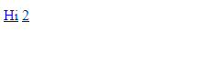

beforestart

<div id="div1">

afterstart

<h1 id="myh1">fdgfdgs</h1>

<a href="#" class="link">1</a>

<a href="#" class="link">2</a>

<a href="#" class="link">3</a>

beforeend

</div>

afterend

<script>

const div1 = document.getElementById("div1");

//在元素的哪裡新增html

//beforeend,afterend,beforestart,afterstart

div1.insertAdjacentHTML("beforeend","<h5>adsfdsfds</h5>")

</script>

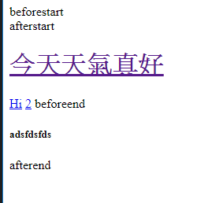

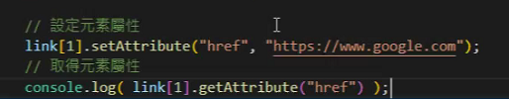

//設定元素

link[1].setAttribute("href", "https://www.google.com");

//取得元素屬性

//console.log( link[1].getAttribute("href"));這樣打會出現錯誤訊息

    console.log( link[1].getAttribute("href") );

// .style.CSS名稱 = 值

div1.style.color = "red";

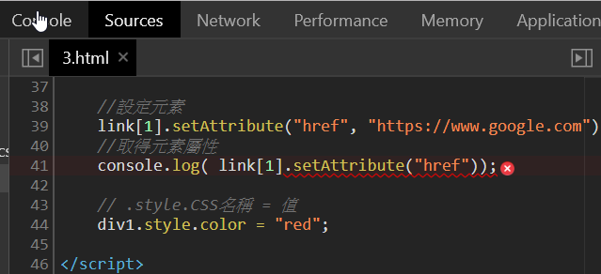 出現錯誤訊息

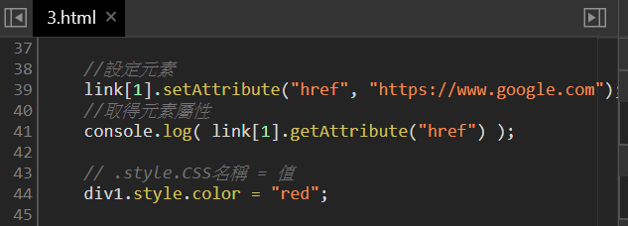

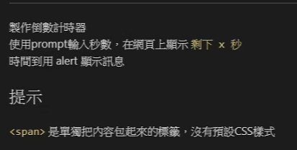

剩下 <span id="sec"></span>秒

<script>

const sec = document.getElementById("sec");

let input = prompt("請輸入秒數");

sec.innerText = input;//innerText 裡面的文字

let timer = setInterval(function(){

input--;

sec.innerText = input; //innerText 裡面的文字

if(input <1){

clearInterval(timer);

setTimeout(function(){

alert("時間到");

}, 100);

}

}, 1000);

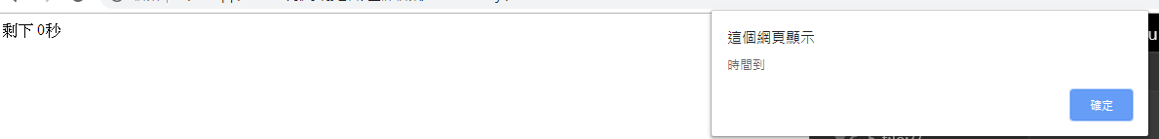

<form action="" name="myform">

<input type="radio" name="buy1" value="購買">購買

<input type="radio" name="buy1" value="不購買">不購買

<input type="radio" name="buy1" value="考慮中">考慮中

<hr>

<input type="radio" name="buy2" value="購買">購買

<input type="radio" name="buy2" value="不購買">不購買

<input type="radio" name="buy2" value="考慮中">考慮中

<input type="button" value="送出" onclick="msg()">

</form>

<script>

function msg(){

let buy1 = myform.buy1.value;

let buy2 = myform.buy2.value;

// \n是換行

confirm(`流行皮件選購確認:\n\n真皮皮包: ${buy1} \n真皮短夾:${buy2}`);

}

//alert( myform.text1.value)

</script>

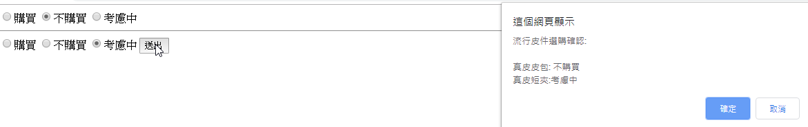

<!DOCTYPE html>

<html lang="en">

<head>

<meta charset="UTF-8">

<meta name="viewport" content="width=device-width, initial-scale=1.0">

<meta http-equiv="X-UA-Compatible" content="ie=edge">

<title>Clock</title>

<style>

#clock{

width: 300px;

height: 300px;

border-radius: 50%;

background: blue;

position: relative;

}

#hour{

height: 5px; /*寬度 */

width: 20%;/* 直徑長度 */ /* width+left 要等於半徑的長度 */

background: yellow;

position: absolute;

top: 50%;

left: 30%;

transform-origin: right center; /* 基準點 */

transform: rotate(60deg);

}

#minute{

height: 5px; /*寬度 */

width: 50%;/* 直徑長度 */ /* width+left 要等於半徑的長度 */

background: lightcoral;

position: absolute;

top: 50%;

left: 0%;

transform-origin: right center; /* 基準點 */

transform: rotate(180deg);

}

#second{

height: 5px; /*寬度 */

width: 50%;/* 直徑長度 */ /* width+left 要等於半徑的長度 */

background: lightgreen;

position: absolute;

top: 50%;

left: 0%;

transform-origin: right center; /* 基準點 */

transform: rotate(200deg);

}

</style>

</head>

<body>

<div id="clock">

<div id="hour"></div>

<div id="minute"></div>

<!-- div#second -->

<div id="second"></div>

</div>

</body>

</html>

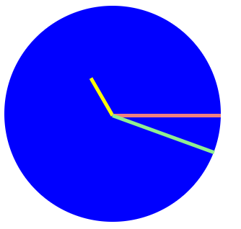

<!DOCTYPE html>

<html lang="en">

<head>

<meta charset="UTF-8">

<meta name="viewport" content="width=device-width, initial-scale=1.0">

<meta http-equiv="X-UA-Compatible" content="ie=edge">

<title>Clock</title>

<style>

#clock{

width: 300px;

height: 300px;

border-radius: 50%;

background: blue;

position: relative;

}

#hour{

height: 5px; /*寬度 */

width: 20%;/* 直徑長度 */ /* width+left 要等於半徑的長度 */

background: yellow;

position: absolute;

top: 50%;

left: 30%;

transform-origin: right center; /* 基準點 */

/* transform: rotate(60deg); */

}

#minute{

height: 5px; /*寬度 */

width: 50%;/* 直徑長度 */ /* width+left 要等於半徑的長度 */

background: lightcoral;

position: absolute;

top: 50%;

left: 0%;

transform-origin: right center; /* 基準點 */

/* transform: rotate(180deg); */

}

#second{

height: 5px; /*寬度 */

width: 50%;/* 直徑長度 */ /* width+left 要等於半徑的長度 */

background: lightgreen;

position: absolute;

top: 50%;

left: 0%;

transform-origin: right center; /* 基準點 */

/* transform: rotate(200deg); */

}

</style>

</head>

<body>

<div id="clock">

<div id="hour"></div>

<div id="minute"></div>

<!-- div#second -->

<div id="second"></div>

</div>

<script>

const hour = document.getElementById("hour");

const minute = document.getElementById("minute");

const second = document.getElementById("second");

console.log(hour);

setInterval(function(){

let date = new Date();

let h = date.getHours();

let m = date.getMinutes();

let s = date.getSeconds();

hour.style.transform = `rotate( ${h*30+90}deg )`; //一小時動30度,90度是校正為直的

minute.style.transform = `rotate( ${m*6+90}deg )`; //rotate( ${m*6+90}deg ) =>rotate() 括號跟rotate中間不能空格

second.style.transform = `rotate( ${s*6+90}deg )`;

}, 1000);

</script>

</body>

</html>

