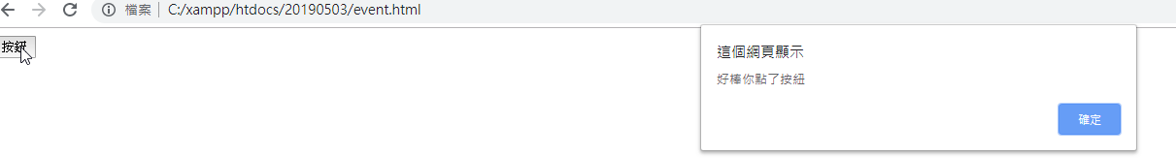

<input type="button" value="按鈕" id="btn" onclick="aa()">

<script>

function aa(){

alert("好棒，你點了按鈕");

}

</script>

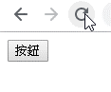 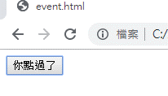

<input type="button" value="按鈕" id="btn" onclick="aa(this)">

<script>

function aa(elemnt){

/\* alert("好棒，你點了按鈕"); \*/

elemnt.value = "你點過了";

}

</script>



<input type="button" value="按鈕" id="btn" onclick="aa(this)">

<a href="www.google.com" onclick="a(event)">abc</a>

<script>

function aa(elemnt){

/\* alert("好棒，你點了按鈕"); \*/

elemnt.value = "你點過了";

}

function a(e){

e.preventDefault();

}

</script>

把預設事件取消,把事件擋下來,不跳下一頁

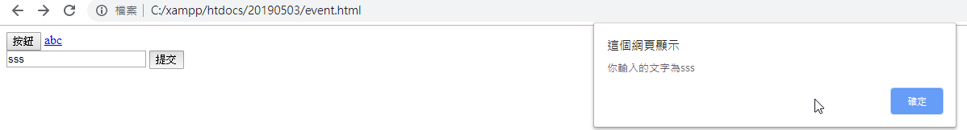

<input type="button" value="按鈕" id="btn" onclick="aa(this)">

<a href="www.google.com" onclick="a(event)">abc</a>

<form action="" name="f" onsubmit="sub(event)">

<input type="text" name="t" id="">

<input type="submit">

</form>

<script>

function aa(elemnt){

/\* alert("好棒，你點了按鈕"); \*/

elemnt.value = "你點過了";

}

function a(e){

e.preventDefault();

}

function sub(e){

alert("你輸入的文字為"+f.t.value);

}

</script>

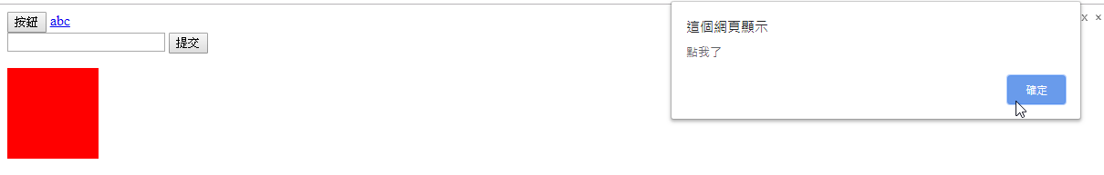

<div style="width: 100px; height: 100px; background:red" id="dd"></div>

<script>

const dd = document.getElementById("dd");

dd.onclick = function(){

alert("點我了");

}

</script>

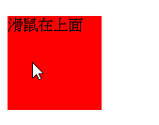

<div style="width: 100px; height: 100px; background:red" id="dd"></div>

<script>

dd.onmouseover = function(){

dd.innerText = "滑鼠在上面";

}

</script>

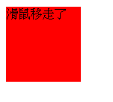

<div style="width: 100px; height: 100px; background:red" id="dd"></div>

<script>

dd.onmouseout = function(){

dd.innerText = "滑鼠移走了";

}

</script>

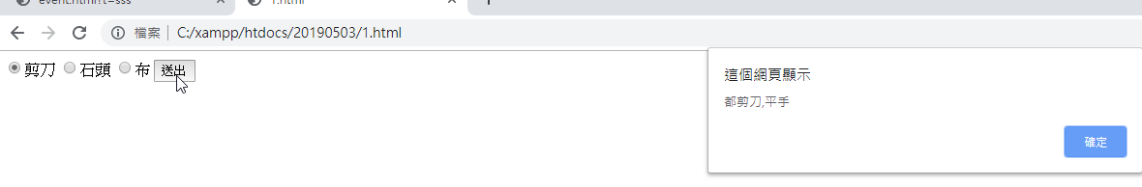

<form action="" name="myform">

<input type="radio" name="b" value="0">剪刀

<input type="radio" name="b" value="1">石頭

<input type="radio" name="b" value="2">布

<input type="button" value="送出" onclick="msg()">

</form>

<script>

function msg(){

let a = Math.round(Math.random()\*(2));

let b = myform.b.value;

console.log(a);

console.log(b);

if(a==0 && b==0){

alert("都剪刀,平手");

}else if(a==0 && b==1){

alert("你剪刀,我石頭,我贏了");

}else if(a==0 && b==2){

alert("你剪刀,我布,我輸了");

}

if(a==1 && b==0){

alert("你石頭,我剪刀,我輸了");

}else if(a==1 && b==1){

alert("你石頭,我石頭,平手");

}else if(a==1 && b==2){

alert("你石頭,我布,我贏了");

}

if(a==2 && b==0){

alert("你布,我剪刀,我贏了");

}else if(a==2 && b==1){

alert("你布,我石頭,我輸了");

}else if(a==2 && b==2){

alert("都布,平手");

}

}

</script>

<form action="" name="form">

<input type="radio" name="in" id="" value="1">剪刀

<input type="radio" name="in" id="" value="2">剪刀

<input type="radio" name="in" id="" value="3">剪刀

<br>

<input type="button" value="猜拳" onclick="game()">

</form>

<p id="result"></p>

<script>

let arr = ["剪刀","石頭","布"];

const result = document.getElementById("result");

function game(){

let rand = Math.floor(Math.random()\*3);

let input = form.in.value;

if(input == "") result.innerText = `你沒出`;

else if(input == rand) result.innerText = `電腦出了${arr[rand]},平手`;

else if(input == 0 && rand == 1) result.innerText = `電腦出了${arr[rand]},你輸了`;

else if(input == 0 && rand == 2) result.innerText = `電腦出了${arr[rand]},你贏了`;

else if(input == 1 && rand == 0) result.innerText = `電腦出了${arr[rand]},你贏了`;

else if(input == 1 && rand == 2) result.innerText = `電腦出了${arr[rand]},你輸了`;

else if(input == 2 && rand == 0) result.innerText = `電腦出了${arr[rand]},你輸了`;

else if(input == 3 && rand == 1) result.innerText = `電腦出了${arr[rand]},你贏了`;

}

</script>

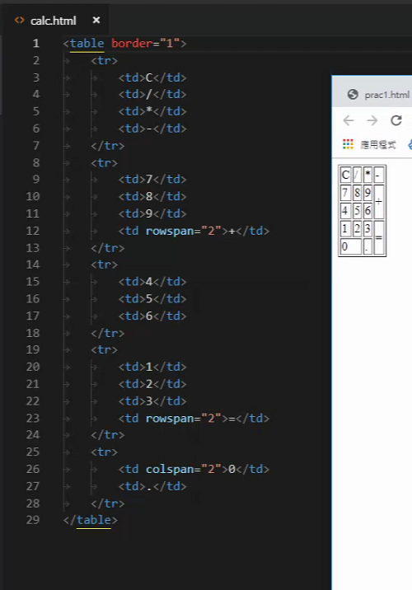

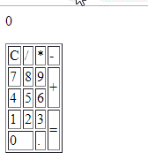

<p id="input">0</p>

<table border="1">

<tr>

<td>C</td>

<td>/</td>

<td>\*</td>

<td>-</td>

</tr>

<tr>

<td>7</td>

<td>8</td>

<td>9</td>

<td rowspan="2">+</td>

</tr>

<tr>

<td>4</td>

<td>5</td>

<td>6</td>

</tr>

<tr>

<td>1</td>

<td>2</td>

<td>3</td>

<td rowspan="2">=</td>

</tr>

<tr>

<td colspan="2">0</td>

<td>.</td>

</tr>

</table>

