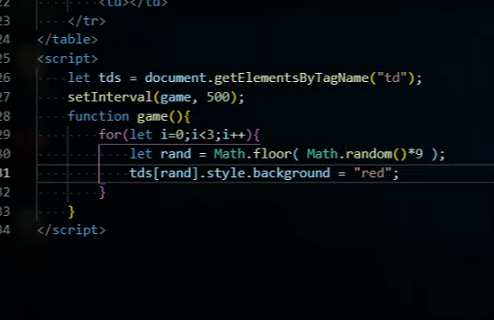

<script>

let tds = document.getElementsByTagName("td");

setInterval(game,500);

function game(){

for(let i=0;i<3;i++){

let rand = Math.floor( Math.random()\*9);

tds[rand].style.background = "red";

}

}

</script>

改為

<style >

td{

border: 1px solid #000;

width: 100px;

height: 100px;

}

.red{

background-color: red;

}

</style>

<script>

let tds = document.getElementsByTagName("td");

setInterval(game,500);

function game(){

for(let i=0;i<3;i++){

let rand = Math.floor( Math.random()\*9);

tds[rand].classList.add("red");

}

}

</script>

<script>

let tds = document.getElementsByTagName("td");

setInterval(game,500);

function game(){

for(let i=0;i<tds.length;i++){

tds[i].classList.remove("red");

}

for(let i=0;i<3;i++){

let rand = Math.floor( Math.random()\*9);

tds[rand].classList.add("red");

}

}

</script>

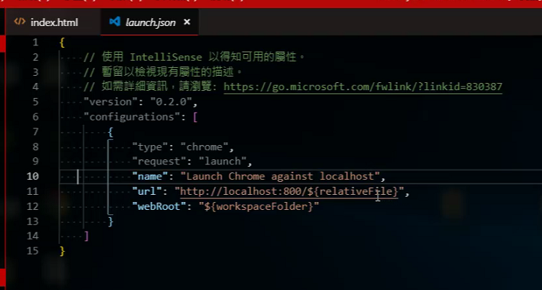

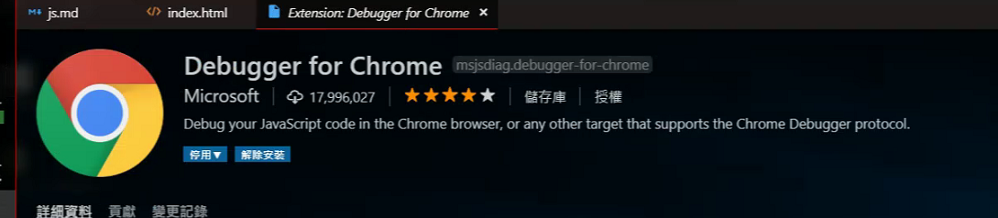

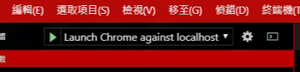

Bracket Pair Colorizer

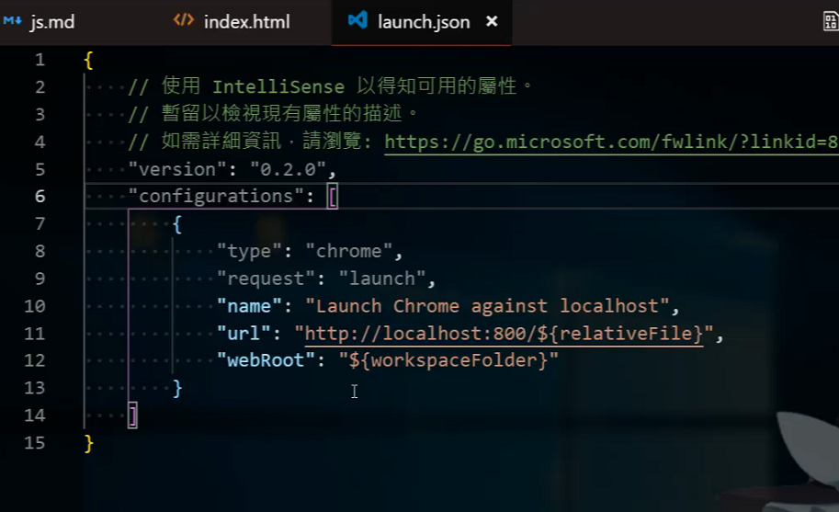

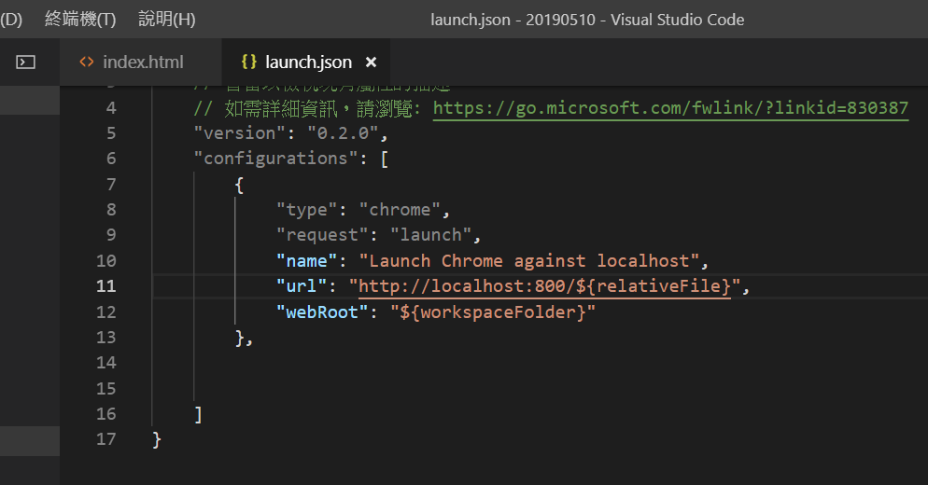

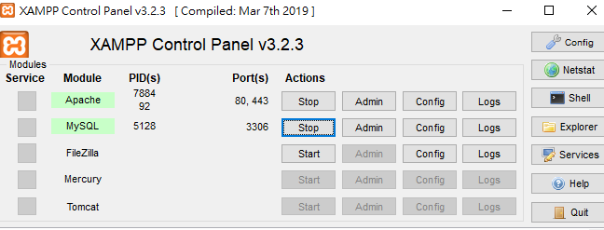

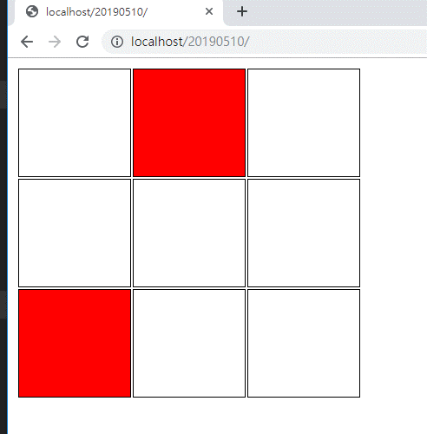

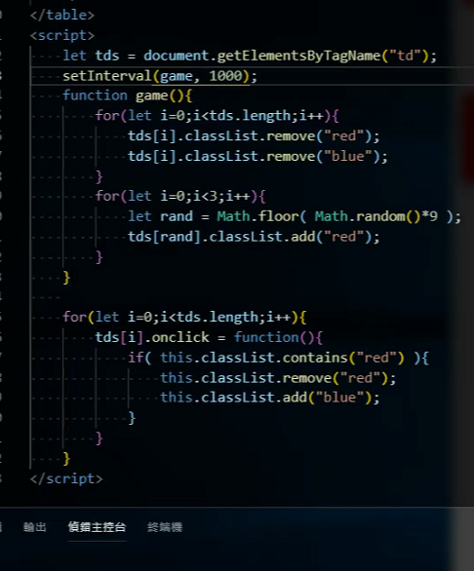

<style >

td{

border: 1px solid #000;

width: 100px;

height: 100px;

}

.red{

background-color: red;

}

.blue{

background-color: blue;

}

</style>

<script>

let tds = document.getElementsByTagName("td");

setInterval(game,1000);

function game(){

for(let i=0;i<tds.length;i++){

tds[i].classList.remove("red"); //依序刪除紅色格子

tds[i].classList.remove("blue");

}

for(let i=0;i<3;i++){

let rand = Math.floor( Math.random()\*9);

tds[rand].classList.add("red"); //隨機加上紅格子

}

}

for(let i=0;i<tds.length;i++){

tds[i].onclick = function(){

if( this.classList.contains("red") ){

this.classList.remove("red");

this.classList.add("blue");

}

}

}

</script>

<input type="button" value="開始遊戲" id="start">

<script>

let start = document.getElementById("start");

let score = 0;

let tds = document.getElementsByTagName("td");

let timer = 0;

timer = setInterval(game,1000);

meta:utf

<meta http-equiv="Content-Type" content="text/html;charset=UTF-8">

