var v ="123";

//const 宣告後就不能改變值

const c="ccc";

let number = 123;

let float =123.456;

let string = "abc";

let string2 = 'abdfsf';

let string3 = `abdfsf`;

let boot = true;

let strint2 = 'abc';

//javacsript的陣列索引只能是1,2,3,4...

let arr = ["asd","123"];

console.log(arr[0]);

//物件,高級的陣列版

let student ={

number:1,

name: "王小明",

speak: function(){

console.log("Hi");

}

}

console.log(student.number);

student.speak();

//docuent.write(string);

//彈出警告視窗

//alert("你好");

//彈出輸入框

let isGood = confirm("今天天氣好嗎");

document.write(isGood);

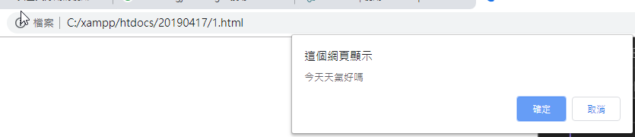

//彈出輸入框

let lunch = prompt("中午想吃啥");

document.write(lunch);

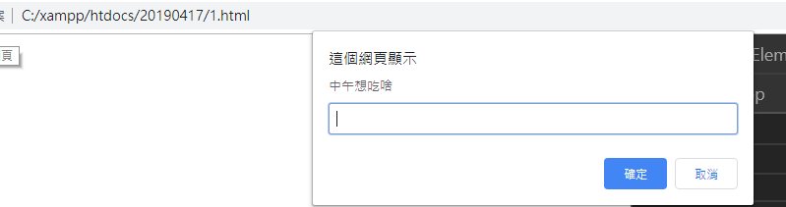

let num1 =1;

let num2 =2;

let num3 ="3";

let num4 ="4";

document.write(num1+num2);

document.write("<br>");

document.write(num3+num4);

let string4 = "數字三是"+num3+"，fdsfsdfdsfd"+num4+"dstfdsfdsf";

let string5 = `數字三是"${num3}，fdsfsdfdsfd${num4}dstfdsfdsf`;

document.write("<br>");

document.write(string4);

document.write("<br>");

document.write(string5);

document.write("<br>");

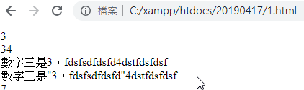

let num1 =1;

let num2 =2;

let num3 ="3";

let num4 ="4";

// \*1把字串轉數字 ，或使用　num3 = num3.parseInt()

document.write(num3\*1+num4\*1);

document.write("<br>");

//toString把數字轉成字串

num1 = num1.toString();

num2 = num2.toString();

document.write(num1+num2);



把兩個輸入相加

let no1 = prompt("數字一");

//let no11 = document.write(no1);

document.write("<br>");

let no2 = prompt("數字二");

//let no22 = document.write(no2);

document.write(no1\*1 + no2\*1);

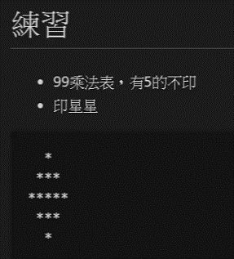

for(let i=1;i<=9;i++){

if(i == 5) continue;

//document.write(i);

document.write("<br>");

for(let j=1;j<=9;j++){

if(j == 5) continue;

//document.write(j);

document.write(i +"\*"+j +"=" +i\*j);

document.write("&nbsp");

}

}

document.write("<br>");

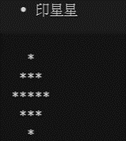

for (let i=0; i <= 3; i++) {

for (let k=1; k < (6-i) ; k++) {

//document.write("a");

document.write("&nbsp");

document.write("&nbsp");

}

for (let j=1; j <=(2\*i-1) ; j++) {

//echo "&nbsp;";

document.write("\*");

}

document.write("<br>");

}

//==========================

for (let i=2; i >= 1; i--) {

for (let k=1; k < (6-i) ; k++) {

//document.write("a");

document.write("&nbsp");

document.write("&nbsp");

}

for (let j=1; j <=(2\*i-1) ; j++) {

//echo "&nbsp;";

document.write("\*");

}

document.write("<br>");

}

九九乘法中,有五的移除,答案有5的也不印

