

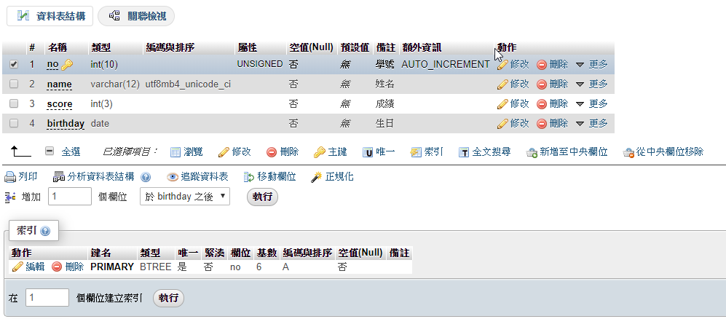

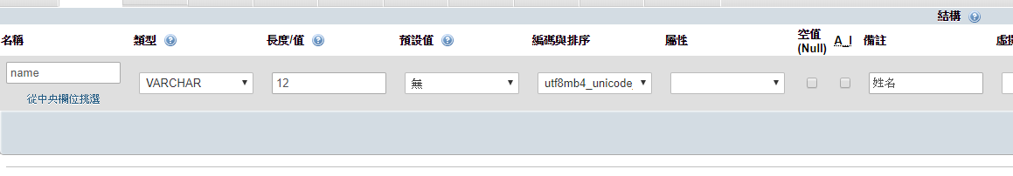

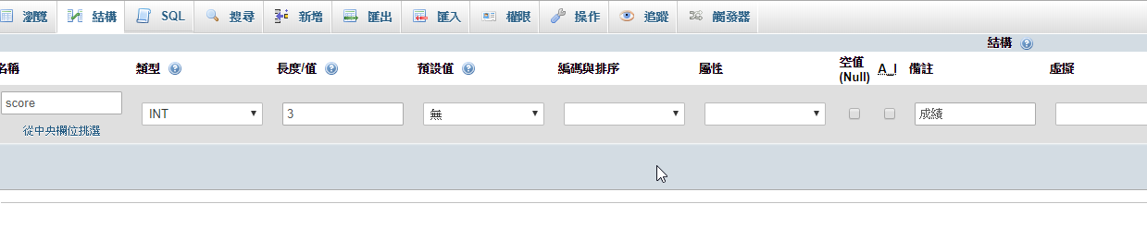

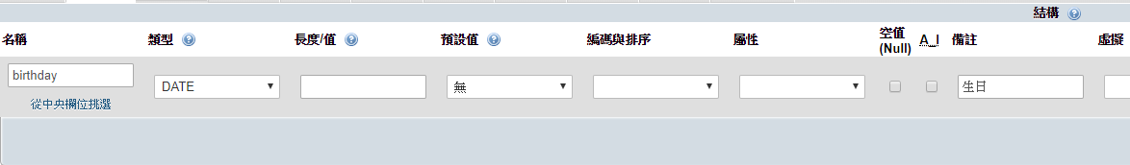

新增

INSERT INTO `student` (`no`, `name`, `score`, `birthday`) VALUES (NULL, '小強', '65', '2019-04-10')

INSERT INTO `student` (`name`, `score`, `birthday`) VALUES ('小強', '65', '2019-04-10')

查詢

SELECT * FROM `student` WHERE 1

SELECT ‘name’ FROM `student`

SELECT name,birthday FROM `student` WHERE `name`='小華'

SELECT name,birthday FROM `student` WHERE score >60

SELECT name,birthday FROM `student` WHERE no>4 && score >60

SELECT count(*) FROM `student` 🡪筆數

SELECT sum(`score`) FROM `student`

SELECT avg(`score`) FROM `student`

更新

UPDATE `student` SET `score` = '33' WHERE `student`.`no` = 9

UPDATE `student` SET `score` = '75' WHERE `student`.`name` = '小英'

INSERT INTO `student` (`name`, `score`, `birthday`) VALUES ('小黑', '65', '2019-03-10'), ('小白', '75', '2019-05-10')

刪除

DELETE FROM `student` WHERE `student`.`no` = 12

DELETE FROM `student` WHERE `student`.`name` = '小白'

class

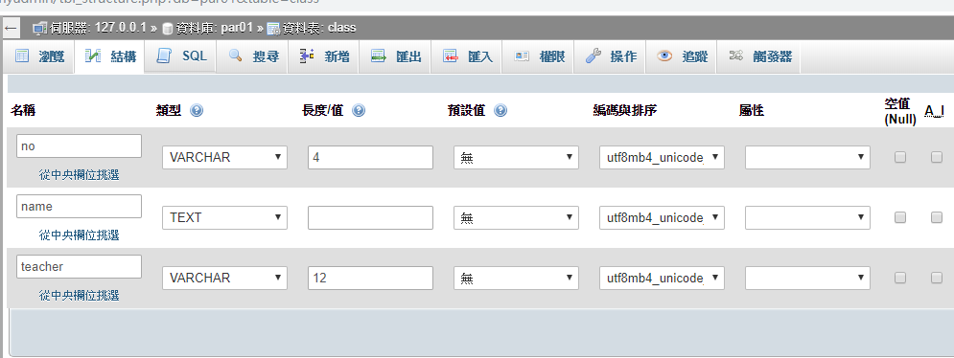

選擇

SELECT name FROM `class` WHERE 1

更新

UPDATE `class` SET `teacher` = '張國強' WHERE `class`.`no` = '0201'; UPDATE `class` SET `teacher` = '許淑華' WHERE `class`.`no` = '0202';

UPDATE `student` SET `class` = '0201', `teacher` = '張國強' WHERE `student`.`no` = 1;

UPDATE `student` SET `class` = '0202', `teacher` = '許淑華' WHERE `student`.`no` = 2;

UPDATE `student` SET `class` = '0201', `teacher` = '張國強' WHERE `student`.`no` = 3;

UPDATE `student` SET `class` = '0202', `teacher` = '許淑華' WHERE `student`.`no` = 4;

UPDATE `student` SET `class` = '0201', `teacher` = '張國強' WHERE `student`.`no` = 5;

UPDATE `student` SET `class` = '0202', `teacher` = '許淑華' WHERE `student`.`no` = 6;

UPDATE `student` SET `class` = '0201', `teacher` = '張國強' WHERE `student`.`no` = 7;

UPDATE `student` SET `class` = '0202', `teacher` = '許淑華' WHERE `student`.`no` = 8;

UPDATE `student` SET `class` = '0201', `teacher` = '張國強' WHERE `student`.`no` = 9;

UPDATE `student` SET `class` = '0202', `teacher` = '許淑華' WHERE `student`.`no` = 10;

UPDATE `student` SET `class` = '0201', `teacher` = '張國強' WHERE `student`.`no` = 11;

UPDATE `student` SET `class` = '0202', `teacher` = '許淑華' WHERE `student`.`no` = 13;

UPDATE `student` SET `class` = '0201', `teacher` = '張國強' WHERE `student`.`no` = 14;

UPDATE `student` SET `class` = '0202', `teacher` = '許淑華' WHERE `student`.`no` = 15;

UPDATE `student` SET `class` = '0201', `teacher` = '張國強' WHERE `student`.`no` = 16;

UPDATE `student` SET `class` = '0202', `teacher` = '許淑華' WHERE `student`.`no` = 17;

UPDATE `student` SET `class` = '0201', `teacher` = '張國強' WHERE `student`.`no` = 18;

UPDATE `student` SET `class` = '0202', `teacher` = '許淑華' WHERE `student`.`no` = 19;

UPDATE `student` SET `class` = '0201', `teacher` = '張國強' WHERE `student`.`no` = 20;

UPDATE `student` SET `class` = '0202', `teacher` = '許淑華' WHERE `student`.`no` = 21;

UPDATE `student` SET `class` = '0201', `teacher` = '張國強' WHERE `student`.`no` = 22;

UPDATE `student` SET `class` = '0202', `teacher` = '許淑華' WHERE `student`.`no` = 23;

SELECT * FROM `student`,`class` WHERE `student`.`class` = `class`.`no`

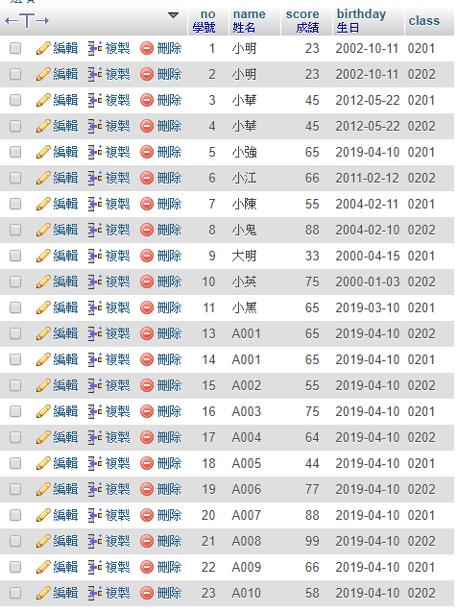 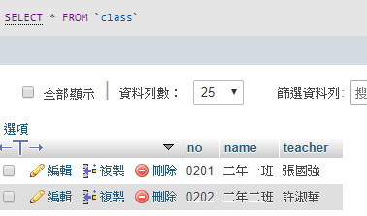

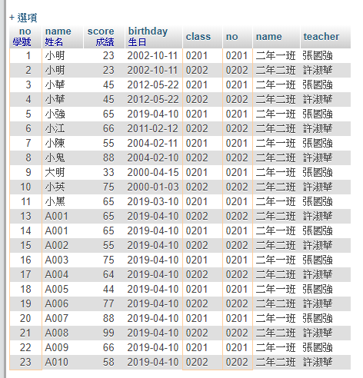

SELECT

`student`.`no`,

`student`.`name`,

`student`.`score`,

`class`.`name`,

`class`.`teacher`

FROM `student`,`class`

WHERE `student`.`class`=`class`.`no`

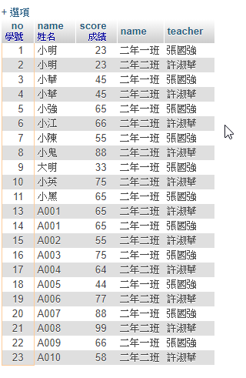

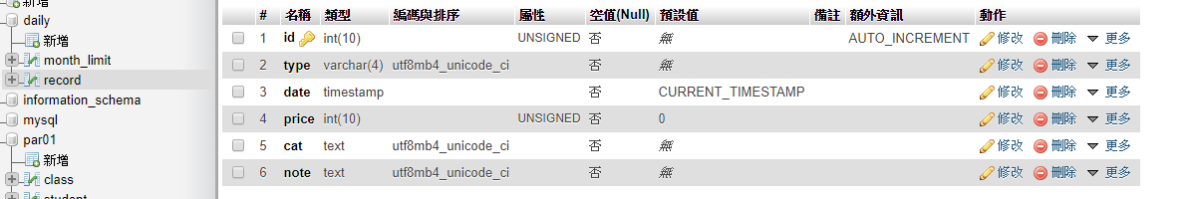

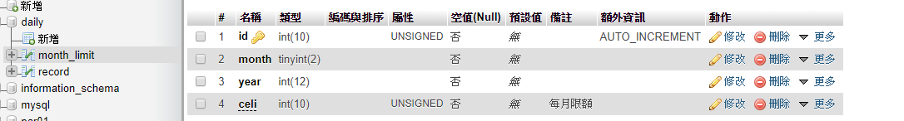

INSERT INTO `record` (`id`, `type`, `date`, `price`, `cat`, `note`) VALUES (NULL, '支出', CURRENT_TIMESTAMP, '30', '飲料', '紅茶');

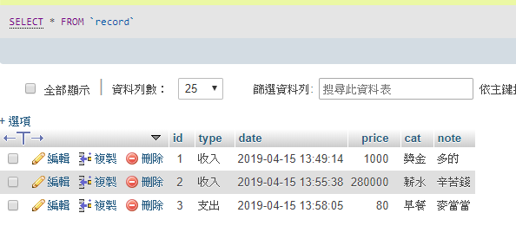

INSERT INTO `month_limit` (`id`, `month`, `year`, `celi`) VALUES (NULL, '5', '2019', '9000');

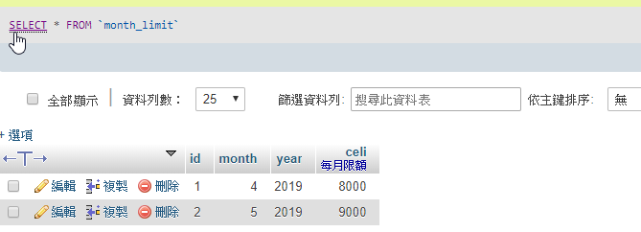

班級102的學生

SELECT * FROM `students` WHERE substr(`班級座號`,1,3)='102'

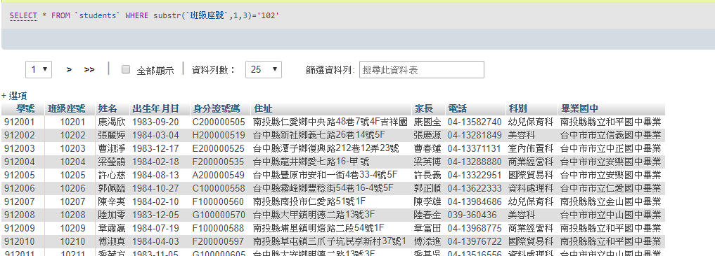

SELECT * FROM `students` WHERE substr(`畢業國中`,10,2)='修業'

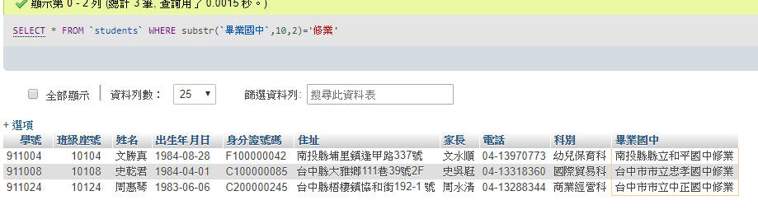

[SELECT](http://localhost/phpmyadmin/url.php?url=https://dev.mysql.com/doc/refman/5.5/en/select.html) `姓名`,substr(`身分證號碼`,2,1) AS'性別'FROM students

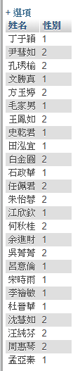

SELECT `姓名`,IF(substr(`身分證號碼`,2,1)=1,'男','女') AS'性別' FROM `students`

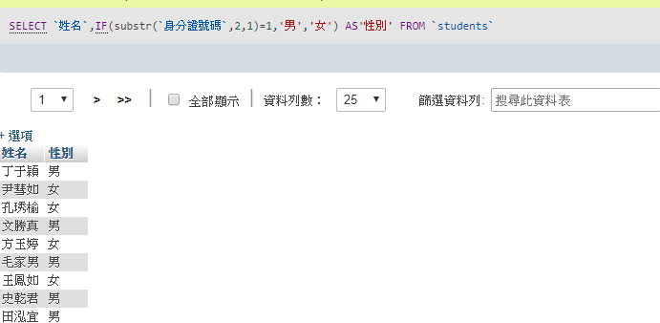

SELECT substr(`班級座號`,1,3) AS '班級' ,count(substr(`班級座號`,1,3)) AS '人數' FROM `students` GROUP BY substr(`班級座號`,1,3)

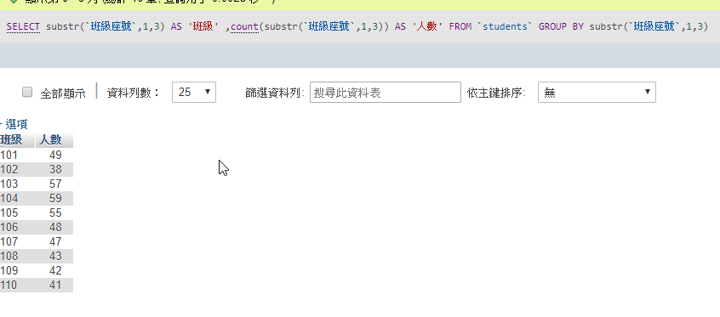

**分解的寫法**

SELECT

`學號`,

`students`.`班級座號`,

`姓名`,

`出生年月日`,

`conduct`.`導師評分`AS 評分

FROM

`students`,`conduct`

WHERE

`students`.`科別`='國際貿易科' &&

`students`.`班級座號`=`conduct`.`班級座號`

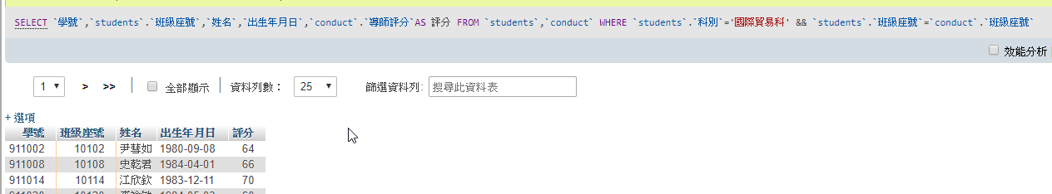

SELECT `學號`,`students`.`班級座號`,`姓名`,`出生年月日`,`conduct`.`導師評分`AS 評分 FROM `students`,`conduct` WHERE `students`.`科別`='國際貿易科' && `students`.`班級座號`=`conduct`.`班級座號`

