1-1.Aluminum reacts with KOH to form Al(OH)4- ions? (4 pts)

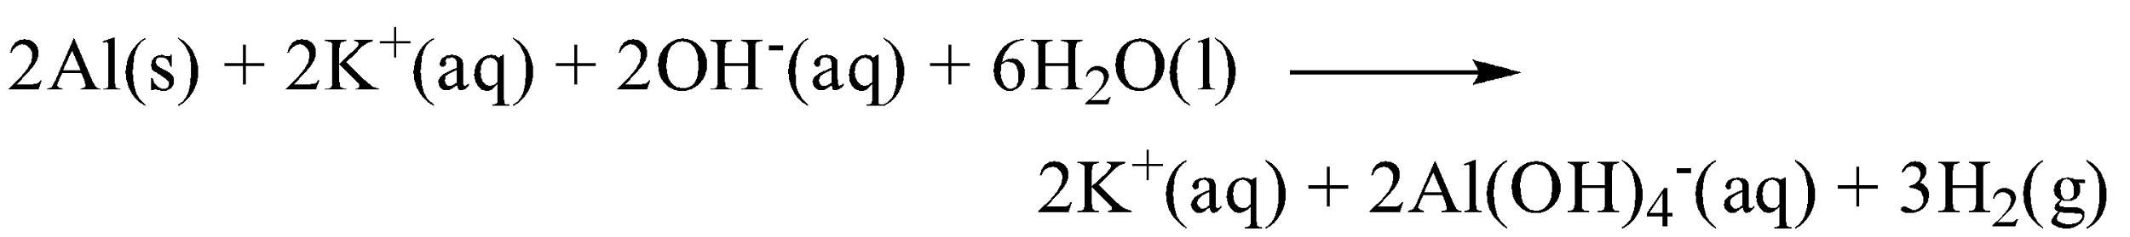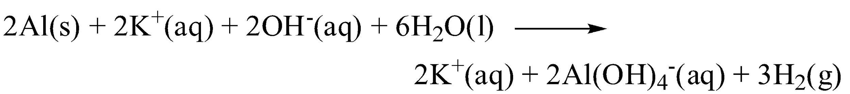

Ans:

1-2. Al(OH)4-Adding H2SO4 forms an Al(OH)3 solid? (4 pts)

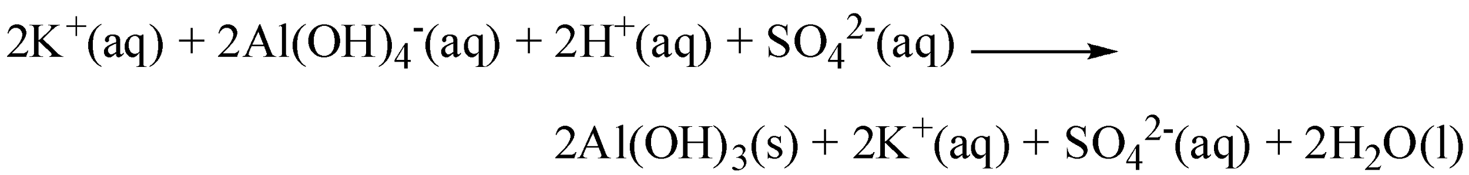

Ans:



1-3. Add H2SO4 dissolve the solid to Al3+ ions? (4 pts)

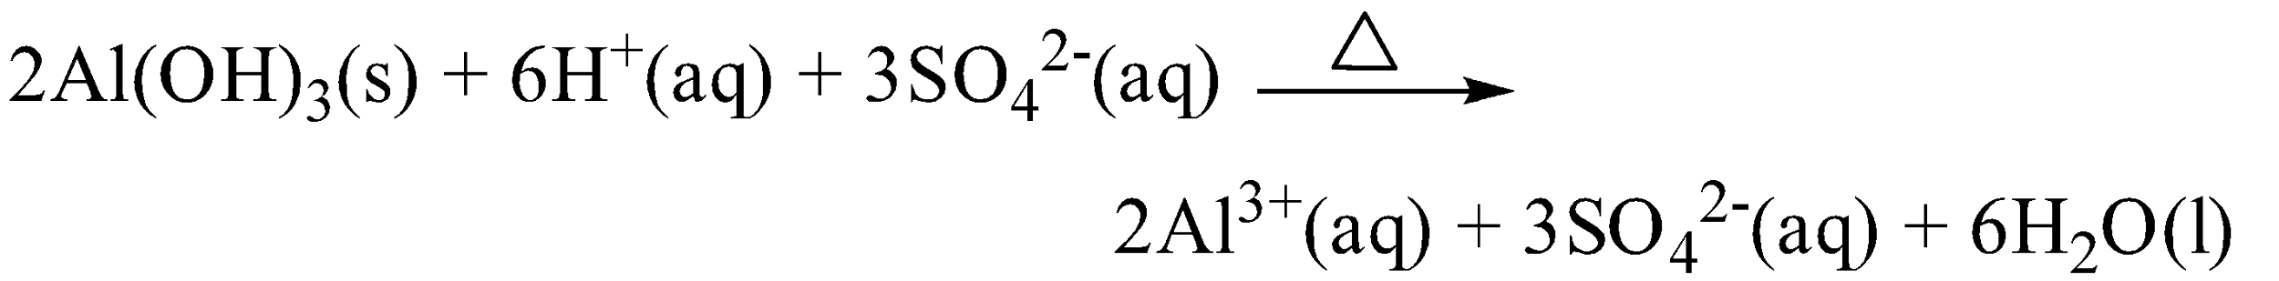

Ans:



1-4.Write down Overall reaction??(4pts)



2. Please write down the synthesis equation of potassium Alum? (4 pts)

Ans: K++Al3++2SO42‐+12H2O KAl(SO4)2．12H2O

3. Write down the general formula for Alum. (2 pts)

Ans: M+M3+(SO4)2．12H2O

4. If 40.0 g of potassium alum is obtained from 3.00 g of aluminum what is the percent yield?

(Atomic weight: Al=27, K=39, S=32) (4 pts)

Ans: 40/[(3/27)\*474] = 75.95%

5. Explain why a melting point determination is a good measure of the purity of the alum. If your sample melted at a lower temperature than the control. Does this mean that your sample is purer or more contaminated than the control? (6 pts)

Ans:

(1)在正常溫度壓力之下,純物質有固定的熔點,所以可以藉此來辨別產物是否為純相.(4pts)

(2)More contaminated (2 pts)

6. Explanation amphoteric element and for example three element? (5pts)

Ans:

1. Amphoteric compound is a molecule or ion that can react both as an acid and as a base.

2. copper, zinc, tin, lead, aluminium, and beryllium

7. Why Alum sample need near the Thermomter blub? (3pts)

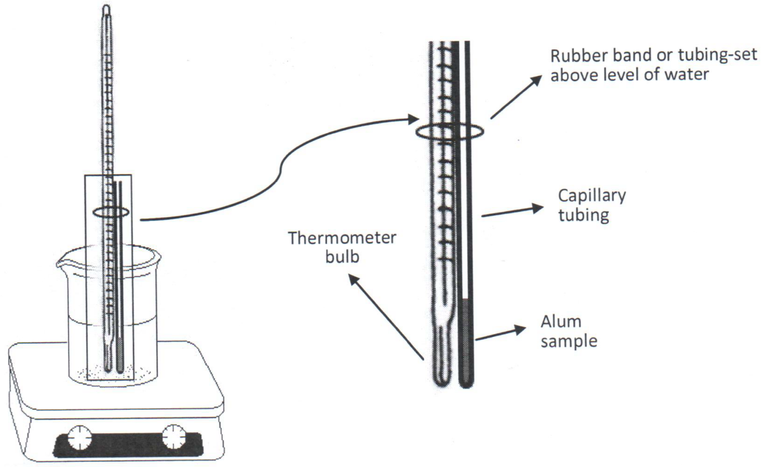

Ans: most accurate temperature

8.Potassium alum(KAl(SO4)2·12H2O) reaction with the water equation? (5pts)

KAl(SO4)2·12H2O+H2O ↔

Ans:

Al3+ + 3H2O ↔ Al(OH)3 + 3H+

9. Other ways to make Potassium alum is mix “Aluminium sulfate” and “Potassium sulfate”, write down reaction equation? (10pts)

Ans:

K2SO4+ Al2(SO4)3+24H2O--> 2KAl(SO4)2·12H2O

10. Why need gravity filter for this second process? (5pts)

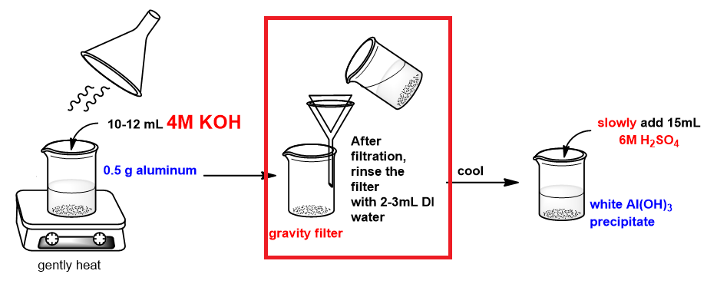

Ans: Because “Al can” has plastic film and some impurity.