Name: _______________________ ID: _______________________

**Analytical Chemistry II – Quiz (17th March, 2020)**

1) Write down the formula for *V*1 in the circuit below. The formula should relate *V*1 with *V*, *R*1, *R*2, and *R*3.

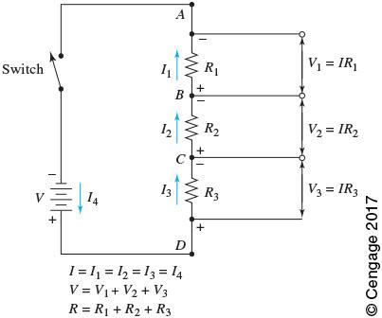 -

2) At certain conditions, a diode conducts electric current in *forward bias* but it has low conductance in *reverse bias*. Explain this phenomenon.

In forward bias (left), anode (*p* region) is connected to positive potential while cathode (*n* region) is connected to negative potential. Electrons in *n* region and holes in *p* region migrate toward the boundary between the two regions, what causes high conductivity. In contrast, in reverse bias (right), high densities of electrons and holes are seen near the terminals. The depletion layer in the center of *pn* junction is wide. It has high resistance. There is almost no flow of electric charge carriers.

