Name: _______________________ ID: _______________________

**Analytical Chemistry II – Quiz (31st March, 2020)**

1) The graph shows absorbances of three elements in relation to measurement height in flame atomization atomic absorption spectrometry. Explain the shapes of the three curves.

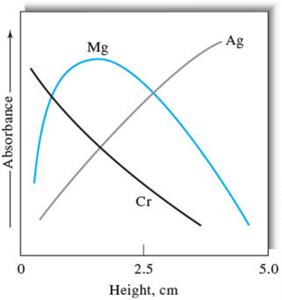

* The absorbance of Mg initially increases because more Mg atoms are formed due to the longer exposure to the heat of the flame. However, when the analyte species approach the secondary combustion zone, Mg is oxidized. The oxide particles do not absorb at the observation wavelength.
* Ag is not easily oxidized. Its absorbance increases because of the increasing number of free atoms from the base to the top of the flame.
* Cr forms very stable oxides. In this case, oxide formation predominates from the start.

2) Define the following terms related to atomic absorption spectrometry:

- releasing agent: A releasing agent is a cation that preferentially reacts with a species that would otherwise react with the analyte to cause a chemical interference.

- ionization suppressor: An ionization suppressor is more easily ionized than the analyte and provides a high concentration of electrons. These electrons suppress the ionization of the analyte.