Name: _______________________ ID: _______________________

**Analytical Chemistry II – Quiz (30th April, 2020)**

1) Specify the wavelength ranges of three regions of IR radiation.

(The error of each value relative to the textbook value must be below 20%.)

| **Region** | **Wavelength (micrometers)** | |
| --- | --- | --- |
| **Minimum** | **Maximum** |
| Near IR | 0.78 (accept 0.62-0.94) | 2.5 (accept 2.0-3.0) |
| Middle IR | 2.5 (accept 2.0-3.0) | 50 (accept 40-60) |
| Far IR | 50 (accept 40-60) | 1000 (accept 800-1200) |

2) The drawing shows interferometer system of a modern FTIR instrument. Explain the principle of its operation. Mention the functions of the elements labeled as *S*1, *S*2, *S*3, *M*1, *M*2, *M*3, *MM*1, *MM*2, *MM*3, *B*1, *B*2, *B*3.

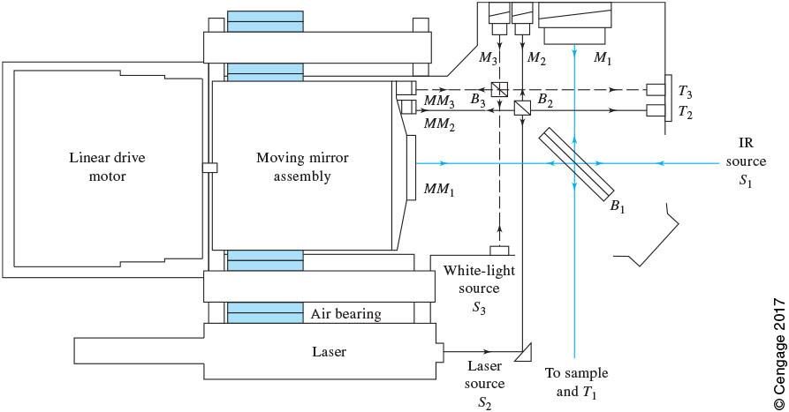

This FTIR instrument takes advantage of three Michelson interferometers to record three interferograms.

During its operation, the moving mirror assembly is moved. The beam from *S*1 is split in *B*1, reflected from fixed mirror *M*1 and movable mirror *MM*1, and the merged beams undergo interference between *B*1 and sample. This way, IR interferogram is created, which can later be converted to IR spectrum. *S*2, *B*2, *M*2, and *MM*2 are used to produce laser-fringe signal, to know the exact position of the moving mirror assembly. *S*3, *B*3, *M*3, and *MM*3 are used to record white light interferogram, to know the position of the moving mirror assembly that corresponds to zero retardation.

*S*1 – IR source used for recording IR interferogram/spectrum of the sample

*S*2 – laser source used to record laser-fringe signal, to know the exact position of the moving mirror assembly

*S*3 – white light source used to record white light interferogram, to know the position of the moving mirror assembly that corresponds to zero retardation

*M*1 – fixed mirror used for recording IR interferogram/spectrum of the sample

*M*2 – fixed mirror used to record laser-fringe signal, to know the exact position of the moving mirror assembly

*M*3 – fixed mirror used to record white light interferogram, to know the position of the moving mirror assembly that corresponds to zero retardation

*MM*1 – movable mirror used for recording IR interferogram/spectrum of the sample

*MM*2 – movable mirror used to record laser-fringe signal, to know the exact position of the moving mirror assembly

*MM*3 – movable mirror used to record white light interferogram, to know the position of the moving mirror assembly that corresponds to zero retardation

*B*1 – beamsplitter used for recording IR interferogram/spectrum of the sample

*B*2 – beamsplitter used to record laser-fringe signal, to know the exact position of the moving mirror assembly

*B*3 – beamsplitter used to record white light interferogram, to know the position of the moving mirror assembly that correspond如s to zero retardation