Chem 2210-02 Organic Chemistry

Exam 2
November 10, 2017
1. Write example for a stereoselective reaction, a regioselective reaction, and an stereospecific reaction. (9%)
Ans:
stereoselective reaction
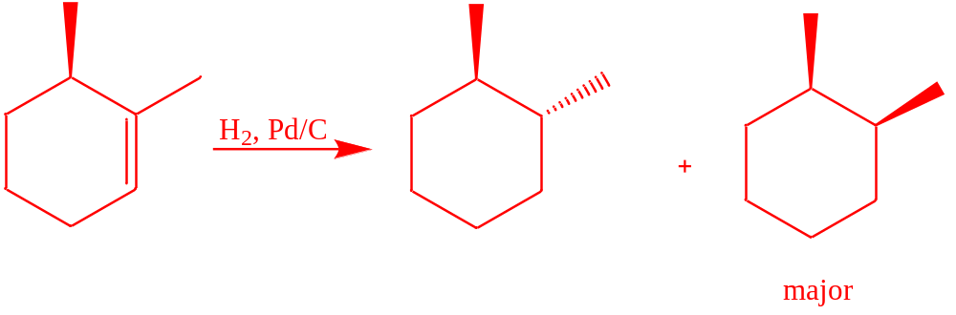
regioselective reaction
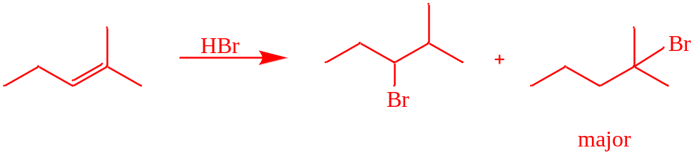
stereospecific reaction
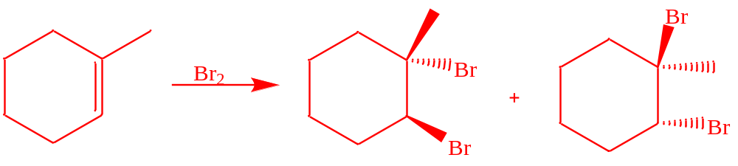
- A chiral compound A has a molecular formula C₅H₉Br with an S configuration at the chiral center. After hydrogenation, compound A was converted to a chiral product B. When compound A was treated with HBr, two dibromo compounds C and D were produced. Compound C is chiral and compound D is achiral. What are the molecular structures of A, B, C, and D? What is the relationship between C and D? (16%)
Ans:
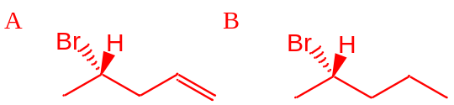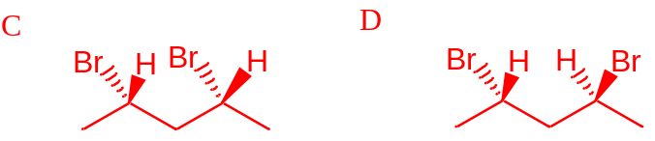
diastereomer

An optically active compound (E), C6H10, reacts with H2/Ni to produce compound (F), C6H14. (F) is optically inactive. Deduce the structures of (E) and (F). (8%)
Ans:
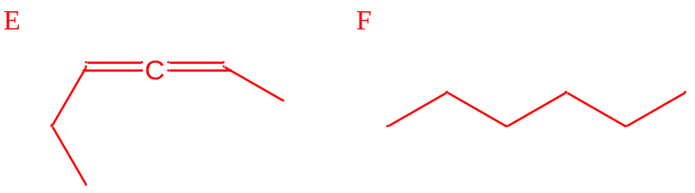
or
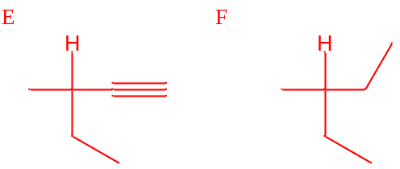
4. Which of the following carbocation(s) is/are likely to rearrange? Why. (5%)
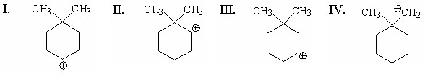
Ans: II、IV
Because II & IV are secondary and primary carbocation, they will rearrange to form more stable carbocations.

5. (a) Convert the following perspective formula to Fischer projection. Label each chiral carbon atom as (R) or (S). (5%)
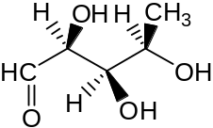
Ans:
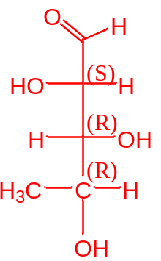

(b) Convert the following Fischer projection to perspective formula. Label each chiral carbon atom as (R) or (S). (5%)
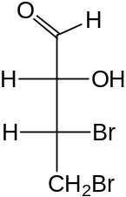
Ans:
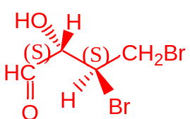

6. Which of the following compounds will react most rapidly with HCl? Give a brief reason for your prediction. (5%)
(a) 5-methyl-1-hexene
(b) 4-methyl-1-hexene
(c) (E)-5-methyl-2-hexene
(d) (E)-2-methyl-3-hexene
(e) 2-methyl-2-hexene

Ans: (e) 2-methyl-2-hexene
The 2-methyl-2-hexene will form tertiary carbocation intermediate, which has the lower energy. Therefore 2-methyl-2-hexene has lower activation energy, thus they would react more rapidly with HCl.

7. How many asymmetric centers are present in a molecule of 2,4,6-trimethylheptane? (3%)

Ans:0

8. Provide necessary reagent(s) to complete each of the following reactions. (18%)
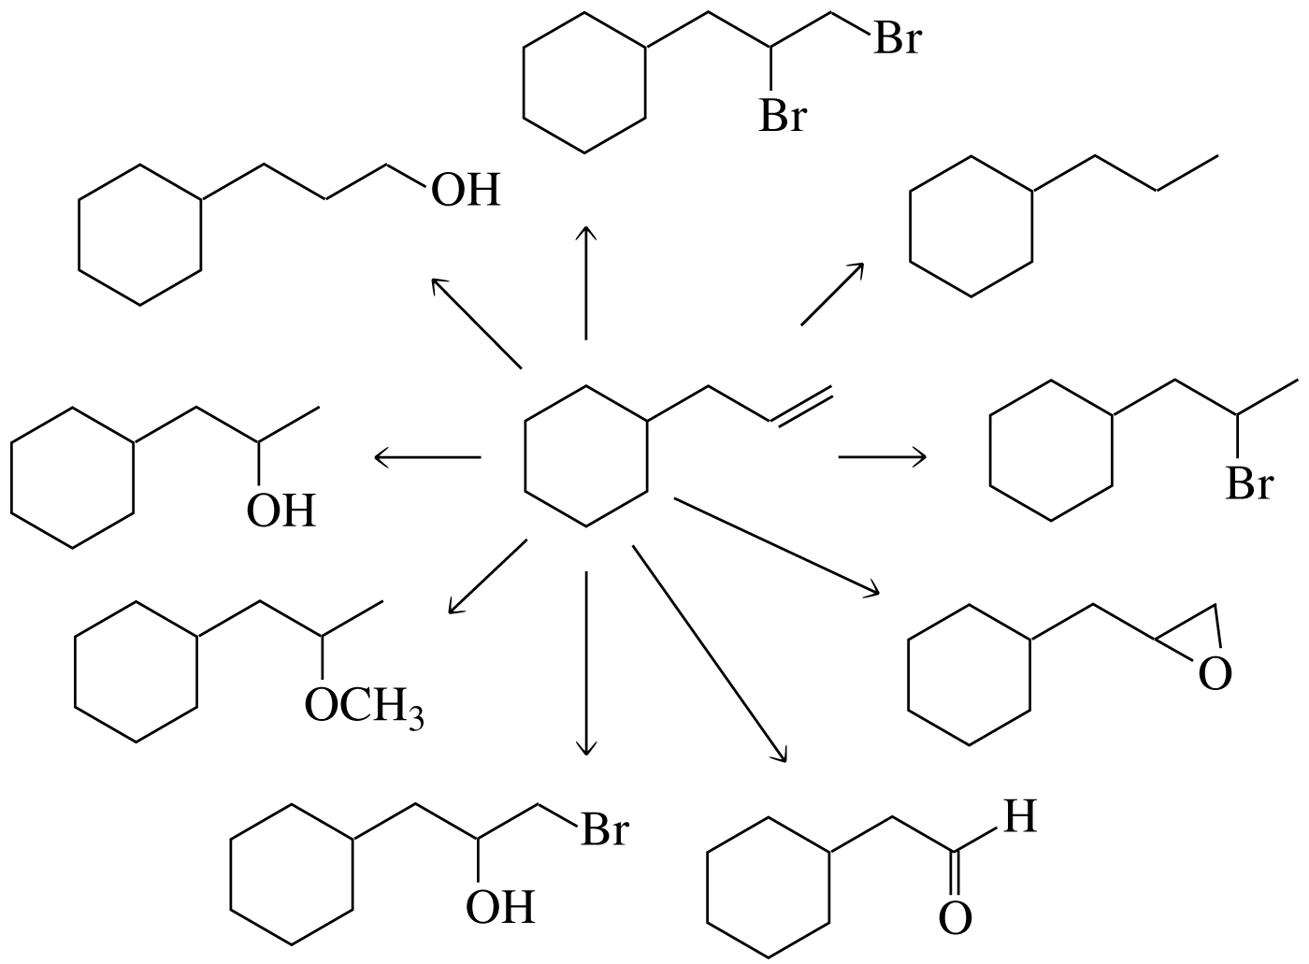

9. The specific rotation of (R)-(+)-glyceraldehyde is +8.7. If the observed specific rotation of a mixture of (R)-glyceraldehyde and (S)-glyceraldehyde is +1.4, what percent of glyceraldehyde is present as the S enantiomer? (3%)

Ans:41.955%

10. Propose a reaction mechanism for the following reaction. (6%)

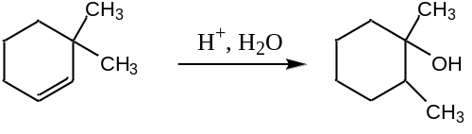
Ans:
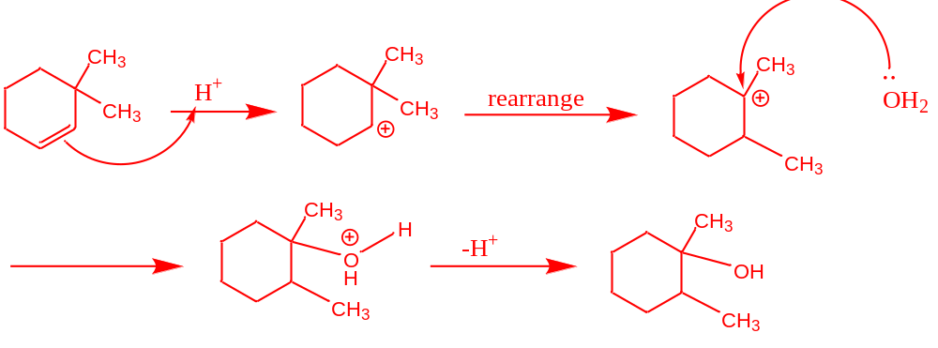

11. In a reaction in which reactant G is in equilibrium with product H at 25 °C, what relative amounts of G and H are present at equilibrium if ΔG° at 25 ºC is 2.72 Kcal/mol? Gas constant = 1.987 cal/mol ºK (3%)

Ans: G: H=100:1

12. How many of the following names are correct? Correct the incorrect names. (10%)
a. 3,4-dimethylpentane b. 2,8-dimethyl-4-ethylnonane c. 3,6,8-trimethyldecane
d. 2-chloropent-l-ene e. (3Z,6Z)-3,6-dimethyldeca-3,6-diene
Ans:
a. 3,4-dimethylpentane 2,3-dimethylpentane
b. 2,8-dimethyl-4-ethylnonane 4-ethyl-2,8-dimethylnonane
c. 3,6,8-trimethyldecane 3,5,8-trimethyldecane
d. 2-chloropent-l-ene correct
e. (3Z,6Z)-3,6-dimethyldeca-3,6-diene correct

13. Draw structures for the following: (4%)
a. (2E,4E)-l-chloro-3-methyl-2,4-hexadiene b. (3Z,5E)-4-methyl-3,5-nonadiene
Ans:
a.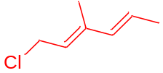 b.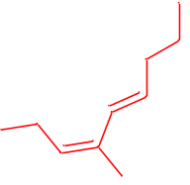

14. Identify two alkenes that react with HBr to form 1-bromo-l-methylcyclohexane without undergoing a carbocation rearrangement. (6%)
Ans:

