Chem 2210-02 Organic Chemistry

Exam 1
October 13, 2017
- (a) Draw the two chair conformations of cis-1,3-dimethylcyclohexane, and label all the positions as axial or equatorial.(2%)

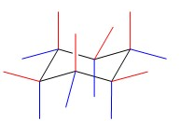 UP DOWN

(A) 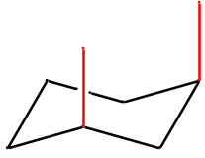 (B)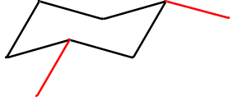

- Label the higher-energy conformation and the lower-energy conformation.(2%)

lower-energy conformation

higher-energy conformation

- The energy difference in these two conformations has been measured as about 5.4 kcal/mol. How much of this energy difference is due to the torsional energy of gauche relationships? (4%)

0.87 x 4 = 3.48 kcal/mole
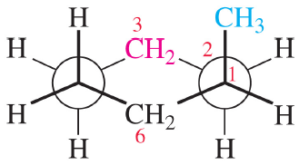

- How much energy is due to the additional steric strain of the 1,3-diaxial interaction? (4%)

5.4-3.48=1.92 kcal/mole
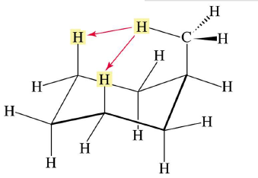

2. Draw the most stable conformation for each of cis- and trans-decalin. Use what you know about the conformational energies of substituted cyclohexanes predict which is the more stable isomer. How much energy difference between these two molecules? Give detail information. (9%)
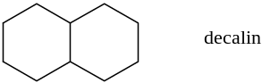

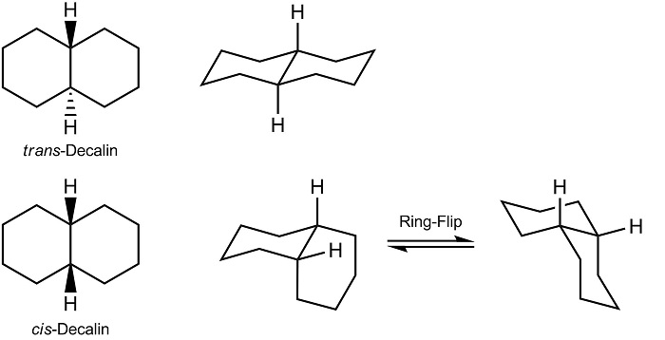

Trans-decalin is more stable

Energy difference : 3 gauche, 3x0.87=2.61 kcal/mole

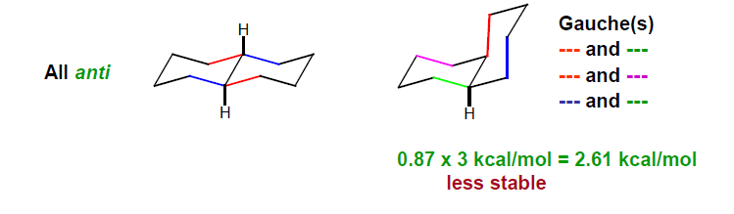

- Calculate the energy difference between the two chair conformations of trans-1,2-dimethylcyclohexane. (4%) (Note: gauche interaction between two methyl groups on cyclohexane is 0.87 kcal/mol)
4 gache – 1 gache = 3 x 0.87=2.61 kcal/mole
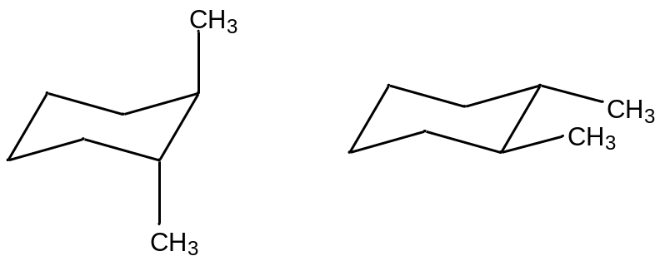

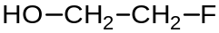
- Use Newman projection to draw totally eclipsed, eclipsed, gauche, and anti conformations for 2-fluoroethanol. Which conformer is the most stable one? Why? (12%)
------------------------------------------------------------------------------------
Total eclipsed eclipsed gauche anti
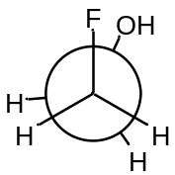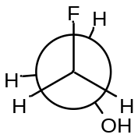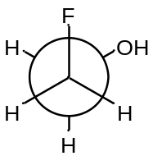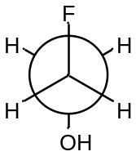

Stable
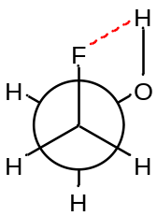分子內氫鍵 (Intramolecular Hydrogen Bond)

5. In which orbitals are the lone pairs in nicotine?(4%)

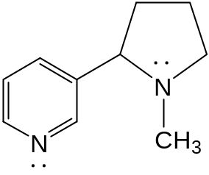
------------------------------------------------
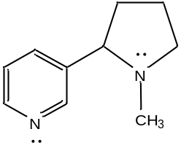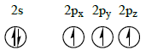
sp³
sp²

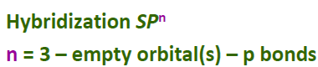
N: n= 3 – 0 – 1 = 2 sp²
N: n= 3 – 0 – 0 = 3 sp³

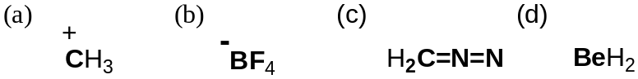
6. Predict bond angles for each of the following molecules, and hybridization of atoms in boldface. (24%)
----------------------------------------------------------------------------------------

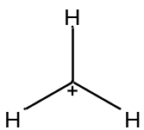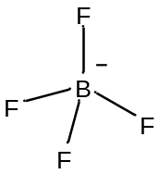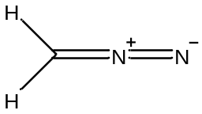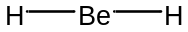

120º 109.5º 120, 180 180
sp² sp³ sp², sp , sp² sp

7. List the following acids in an order of decreasing acidity, and give a brief explanation for your arrangement. (6%)
-----------------------------------------------------------------------------------------------------
3 > 1 > 4 > 2 Inductive effect

8. (a) Rank the following species from strongest base to weakest base, and give a brief explanation for your arrangement. (6%)
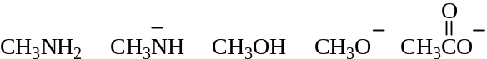

- Electronegativity O⁻ > N⁻
- The Brønsted-Lowry Acid Base Theory
Conjugate Acid : CH₃COOH > CH₃NH₃⁺
Therefore for the basicity : CH₃NH₂ > CH₃COO⁻

(b) Rank the following species from strongest acid to weakest acid, and give a brief explanation for your arrangement (6%)

- S的原子大小 > O原子大小，可以讓負電比較安定(delocaliz)
- 電負度O > N，故O可以讓電子比較安定，因此較酸
- 直鏈的烷類沒有電負度大的原子可以穩定負電，因此酸性很低

9. List the following compounds in an order of decreasing boiling point and give a brief explanation. (5%)
CH₃CH₂CH₂CH₂CH₃ CH₃CH₂CH₂CH₂OH CH₃CH₂CH₂CH₂Cl CH₃CH₂CH₂CH₂CH₂OH

- 碳鏈較長，鏈與鏈之間有較大的凡德瓦作用力
- OH相較Cl可以產生氫鍵，沸點較高
- Cl（dipole-dipole interaction）相較直鏈烷類（London Dispersion Force），有較大的極性

10. Give IUPAC name for each of the following molecules. (12%)

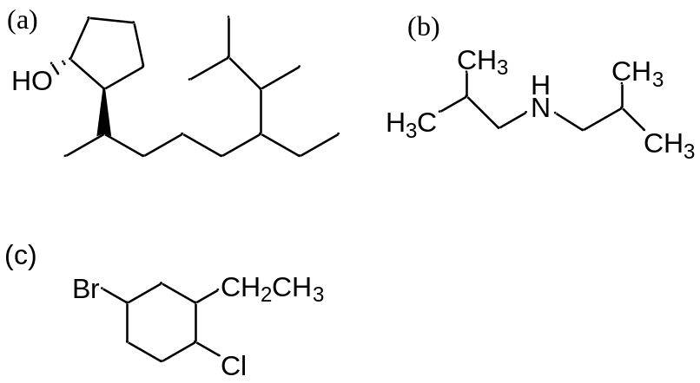

(a)
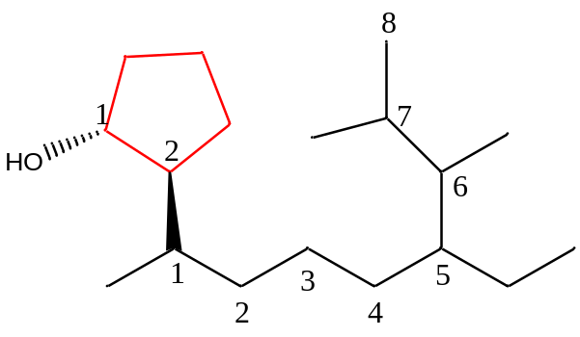
trans-2-(5-ethyl-1,6,7-trimethyloctyl)cyclopentanol

(b)
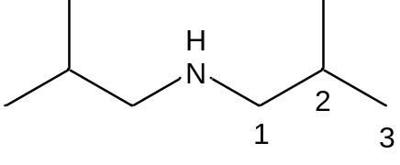
N,N-Bis(2-methylpropyl)amine

(c)
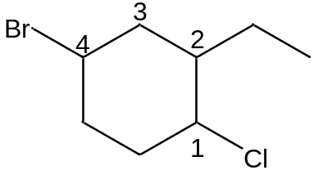
4-bromo-3-chloro-2-ethylcyclohexane

11. Give each labeled atom the appropriate formal charge. (6%)

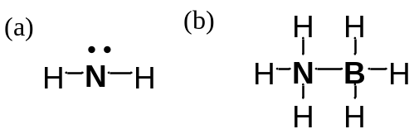

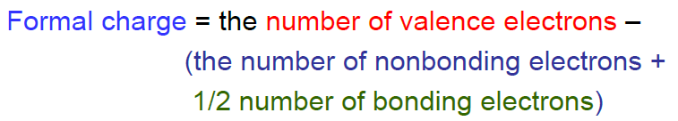
- 5 – ( 2 + 4x1/2) = +1
- N：5 – ( 0 + 8x1/2) = +1
B：3 – ( 0 + 8x1/2 ) = -1

