Name-Surname: Chiho Li ID: 64011378
Introduction to Computers and Programming, SE Programme
Direction Lab #6
13th September 2021
1. Write a Python function which takes a student’s marks and returns his/her grade according to this criteria:

A student will get A grade if 80 ≤ his/her marks ≤ 100
A student will get B grade if 70 ≤ his/her marks < 80
A student will get C grade if 60 ≤ his/her marks < 70
A student will get D grade if 50 ≤ his/her marks < 60
A student will get F grade if his/her marks < 50

def criteria(y):
if y in range(80,101):
return"Grade A"
elif y in range(70,80):
return"Grade B"
elif y in range(60,70):
return"Grade C"
elif y in range(50,60):
return"Grade D"
elif y in range(0,50):
return"Grade F"
print(criteria(int(input("Enter your score: "))))
ok

2. Write two Python functions, one function draws just a square of any size while the second function calls the first one in order to draw the following picture where X is any integer.
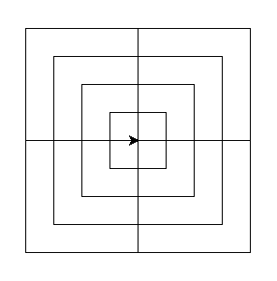
x
x
x
x

from turtle import *
speed(0)
def draw_square(y):
for i in range(4):
fd(y)
left(90)
def draw_pattern(z):
for i in range(4):
for x in range(1,5):
draw_square(z*x)
left(90)
draw_pattern(int(input("Enter size: ")))
done()

ok

3. Define a Python function draw_polygon to draw a polygon at given x and y positions. The function takes the size and the type (specified by the number of sides) of the polygon as only default arguments. If the size is not specified, the function draw a polygon of size 100 at the given x and y positions. In addition, if the type (specified by the number of sides) of the polygon is not specified, the function draws a square of a size at the given x and y positions.

Instruction Use the turtle module to define the function draw_polygon.

For example, draw_polygon(0,0) draws a square of size 100 at (0,0).

draw_polygon(10,10,5) draws a pentagon of size 100 at (10,10).

draw_polygon(10,10,5,200) draws a pentagon of size 200 at (10,10).

from turtle import *
def draw_polygon(x,y,side = 4, size = 100):
penup()
goto(x,y)
pendown()
for i in range(0,side):
fd(size)
left(360/side)
draw_polygon(0,0)
draw_polygon(10,10,5)
draw_polygon(10,10,5,200)
done()

ok

4. Write a Python function to compute the sum of all digits appearing in an integer.

For example, sum_of_digits(234) returns 9 (which is 2 + 3 + 4).

def sum_of_digits(x):
x = str(x)
sum = 0
for i in range(len(x)):
sum += int(x[i])
return sum
print(sum_of_digits(234))

ok

