Name-Surname: Chiho Li ID: 64011378
Introduction to Computers and Programming, SE Programme
Direction Lab #2
16th August 2021

1. Given w = 2, x = 3, y = 4, z = 5, write a Python expression to express , and write down the answer.

w = 2
x = 3
y = 4
z = 5
formula = (x * x * x) + y * (z / 2) - w
answer = formula
print(answer)

yes

2. Write a Python program that reads in the radius and length of a cylinder and computes its area and volume using the following formulas.

area = pi * radius * radius
volume = area * length

radius = int(input("Enter radius: "))
length = int(input("Enter length: "))
pi = float(3.14)
area = radius * radius * pi
volume = area * length
print(area)
print(volume)

yes

3. Please use turtle module and write Python statements to draw a shape below of size 100.

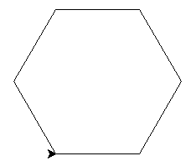
Size 100

import turtle
t = turtle.Turtle()
t.forward(100)
t.left(60)
t.forward(100)
t.left(60)
t.forward(100)
t.left(60)
t.forward(100)
t.left(60)
t.forward(100)
t.left(60)
t.forward(100)
t.left(60)
turtle.done()

yes

4. Write a Python program that prompts the user to enter the center and the radius of a circle, and then displays the circle and its area as shown. In this example, it shows a circle of radius 100.

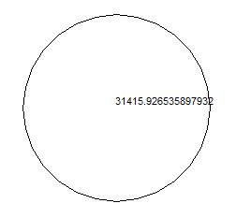

import turtle
t=turtle.Turtle()
radius = int(input("Enter radius: "))
t.circle(radius)
area = radius*radius*3.14
t.write(area)
turtle.done()
yes

