Name-Surname: Chiho Li ID: 64011378
Introduction to Computers and Programming, SE Programme
Direction Lab #13
22nd November 2021
1. Define a recursive function to check a membership in a list.

For example:
list_member(2, [1,2,3]) → True.

def list_member(x, num):
if len(num) == 0:
return False
elif x == num[0]:
return True
else:
return list_member(x,num[1:])
print(list_member(2, [1,2,3]))

ok

2. Define a recursive function to reverse a list.

For example:
list_reverse([1,2,3]) → [3,2,1].

def list_reverse(list):
if len(list) == 0:
return []
elif len(list) == 1:
return list
return [list[len(list) -1]] + list_reverse(list[:len(list)-1])
print(list_reverse([2,4,6]))

ok

3. Define a recursive function to calculate a greatest common divisor (gcd) of two numbers, x and y, by using this Euclid definition of gcd:

gcd(x,0) = x
gcd(x,y) = gcd(y, x mod y)

def gcd(x,y):
if y == 0:
print(x)
else:
return gcd(y,x % y)

ok

4. Define a recursive function to draw a cross. For example cross(100,4), it draws:

100
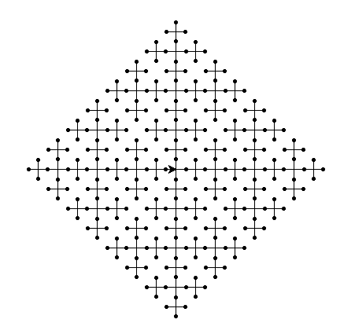

5. Subset sum problem is an important problem in complexity theory and cryptography. The problem is this: given a set of integers, is there a non-empty subset whose sum is zero? Write a recursive function to solve this problem.

Input: -7 -3 -2 5 7
Output: Yes, (-3,-2,5) (-7,7) (-7,-3,-2,5,7)

------------------------------------------------------

Input: 2 -3 5 8 11 23 -1
Output: No

