Name-Surname:Chiho Li ID: 64011378
Introduction to Computers and Programming, SE Programme
Homework #13
22nd November 2021
1. Write a recursive function to traverse and print a binary tree.

For example, print_btree( [1, [[11, [111, 112]], [12, [121, [122, [1221, 1222]]]]]], 0 ), it will print

1
. 11
. . 111
. . 112
. 12
. . 121
. . 122
. . . 1221
. . . 1222

The tree pattern of the first parameter is: [node, [left sub-tree, right sub-tree]]. The second parameter is a depth that the recursive function will use to count the number of dots when it prints out the result. At the beginning, this parameter will be set to zero and it will get increase incrementally when the function makes a recursive call to itself.

1  . 11  . . 111  . . 112  . 12  . . 121  . . 122  . . . 1221  . . . 1222 | Depth = 0, Root, Children = [ [11, ...], [12, ...] ]  Depth = 1, Left child, Children = [111, 112]  Depth = 2, Left child, Leaf  Depth = 2, Right child, Leaf  Depth = 1, Right child, Children = [ 121, [122, ...] ]  Depth = 2, Left child, Leaf  Depth = 2, Right child, Children = [1221, 1222]  Depth = 3, Left child, Leaf  Depth = 3, Right child, Leaf

2. Let f be the function on natural numbers defined recursively as follows:

f(0) = 0,
f(n) = 2 * f(n/2) + 1, if n > 0 and n is even
f(n) = 0, if n > 0 and n is odd

Write a Python function display_f(n), which given an integer n ≥ 0, prints out the value of f(0), f(1), …, f(n).

def display_f(n):
if n == 0:
return n
elif n > 0 and n % 2 == 0:
return display_f()
elif n > 0 and n % 2 != 0:
return display_f()
print(display_f())

3.1 Write a Python recursive function perm2(t) which, given a tuple t of numbers, prints out all possible pairs of distinct numbers in t. Each pair that is printed out may not contain duplicating numbers.

For example,
>>> perm2( (1,2,3) )
(1,2) (1,3) (2,1) (2,3) (3,1) (3, 2)

3.2 Write a Python recursive function perm3(t) which, given a tuple t of numbers, prints out all possible triples of distinct numbers in t. Each triple that is printed out may not contain duplicating numbers.

For example,
>>> perm3( (1, 2, 3, 4) )
(1,2,3) (1,2,4) (1,3,2) (1,3,4) (1,4,2) (1,4,3)
(2,1,3) (2,1,4) (2,3,1) (2,3,4) (2,4,1) (2,4,3)
(3,1,2) (3,1,4) (3,2,1) (3,2,4) (3,4,1) (3,4,2)
(4,1,2) (4,1,3) (4,2,1) (4,2,3) (4,3,1) (4,3,2)

3.3 Write a Python recursive function perm(t, n) which, given a tuple t of numbers and a number n ≥ 0, prints out all possible n-tuples of numbers in t. Each tuple that is printed out may not contain duplicating numbers. You may assume that n is no greater than the number of elements in t.

perm(t,2) should produce the same result as perm2(t).
perm(t,3) should produce the same result as perm3(t).

For example,
>>> perm( (1, 2, 3), 3)
(1,2,3) (1,3,2) (2,1,3) (2,3,1) (3,1,2) (3,2,1)

send help
4. Write a recursive program to solve the tower of Hanoi and draw an animation of it.

5. Write a program to display a recursive tree, as shown below.

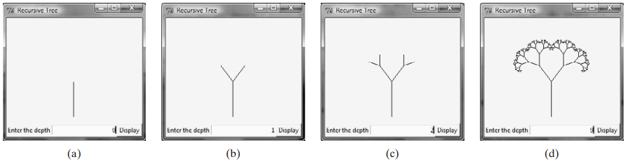

from turtle import *
def tree(length, order):
if length < (length / order):
return
forward(length)
left(45)
tree(length * 0.5, length / order)
right(90)
tree(length * 0.5, length / order)
left(45)
backward(length)
return
left(90)
tree(100, 4)
speed(0)
done()

