Name-Surname: ID:
Introduction to Computers and Programming, SE Programme
Direction Lab #9
11th October 2021
1. Write a program to create a graphical user interface (GUI) having a windows which contains a label for displaying a number on the left and three buttons on the right as follows:

- Count Up Button: The button with the text “+”. When the button is pressed, the number of the label on the left will be increased by one.
- Count Down Button: The button with the text “-”. When the button is pressed, the number of the label on the left will be decreased by one.
- Reset Button: The button with the text “Reset”. When the button is pressed, the number of the label on the left will be reset to zero.

The number of the label is initially set to “0”.

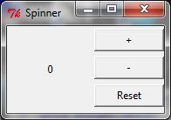
ok
from tkinter import *
class Spinner:
def __init__(self, window):
self.window = window
self.window.title("Spinner")
self.current_value = 0
self.sum_label = Label(self.window, text=self.current_value, width=40, height=10)
self.sum_label.grid(row=0, column=0, rowspan=3, columnspan=2)
self.add_button = Button(self.window, text="+", width=10, height=5, command=self.add_num)
self.add_button.grid(row=0, column=2)
self.minus_button = Button(self.window, text='-', width=10, height=5, command=self.minus_num)
self.minus_button.grid(row=1, column=2)
self.reset_button = Button(self.window, text="Reset", width=10, height=5, command=self.reset_num)
self.reset_button.grid(row=2, column=2)
def add_num(self):
self.current_value += 1
self.sum_label["text"] = self.current_value
def minus_num(self):
self.current_value -= 1
self.sum_label["text"] = self.current_value
def reset_num(self):
self.current_value = 0
self.sum_label["text"] = self.current_value
root = Tk()
Spinner(root)
root.mainloop()

2. Create an application to convert between two currencies: Thai Bahts and US Dollars (let’s assume that
1 USD = 30 THB).

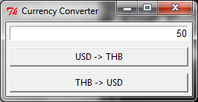

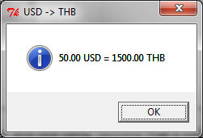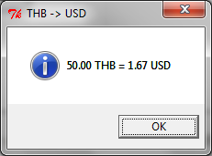

3. Create a simple freehand drawing program with a clear button when pressed, the drawings will be erased.

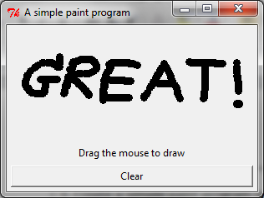

4. Write a program that draws a fixed rectangle with width 350 and height 200. If the left mouse is clicked inside the rectangle, display a circle with random colors at the current mouse pointer. If the left mouse is clicked outside the rectangle, display the message “Mouse pointer is not in the rectangle” in a dialog box.

