Name-Surname: ID:
Introduction to Computers and Programming, SE Programme
Homework #9
11th October 2021
1. Create a mobile phone user interface as follows.

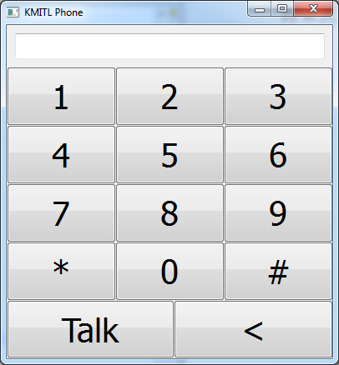
1) When pressing the buttons 0-9, *, and #, the number or the symbol will be appended to the display area on the top.
2) When pressing the “<” button, the rightmost character in the display area will be deleted.
3) When pressing the “Talk” button, a dialog that displays the message below will pop up:
“Dialling <<current number displayed>>”.

from tkinter import *
import tkinter.messagebox
root = Tk()
class General:
def __init__(self,root):
self.window = root
root.geometry("233x390")
root.title("KMITL Phone")
root.configure(bg="Grey")
self.phonenum=[]
self.displaybox = Label(root, width=31, text="".join(self.phonenum), bg = "white")
self.displaybox.place(x=5, y=5)
self.button_1 = Button(root, text="1", width = 9, height =4, command= lambda: self.add("1"))
self.button_1.place(x=5, y=28)
self.button_2 = Button(root, text="2", width=9, height=4, command=lambda: self.add("2"))
self.button_2.place(x=80, y=28)
self.button_3 = Button(root, text="3", width=9, height=4, command=lambda: self.add("3"))
self.button_3.place(x=155, y=28)
self.button_4 = Button(root, text="4", width=9, height=4, command=lambda: self.add("4"))
self.button_4.place(x=5, y=100)
self.button_5 = Button(root, text="5", width=9, height=4, command=lambda: self.add("5"))
self.button_5.place(x=80, y=100)
self.button_6 = Button(root, text="6", width=9, height=4, command=lambda: self.add("6"))
self.button_6.place(x=155, y=100)
self.button_7 = Button(root, text="7", width=9, height=4, command=lambda: self.add("7"))
self.button_7.place(x=5, y=172)
self.button_8 = Button(root, text="8", width=9, height=4, command=lambda: self.add("8"))
self.button_8.place(x=80, y=172)
self.button_9 = Button(root, text="9", width=9, height=4, command=lambda: self.add("9"))
self.button_9.place(x=155, y=172)
self.button_star = Button(root, text="*", width=9, height=4, command=lambda: self.add("*"))
self.button_star.place(x=5, y=245)
self.button_0 = Button(root, text="0", width=9, height=4, command=lambda: self.add("0"))
self.button_0.place(x=80, y=245)
self.button_sharp = Button(root, text="#", width=9, height=4, command=lambda: self.add("#"))
self.button_sharp.place(x=155, y=245)
self.button_call = Button(root, text="Call", width=14, height=4, command= self.calling)
self.button_call.place(x=5, y=316)
self.button_delete = Button(root, text="<", width=15, height=4, command=self.delete)
self.button_delete.place(x=115, y=316)
def add(self,data):
self.phonenum.append(data)
self.displaybox['text'] = "".join(self.phonenum)
def delete(self):
self.phonenum.remove(self.phonenum[-1])
self.displaybox['text'] = "".join(self.phonenum)
def calling(self):
tkinter.messagebox.showinfo("KMITL Phone",f"Dialling:{''.join(self.phonenum)}")
gui = General(root)
root.mainloop()

2. Create a GUI of your Python project and submit it as a homework No. 9.

from tkinter import *
root=Tk()
root.geometry("1000x200+200+200")
root.title("MusicPlayer")
frame = LabelFrame(root,text="Control",font =("Helvetica",16,"bold"),bg="lightgrey",fg="white")
frame.place(x=0,y=0,width=600,height=100)
Button1 = Button(frame, width=15, height=3,font =("Helvetica",10,"bold"),text="PLAY", bg="wheat",fg="white").grid(row=0,column=0,padx=10,pady=5)
Button2 = Button(frame, width=15, height=3, text="PAUSE",font =("Helvetica",10,"bold"), bg="turquoise", fg="white").grid(row=0,column=1,padx=10,pady=5)
Button3 = Button(frame, width=15, height=3, text="STOP",font =("Helvetica",10,"bold"), bg="cyan", fg="white").grid(row=0,column=2,padx=10,pady=5)
Button4 = Button(frame, width=15, height=3, text="UNPAUSE",font =("Helvetica",10,"bold"), bg="violet", fg="white").grid(row=0,column=3,padx=10,pady=5)
import_frame = LabelFrame(root,text="Add",font =("Helvetica",16,"bold"),bg="mediumslateblue",fg="white")
import_frame.place(x=0,y=100,width=600,height=100)
add_button = Button(import_frame, width=15, height=3,font =("Helvetica",10,"bold"),text="Add song", bg="lightgreen",fg="white").grid(row=0,column=0,padx=30,pady=5)
remove_button = Button(import_frame, width=15, height=3, text="Remove song",font =("Helvetica",10,"bold"), bg="lightblue", fg="white").grid(row=0,column=1,padx=30,pady=5)
clear_button = Button(import_frame, width=15, height=3, text="Clear",font =("Helvetica",10,"bold"), bg="pink", fg="white").grid(row=0,column=2,padx=30,pady=5)
playlist_frame = LabelFrame(root,text="Playlist",font =("Helvetica",16,"bold"),bg="hotpink",fg="white")
playlist_frame.place(x=600,y=0,width=600,height=200)
root.mainloop()

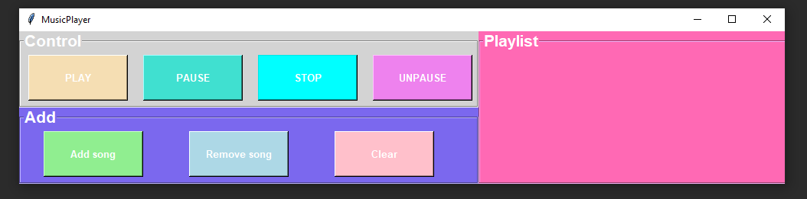

3. Write a program that displays a new circle at the position of the left mouse click and removes the circle at the position of the right mouse click.

from tkinter import *
root = Tk()
class General:
def __init__(self,root):
self.window = root
self.frame = Canvas(width = 700, height = 550)
self.frame.bind("<Button-1>", self.leftclick)
self.frame.bind("<Button-3>",self.rightclick)
self.frame.pack()
def leftclick(self,pos):
x = pos.x
y = pos.y
self.frame.create_oval(x-20,y-20,x+20,y+20,fill='green')
def rightclick(self,pos):
x = pos.x
y = pos.y
self.frame.delete(self.frame.delete(self.frame.find_closest(x,y)))
General(root)
root.mainloop()

