WHITE PAPER · THE AGRI-TOKEN EXCHANGE
AgriBridge
Crop in storage becomes money farmers can use
VERSION  1.0, October 2026 | NETWORK  Ethereum Sepolia testnet | LIVE DEMO  agribridge-lilac.vercel.app | STATUS  Working prototype, not audited

Summary
At harvest, many smallholder farmers must sell straight away, when prices are lowest, because they need cash and cannot borrow against the crop they hold. AgriBridge turns stored, graded crop into a digital warehouse receipt that a farmer can borrow against or sell, and lets investors fund those advances for interest.
A partner warehouse weighs and grades each delivery. The verification is approved by a multi-signature wallet (a Safe), the only party that can create crop tokens: one token for each kilogram, in a lot that records the crop, grade, warehouse and inspection evidence. With the tokens, a farmer can take a cash advance of up to 50% of the crop's value from a lending pool, or sell any part of the lot on a built-in market. Value falls as the crop ages, the contracts know it, and loans are settled automatically if they become unsafe.
The whole system runs today on the Ethereum Sepolia test network with play money: nine smart contracts, more than 250 contract tests (including fuzz and attack tests) and a web app for farmers, investors, buyers and the verifier team, tested end to end in the browser. Anyone can try it at agribridge-lilac.vercel.app with MetaMask.

1. The problem
Crops are seasonal, but a farmer's bills are not. Selling at harvest floods the market and pushes prices down, while storing the crop for a better price means waiting months without cash. Formal credit rarely reaches smallholders: banks see small loans, little collateral they can value, and high costs to check it.
Warehouse receipt systems answer part of this: crop held in a trusted warehouse becomes a receipt that can back a loan. In practice, paper receipts are hard to verify, easy to forge or pledge twice, slow to transfer, and they say nothing about how the crop's value falls as it ages. Lenders discount them heavily, and buyers cannot see what stock exists.
- Farmers need cash at harvest without selling at the lowest price.
- Lenders and investors need collateral they can verify, value and recover.
- Buyers, from processors to feed makers, need to see graded stock and buy exactly the quantity they want.
- Everyone needs a record nobody can quietly change.

2. How AgriBridge works
AgriBridge connects five parties through smart contracts. Each action is a transaction anyone can check on a public blockchain explorer.
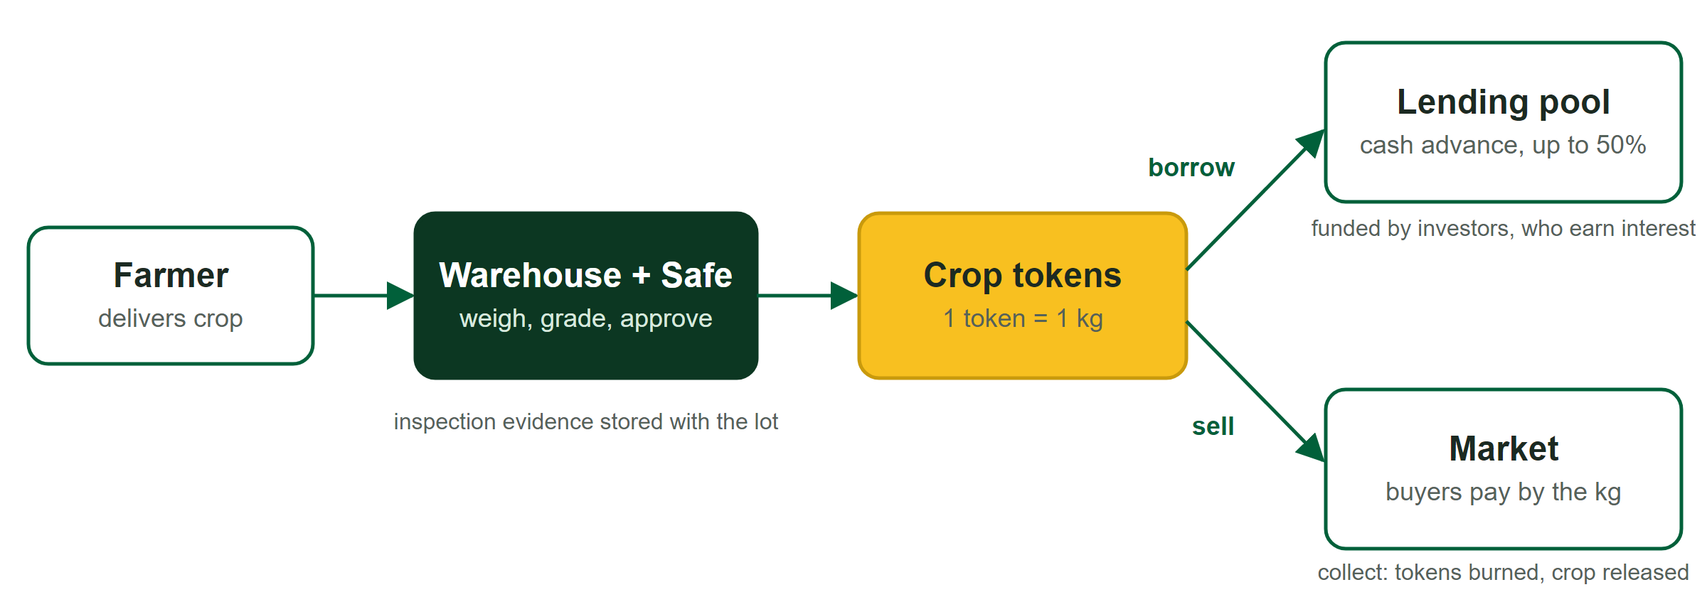
Figure 1. From a delivery to cash: the verified lot backs an advance or a sale.
Role | What they do
Farmer | Books a delivery, receives crop tokens once it is verified, then borrows against them, sells them, or collects the crop.
Verifier (the Safe) | The warehouse team. Weighs and grades each delivery and approves it. Every approval needs its owners' signatures. It also sets prices for the demo and manages warehouses and crop rules.
Investor | Deposits dollars (USDC) into the lending pool and earns the interest farmers pay, less a share kept as a loss cushion.
Buyer | Buys graded crop on the market by the kilogram, then collects it, has it delivered, or resells it.
Keeper | An automated job that settles unsafe or overdue advances, so the pool is protected even if nobody else acts.
Table 1. Who takes part.
A typical journey: a farmer delivers 1,000 kg of cocoa to the Ibadan warehouse; the warehouse grades it A and the Safe approves; the farmer receives 1,000 cocoa tokens for that lot; a cash advance arrives in the same session; later the farmer repays and the tokens come back, or sells part of the lot on the market. The warehouse releases goods only when tokens are handed back and burned, so tokens always match the crop in store.

3. Verified crop, on chain
Each delivery becomes a lot in the commodity registry: the crop, the warehouse, the estimated and measured weight, the grade at intake, the time of intake and a hash of the inspection report. The farmer requests intake; only the Safe can approve or reject it. On approval the registry mints ERC-1155 tokens for the lot, one per kilogram, and adds the weight to the warehouse's stock. A delivery that would exceed the warehouse's capacity is refused.
- One verifier. The verifier role can have exactly one holder, enforced by the contract itself: the AgriBridge Safe. No individual key can create crop.
- Withdrawals burn tokens. Collecting or delivering crop goes through the warehouse desk: the holder pays the storage fee, the Safe confirms the goods left, and the tokens are burned.
- A regulator can freeze. A frozen lot or warehouse cannot be borrowed against, sold, moved between users or collected, while the contracts can still hand tokens back to their owners. The role exists in the contracts and will be assigned after the demo.
- Six crops at launch: cocoa, rice, maize, cashew, yam and soybeans, each with its own rules (Table 2).

4. Valuing crop that ages
Stored crop loses value over time. AgriBridge builds this into every valuation, so a loan never assumes the crop will be worth tomorrow what it is worth today. The value of one kilogram is:
Value per kg = price × ageing factor × (1 − basis cut)
The price is the crop's price for grade A. The ageing factor starts at 100% for grade A and falls day by day to the grade B level (75%), then to the grade C level (40%), where it holds until the crop expires. A lot graded B at intake starts part-way along the curve. The basis cut removes transport, export and storage costs from world prices; crops priced locally have none.
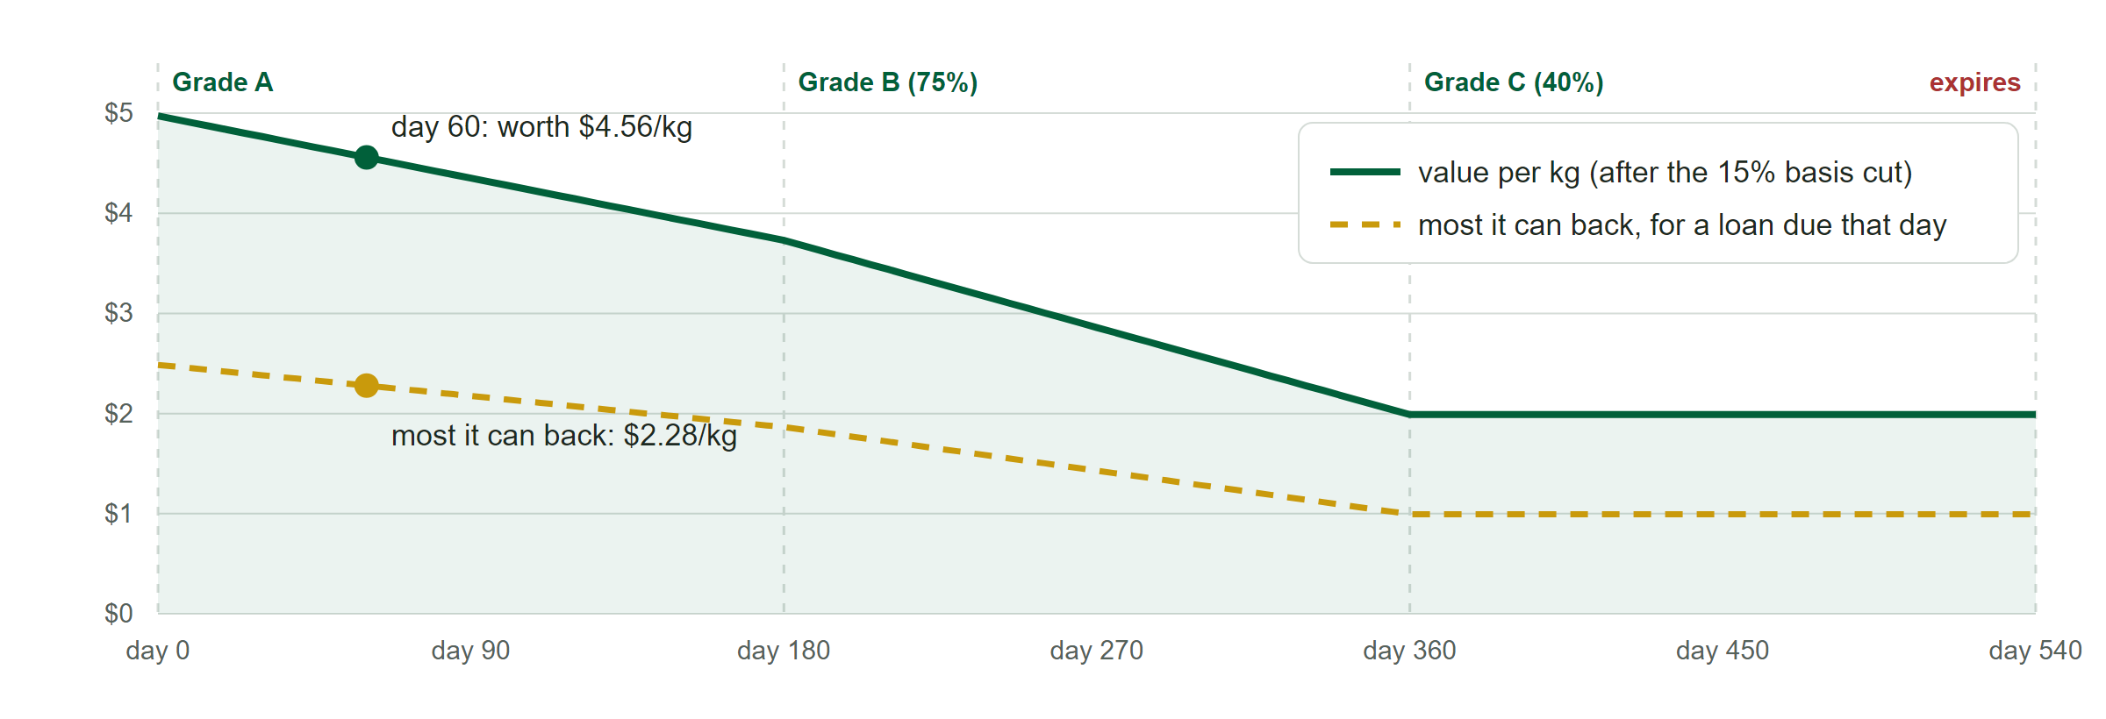
Figure 2. What 1 kg of grade A cocoa is worth as it ages, and the most a farmer can borrow against it.
Crop | Grade B from | Grade C from | Expires | Max advance | Basis cut | Storage / t / month
Cocoa | day 180 | day 360 | day 540 | 50% | 15% | $5
Rice | day 180 | day 360 | day 540 | 50% | 10% | $4
Maize | day 180 | day 360 | day 540 | 50% | 10% | $3
Cashew | day 270 | day 450 | day 720 | 50% | 0% | $5
Yam | day 60 | day 120 | day 180 | 40% | 0% | $4
Soybeans | day 180 | day 360 | day 540 | 50% | 10% | $3
Table 2. Crop rules at launch. These are starting values to be confirmed with a warehouse partner; the Safe can change them.
Worked example. 1,000 kg of grade A cocoa at $5.85 per kg is worth $5,850 on world markets, or $4,972 after the 15% basis cut. For a 60-day advance, the contracts value the lot as it will be on the day the advance is due (about 91.7% of today's value) and allow half of that: $2,279.

5. Cash advances and the lending pool
Investors deposit USDC into a single lending pool and receive pool shares. Farmers borrow from the pool against any part of a lot, for a term they choose (from one day up to 30 days before the crop expires). The limit is the crop's maximum advance (50%, or 40% for yam) of its value at the end date, so ageing during the loan is already priced in.
Rule | Setting
Interest rate | Moves with demand: 5% a year when little is lent, rising to 13% at 80% of the pool lent, and up to 23% when fully lent.
Interest for investors | Everything borrowers pay, less 20% kept as the pool's loss cushion (reserves).
Settlement point | When debt reaches 80% of the crop's current value, or the advance is more than 7 days overdue.
Settlement | Anyone may repay the debt and receive crop worth the debt plus 5%; whatever is left goes back to the farmer.
Losses | If crop does not cover a debt, the loss cushion pays first and investors only after it.
Repayment | Anyone can repay; interest accrues by the second; collateral returns in full when the debt is cleared.
Table 3. Lending rules.
Worked settlement. An advance of $2,000 is backed by crop worth $2,500. After a price fall, the debt reaches 80% of the crop's value. A settler repays the $2,000 and receives crop worth $2,100; the remaining $400 of crop goes back to the farmer. If nobody acts, the keeper settles the advance using the loss cushion. Settlement is partial by design: it takes only what covers the debt and the 5% reward.
Investor funds are protected by the accounting itself. The pool keeps its own books, so sending money to it directly cannot move the share price; interest is counted continuously, so depositing just before a large repayment earns nothing extra; and depositing and withdrawing in the same block is refused.

6. The market
The market lists every verified lot that is for sale, by crop, grade and warehouse, with the crop's ageing schedule shown next to its price. Tokens are held by the market while listed and pass to the buyer in the same transaction as the payment.
- Two kinds of price. A seller fixes a price per kilogram, or follows the market at a percentage of the crop's reference value (up to 200%), so the asking price moves with prices and ageing.
- Any quantity. Buyers buy any part of a listing at the quoted cost, with a price guard against changes while they decide.
- Bulk deals. A seller can offer a discount (up to 50%) on orders above a set weight, for large buyers.
- Fees. 1% of each sale goes to the AgriBridge treasury (the Safe).
- Collection. Buyers collect at the warehouse or pay for delivery; storage is charged by the day to whoever withdraws.
- Expired stock. Holders can sell expired crop to AgriBridge at 30% below its reference value, from a fund the Safe tops up. AgriBridge then lists it for feed makers, so nothing is left unsold.

7. Prices you can trust
Prices decide how much can be borrowed and when advances are settled, so they are the most attacked part of any lending system. AgriBridge never reads prices from its own market, which a buyer could move. Instead:
- World-price crops (cocoa, rice, maize, soybeans) are designed to use Chainlink Functions, taking the median of several price providers and requiring at least two.
- Local-price crops (cashew, yam) count a price only when two of three approved reporters agree within 5%, so one wrong report is outvoted.
- Move cap. A price move above 10% is held until a later update, at least ten minutes on, confirms it.
- Staleness and a circuit breaker. Each crop has a maximum age for its price; a stale price stops borrowing and settlement. Pausing the oracle stops every valuation at once.
- For the festival demo prices are set at deployment from current world prices and only the Safe can change them. The live feeds are built and tested, ready to switch on.

8. Security
Every defence below is in the code and backed by a named test. The contracts are a working prototype on a test network and have not been audited.
Threat | Defence
Reentrancy | Every function that moves money or tokens is guarded, and state is updated before anything leaves. An attack contract trying to re-enter during repayment makes the whole repayment fail.
Flash loans | No price comes from a market that borrowed money could move. Donations cannot change the share price, first-deposit inflation fails, and same-block deposit-and-withdraw is refused.
Oracle manipulation | Median of several sources, a 2-of-3 reporter quorum, a 10% move cap with confirmation, staleness limits and a circuit breaker.
Fake collateral | Only the single verifier Safe can create tokens, against weighed and graded crop with stored evidence, within warehouse capacity.
Admin keys | Every admin role sits with the Safe; the deployer gives up all roles at the end of deployment, which the deploy script checks.
Unsettled bad loans | A 20-point buffer between the 50% limit and the 80% settlement point, permissionless settlement, the keeper, and the loss cushion before investors.
Table 4. Threats and defences.
Testing covers unit and integration tests for each contract, fuzz tests of key properties (settlement never takes more than debt plus 5%; a deposit never moves the share price; tokens always match stored stock), an attack suite, a rehearsal of the full story on a copy of Sepolia, and 30 browser tests that drive every role through the app.

9. Built and running
The contracts are written in Solidity and built with Foundry. The web app is built with Next.js and React, signs people in with MetaMask, and works on phones through the MetaMask app. The verifier team uses a separate, hidden console that opens only inside Safe{Wallet}, so each approval is a Safe transaction that the owners sign.
Part | Detail
Contracts | Commodity settings, lot registry, crop tokens, price oracle, lending pool, pool shares, settlement keeper, market, warehouse desk.
Network | Ethereum Sepolia (test network), deployed 8 October 2026; all admin and verifier roles held by the Safe 0xDa15…de12.
App | agribridge-lilac.vercel.app: farmer, investor and buyer screens, market and activity record, and the verifier console.
First real lot | A 122 kg rice delivery, graded B at the Ibadan warehouse and approved by the Safe on Sepolia.
Table 5. What exists today.

10. Risks and limitations
- Physical risk. Loss, theft or mis-grading in a warehouse cannot be seen by a contract. It is handled off chain by the warehouse operator, insurance and audits; the contracts record evidence and can freeze stock.
- Starting numbers. Shelf lives, grade values, basis cuts and storage fees are placeholders until confirmed with a warehouse partner.
- No audit, no timelock. Admin actions take effect immediately once the Safe signs; a timelock is planned before real money.
- Fixed contracts. The contracts cannot be upgraded; a fix means redeploying and moving funds.
- Network fees. Each user pays a small network fee in their own wallet.
- One verifier team. Every delivery waits for the Safe's owners to sign. If they are unavailable, deliveries queue; more owners (2 of 3) reduce this.
- Stale prices pause lending. When a price is older than its limit, new advances and settlements stop until it is refreshed. This is safer than lending on an old price, but it needs a reliable feed.

11. Roadmap
Stage | What happens
Festival demo | The full story on Sepolia with play money: deliver, verify, borrow, sell, collect, settle.
Live prices | Switch on Chainlink Functions with chosen price providers, and appoint three local price reporters.
Governance | Assign the regulator role, add a timelock to admin actions, and move the Safe to 2 of 3 owners.
Pilot | Confirm crop rules with a warehouse partner, independent audit, then a small pilot with real crop on a low-fee network.
Table 6. Next steps.

12. Conclusion
AgriBridge shows that a warehouse receipt can be more than paper: verified by a multi-signature warehouse team, valued honestly as the crop ages, and usable at once for credit or sale, with every step on a public record. Farmers keep the choice of when to sell, investors fund real stored crop under clear rules, and buyers see exactly what is in the warehouses.
Try it at agribridge-lilac.vercel.app: sign in with MetaMask on Sepolia, take the farmer, investor or buyer role, and follow each step on the activity record.

Appendix: terms used in this paper
Term | Meaning
Safe | A wallet that needs several owners to sign before anything happens. AgriBridge's verifier and admin is a Safe, so no single person can create crop or change the rules.
Token | A digital record of ownership. Here one crop token stands for one kilogram of a specific verified lot in a specific warehouse.
Smart contract | A program on the blockchain that holds funds and follows fixed rules that everyone can read and nobody can quietly change.
USDC | A digital dollar. The demo uses a play-money version with no real value.
Sepolia | Ethereum's public test network: it works like the real network, but its money has no value.
Oracle | The contract that brings outside prices on chain, with checks against wrong or manipulated prices.
Loan-to-value | How much is owed compared with what the crop is worth. AgriBridge lends up to 50% and settles at 80%.
MetaMask | The wallet app people use to sign in to AgriBridge and approve each action.

