Bullet Hell Game with Arduino Tilting Controller

# Description

The purpose of this applications is to control a bullet hell game, in which player needs to evade upcoming bullets and survive as long as possible to score higher marks, using an Arduino controller.

In the bullet hell game, the movement of player can be controlled through tilting the Arduino controller leftwards or rightwards. The enemy spaceship, shown as blue triangle, will keep shooting bullets with variant speed towards player, shown as red circle, while it keeps moving across screen. If the player failed to dodge the bullets, game will end and player can choose to restart game by pressing Enter or upload score to cloud scoreboard by pressing Space.

Before uploading to scoreboard, player will be asked to type in their names. If the connection to database is failed, the error message will be displayed and game will restart automatically.

The scoreboard is available at:

<http://arduino-coursework.azurewebsites.net/>

# Set up

To run the application, first connect Arduino to USB port, then run the game source code using processing 2.2.1 with Firmata library and SQLi library installed (see reference). Please node the SQLi library does not work for processing 3.

The game will then start properly and user can control the movement of player by tilting Arduino controller.

# Game Control

Basic:

Tilt Arduino controller to the left - move left

Tilt Arduino controller to the right - move right

Game over:

Enter – restart

Space – upload score to scoreboard

Uploading:

Letters, numbers, spaces and backspaces – type name

Enter – start uploading

# Demo Video

Available at <https://youtu.be/t4THEHJvagc>

# Circuit

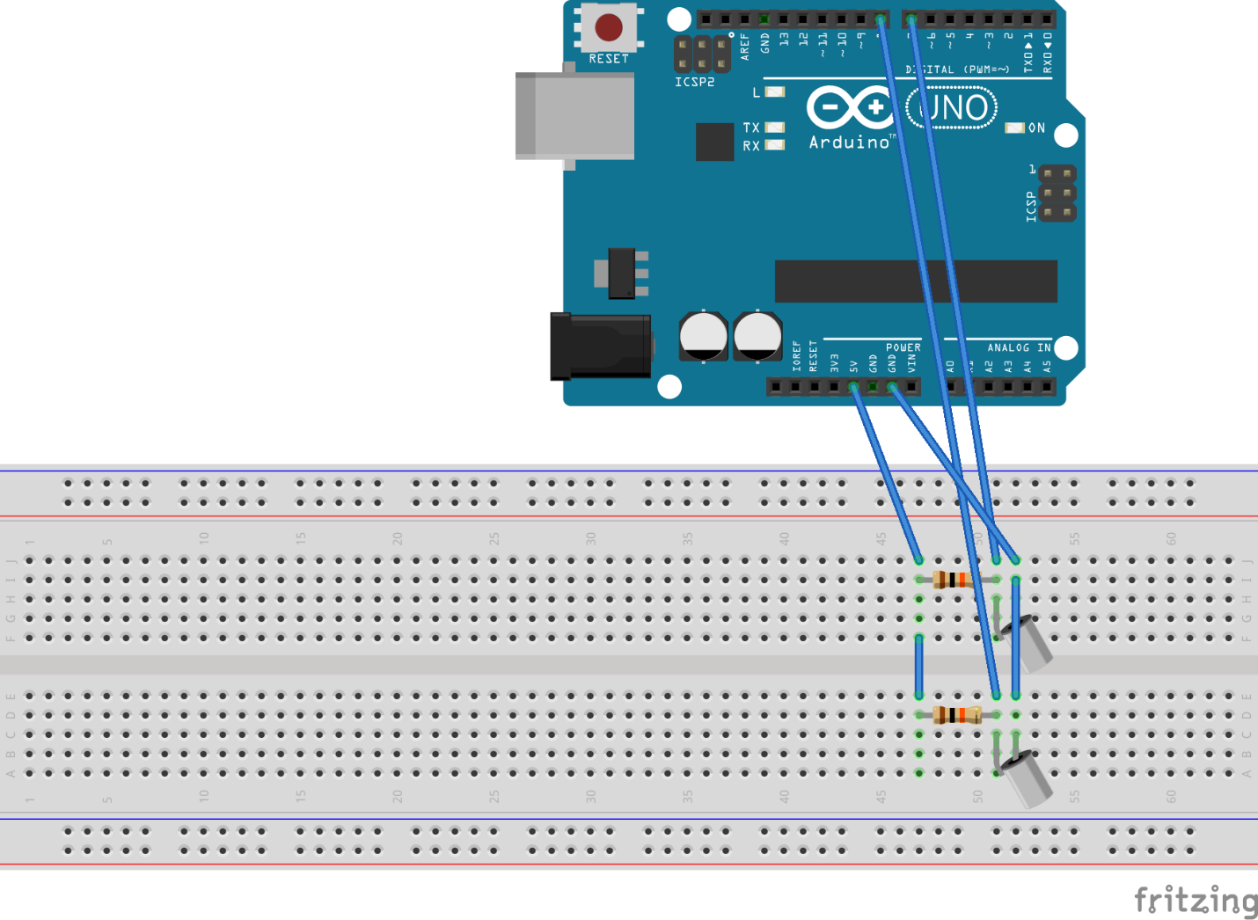 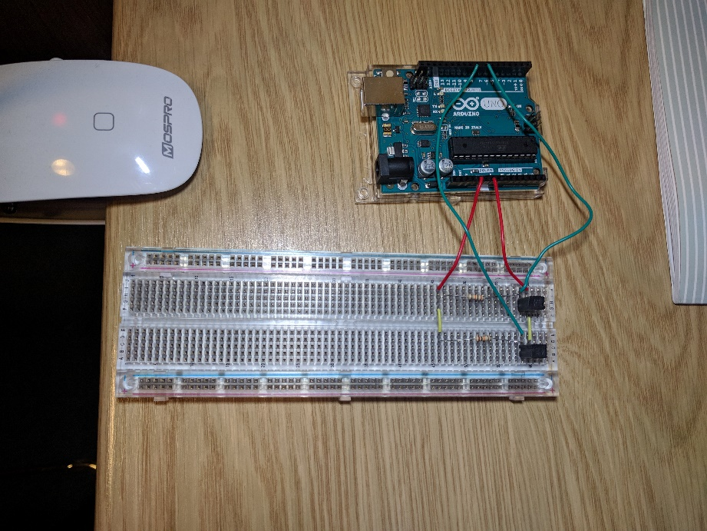

# OpenSCAD Arduino Case

The case includes two parts: the first part is the base to hold Arduino. It has raised blocks and cylinders corresponding to holes in Arduino UNO to hold it firmly.

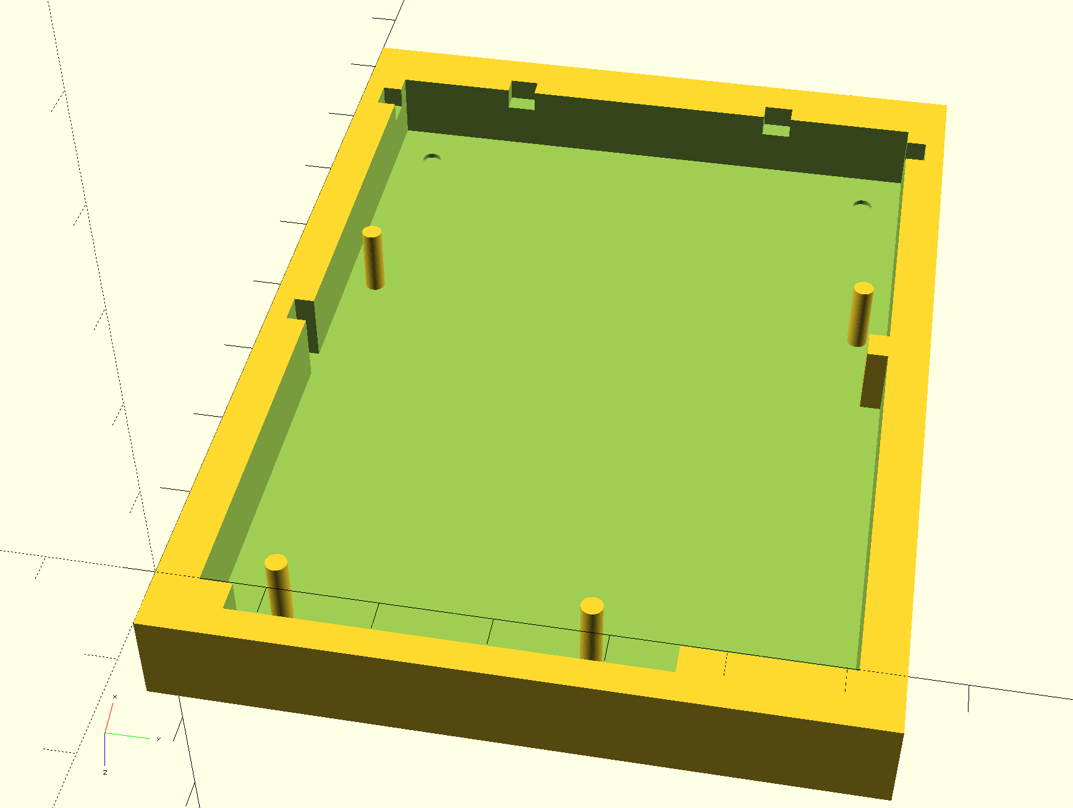

1

The second part can be attached to first part at the position labeled with 1. It covers the end of Arduino and prevents Arduino from slipping out, and since it’s slightly lower than height of the ports, it will not block the cables.

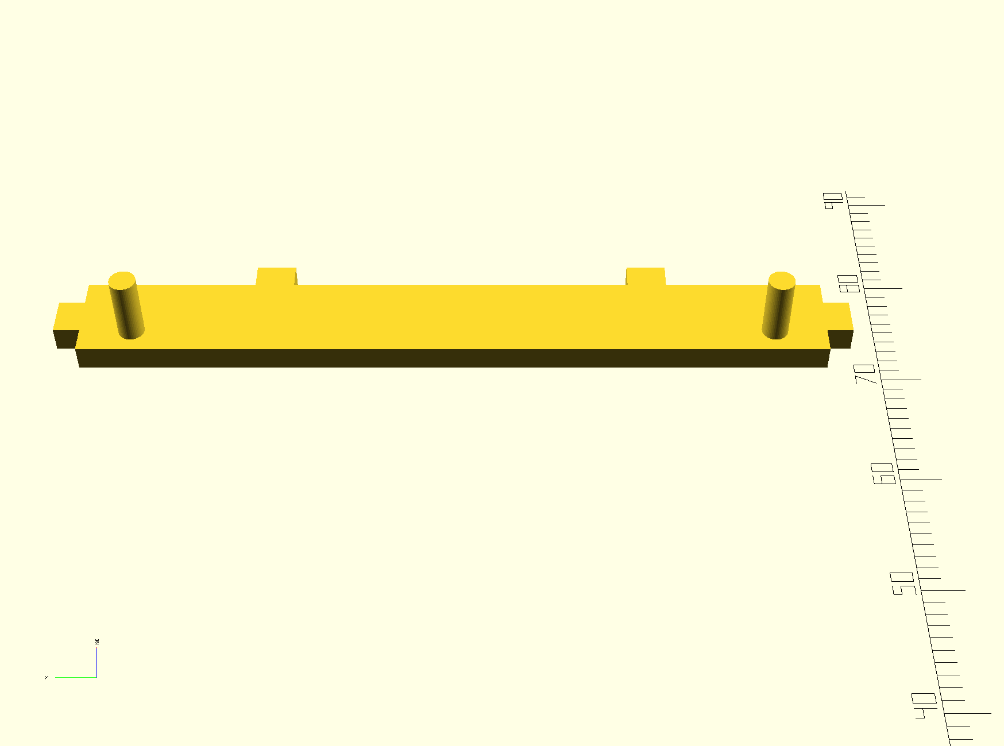

# Reference

Following library is used in this program:

Title: Firmata library for Processing

Author: soundanalogous

Date: 8 Nov 2016

Availabile at <https://github.com/firmata/processing/releases/tag/latest>

Title: SQLibrary

Author: fjenett

Date: 11 Apr 2013

Avaliable at <https://github.com/fjenett/sql-library-processing/releases>

To enable Processing Firmata library, the Arduino sketch StandardFirmata is uploaded to Arduino UNO. The sketch is obtained at Arduino IDE > Examples > Firmata > StandardFirmata.

The style of table used in online scoreboard webpage comes from <https://www.w3schools.com/html/tryit.asp?filename=tryhtml_table_intro>