Visual Analytics of Movie Dialogues

Chikaze Mori

City, University of London  
Student ID: 200038013

# Problem statement

The number of video contents provided by streaming services such as Netflix has significantly increased in the last decade, and further analyses on the data of these videos have become more demanded. The direct approach to such analysis of their content and inherent structure is watching the movie and taking notes, however, with the technological advances in the last decades, there are numerous semi- and fully automatic systems to help with the annotation and summarisation of movies [1].

With a focus on summarising movies, this study aims to answer the following questions:

1. Can we identify main characters of a movie and their relationships through network analysis?
2. How does visualising keywords by a word cloud helps us to understand the movie?
3. Is it possible to make a summary of a movie thorough sentiment and emotion analysis along with other analyses mentioned in the other questions?

This research will explore and summarise the movie ‘Harry Potter and the Philosopher’s Stone’ by applying visual analysis techniques to its dialogue, and its result is to provide a new way of understanding movies to the film industry. The dataset, which is a collection of dialogues of the movie, is suitable for answering my analytical questions, as it provides all the names of the characters and is temporal by nature. The dataset also covers what scene a dialogue belongs, which is desirable for our analysis as descriptive information is essential for a deeper analysis of movie content on a semantic level [1].

# State of the art

The purpose of movie summarisation is to provide information that helps users to understand the whole story of the movie efficiently while still keeping the content of the original movie [2][3]. The three previous empirical studies I have analysed, [4], [5] and [6], approach to content summarisation thorough different visual analytics techniques.

The datasets used in the three papers are dialogues in novels, movie information and viewer comments collected from a website, and movie reviews, which is all text-based and comes from the same domain, movie. Though the datasets are not movie dialogues, the papers are still to give us inspirations for our analysis, as analysing movie dialogues essentially is a branch of text analysis, in which techniques easily across other different domains.

The studies all vary in their questions to answer and their approaches. Waumans et al. [4] implemented network analysis on dialogues in popular novels to discover how the technique, social network analysis, can be applied to popular culture. They approached to this question by forming a network between each interaction of the characters, in this case, conversation. The context network was built using only the dialogs corresponding to a single conversation, for which the network is built. The key assumption of the research is that constructing social networks falls into the exploitation and successions of dialogs to automate the extraction in time of the nodes and the links. This type of networks can be used to analyse a precise sequence of storytelling [4], which is movie summarisation in other words.

Li et al. [5] approached differently and presented a movie recommendation application system focusing on building a word cloud based on movie comments from a movie information website as a new way of advertisement. They applied a token filter as a method of extracting keywords from comments to build a word cloud and deleted stop-words. In their research, it was shown that word cloud can help customers to recognise the movie without watching it, as a bigger size of a word in a word cloud represents a higher frequency appearance of the word [5].

Topal and Ozsoyoglu [6] took a different approach to analysis of movies. They argued that there is a better way for one to make a decision on which movie to watch next, and their research showed a solution which is an emotion map generated by analysing movie reviews with respect to their emotion content aggregated and projected onto a movie [6]. This work also inspires us to conduct sentiment analysis by each scene.

Despite the different analytical questions these studies answered, their methods are applicable to our analysis, as any of the objectives was to provide information about the contents and a new insight based on the analyses, which correspond to our goal. For instance, the technique of applying a token filter on movie comments to build a word cloud used by Li et al. [5] will aid our study, as it is directly applicable to movie dialogues which are also text-based data.

# Properties of the data

The dataset we use for our analysis is the dialogues of the movie ‘Harry Potter and the Philosopher’s Stone’, originally scraped from the DVD of the movie and published on Kaggle. The data is a CSV file, which contains the following columns:

* ID_number
* scene
* character_name
* dialogue

The column ‘ID_number’ is a numerical value and plays a role as an index of each line of dialogue, however, it is not semantic per se and can be removed during data pre-procession. The key columns for our analysis are ‘character_name’ and ‘dialogue’, which represent name of the character speaking the line of dialogue and the dialogue of the character respectively. These main columns are both text data. The column ‘scene’ indicates the scene number as stated on the DVD and can be used for sentiment analysis. For each column, there are 793 entries of data, and there is no missing value.

As the important part of the dataset is in string format, it is necessary to investigate the data properties in a different way from traditional summary of numeric statistics. In our exploratory data analysis, we investigate characters by the number of lines and words in the dialogues.

Figure 1

In figure 1, which shows the characters by the number of lines, Harry has by far the most lines followed by Ron and Hermione. It is also shown that most characters have less than 50 lines, despite the fact top ones have more than 100 lines.

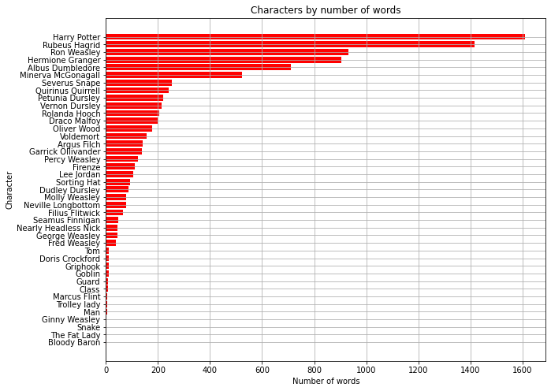

Figure 2

This extreme trend, that a few characters have most of the lines of the movie, is also found in figure 2, which is a list of the characters by number of words in the dialogues. The difference between the two figures is that some characters such as Rubeus rank higher in the figure 2. From this, we assume that the roles of those characters in the movie is important even though they do not appear as often as other main characters. Thus, it is important to look into these characters during our network analysis to see if they are more centred in the network despite their relatively small number of appearances. These figures are only to show the estimated importance of each character. Thus, network analysis is required to investigate the relationships of the characters.

As the lines of the characters are contained one by one in the dataset, we need to combine them into one and store it as a dialogue for the whole movie. By doing so, we can analyse the dialogue further with word cloud and sentiment and emotion analysis after applying a token filter to the dialogue as Li et al [5] suggested.

Since we have already known that a few characters are by far more important than others, we can assume analysing only those characters could be sufficient for summarisation of the movie. However, as only 40 characters appear in the dialogue, removing other characters in our network analysis is not necessary, although focusing on these characters in our emotion analysis would be better.

# Analysis

## Analysis Approach

In this section, the tasks we carry out to answer our analytical questions are explained, in order to show how the visualisation techniques that we use in the tasks help us to answer our questions along with human reasoning.

Figure 3

Figure 3 shows the diagram of our analysis workflow inspired by the work of Kohlhammer et al. [7]. The proposed analytical approach is split into five phases, including two tasks which are two visualization phases each followed by an analysis phase. The first step of our analysis is Preparation, where Exploratory data analysis and data pre-processing are conducted. EDA has already been done in the previous section. In this step, we tokenise the dialogues into words in order to extract keywords and remove stop-words such as ‘when’ or ‘and’, which allows us to efficiently apply techniques such as word cloud and sentiment analysis.

Our first task is to visualise network analysis of the characters and a word cloud of keywords of the movie, which is shown as the yellow circles in figure 3. The aim of this task is to show how these visualisation techniques can help us to answer our first and second analytical questions. Network analysis will be built by weighting the number of times that the characters interact in the dialogues, in order to provide us information about the relationships of the characters. After visualising network analysis, human reasoning is required to see how the analysis represents the movie through the characters and identify main characters who will be analysed in our second task. Although word cloud is to visualise words in different sizes by their frequencies, it is not semantic as it does not tell us the meaning of the words. Thus, human reasoning is also necessary for word cloud, especially in order to find some patterns in it.

The second task is visualisation of emotion and sentiment analyses, which is shown as the green circles in figure 3. Emotion analysis will be applied to the main characters identified in our first task and reveal their feelings, whereas sentiment analysis will allow us to highlight important moments or scenes of the movie. Both analyses are a powerful and useful tool, however, it is required to interpret the results of these analyses thorough human reasoning in order to answer our questions as the techniques are not meant to extract any meanings of the movie. For instance, semantic analysis would be able to point out which scene is important, while it cannot tell us the meaning of the scene, which is crucial for movie summarisation.

In the last phase, Summarisation, we extract the main results and summarise them to answer our third analytical question. The results and insights that we must have gained from the analyses would include the relationships and feelings of the characters, the keywords, and the sentiments by scene. The goals of this phase are to review our analyses and to see how well the results summarise the movie as a whole.

## Analysis Process

In this section, we will conduct the two tasks mentioned in the previous section to answer our analytical questions listed below:

1. Can we identify main characters of a movie and their relationships through network analysis?
2. How does visualising keywords by a word cloud helps us to understand the movie?
3. Is it possible to make a summary of a movie thorough sentiment and emotion analysis along with other analyses mentioned in the other questions?

### Preparation

Before tackling these questions, it is necessary to prepare the dataset for the following analyses. As mentioned in the previous section, it is necessary to tokenise the dialogues by applying a token filter for our analyses. Thus, we used a Python library, Natural Language Toolkit (NLTK), and tokenised all the dialogues in the dataset. Moreover, for word cloud analysis, we also categorised the tokenised words by parts of speech. For instance, ‘Harry’ is categorised as a singular proper noun, while ‘good’ is categorised as an adjective. This allows us to generate a word cloud that only includes proper nouns, which more likely are keywords than adjectives or adverbs.

### Task 1

Our first task consists of two analyses, network analysis and word cloud. We conduct network analysis first, and then word cloud.

We built networks of the characters by weighting interactions of the characters in the dialogues. For each conversation, we identified the two characters intervening, and formed a network between them based on the interaction. For example, if a dialogue of Harry Potter is followed by a dialogue of Ron Weasley, we consider this as a conversation between them and it will be counted as one interaction and a network between them will be built. In this way, the dialogues themselves are not analysed, however, it should not be a concern as our aim of network analysis is to discover the relationships of the characters and our following analyses will inspect the dialogues anyhow.

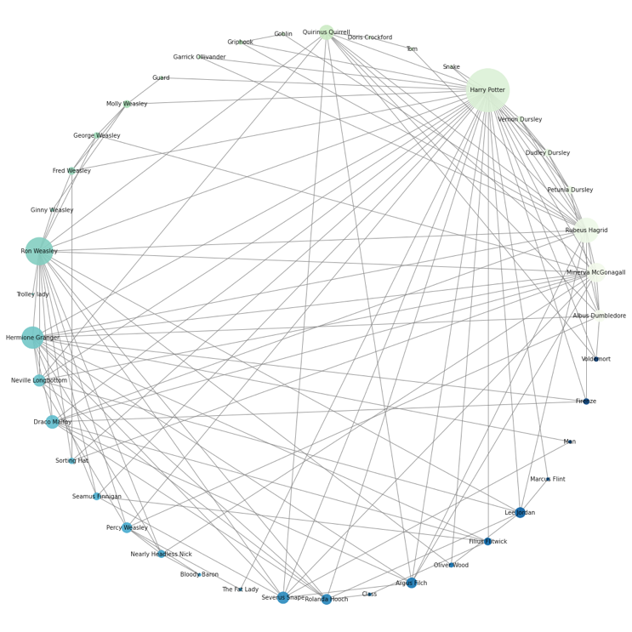

Figure 4 (Larger figure in appendices)

Figure 4 is the visualisation of our character network analysis. Each circle is a node which represents a character, and its sizes are based on degree centrality, where degree is the sum of nodes which are connected to a node [8]. The colours and positions of the nodes are based on the chronological order of the appearances of the characters, starting from Albus at the far right in pale green to Voldemort in indigo.

What is clear from this figure is that Harry is by far the biggest node and has the most connections with other characters, considering the intense concentration of the edges. Furthermore, it is shown that characters who have relatively bigger degree centrality such as Rubeus and Ron appear relatively early in the movie, which indicates that main characters appear in the early stage of the movie as they are the main characters.

Figure 5 (Larger figure in appendices)

As figure 4 is not a good representation of the relationships between the characters, we have visualised the network in another way, figure 5. In this figure, the distance between two nodes illustrates the strength of the relationship between the characters. It is clear that Harry is the centre of the network closely surrounded by the characters who have a big degree centrality, Ron and Hermione. Thus, we conclude that these characters are the main characters in the movie having Harry as the protagonist, which is consistent with our EDA and existing knowledge of the movie.

Word cloud, also known as tag cloud, is a text summarisation technique used in various contexts to provide an overview by distilling text down to those words that ap- pear with highest frequency [9]. By applying this technique to our dataset, those words that appeared most frequently in the dialogues are to be shown, and we can discover keywords of the movie.

Figure 6

Figure 6 is the word cloud of all the singular proper nouns in the dialogues. The biggest word is Harry, and many of other big words are also the names of the characters, while there are some big words that are not names of the characters, e.g., Hogwarts, Gryffindor, and Slytherin, which are the names of the school and houses. It is important to mention that some noticeably big words are the names of the characters that were not identified as a main character in the network analysis, such as Dumbledore and Snape. This suggests that these characters play a relatively important role in the movie despite their infrequent appearance. From all the above, we conclude that the keywords of the movie are Harry, the names of other main characters, and the name of their school, that is to say, the movie is about Harry, people around him, and their school life. Although we successfully extracted information from the word cloud, some adjustments are required as the word cloud is not the most desirable. For instance, we can see there is ‘Mr Potter’, whose meaning is the same as Harry despite the fact that these words are literally entirely different. Moreover, words such as ‘Hey’ or ‘Yay’ appear in the word cloud, although these words are not proper nouns.

### Task 2

Sentiment analysis is a language processing task that uses a computational approach to identify opinionated content and categorise it as positive, negative, or neutral [10]. We applied sentiment analysis to the tokenised dialogues that we generated in the previous section and visualised it by mean sentiment of each scene to understand the movie from the sentimental and temporal point of view.

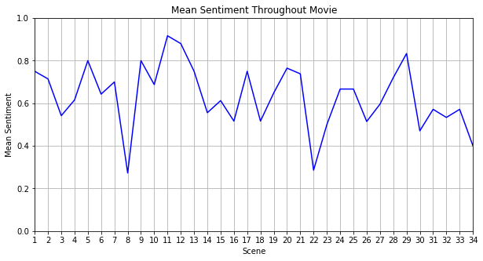

Figure 7

Figure 7 is the visualised result of the sentiment analysis, which shows two most negative points at 8 and 22, and two consecutive most positive points at 11 and 12. The first most negative point in the movie was scene 8, where Hagrid tells Harry how his parents were killed by Voldemort, which is undoubtedly a quite negative scene based on our prior knowledge of the movie. The second most negative point, scene 22, however, is where Harry overhears the conversation between Snape and Quirrell, which is not negative as scene 8. The two most positive scenes, 11 and 12, are where the main characters arrive in Hogwarts and Harry is sorted into Gryffindor. These scenes are one of the most positive moment in the movie, however, scene 29, which is shown the third most positive in figure 7, is definitely not a positive scene as it is where Ron sacrifices himself in the chess game. Sentiment analysis, on the whole, helped us to understand the transition of sentiment in the movie and point out key scenes, however, some scenes showed significant sentiment despite that they are not very sentimental. Furthermore, sentiment analysis is not a tool that takes temporality into account. For instance, a climax scene is usually the most sentimental scene of a movie as the story goes and the emotions of the characters pile up towards the finale, however, this nature of a movie is not concerned in sentiment analysis.

Emotion analysis is an important method for automatic mining and analysis of subjective information, such as views, opinions, emotions, and likes and dislikes in texts [11]. It is similar to sentiment analysis but different in a way that it is more sophisticated and complex as it specifies kinds of emotions. In addition to sentiment analysis, we also conducted emotion analysis to take a closer look at the emotions in the movie.

Figure 8

Figure 8 shows the emotions in the movie by number of appearances. Besides neutral, the most common emotion is worry, followed by empty. As this graph does not contain much information by itself, we conduct another emotion analysis which focuses on the emotions of the main character for comparison.

Figure 9

Figure 9 is the visualisation of emotions of the main characters. As the characters have different number of dialogues, the counts of appearances of emotions are normalised to allow us to compare them. It is clear that the main emotions of the main characters correspond to the ones in the entire movie, that is to say, these characters are the ones that represent the movie. For each character, there are key emotions that distinguish the character from others. For instance, Harry has emotions of neutral and empty more than others, which corresponds to his role as a protagonist who lost his parents. On the other hand, Ron feels relieved more often than others, which is consistent with our prior knowledge of the movie.

Along with the other analyses, sentiment analysis and emotion analysis helped us to understand the movie better. In another words, it was shown that those analyses were able to summarise the movie in accompany with the other analyses. Thorough all the analyses, we discovered the relationships of the main characters, their emotions, and the keywords and key scenes of the movie. All the analyses worked well as a cohort and provided the information that is sufficient to summarise the movie.

## Analysis Results

Through the network analysis, the main characters of the movie including the protagonist were identified, and their close relationships were also discovered. This finding answered our first analytical question and demonstrated the superior ability of network analysis over simply looking at quantity of dialogues, as it also shows distances between characters. Another key finding was how effective word cloud is for picking up keywords and understanding a movie, which answered our second question. Lastly, sentiment and emotion analyses discovered the key scenes of the movie and the main emotions of the main characters. In conclusion, all the analyses helped us to summarise the movie, which answers our third question.

Our approach to the research questions and the techniques we applied are to help those who in the film industry to summarise and analyse the movie. For instance, as the work of Li et al. [5], we can build a movie recommendation application system that provides more than ratings and comments about the movie by using word cloud and help audiences find the movie they are interested in. Moreover, film makers can follow our approach and criticise a movie to reduce a risk of leading a project that might fail.

# Critical reflection

Our word cloud allowed us to successfully extract the keywords of the movie, however, the performance was not most desirable as some words were not properly categorised. To solve this problem, more sophisticated and suited methods of lemmatisation could have been applied, even though we automatically conducted stemming in the process of tokenisation by using NLTK and it is almost impossible to categorise all the words perfectly because of the nature of the dataset which is a dialogue of a fantasy movie.

The most effective analysis was network analysis, as it identified the protagonist and the other main characters, their relationships, and the strengths of them, which are all important information of the movie. The network analysis visualised in a circle, figure 4, also included time-related information, which is the order of appearances of the characters. However, in a movie, main characters often appear in an early stage of the movie, and figure 5 did not take this into account, as it was only about the orders of the appearances. Thus, some modification would be beneficial for us to extract more information, e.g., instead of the orders, we can colour and locate the characters based on the scene number where they appeared, which makes the data temporal and allows us to investigate the phenomenon that main characters appear in an early stage.

Thorough the analyses, we were able to extract the key information and summarise the movie, however, the part of the reasoning that depended on our domain knowledge was not small. This was most likely inevitable as we only used the dialogues of the movie for the analyses. For instance, we could analyse the dialogues of the other movies in the same series and compare the results to identify main characters and their emotions throughout the series. In this way, we could build a bigger character network and discover dynamics of character relationships and later focus on the small network of the main characters. Moreover, using movie scripts as a dataset instead of dialogues would simply be beneficial, as they contain more information than dialogues such as where each scene is taken. To significantly increase the potential of extracting more information of the movie, video data can be a good dataset, as it contains auditory and visual data, although analysis would be more complicated.

On the other hand, it is possible to generate the same quality of movie summarisation even without prior knowledge of the movie as with the knowledge. For instance, we concluded that the main characters of the movie were Harry, Ron, and Hermione, as it corresponds to our domain knowledge, however, this conclusion could be led solely by the analyses by comparing and reasoning the results. That is to say, our visual analytics approach to movie summarisation was successful and addressed the research questions.

##### References

1. K. Kurzhals, M. John, F. Heimerl, P. Kuznecov, and D. Weiskopf, ‘Visual Movie Analytics’, *IEEE Transactions on Multimedia*, vol. 18, no. 11, pp. 2149–2160, Nov. 2016, doi: [10.1109/TMM.2016.2614184](https://doi.org/10.1109/TMM.2016.2614184).
2. B. Chen, J. Wang, and J. Wang, ‘A Novel Video Summarization Based on Mining the Story-Structure and Semantic Relations Among Concept Entities’, *IEEE Transactions on Multimedia*, vol. 11, no. 2, pp. 295–312, Feb. 2009, doi: [10.1109/TMM.2008.2009703](https://doi.org/10.1109/TMM.2008.2009703).
3. Q. D. Tran, D. Hwang, L. O-Joun, and J. E. Jung, ‘Exploiting character networks for movie summarization’, *Multimedia Tools and Applications*, vol. 76, no. 8, pp. 10357–10369, Apr. 2017, doi: <http://0-dx.doi.org.wam.city.ac.uk/10.1007/s11042-016-3633-6>.
4. M. C. Waumans, T. Nicodème, and H. Bersini, ‘Topology Analysis of Social Networks Extracted from Literature’, *PLOS ONE*, vol. 10, no. 6, p. e0126470, Jun. 2015, doi: [10.1371/journal.pone.0126470](https://doi.org/10.1371/journal.pone.0126470).
5. T. Li, Y. Chen, and C. Zhang, ‘A Novel Word Cloud Graph System Design for Movie Comments’, in *2018 International Conference on Cloud Computing, Big Data and Blockchain (ICCBB)*, Nov. 2018, pp. 1–5, doi: [10.1109/ICCBB.2018.8756457](https://doi.org/10.1109/ICCBB.2018.8756457).
6. K. Topal and G. Ozsoyoglu, ‘Movie review analysis: Emotion analysis of IMDb movie reviews’, in *2016 IEEE/ACM International Conference on Advances in Social Networks Analysis and Mining (ASONAM)*, Aug. 2016, pp. 1170–1176, doi: [10.1109/ASONAM.2016.7752387](https://doi.org/10.1109/ASONAM.2016.7752387).
7. J. Kohlhammer, D. Keim, M. Pohl, G. Santucci, and G. Andrienko, ‘Solving Problems with Visual Analytics’, *Procedia Computer Science*, vol. 7, pp. 117–120, Jan. 2011, doi: [10.1016/j.procs.2011.12.035](https://doi.org/10.1016/j.procs.2011.12.035).
8. Y. Yustiawan, W. Maharani, and A. A. Gozali, ‘Degree Centrality for Social Network with Opsahl Method’, *Procedia Computer Science*, vol. 59, pp. 419–426, 2015, doi: <https://doi.org/10.1016/j.procs.2015.07.559>.
9. F. Heimerl, S. Lohmann, S. Lange, and T. Ertl, ‘Word Cloud Explorer: Text Analytics Based on Word Clouds’, in *2014 47th Hawaii International Conference on System Sciences*, Jan. 2014, pp. 1833–1842, doi: [10.1109/HICSS.2014.231](https://doi.org/10.1109/HICSS.2014.231).
10. V. K. Singh, R. Piryani, A. Uddin, and P. Waila, ‘Sentiment analysis of movie reviews: A new feature-based heuristic for aspect-level sentiment classification’, in *2013 International Mutli-Conference on Automation, Computing, Communication, Control and Compressed Sensing (iMac4s)*, Mar. 2013, pp. 712–717, doi: [10.1109/iMac4s.2013.6526500](https://doi.org/10.1109/iMac4s.2013.6526500).
11. D. Xu, Z. Tian, R. Lai, X. Kong, Z. Tan, and W. Shi, ‘Deep learning based emotion analysis of microblog texts’, *Information Fusion*, vol. 64, pp. 1–11, Dec. 2020, doi: [10.1016/j.inffus.2020.06.002](https://doi.org/10.1016/j.inffus.2020.06.002).

##### Word counts

|  |  |
| --- | --- |
| Section | Word counts |
| Problem statement | 249/250 |
| State of the art | 500/500 |
| Properties of the data | 500/500 |
| Analysis Approach | 496/500 |
| Analysis Process | 1472/1500 |
| Analysis Results | 199/200 |
| Critical reflection | 468/500 |

Appendices

Data : <https://www.kaggle.com/eward96/harry-potter-and-the-philosophers-stone-script>

Larger figure of the character network analysis in a circle form (Figure 4):

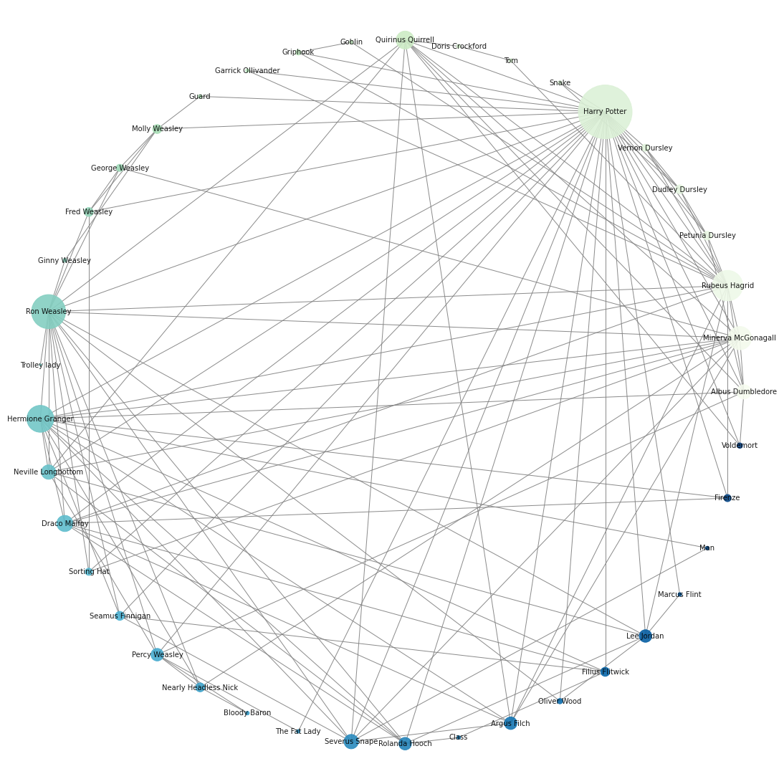

Larger figure of the character network analysis (Figure 5):

