TechBridge Data Analytics Internship — Task 8

Retail Sales Performance Analysis

Project Objective
To use the raw data to understand the sales performance and customer activity of the company; cleaning the data, combining the related tables, analysing the sales information, creating visualizations, and using SQL to answer business questions.

Dataset Description
There are three datasets: Customers, Products, and Transactions.
The Customers dataset has three columns: CustomerID, City, and CustomerType, and 20 rows.
The Products dataset has four columns: ProductID, ProductName, Category, and UnitPrice, and 10 rows.
The Transactions dataset has six columns: TransactionID, CustomerID, ProductID, TransactionDate, Quantity, and Discount, and 150 rows.
The three datasets are connected together with three of the columns: CustomerID and ProductID.
Important fields for our analysis are CustomerID, CustomerName, CustomerType, City, ProductID, ProductName, TransactionDate, UnitPrice, and Quantity.

Data Cleaning
- In the transaction table, there is an unmatched CustomerID (C999) which isn’t in the Customer table. I deleted the row with the customerID C999, because the ID doesn’t exist in the Customer table; it is an error entry.
- There are no duplicate rows found in each dataset table.
- There were no missing values or blank cells.
- Used the TRIM function to remove spaces.
- In the transaction table, there is an unmatched ProductID (P999) which isn’t in the Product table. I deleted the row with the ProductID P999, because the ID doesn’t exist in the Product table; it is an error entry.
- Corrected cell format and data types to ensure consistency and accurate analysis.
- In the Transaction table, in the Quantity field there is -2 value for transaction T0120. This could imply that 2 items were ordered but not delivered to the customer, or that two items were delivered but the prices were not paid for by the client. I have decided to flag it as an invalid record; for management to review. But I have to remove the row because it would affect my final analysis, especially the product category (giving a -900,000.00 value for laptop sold for T0120).

BUSINESS ANALYSIS

Question 1 — Total Revenue

Business question:
What is the total revenue generated from all transactions?
Answer: #42,013,200.00

Question 2 — Total Transactions

Business question:
How many transactions were recorded?
Answer: 147 transactions.

Question 3 — Total Quantity Sold

Business question:
How many units of products were sold?
Answer: 447 units of products sold.

Question 4 — Best-Performing Product

Business question:
Which product generated the highest revenue?
Answer: Monitor has the highest revenue with #7,992,000.00
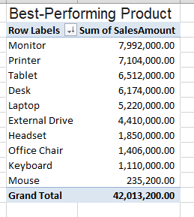

Question 5 — Product Category Performance

Business question:
Which product category generated the highest revenue?
Answer: Electronics has the highest performance at #24,134,000.00
Accessories has the lowest performance at #3,195,200.00
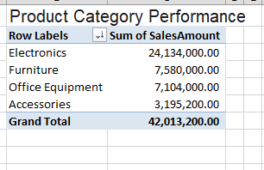

Question 6 — Customer Performance

Business question:
Which customers generated the highest revenue?
Answer: Ibrahim Sani has the highest generated revenue at #4,716,000.00
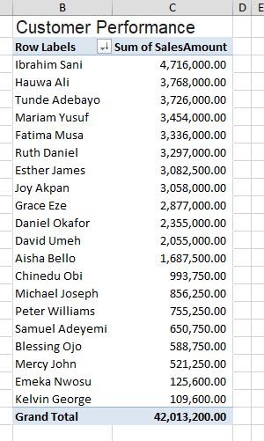

Question 7 — Location Performance

Business question:
Which city generated the highest revenue?
Answer: Kano has the highest location performance at #7,222,000.00
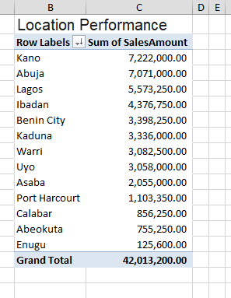

Question 8 — Customer Type

Business question:
Which customer type generates the most revenue?
Answer: Retail customers have the highest revenue at #23,075,850.00
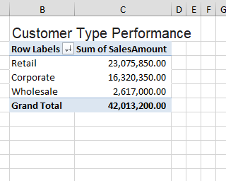

Question 9 — Average Transaction Value

Business question:
What is the average revenue generated per transaction?
Answer: #285,804.08 is the average revenue generated per customer purchase.
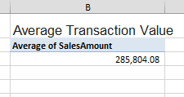

Question 10 — Sales Trend

Business question:
How did revenue change over time?
Answer: January has the highest-sales month, while June has the lowest-sales month.
The trend shows that sales generally were fluctuating.
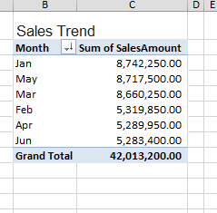

PIVOT TABLES

Pivot Table 1 — Revenue by Product
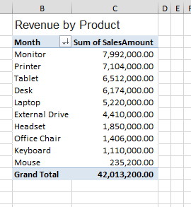

Pivot Table 2 — Revenue by Category
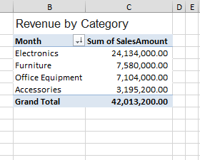

Pivot Table 3 — Revenue by City

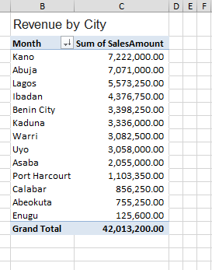

Pivot Table 4 — Revenue by Customer
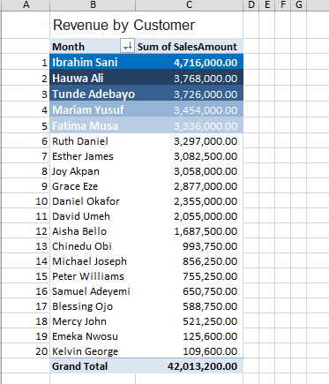

Pivot Table 5 — Monthly Revenue
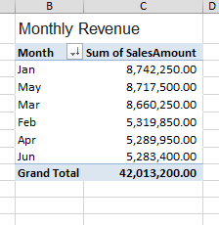

DASHBOARD

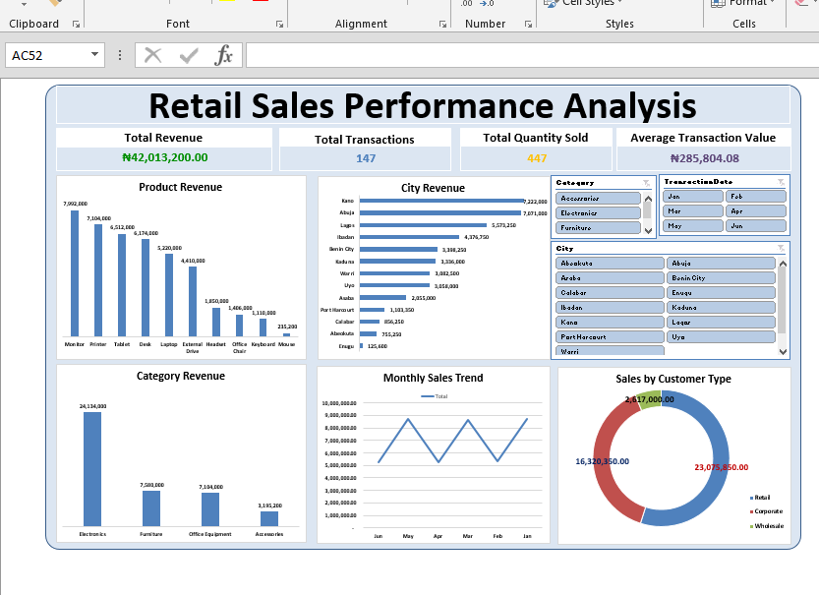

SQL Analysis

BUSINESS QUESTIONS

SQL Question 1
What is the total revenue generated by each product?
SQL QUERY:
SELECT
p.ProductName,
ROUND(SUM((t.Quantity * p.UnitPrice) * (1 - t.Discount)),
2) AS Revenue
FROM
productTable p
INNER JOIN transactionTable t
ON p.ProductID = t.ProductID
GROUP BY ProductName
ORDER BY Revenue DESC
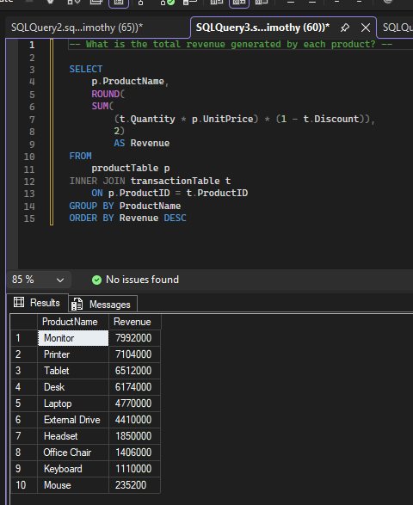

SQL Question 2
Which product category generated the highest revenue?
SQL QUERY:
SELECT
p.Category,
ROUND(
SUM(
(t.Quantity * p.UnitPrice) * (1 - t.Discount)),
2)
AS Revenue
FROM
productTable p
INNER JOIN transactionTable t
ON p.ProductID = t.ProductID
GROUP BY Category
ORDER BY Revenue DESC
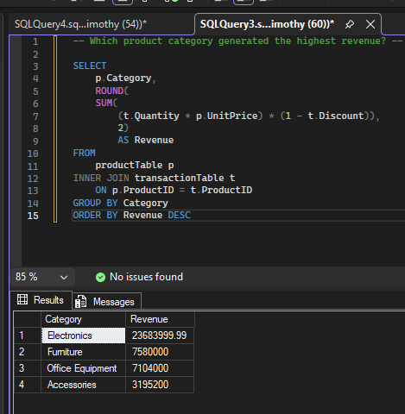

SQL Question 3
Which customers generated the most revenue?
SQL QUERY:
SELECT
c.CustomerName,
ROUND(
SUM(
(t.Quantity * p.UnitPrice) * (1 - t.Discount)),
2)
AS TotalRevenue
FROM
customersTable c
INNER JOIN transactionTable t
ON c.CustomerID = t.CustomerID
INNER JOIN productTable p
ON p.ProductID = t.ProductID
GROUP BY CustomerName
ORDER BY TotalRevenue DESC

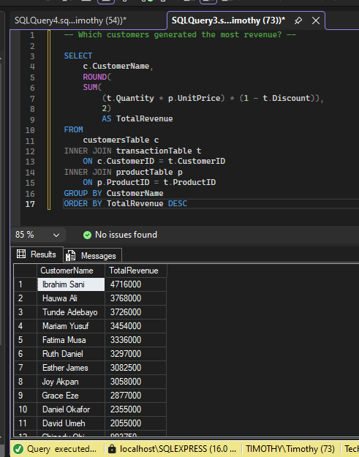

SQL Question 4
Which city generated the highest revenue?
SQL QUERY:
SELECT
c.City,
ROUND(
SUM(
(t.Quantity * p.UnitPrice) * (1 - t.Discount)),
2)
AS TotalRevenue
FROM
customersTable c
INNER JOIN transactionTable t
ON c.CustomerID = t.CustomerID
INNER JOIN productTable p
ON p.ProductID = t.ProductID
GROUP BY City
ORDER BY TotalRevenue DESC

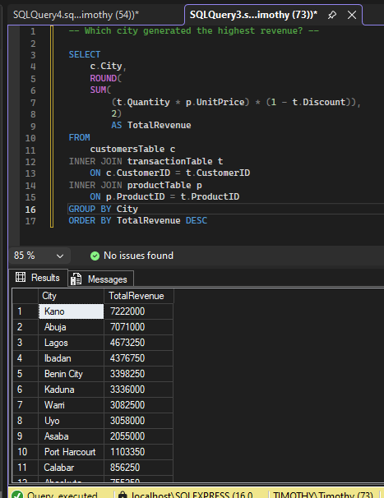

SQL Question 5
What is the average transaction value?
SQL QUERY:
SELECT
ROUND(
AVG((t.Quantity * p.UnitPrice) * (1 - t.Discount)),2)
AS AverageTransactionValue
FROM
transactionTable t
INNER JOIN productTable p
ON t.ProductID = p.ProductID

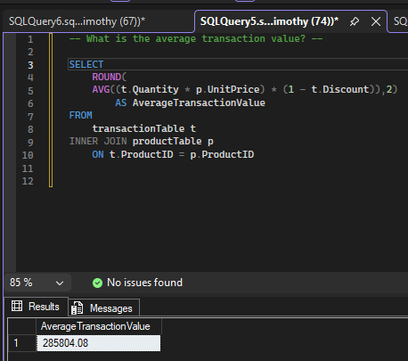

SQL Question 6 — Optional
Which customer type generated the highest revenue?
SQL QUERY:
SELECT
c.CustomerType,
ROUND(
SUM(
(t.Quantity * p.UnitPrice) * (1 - t.Discount)),
2)
AS TotalRevenue
FROM
customersTable c
INNER JOIN transactionTable t
ON c.CustomerID = t.CustomerID
INNER JOIN productTable p
ON p.ProductID = t.ProductID
GROUP BY CustomerType
ORDER BY TotalRevenue DESC

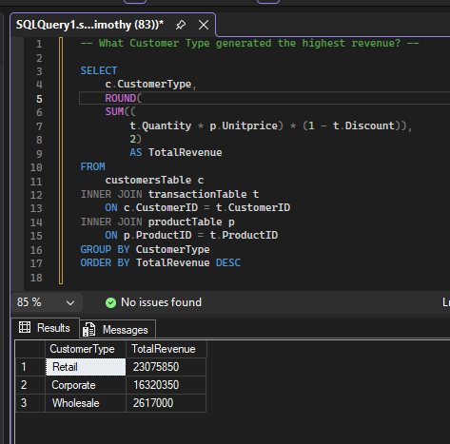

COMPARE EXCEL AND SQL RESULTS

Analysis | Excel/Sheets Result | SQL Result | Match?
Highest revenue product | Monitor | Monitor | Yes
Highest revenue city | Kano | Kano | Yes
Highest revenue category | Electronics | Electronics | Yes
Highest revenue by CustomerType | Retail | Retail | Yes
Highest revenue by CustomerName | Ibrahim Sani | Ibrahim Sani | Yes
Average Transaction Value | 285,804.08 | 285,804.08 | Yes

KEY INSIGHTS
Insight 1

Electronics is the dominant product category driving business revenue.
It generated ₦24,134,000.00 in revenue.
The Electronics category is the primary growth engine for sales, outperforming all other product categories (with Accessories generating the lowest at ₦3,195,200.00).

Insight 2

Retail customers generate more revenue than any other customer segment.
Retail customers contributed ₦23,075,850.00 to total revenue.
Individual consumer purchasing represents over half of total revenue (from ₦42,013,200.00 total), making the retail segment essential to the business’s bottom line.

Insight 3

Kano is the highest-performing geographic location for sales.
It generated ₦7,222,000.00 in revenue.
Kano represents the company's strongest city market and highest customer demand concentration.

BUSINESS RECOMMENDATIONS
- Prioritize High-Margin Electronics & Monitor Inventory in Kano
  - Rationale: Electronics generated ₦24,134,000.00 (the top category), Monitors generated ₦7,992,000.00 (the top individual product), and Kano produced the highest city revenue at ₦7,222,000.00.

  - Action: Allocate a larger share of stock and regional marketing budgets for high-performing tech items specifically to fulfillment hubs and outlets in Kano to prevent stockouts and maximize profitability in your top-performing market.

- Develop Tailored Retargeting & Loyalty Programs for Retail Customers and VIPs
  - Rationale: Retail customers represent over 50% of overall revenue at ₦23,075,850.00, while top individual buyers like Ibrahim Sani (₦4,716,000.00) drive substantial value. Additionally, revenue experiences mid-year dips (dropping from a peak in January to a low point in June).

  - Action: Launch a retail loyalty program to retain individual shoppers and create targeted mid-year promotions during slower months (such as May and June) to smooth out sales fluctuations and ensure consistent revenue flow.

Conclusion

Overall, the analysis reveals a healthy retail-driven business generating ₦42,013,200.00 across 147 transactions, with high-value product categories and key markets driving the vast majority of performance. Electronics remains the primary engine of revenue, supported heavily by top products like Monitors and strong demand in regional hubs like Kano and Abuja. By strategically focusing inventory on these top-performing segments, addressing mid-year sales fluctuations through targeted promotions, and strengthening relationships with key retail buyers, the company can eliminate inefficiencies and drive sustainable revenue growth.

Excel worksheet
Link to Excel sheet:

https://1drv.ms/x/c/68c23cafff6a5be3/IQAXCPhD_S5iRLHuZhG5pf0NAdBqIj0OVORj0QEIfaFL10s

