**Health Care Data Driven Decisions using Power BI**

**Week2: Data Analysis Expression-DAX**

**Creating Columns using DAX :-**

* . Duration of Stay = ABS(DATEDIFF('Patient Details'[D.O.A],'Patient Details'[D.O.D],DAY))

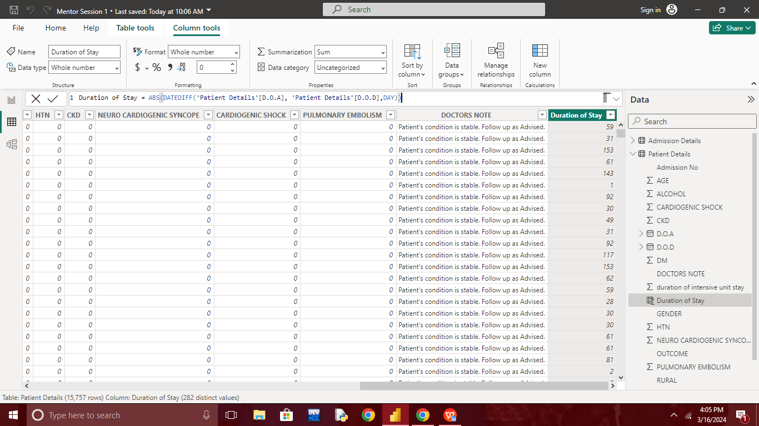

* Smoking = IF('Patient Details'[SMOKING ]=0,"No","Yes")

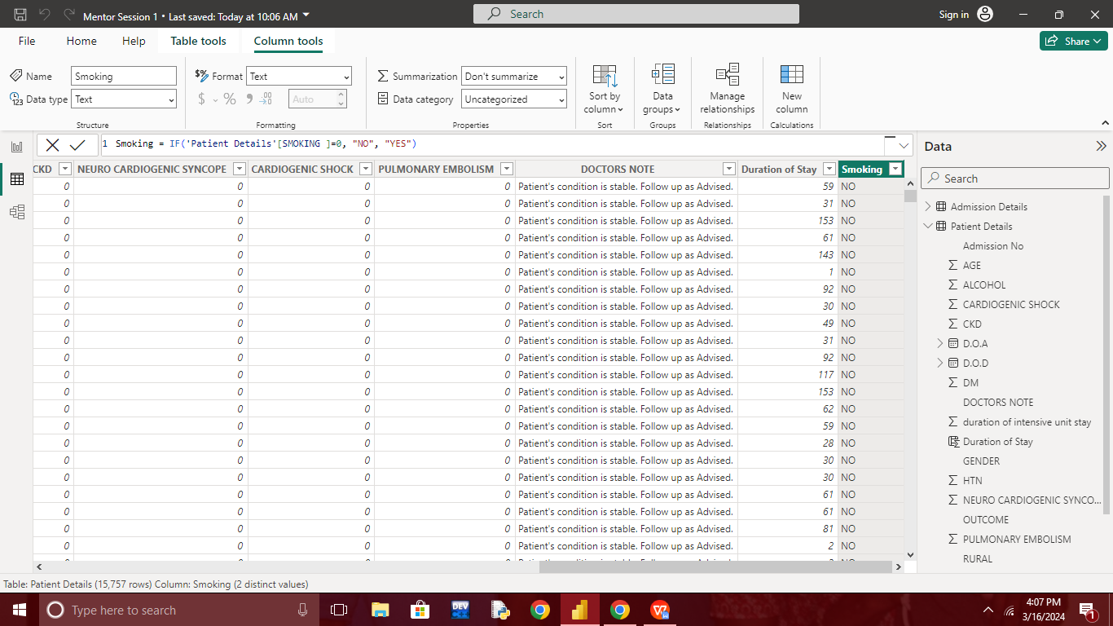

* Alcohol = IF('Patient Details'[ALCOHOL]= 0,"No","Yes")

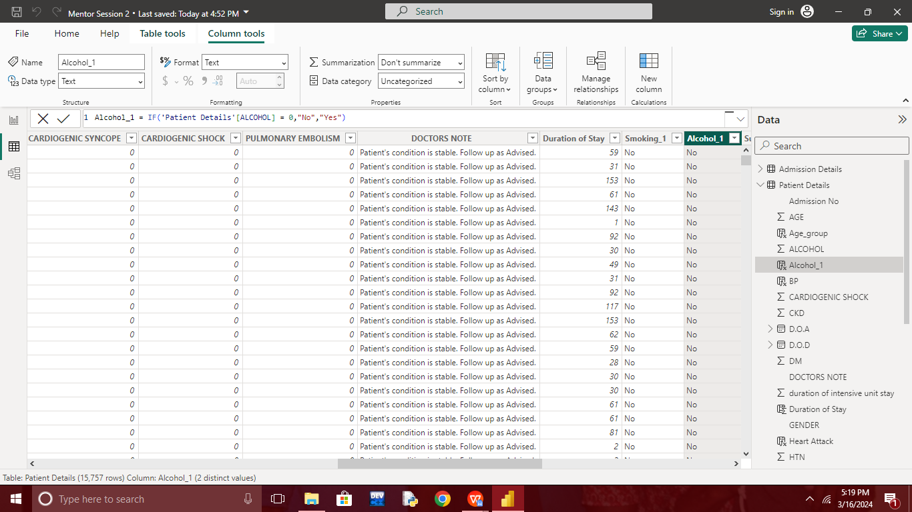

* Sugar = IF('Patient Details'[DM]= 0,"No","Yes")

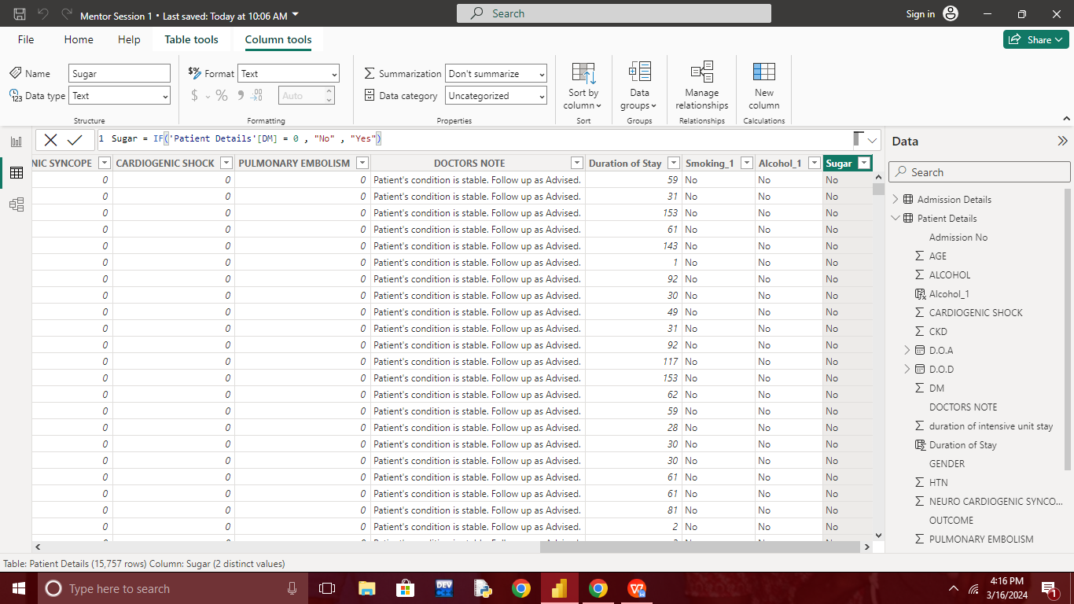

* BP = IF('Patient Details'[HTN]= 0,"No","Yes")

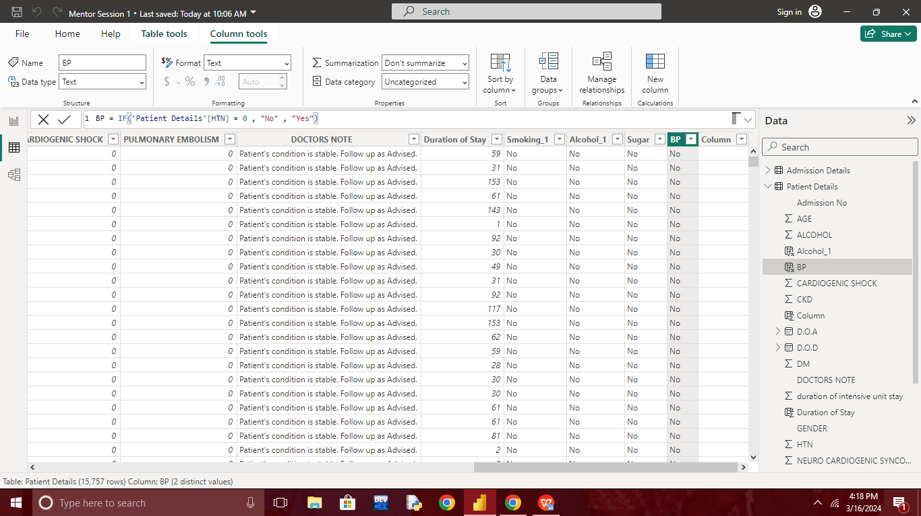

* Kidney = IF('Patient Details'[CKD]= 0,"No","Yes")

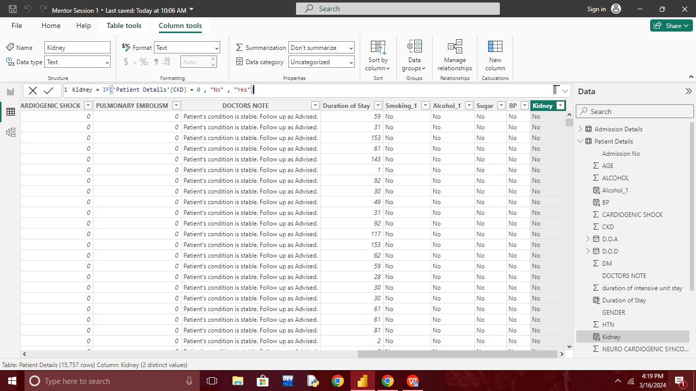

* Neuro = IF('Patient Details'[NEURO CARDIOGENIC SYNCOPE]= 0,"No","Yes")

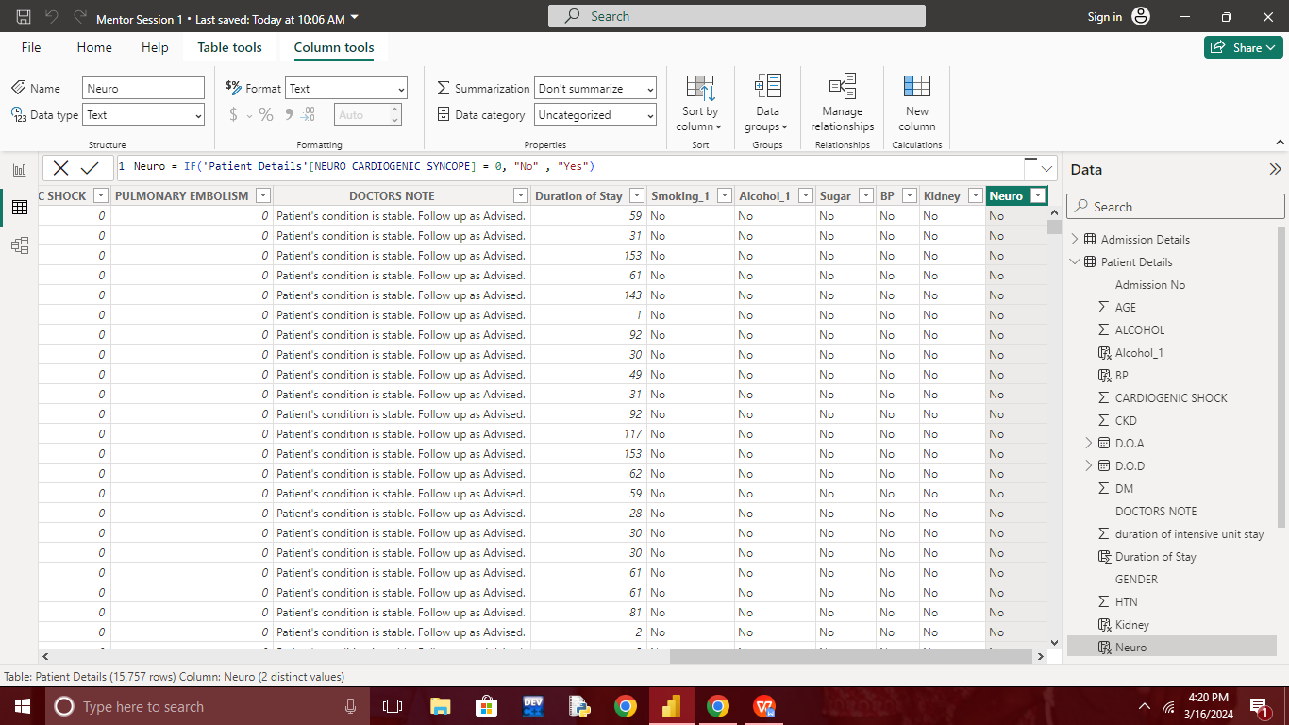

* Heart Attack = IF('Patient Details'[CARDIOGENIC SHOCK]=0,"No","Yes")

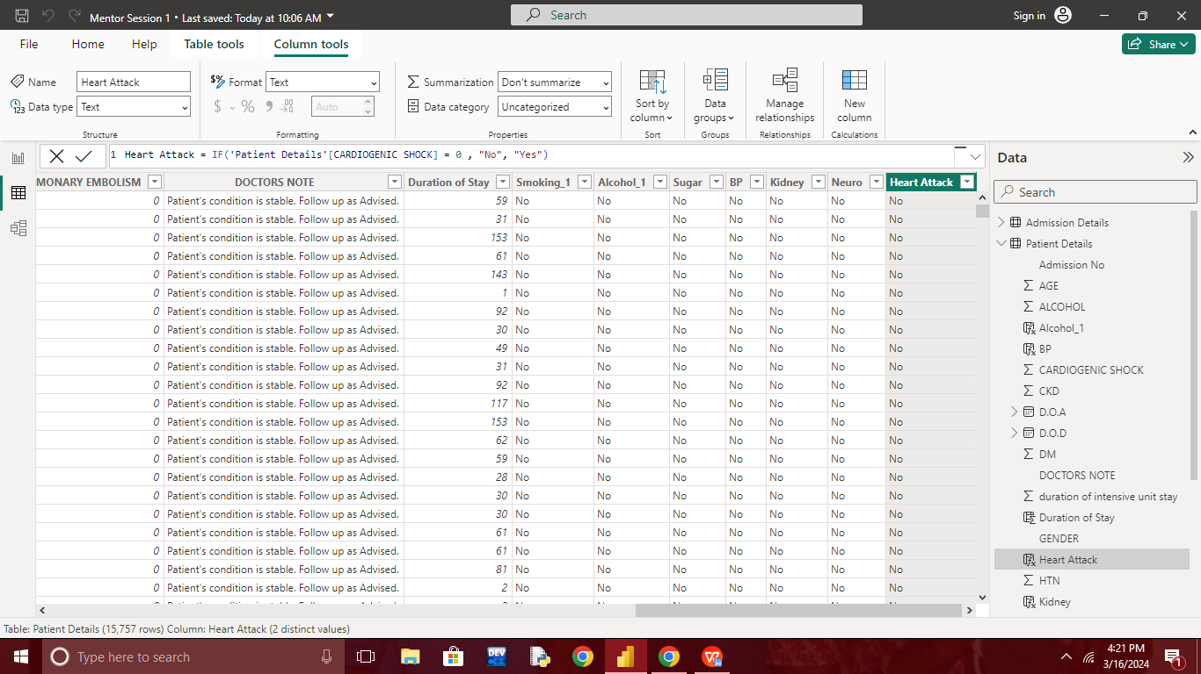

* Lungs_BloodClot = IF('Patient Details'[PULMONARY EMBOLISM]=0,"No","Yes")

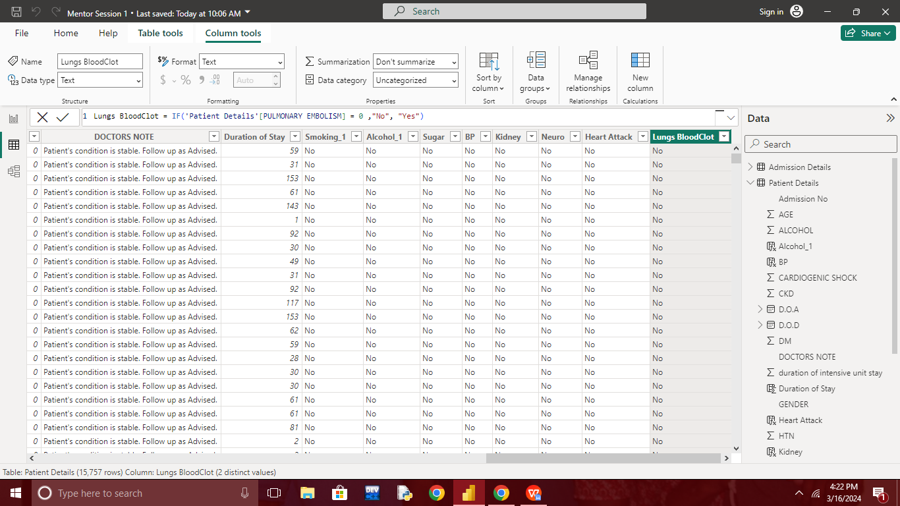

* Year = YEAR('Patient Details'[D.O.A])

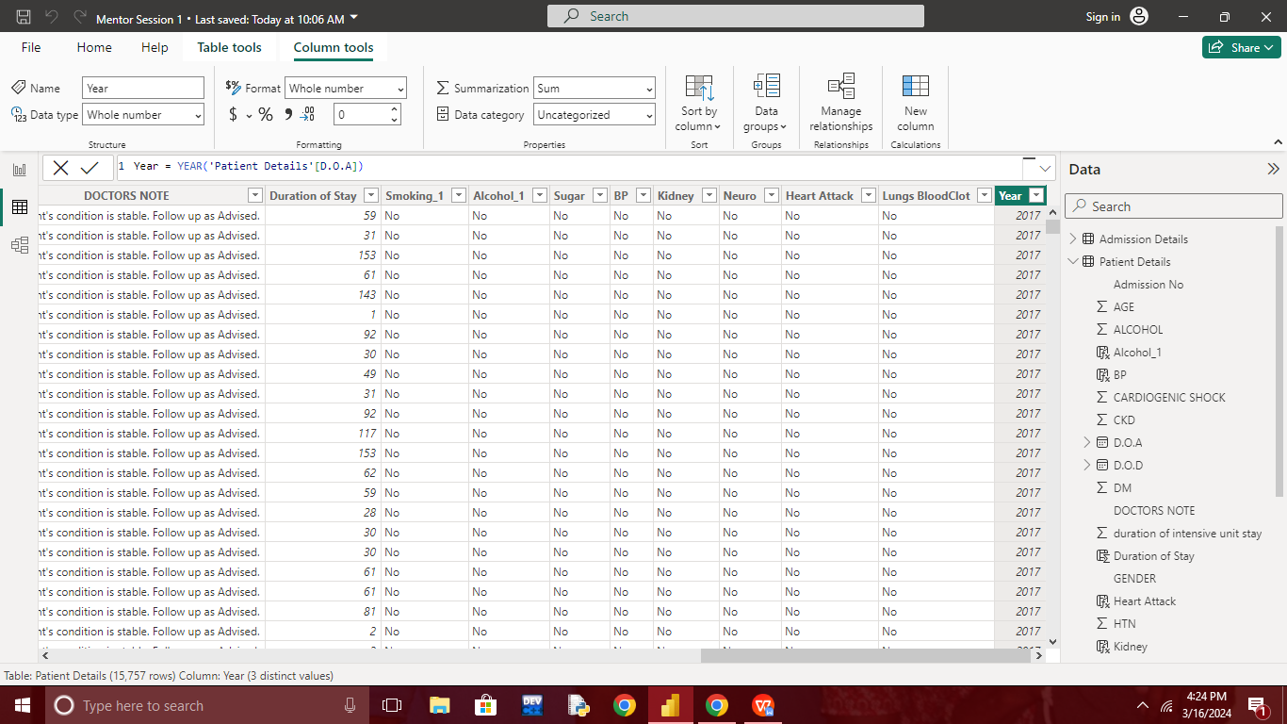

* Month = FORMAT('Patient Details'[D.O.A],"MMM")

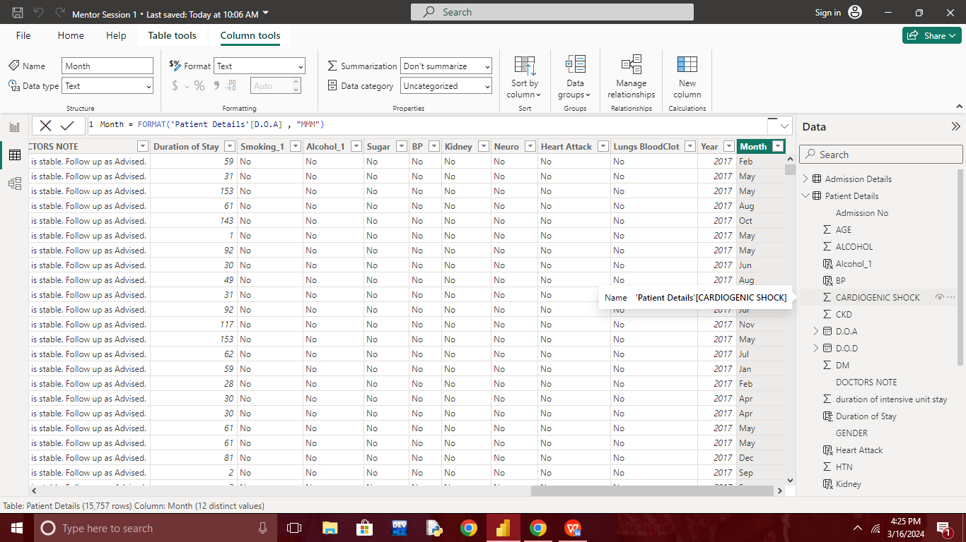

* Month No = MONTH('Patient Details'[D.O.A])

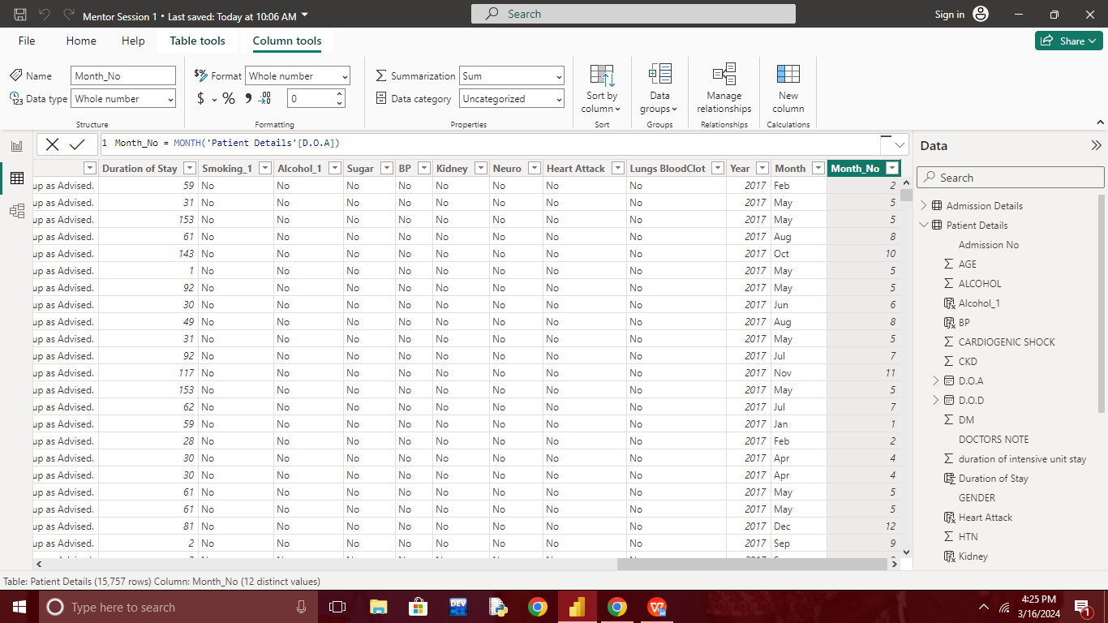

* weekday = WEEKDAY('Patient Details'[D.O.A].[Date])

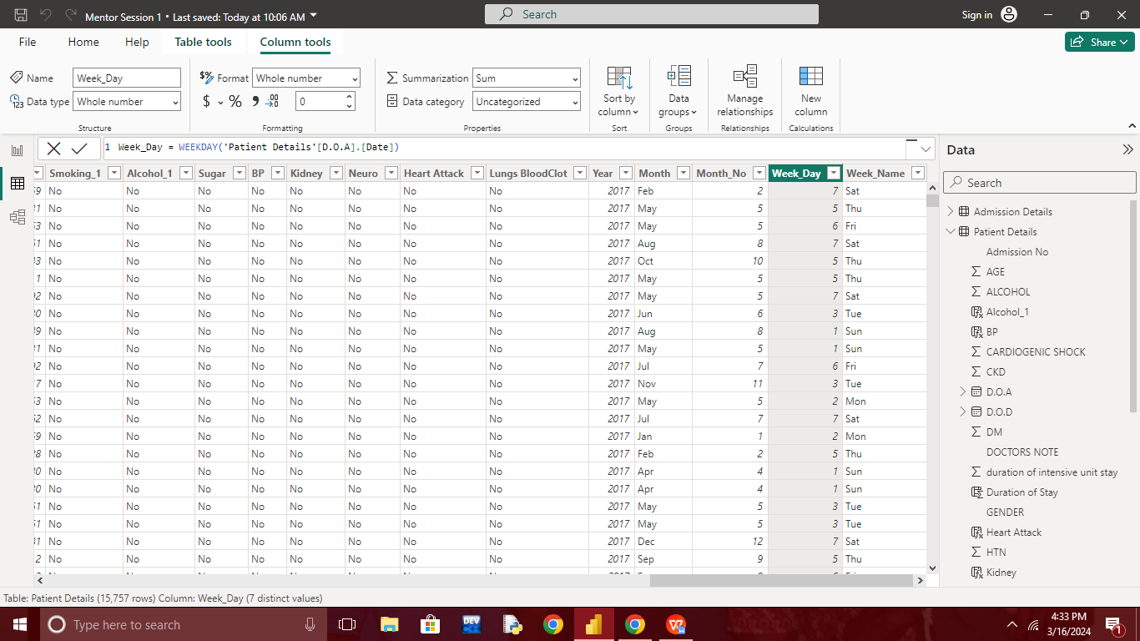

* Week_name = FORMAT('Patient Details'[D.O.A],"DDD")

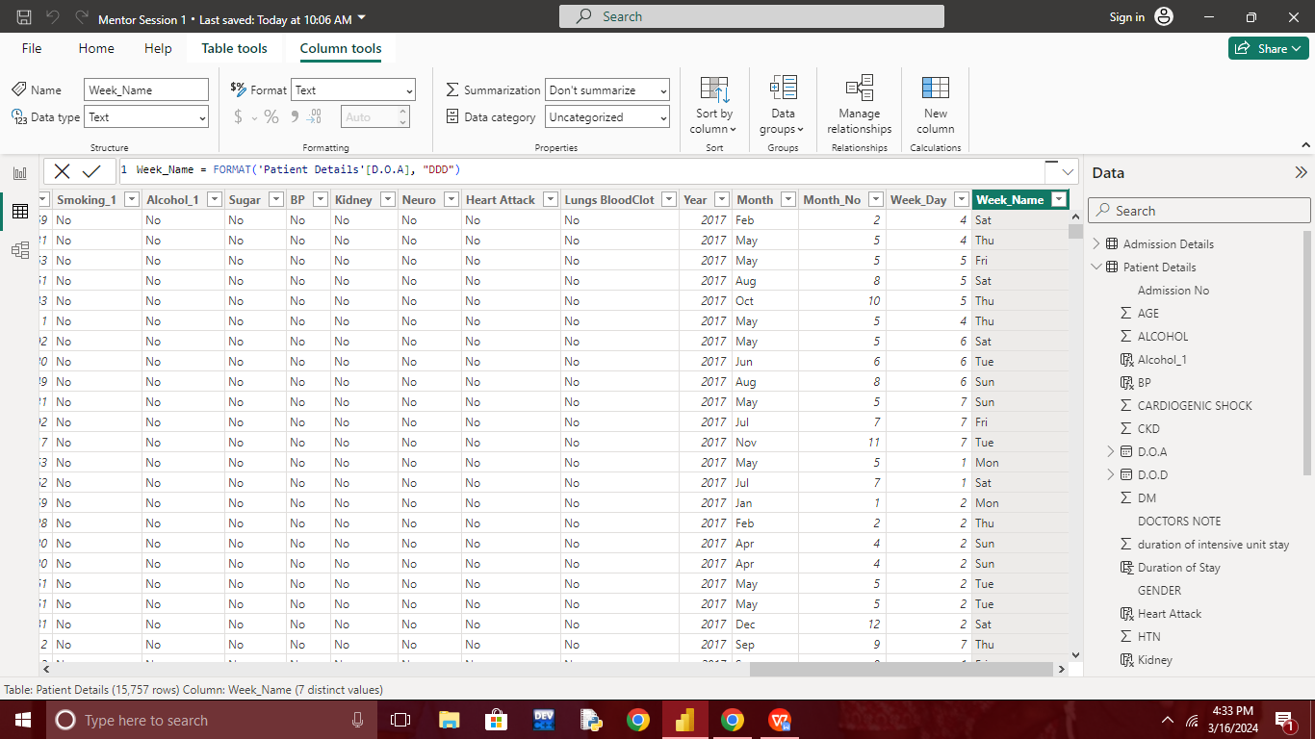

age_group = SWITCH(TRUE(),

'Patient Details'[AGE]<=25,"1-25",

'Patient Details'[AGE]<=50,"26-50",

'Patient Details'[AGE]<=75,"51-75",

'Patient Details'[AGE]<=100,"76-100",

'Patient Details'[AGE]<=125,"101-125"

)

