**Health Care Data Driven Decisions using Power BI**

**Week3 : Visualization and Dashboard**

**New Measures:**

* Total Patients = COUNTROWS('Patient Details')

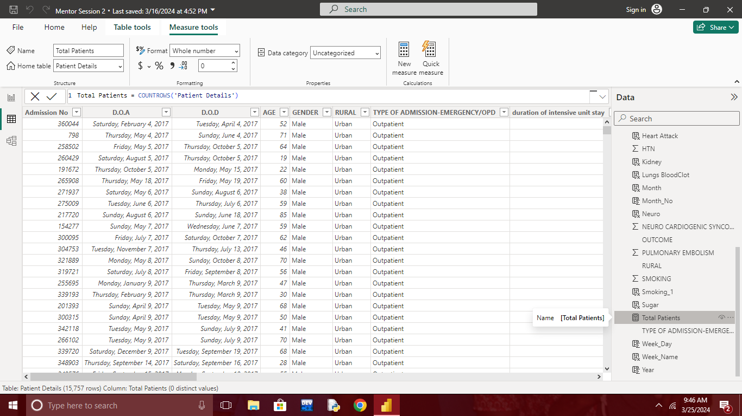

* Males = DIVIDE( CALCULATE([Total Patients],'Patient Details'[GENDER]="Male"),[Total Patient])

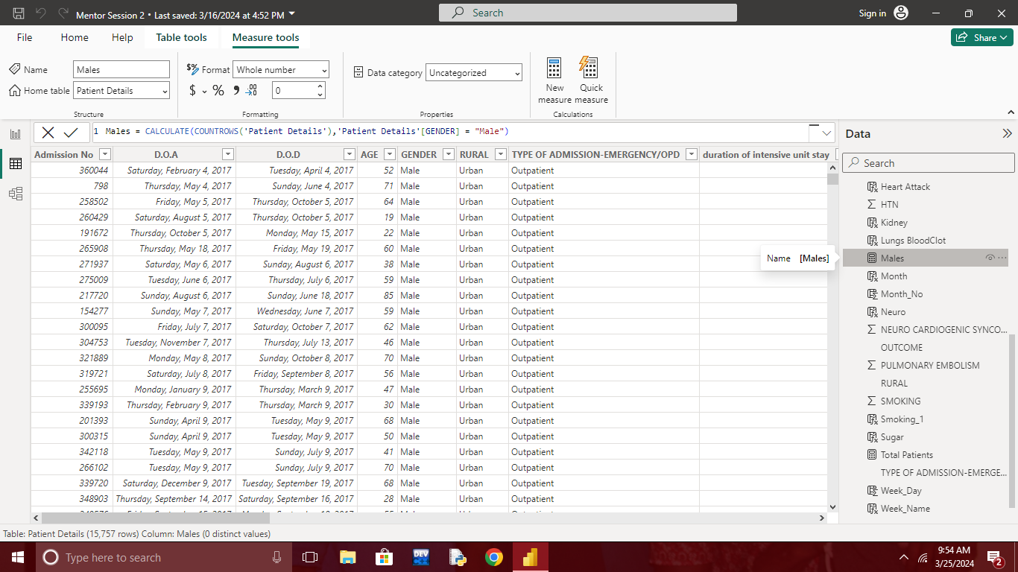

* Females = DIVIDE( CALCULATE([Total Patients],'Patient Details'[GENDER]="Female"),[Total Patient])

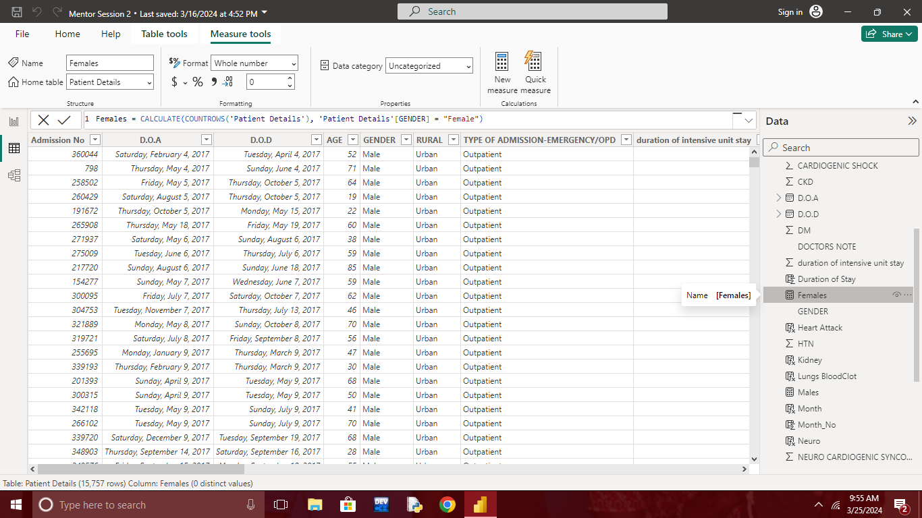

* Report on How many Patients are getting Various Diseases by Alcohol Habit and How many are not?

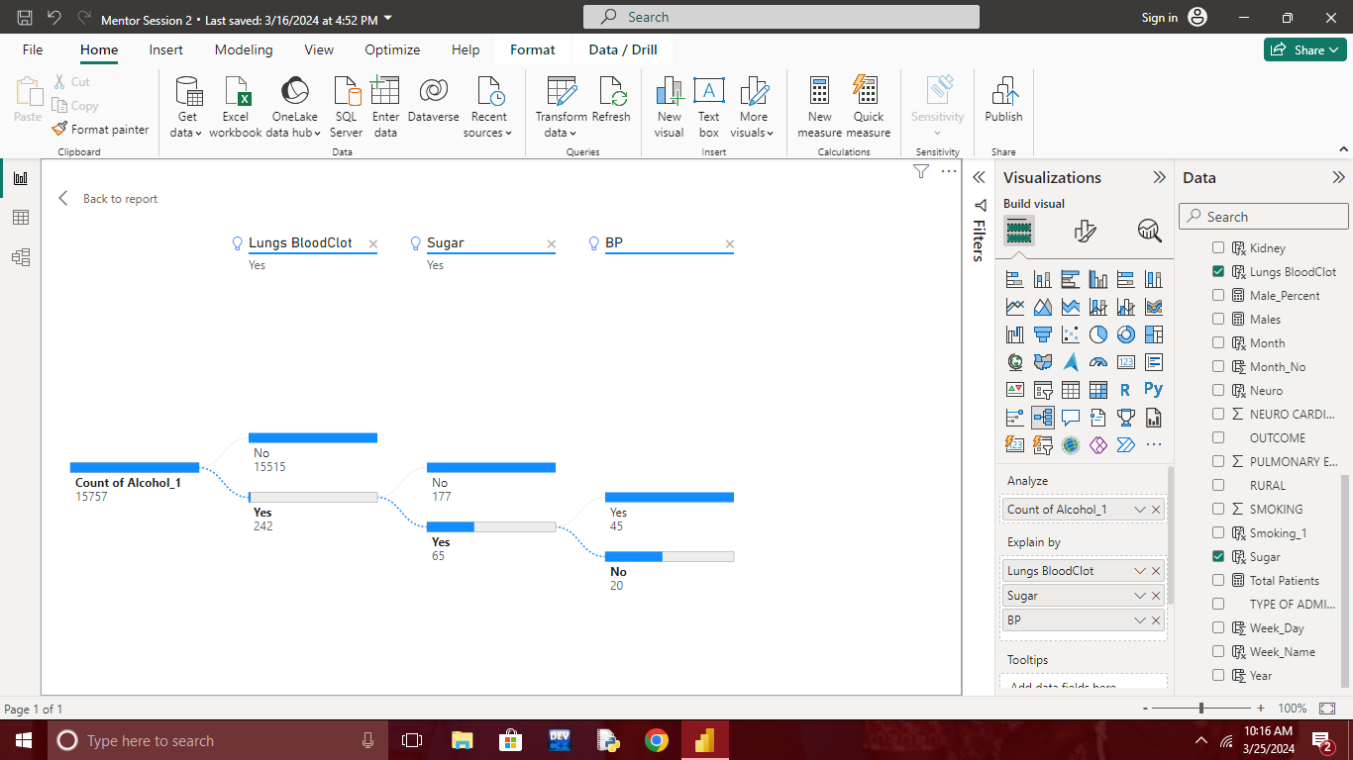

* Report on How many Patients are getting Various Diseases by Smoking Habit and How many are not?

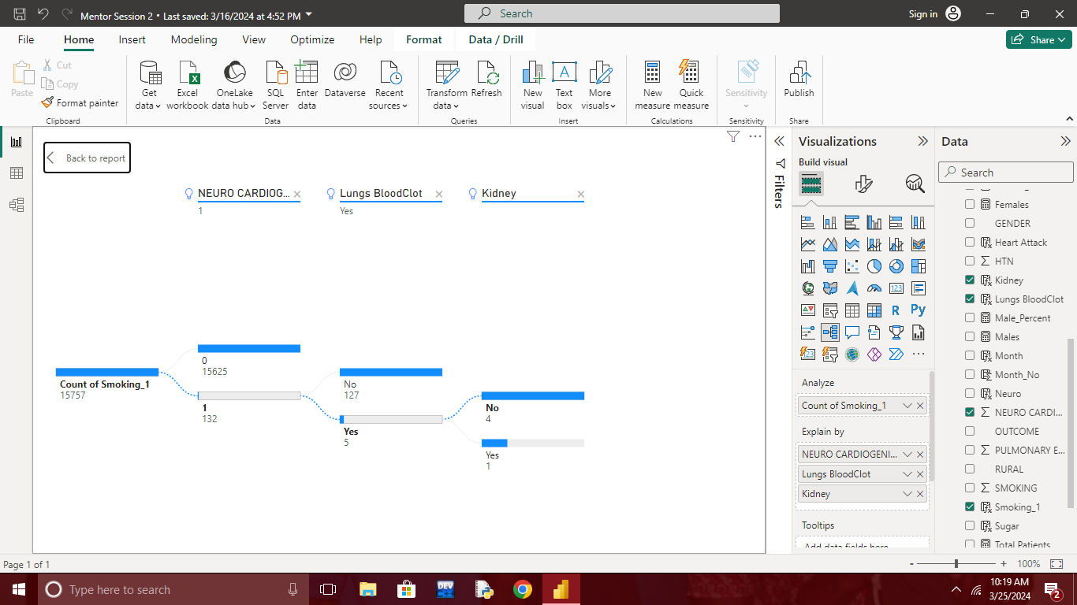

* Report on no.of Patients joined based on the age group

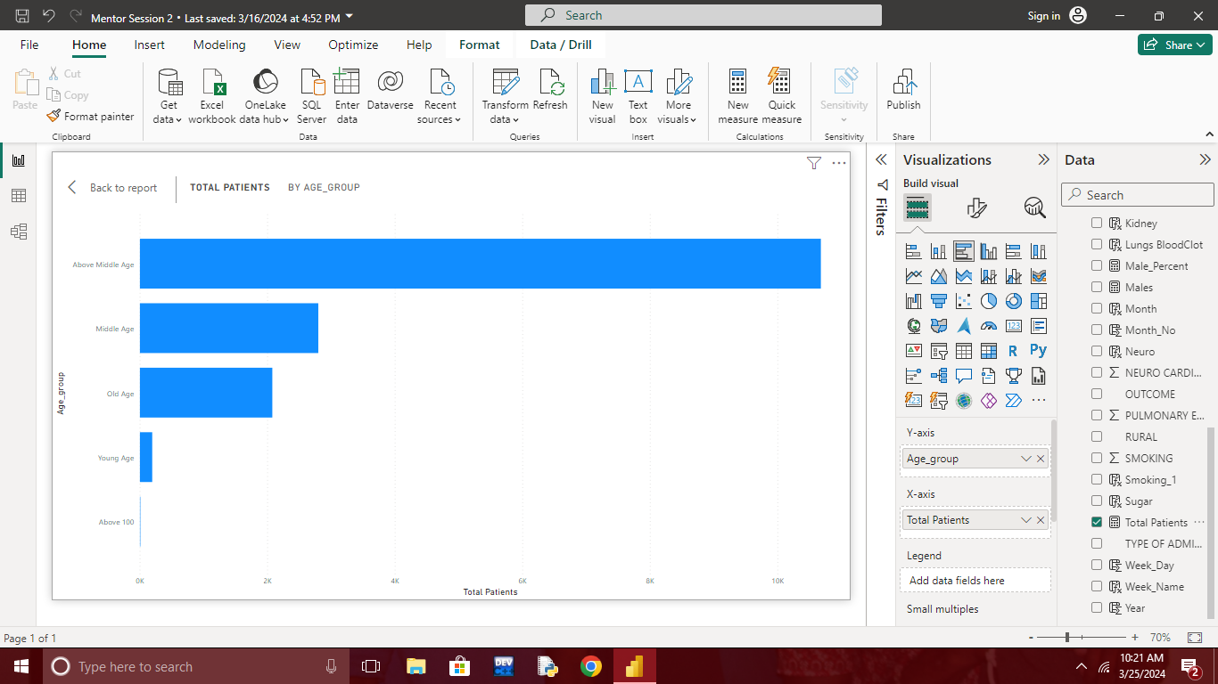

* Report on No.of patients joined based on the week name

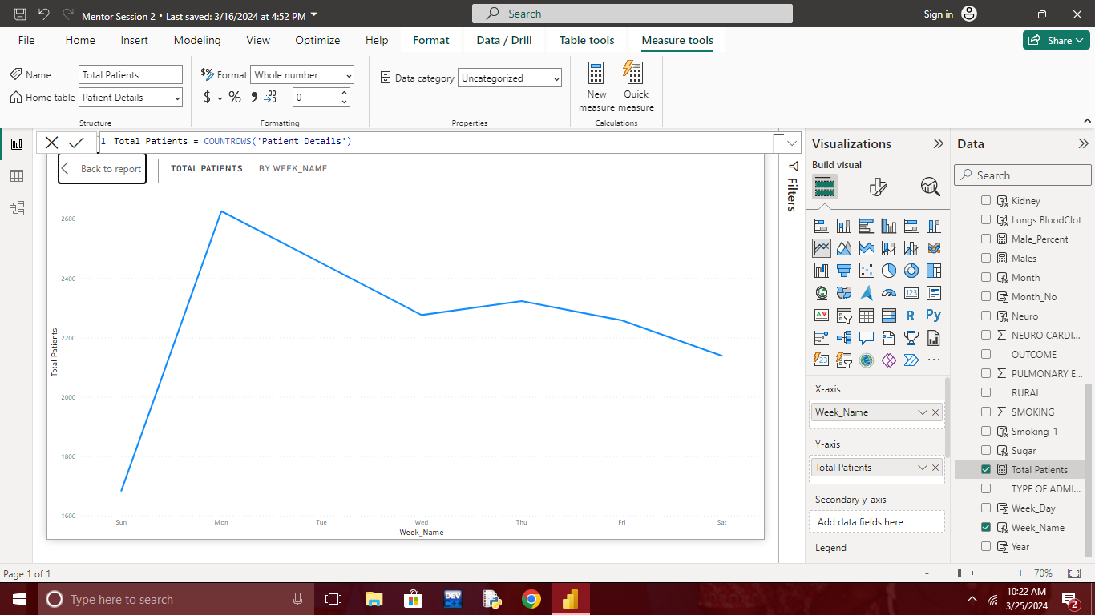

**Creating Cards by using created measures :-**

* Total No.of Patients

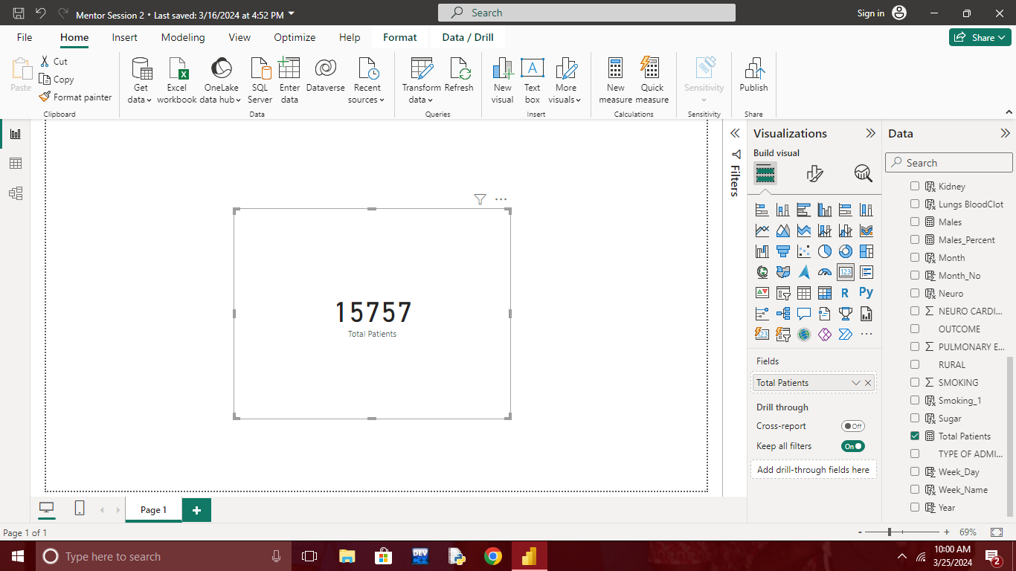

* Male patients percentage

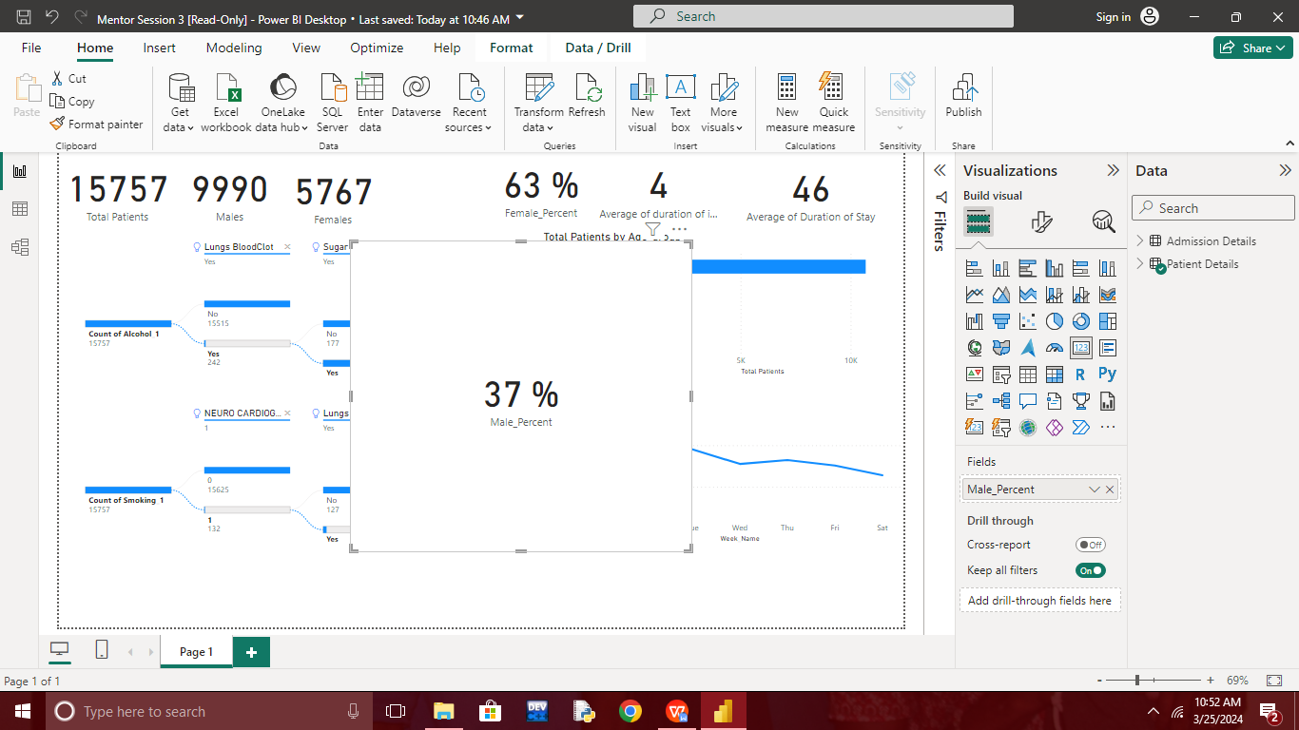

* Female patients percentage

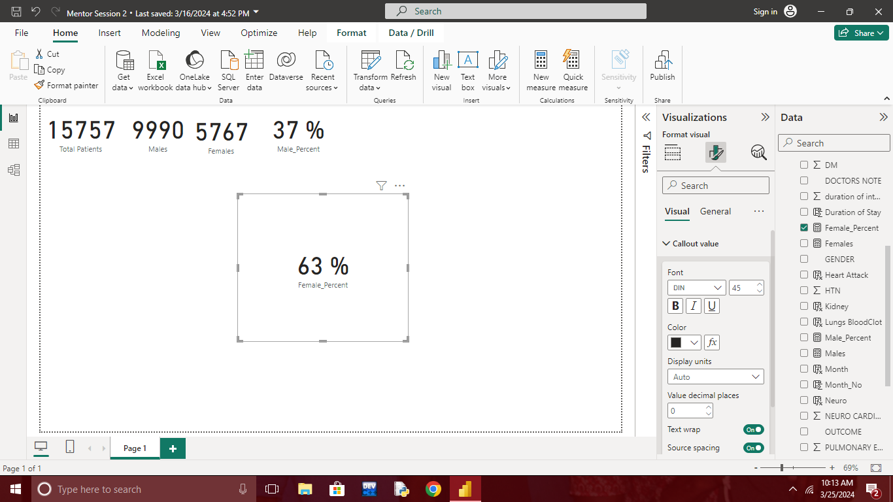

* Avg. Duration of stay in Hospital

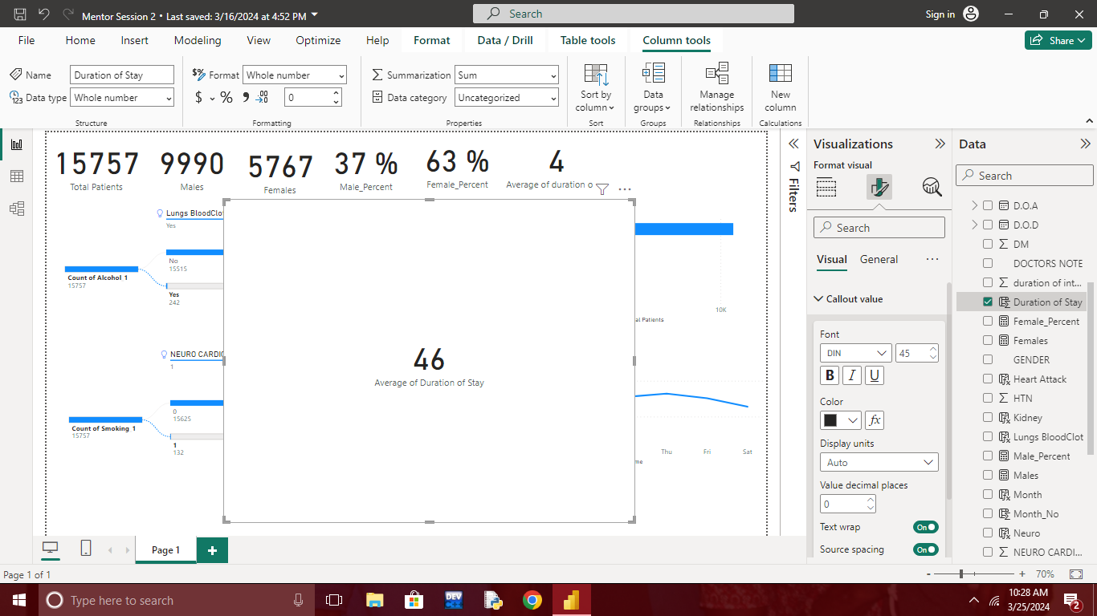

* Avg. Duration of Stay in ICU

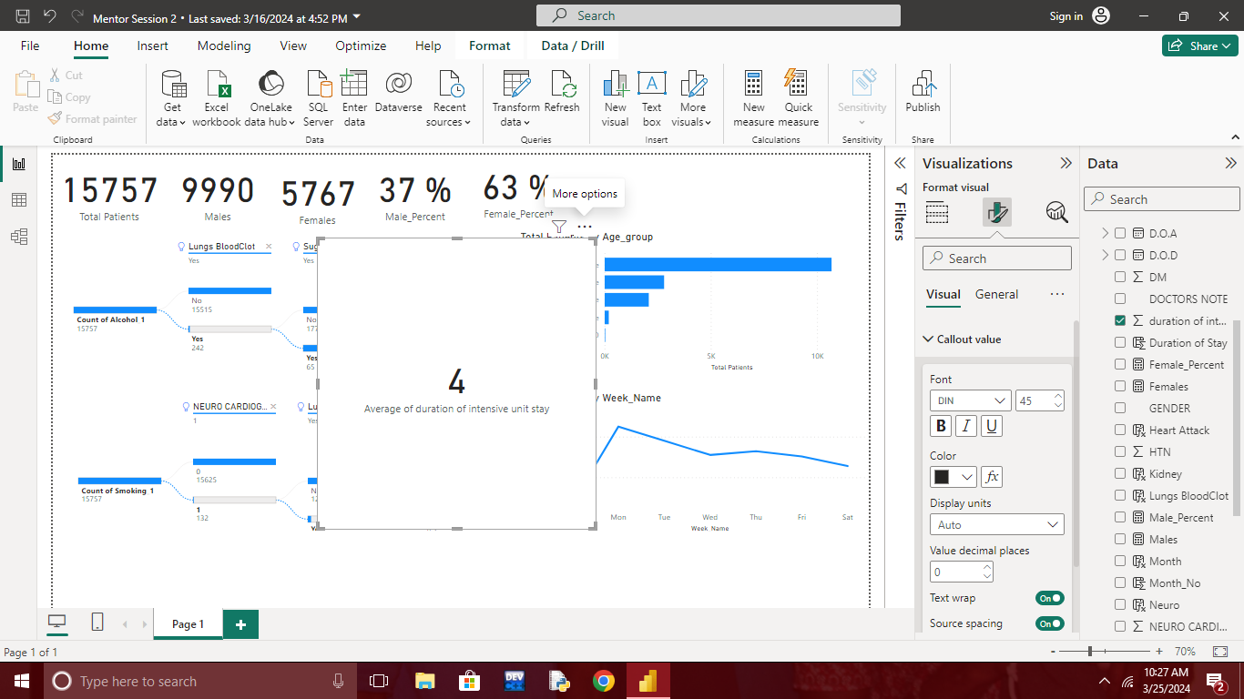

* Overall View of Week 3

