Q1：

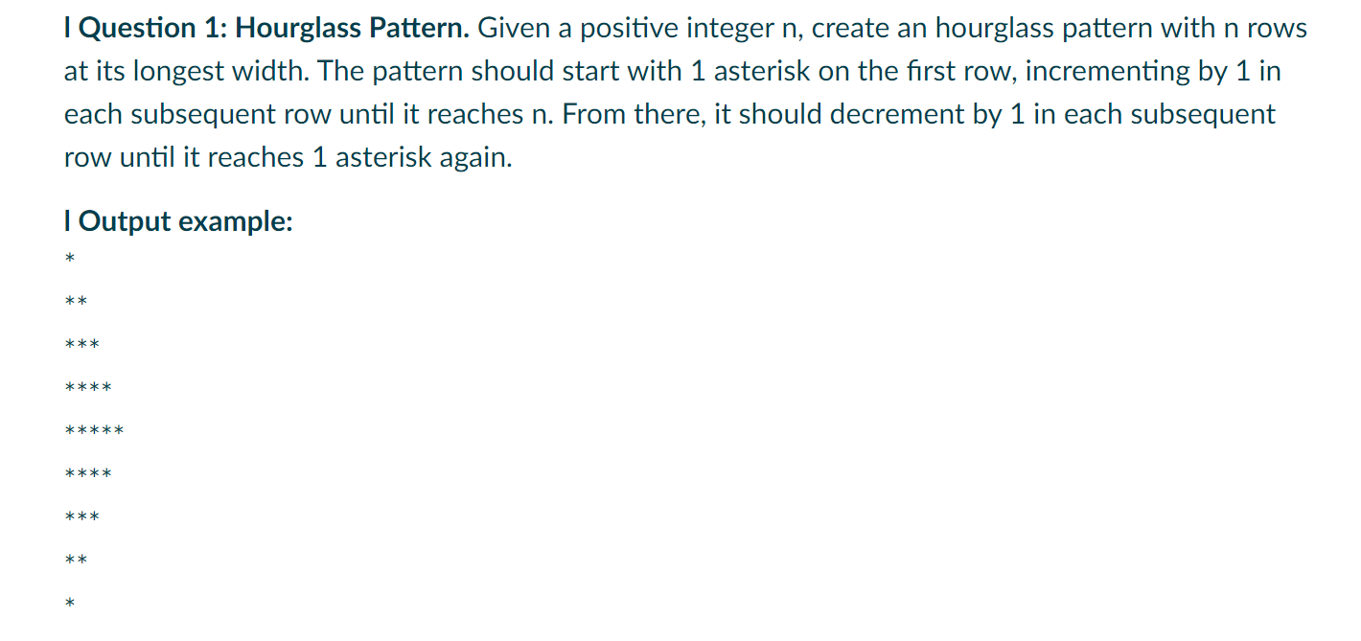

# Get the number of rows from user input

n=int(input("Enter the number of rows: "))

# Initialize row number to 1

row=1

# Outer while loop for iterating through rows

while row<=2*n-1:

    # Initialize counter variable for inner loop

    i=1

     # Inner while loop for printing asterisks on each row

    while i<=(n-abs(n-row)):

        # Print asterisk without newline

        print("*",end='')

        # Increment the counter variable

        i+=1

    # Print newline after each row of asterisks

    print()

    # Update variables for next row and move to the next row

    row+=1

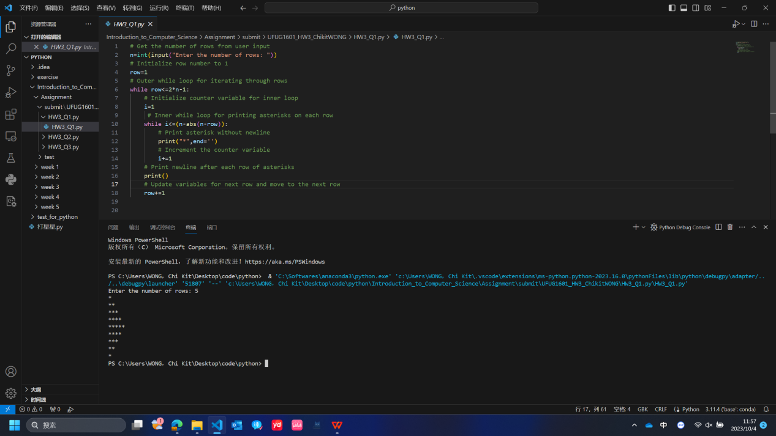

Q2：

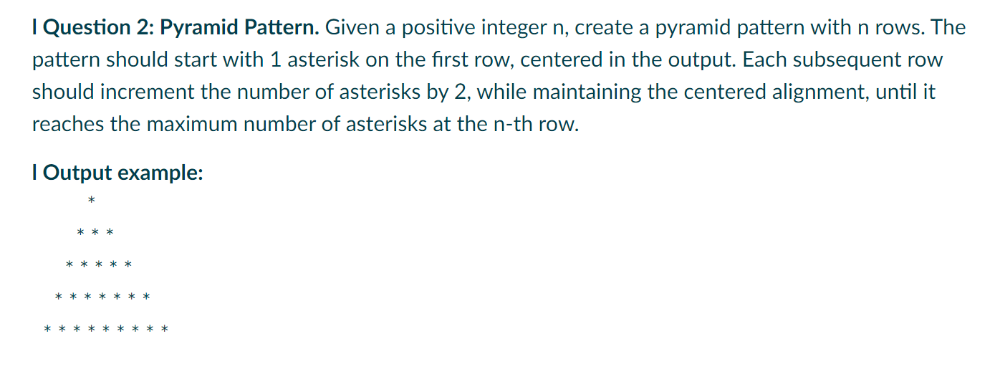

# Get the number of rows from user input

n=int(input("Enter the number of rows: "))

# Initialize the row number to 1

row=1

# Initialize the number of asterisks to print on the first row

num_asterisks=1

# Outer while loop for iterating through rows

while row<=n:

    # Calculate the number of spaces before asterisks

    space_count=n-row

    # Initialize the counter for printed asterisks on the current row

    asterisks_count=1

     # Inner while loop for printing spaces and asterisks on each row

    while space_count>0 or asterisks_count<=num_asterisks:

        # If there are spaces to print, print a space

        if space_count>0:

            print(" ",end='')

             # Decrease the space_count

            space_count-=1

        # If there are no more spaces to print, print an asterisk

        else:

            print("*",end="")

            # Increase the asterisks_count

            asterisks_count+=1

     # Print a newline after each row of spaces and asterisks

    print()

    # Move to the next row

    row+=1

     # Increment the number of asterisks for the next row by 2

    num_asterisks+=2

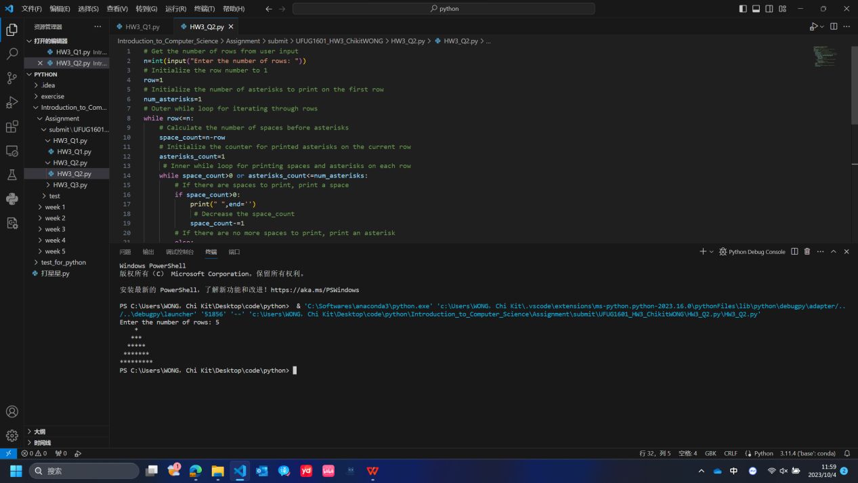

Q3：

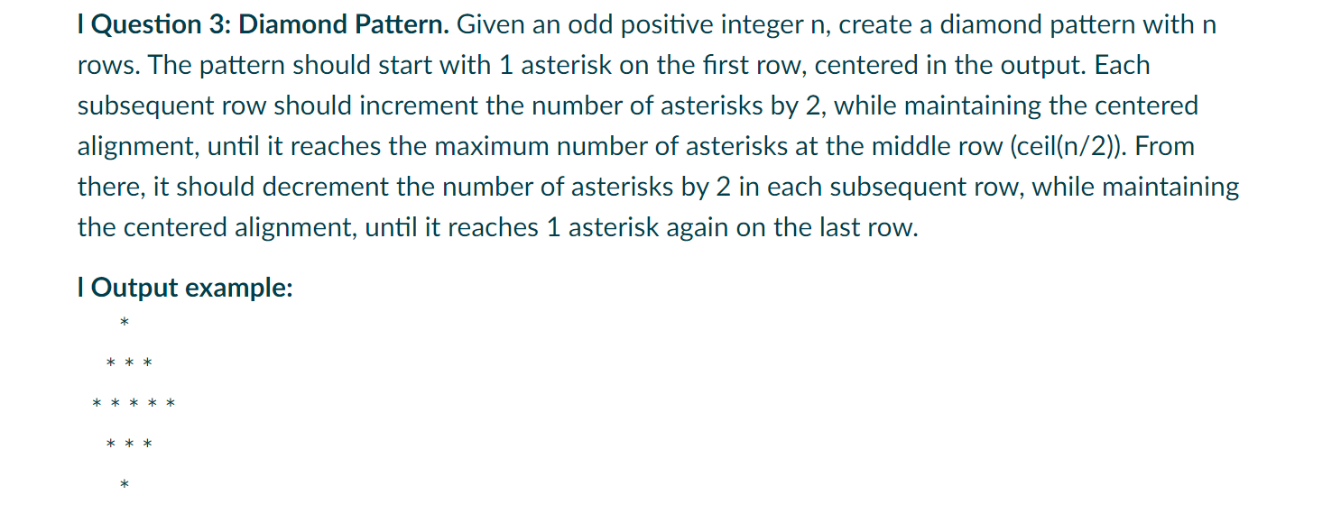

import math

# Get the number of rows from user input

n=int(input("Enter the number of rows: "))

# Initialize variables

row=1

num_asterisks=1

# Calculate the middle row

middle_row=math.ceil(n/2)

# Outer loop for rows

while row<=n:

    # Calculate spaces before asterisks

    spaces=(n-num_asterisks)//2

    # Inner loop for printing spaces and asterisks

    for i in range(n):

        if i<spaces:

            print(" ", end="")

        elif i<spaces+num_asterisks:

            print("*", end="")

    # Print newline for the next row

    print()

    # Update variables for the next row

    if row<middle_row:

        num_asterisks+=2

    else:

        num_asterisks-=2

    row+=1

