AWS CLOUD PROJECT

Amazon S3 Cross-Region
Replication for Compliance
A practical implementation using Amazon Web Services

Source bucket | aws-sourcebucket1-project
Source Region | Asia Pacific (Mumbai) — ap-south-1
Destination bucket | aws-destinationbucket1-project
Destination Region | US East (N. Virginia) — us-east-1
Prepared for academic project submission
2400032263 – Ch. Tejaswi
2400032284 – A. Vikas Reddy
2400032290 – B. Lohitha
2400032297 – P. Yoshitha
Project Team Members

Abstract
Project Name: Amazon S3 Cross-Region Replication for Compliance
Team Members:
2400032263 – Ch. Tejaswi
2400032284 – A. Vikas Reddy
2400032290 – B. Lohitha
2400032297 – P. Yoshitha
This project demonstrates Amazon S3 Cross-Region Replication (CRR), a feature that automatically copies eligible objects from a source S3 bucket in one AWS Region to a destination bucket in another Region. The implementation uses a source bucket in Mumbai (ap-south-1) and a destination bucket in US East (N. Virginia, us-east-1). Bucket versioning is enabled, and an enabled replication rule named “AuditLogsReplication” is configured to apply to the entire source bucket. The uploaded test object audit-log-01.txt shows a replication status of COMPLETED in the source object's properties. The report describes the architecture, configuration, test evidence, compliance considerations, and important limitations.

1. Introduction
Organizations store audit logs to investigate events, monitor systems, and support internal or external audits. Keeping a replica in a separate AWS Region can improve geographic resilience and help meet certain operational requirements. Amazon S3 CRR provides managed, asynchronous object replication between buckets in different Regions.
Replication is not a complete compliance solution by itself. The destination Region, retention period, access controls, encryption, and legal or contractual requirements must all be reviewed before using the design for regulated data.

2. Objectives
- Create source and destination S3 buckets in separate AWS Regions.
- Enable S3 Versioning on the source and destination buckets.
- Configure an enabled replication rule for the source bucket.
- Upload a sample audit-log file and verify its replication status.
- Document existing-object replication and delete-marker behaviour relevant to compliance.

3. Architecture and Environment
Source | Replication | Destination
S3 bucket  aws-sourcebucket1-project  Mumbai: ap-south-1 | Enabled rule  AuditLogsReplication  IAM role for S3 CRR | S3 bucket  aws-destinationbucket1-project  N. Virginia: us-east-1
Test object: audit-log-01.txt (54 bytes). The source object properties page displays Replication status: COMPLETED.

4. AWS Services and Prerequisites
- Amazon S3 — stores the source and replicated objects.
- S3 Versioning — enabled on both buckets; required for live replication.
- IAM role — s3crr_role_for_aws-sourcebucket1-project, selected in the replication configuration.
- S3 replication rule — AuditLogsReplication, enabled and scoped to all objects in the source bucket.

5. Implementation Steps

5.1 Create the buckets
Created aws-sourcebucket1-project in Asia Pacific (Mumbai), ap-south-1, and aws-destinationbucket1-project in US East (N. Virginia), us-east-1.

5.2 Enable versioning
Opened the source bucket's versioning settings and selected Enable. The replication destination must also have versioning enabled for CRR to operate.

5.3 Create the replication rule
Configured the rule named AuditLogsReplication and set its status to Enabled.

5.4 Choose the replication scope
Selected Apply to all objects in the bucket, so the rule is not limited to a prefix or tag filter.

5.5 Select the destination
Selected s3://aws-destinationbucket1-project in us-east-1 as the destination bucket.

5.6 Configure the IAM role and options
Selected the IAM role s3crr_role_for_aws-sourcebucket1-project. The configuration shows delete-marker replication enabled. KMS-encrypted object replication, Replication Time Control, replication metrics, and replica modification sync were not selected in the captured settings.

5.7 Upload a test object
Uploaded audit-log-01.txt to the source bucket.

5.8 Verify the result
Opened the source object's properties and confirmed that its Replication status is COMPLETED. This is evidence that S3 reports successful replication for the test object.

6. Screenshot Evidence

Figure 1. Source and destination buckets
The bucket list identifies both buckets and their Regions.
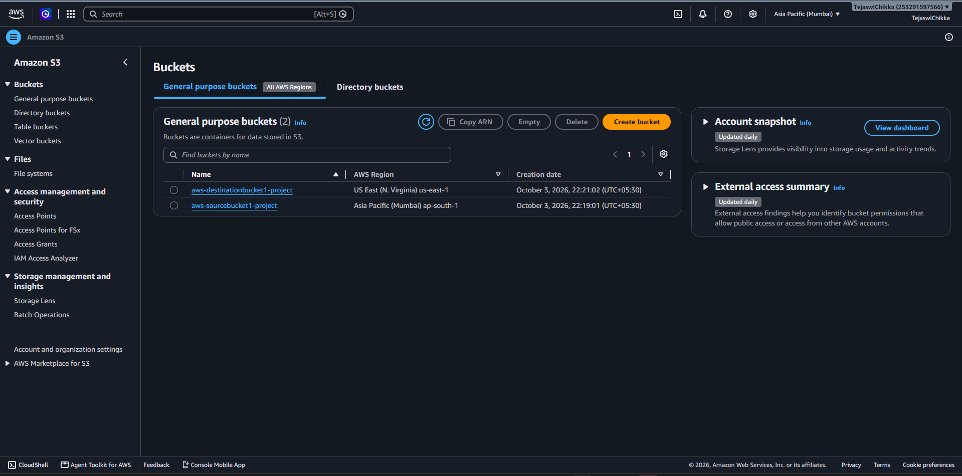

Figure 2. Source bucket versioning
The source bucket's versioning setting is enabled.
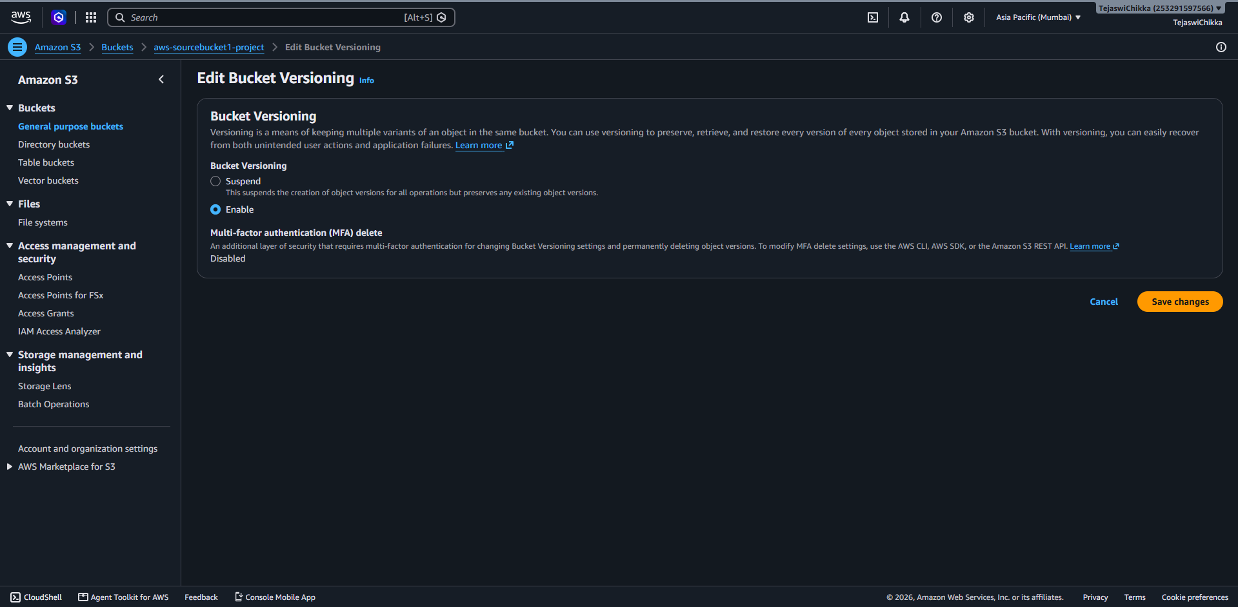

Figure 3. Replication rules overview
The source bucket shows one enabled replication rule and the configured destination.
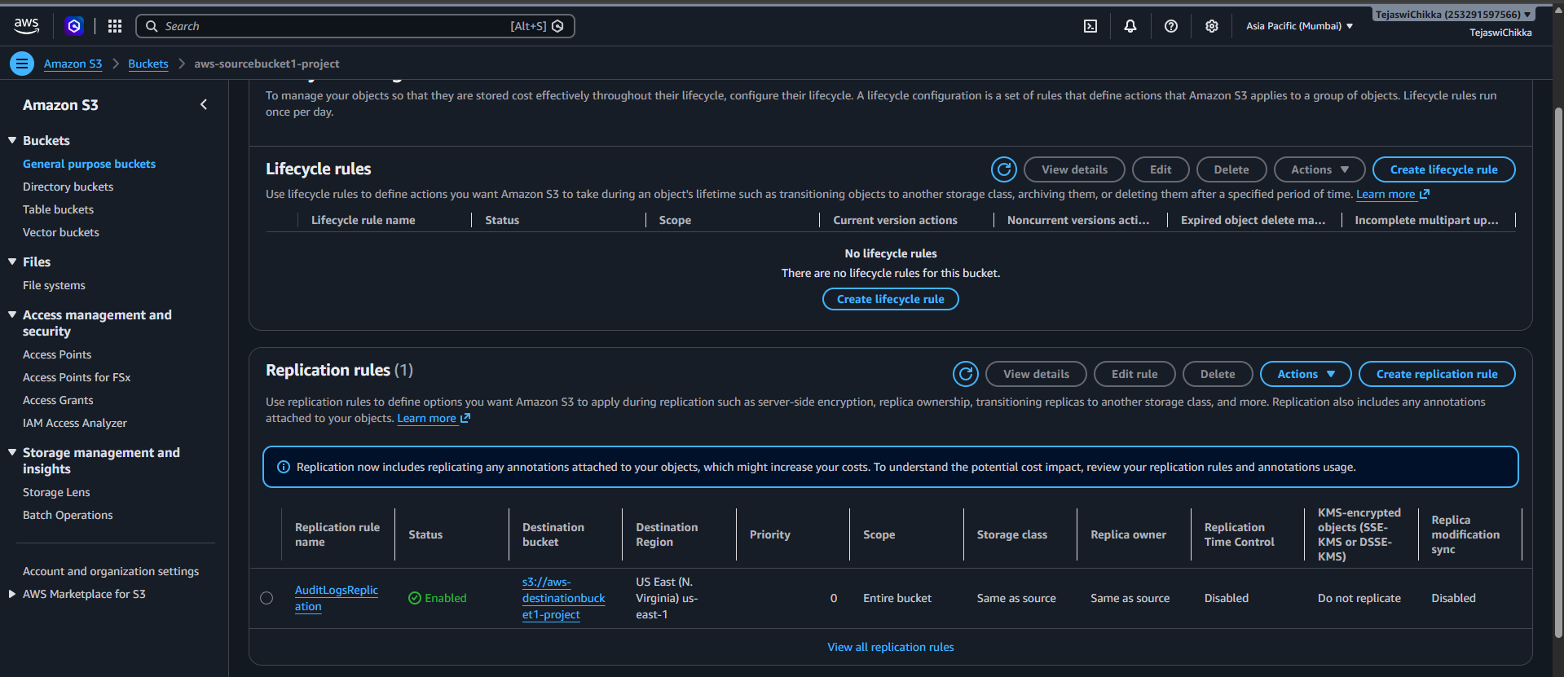

Figure 4. Replication rule creation
The rule name, enabled status, source bucket, and all-object scope are visible.
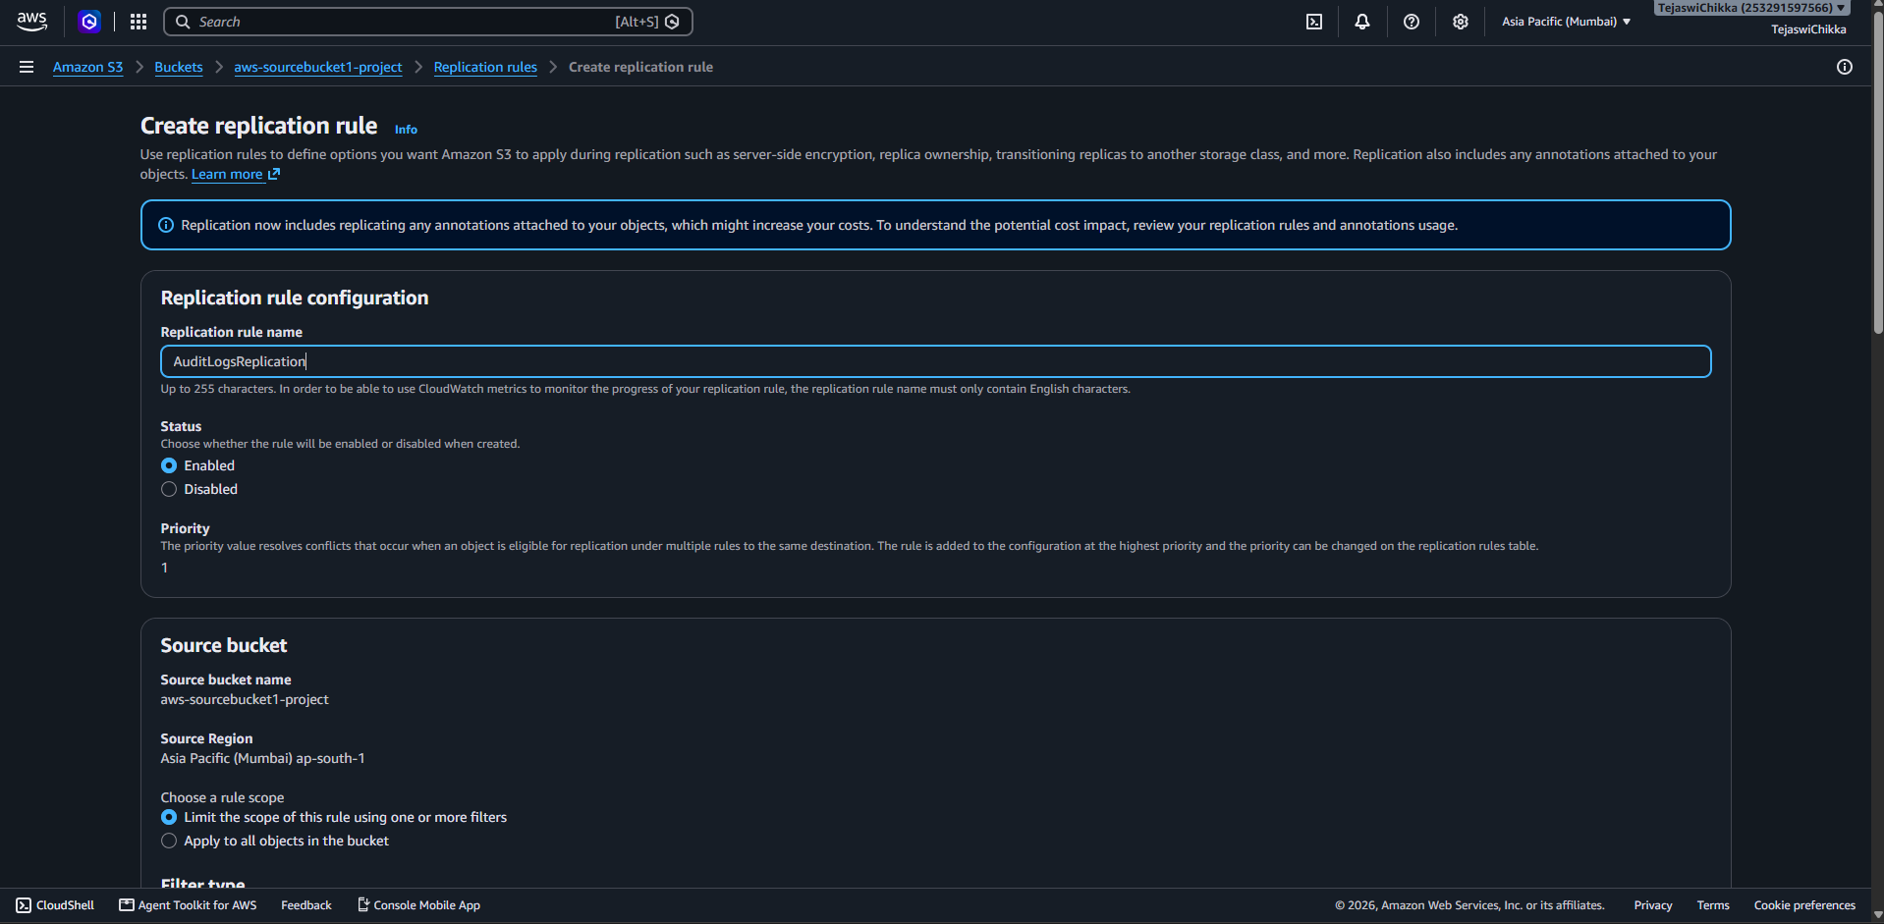

Figure 5. Source audit-log object
The source bucket contains audit-log-01.txt.
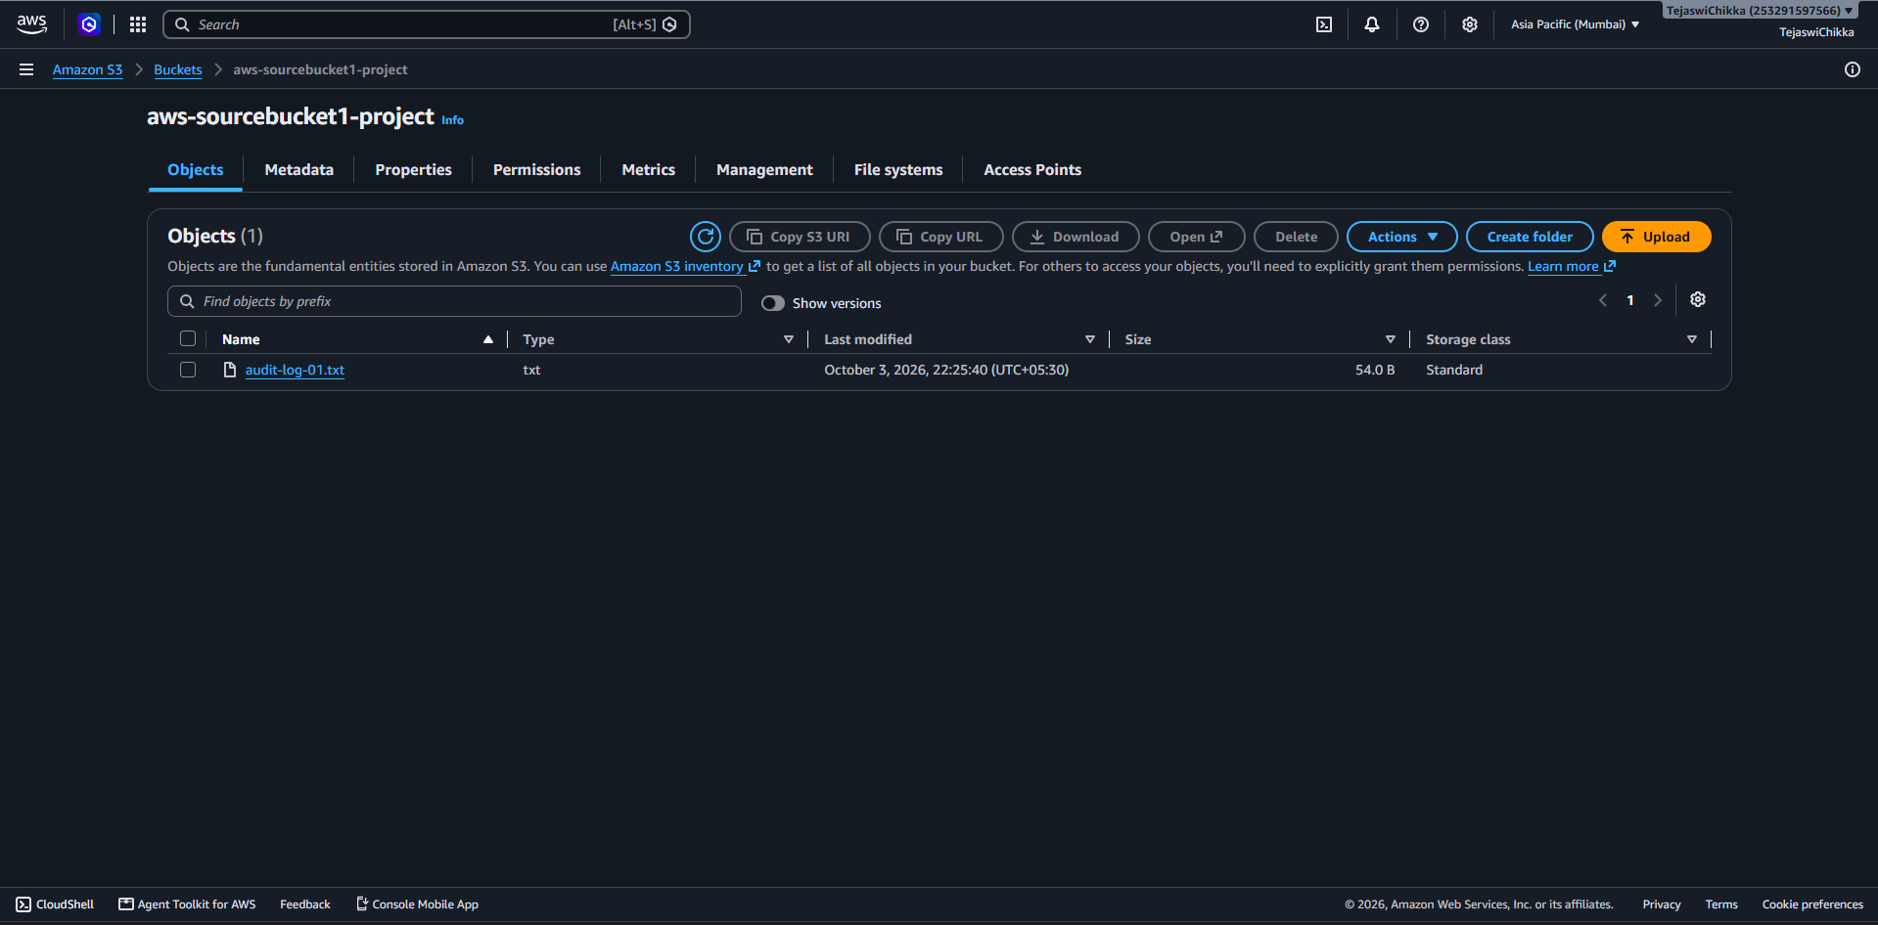

Figure 6. Replication rule destination and scope
The configuration identifies the source and destination buckets in separate Regions.
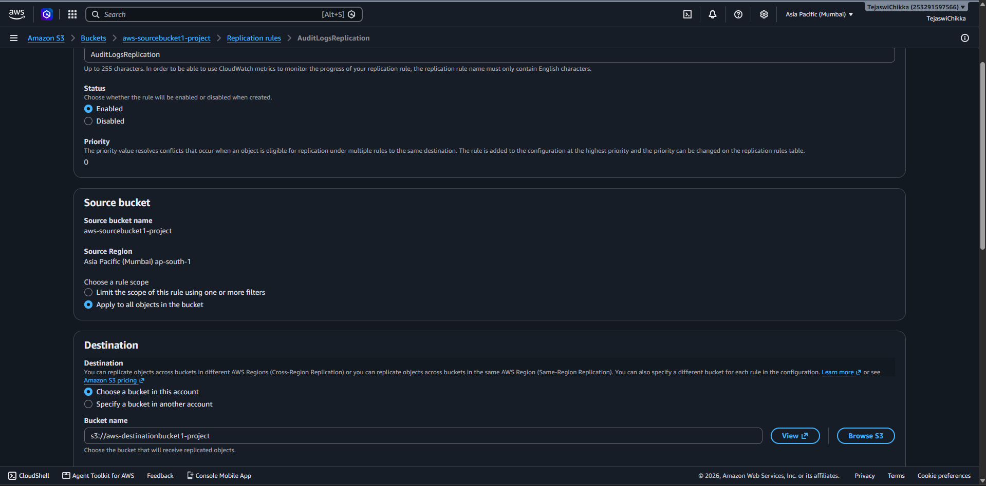

Figure 7. Object replication status
The source object properties show Replication status: COMPLETED.
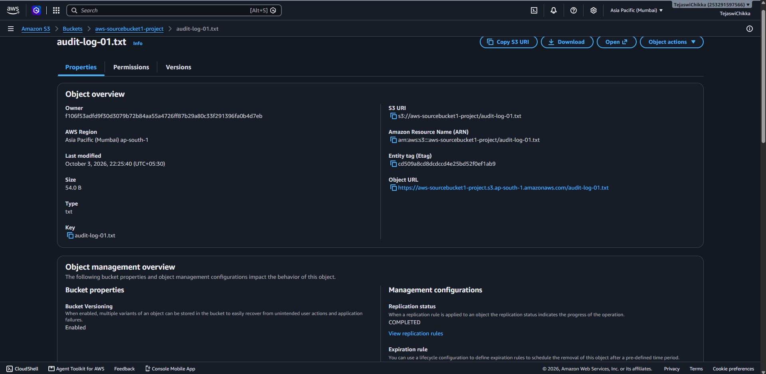

Figure 8. Additional replication options
The selected IAM role and delete-marker replication setting are visible.
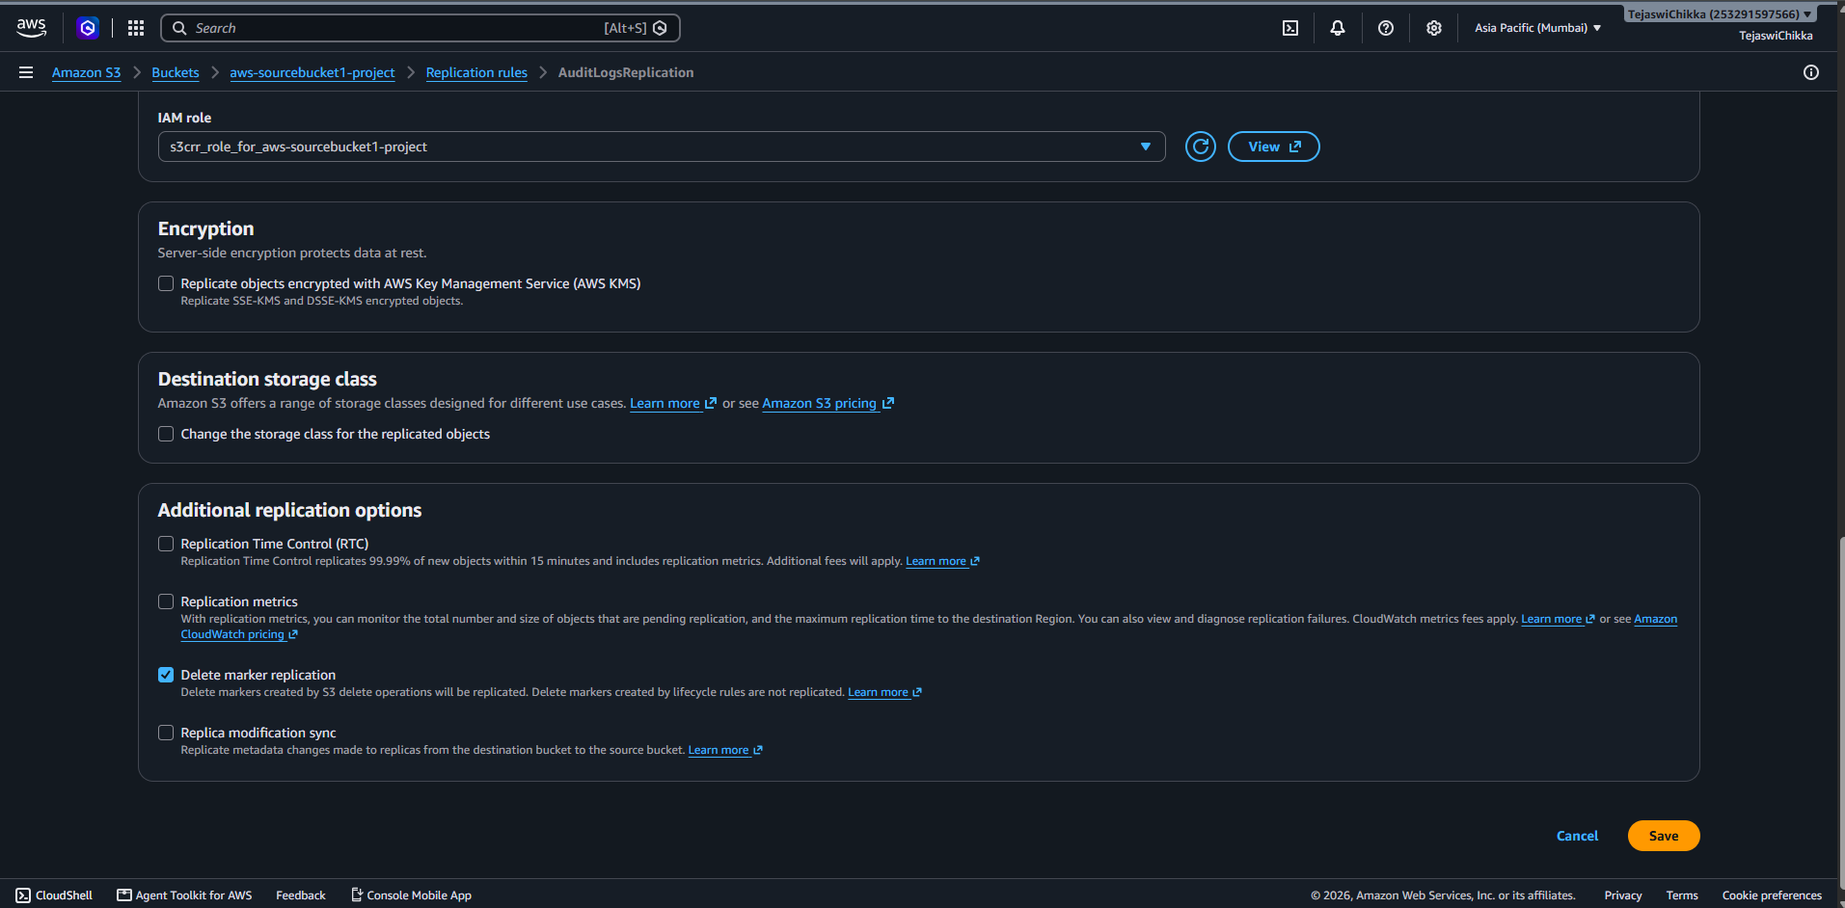

7. Testing and Results
Test | Evidence | Result
Source and destination buckets | Bucket list with Regions | Configured
Source versioning | Edit Bucket Versioning screen | Enabled
Replication rule | Replication rules overview | Enabled
Sample object | audit-log-01.txt in source bucket | Uploaded
Replication status | Object properties show COMPLETED | Successful for the test object
Delete-marker replication option | Rule options screen | Enabled in captured configuration; end-to-end deletion test not shown

8. Important Bottlenecks and Considerations

8.1 Existing objects
A live replication rule generally applies automatically to eligible new object versions after the rule is enabled; it does not automatically backfill all objects that already existed. Existing objects can be handled with S3 Batch Replication. A compliance deployment should identify pre-existing objects and verify that the required historical data has been replicated.

8.2 Delete markers
The captured rule has Delete marker replication selected. When enabled, delete markers created by supported S3 delete operations can be replicated; delete markers created by lifecycle expiration are not replicated by this setting. A delete marker generally makes an object appear deleted in normal listings but does not itself erase previous object versions. Test deletion behaviour in both Regions before relying on it for retention or audit requirements.

8.3 Data residency and compliance
The current destination is US East (N. Virginia), while the source is in Mumbai. This demonstrates cross-region replication, but it may not satisfy a requirement to keep data only in India or another specified geography. Confirm the permitted Region with the organization's compliance owner before storing regulated audit logs.

8.4 Permissions, encryption, and monitoring
The IAM role must permit S3 to read eligible source versions and replicate objects to the destination. The captured configuration does not enable replication of AWS KMS-encrypted objects, Replication Time Control, or replication metrics. If the workload needs KMS-encrypted log replication or operational alerts, configure and test the required permissions, key policies, metrics, and alarms.

8.5 Cost and operational impact
Cross-Region Replication can incur destination storage, inter-Region data transfer, requests, and optional monitoring or RTC charges. Estimate costs and apply least-privilege access, lifecycle policies, and appropriate retention controls.

9. Security and Compliance Recommendations
- Choose a destination Region that is approved for the data classification and residency rules.
- Use least-privilege IAM permissions and review bucket policies regularly.
- Consider encryption at rest and configure KMS replication correctly if required.
- Use S3 Object Lock or suitable retention controls when immutable audit-log retention is required and approved.
- Monitor replication failures and pending replication where operationally necessary.
- Test new objects, pre-existing objects, versioning, delete markers, and recovery procedures.

10. Conclusion
The project configured Amazon S3 Cross-Region Replication from aws-sourcebucket1-project in Mumbai to aws-destinationbucket1-project in N. Virginia. Versioning was enabled on the source bucket, an enabled all-object rule named AuditLogsReplication was created, and the sample object audit-log-01.txt showed a replication status of COMPLETED. The implementation demonstrates the core CRR workflow. Before using it for real compliance workloads, the destination Region, destination versioning, historical-object backfill, deletion behaviour, encryption, retention, monitoring, and cost should be validated.

Appendix A. Project Configuration Summary
Feature | Captured configuration
Source bucket | aws-sourcebucket1-project
Source Region | ap-south-1 (Mumbai)
Destination bucket | aws-destinationbucket1-project
Destination Region | us-east-1 (N. Virginia)
Rule name | AuditLogsReplication
Rule status | Enabled
Scope | Entire bucket / all objects
IAM role | s3crr_role_for_aws-sourcebucket1-project
Delete marker replication | Enabled
Replication Time Control | Not enabled in captured settings
Replication metrics | Not enabled in captured settings
Replica modification sync | Not enabled in captured settings
KMS-encrypted object replication | Not enabled in captured settings
Test object | audit-log-01.txt
Observed replication status | COMPLETED

