**1. Git-HOL**

**Objectives**

Familiar with Git commands like git init, git status, git add, git commit, git push, and git pull.

In this hands-on lab, you will learn how to

* Setup your machine with Git Configuration
* Integrate notepad++.exe to Git and make it a default editor
* Add a file to source code repository

**Step 1: Git Configuration**

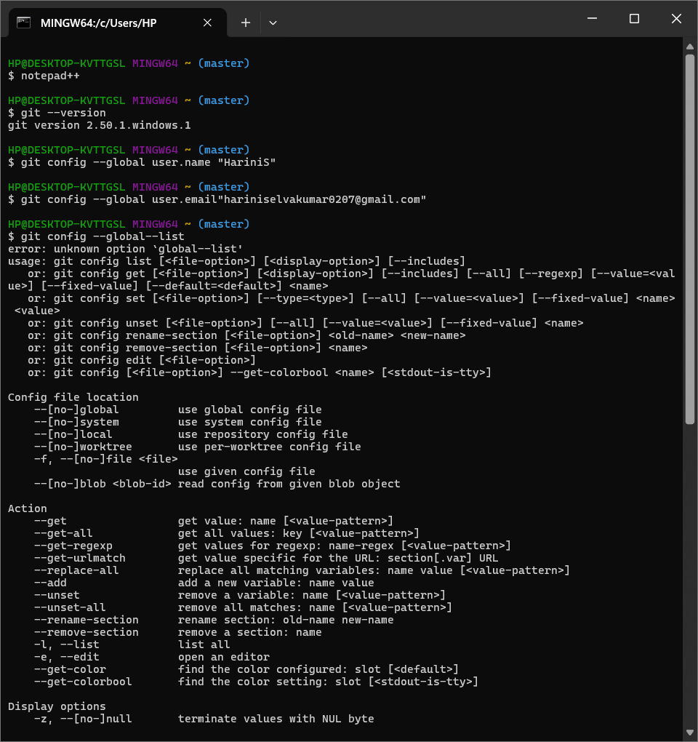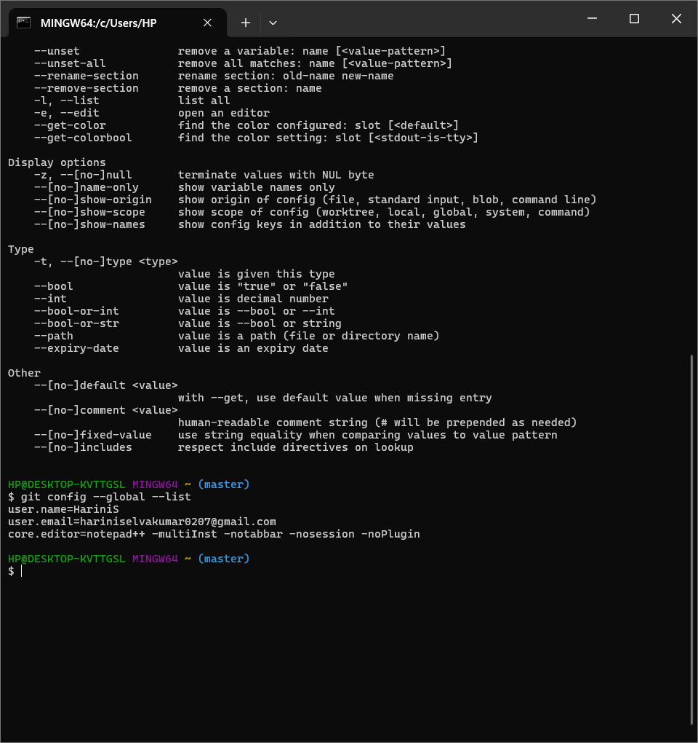

**Step 2: Integrate notepad++.exe to Git and make it a default editor**

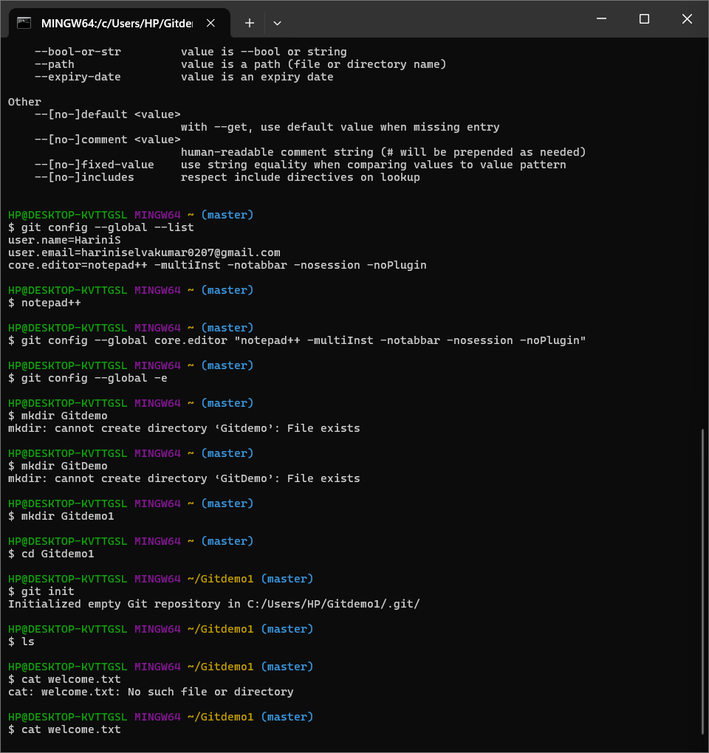

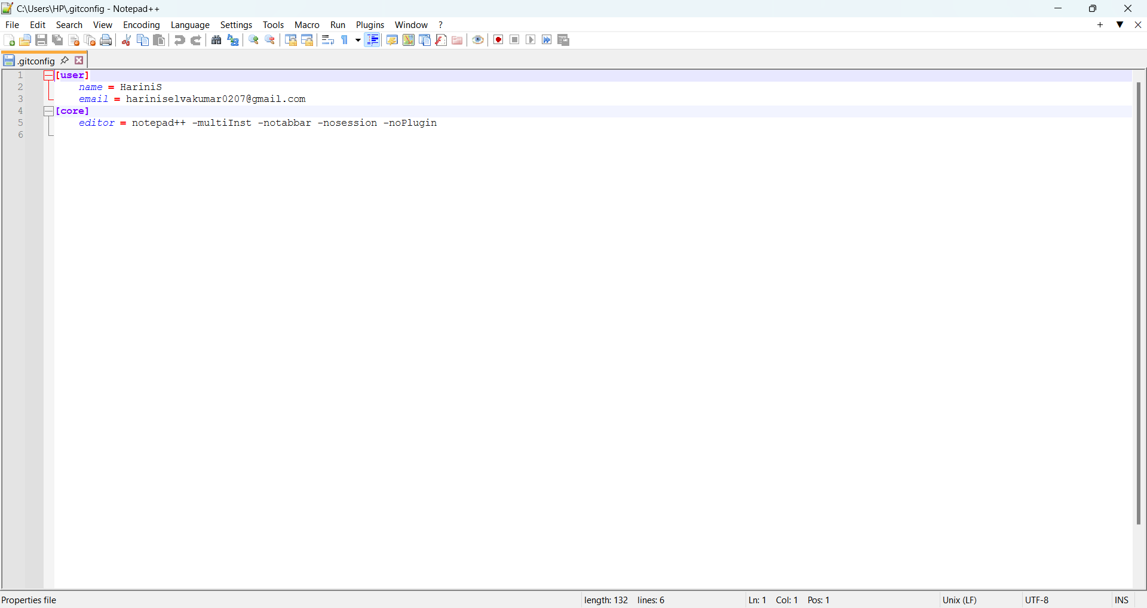

**Step 3: Add a file to source code repository**



**Step 4: Signup with GitLab and create a remote repository “GitDemo”**

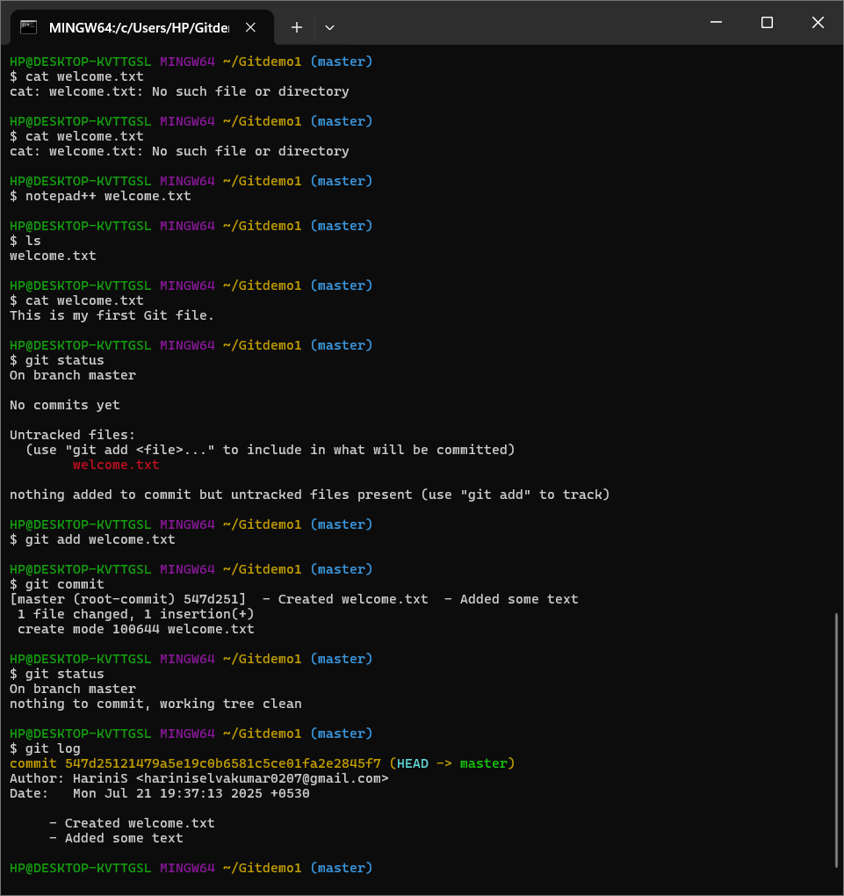

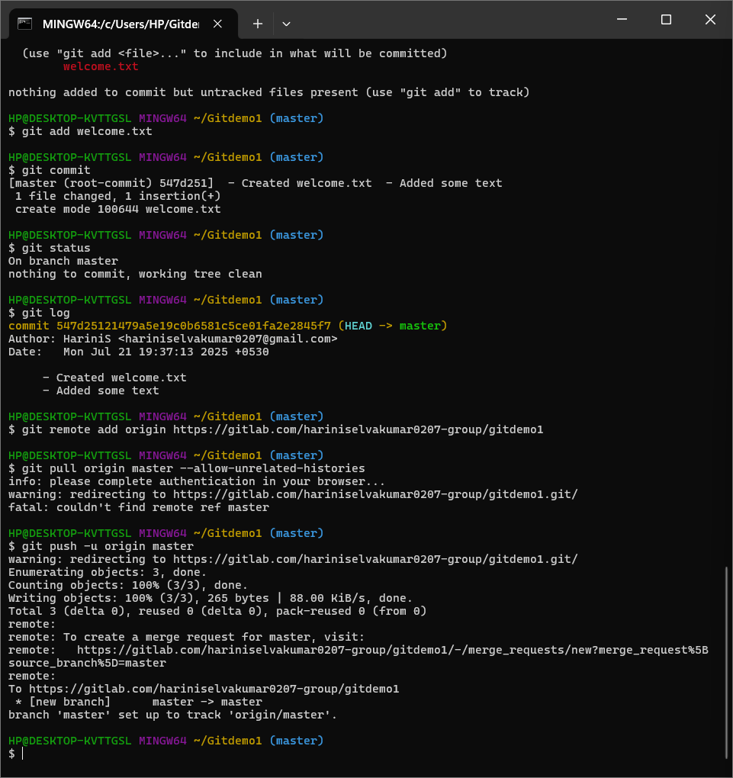

**2. Git-HOL**

**Objectives**

**🡪 Explain git ignore**

.gitignore is a special file in your Git repository that tells Git:

"Do **not track** these files or folders."

It's used to ignore:

* Temporary files (like .log, .tmp)
* Build/output folders (like node_modules/, target/, log/)
* IDE files (.vscode/, .class files, etc.)

In this hands-on lab, you will learn how to:

🡪Implement git ignore command to ignore unwanted files and folders

**🡪Explain how to ignore unwanted files using git ignore**

**Git Ignore Implementation:**

1. **Created unwanted file and folder:**

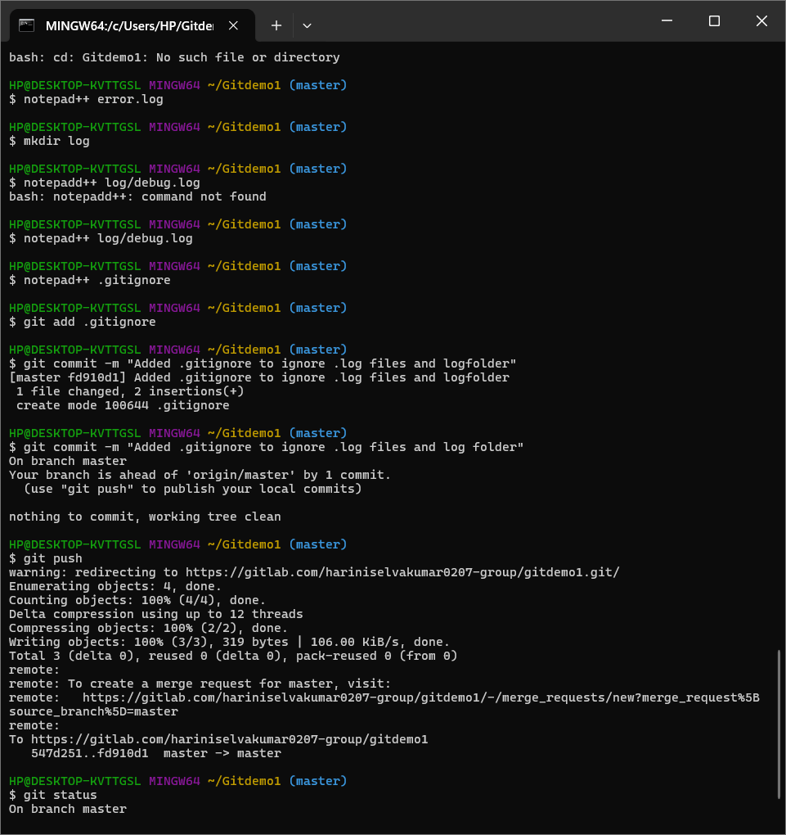

**2.Created .gitignore file and added:**



**\*.log**

**log/ (added inside the notepad++)**

**3.Added and committed .gitignore:**





**4.** **Verified using:**

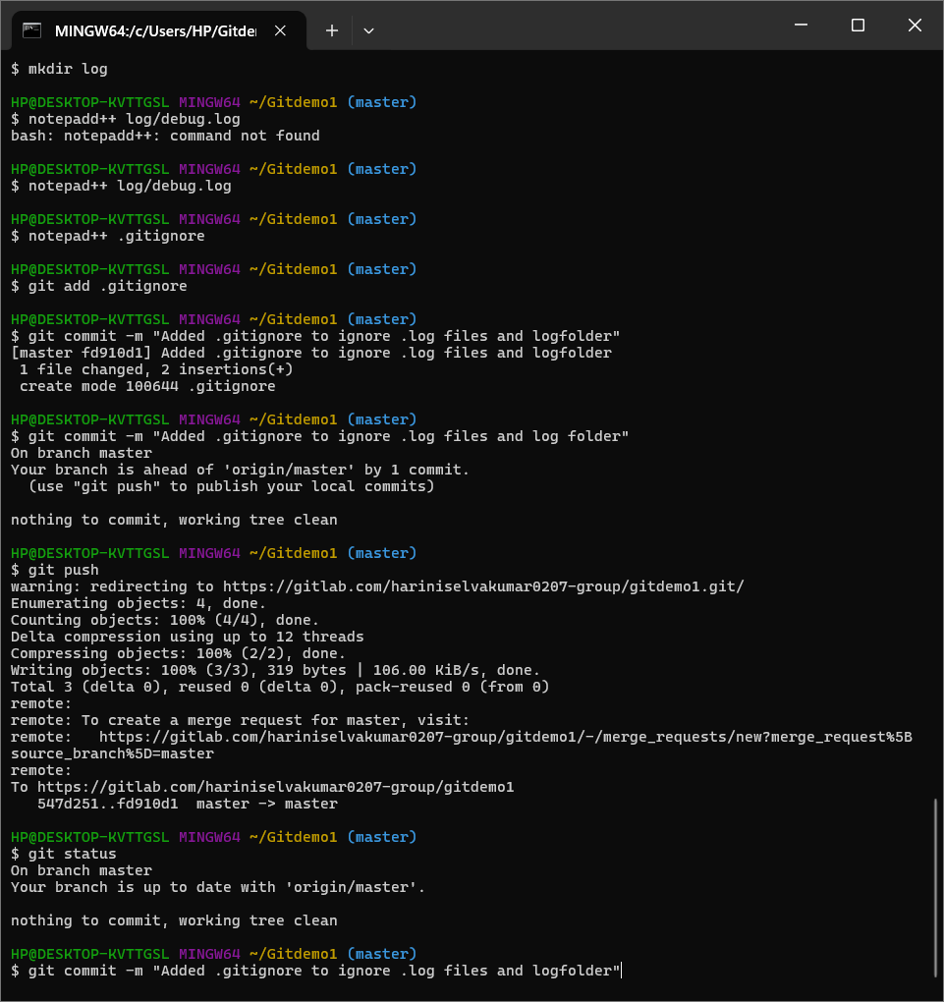

**3.Git-HOL**

**Objectives**

Explain branching and merging

Explain about creating a branch request in GitLab

Explain about creating a merge request in GitLab

In this hands-on lab, you will learn how to:

Construct a branch, do some changes in the branch, and merge it with master (or trunk)

**Part 1: Branching**

**Step 1: Create a new branch**

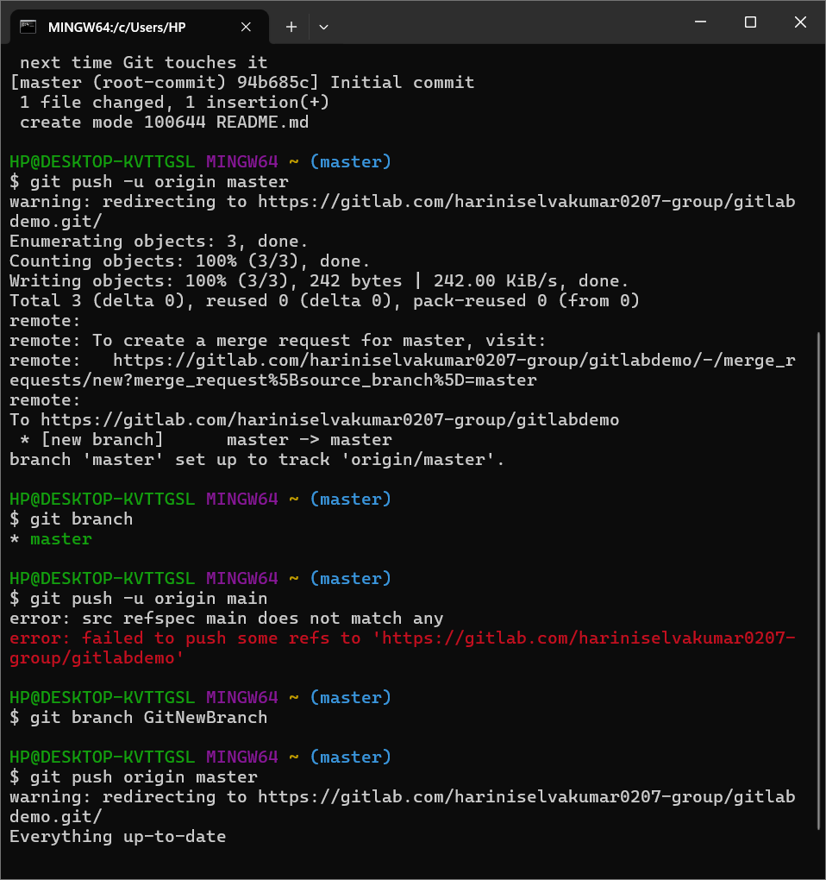

**Step 2: List all local branches**



**Step 3: Switch to the new branch**

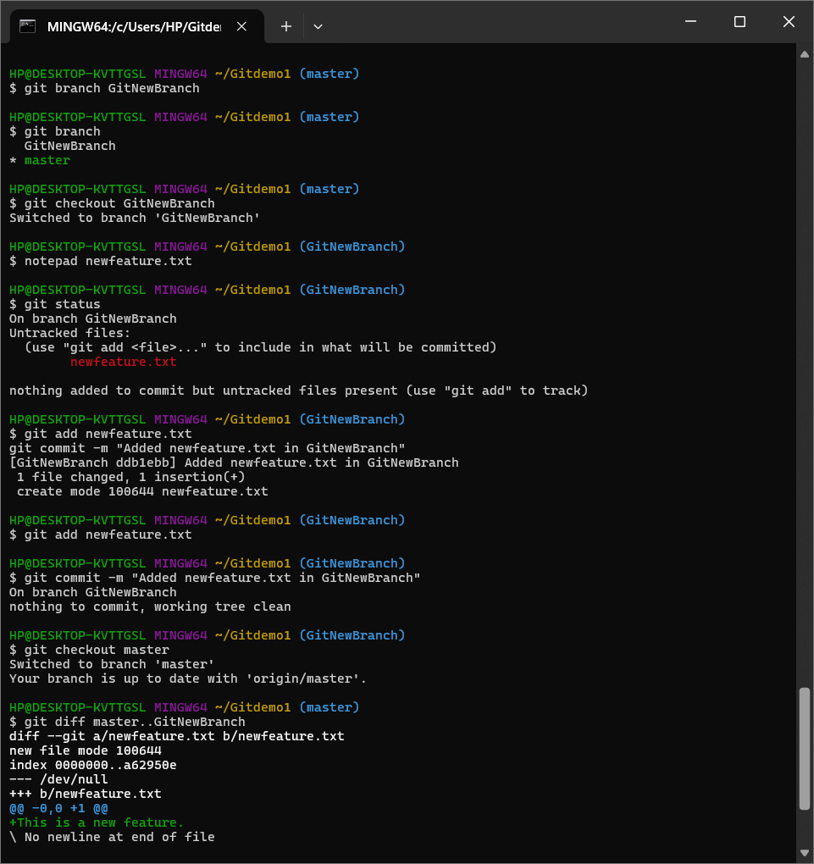

**Step 4: Create a new file in the branch**

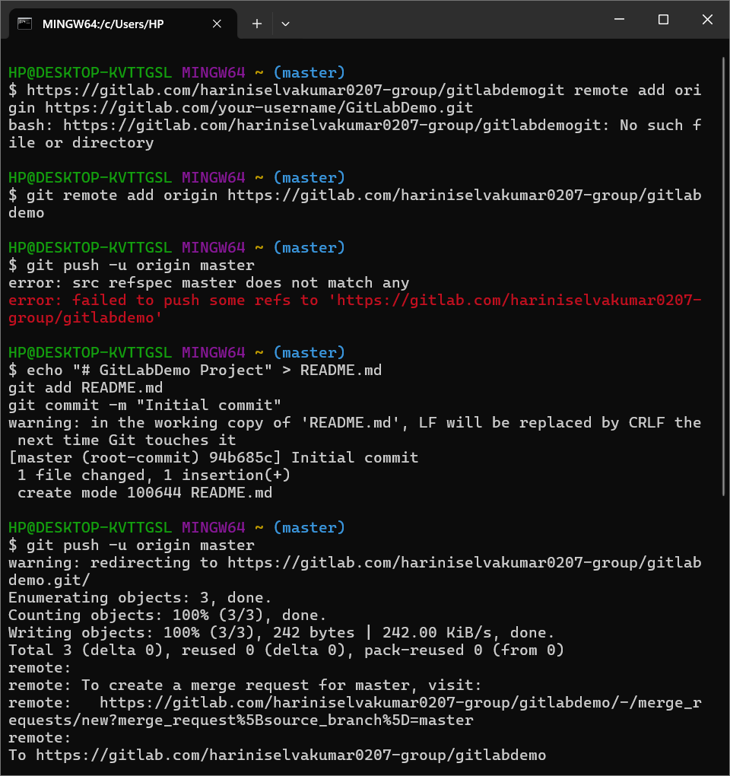

**Step 5: Check branch status**

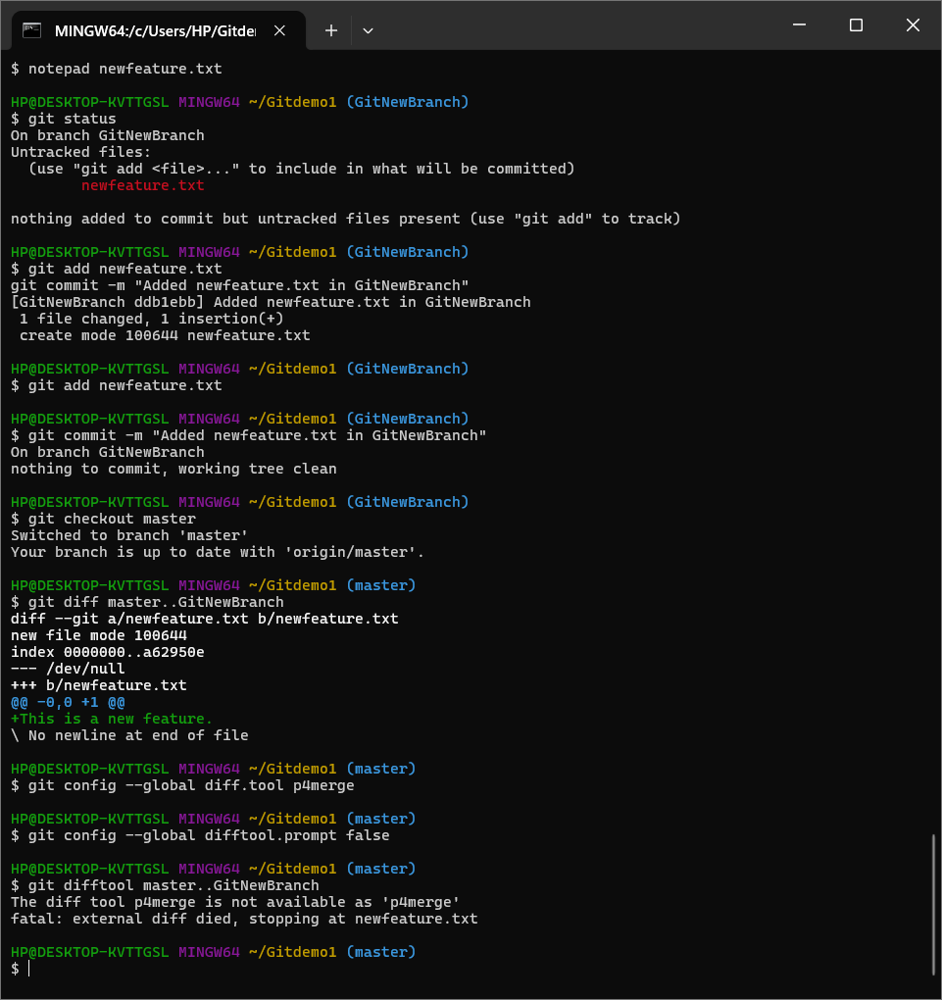

**Part 2: Merging**

**Step 1: Switch back to master**



**Step 2: See differences between branches (CLI)**



**Step 3: See visual differences (P4Merge)**

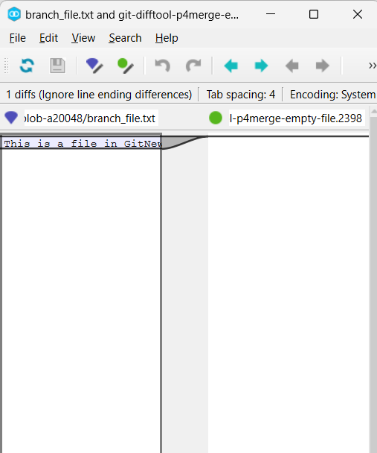

**Step 4: Merge GitNewBranch into master**

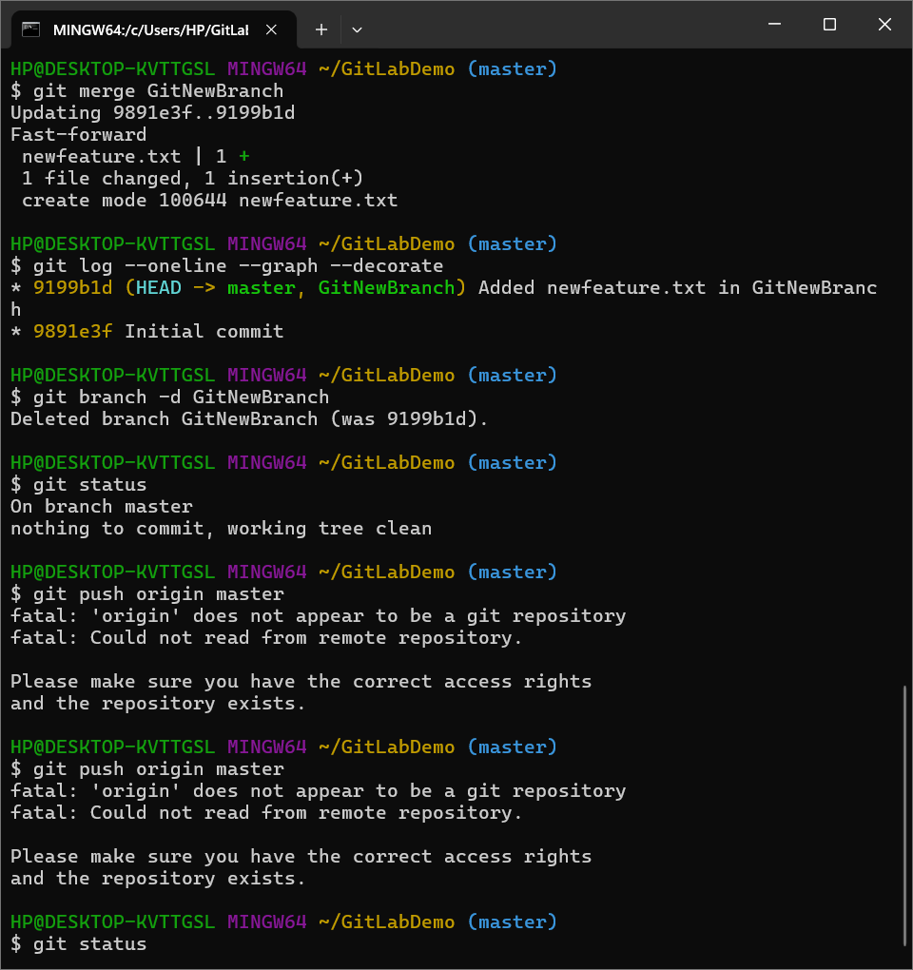

**Step 5: View merge history visually**



**Step 6: Delete the merged branch**



**Verify:**



**🡪** **Successfully practiced Git branching and merging using CLI and visual tools.**

**4. Git-HOL**

**Objectives**

Explain how to resolve the conflict during merge.

In this hands-on lab, you will learn how to:

* Implement conflict resolution when multiple users are updating the trunk (or master) in such a way that it results into a conflict with the branch’s modification.

**Step-by-Step: Conflict Resolution Hands-On Lab**

**1.Verify master is in a clean state**

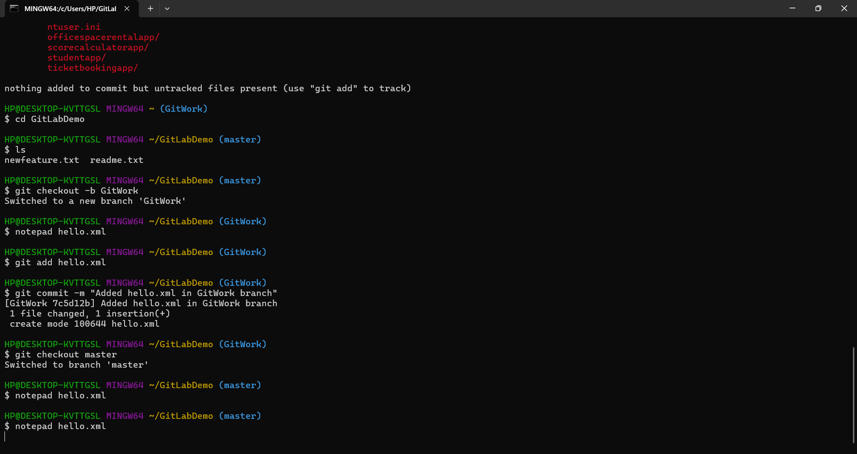

**2.Create branch GitWork and add hello.xml**

**3. Check status and commit**



**4.** **Switch back to master**



**5.** **Create same hello.xml with different content**



**6.** **Observe log (visualize both branches)**

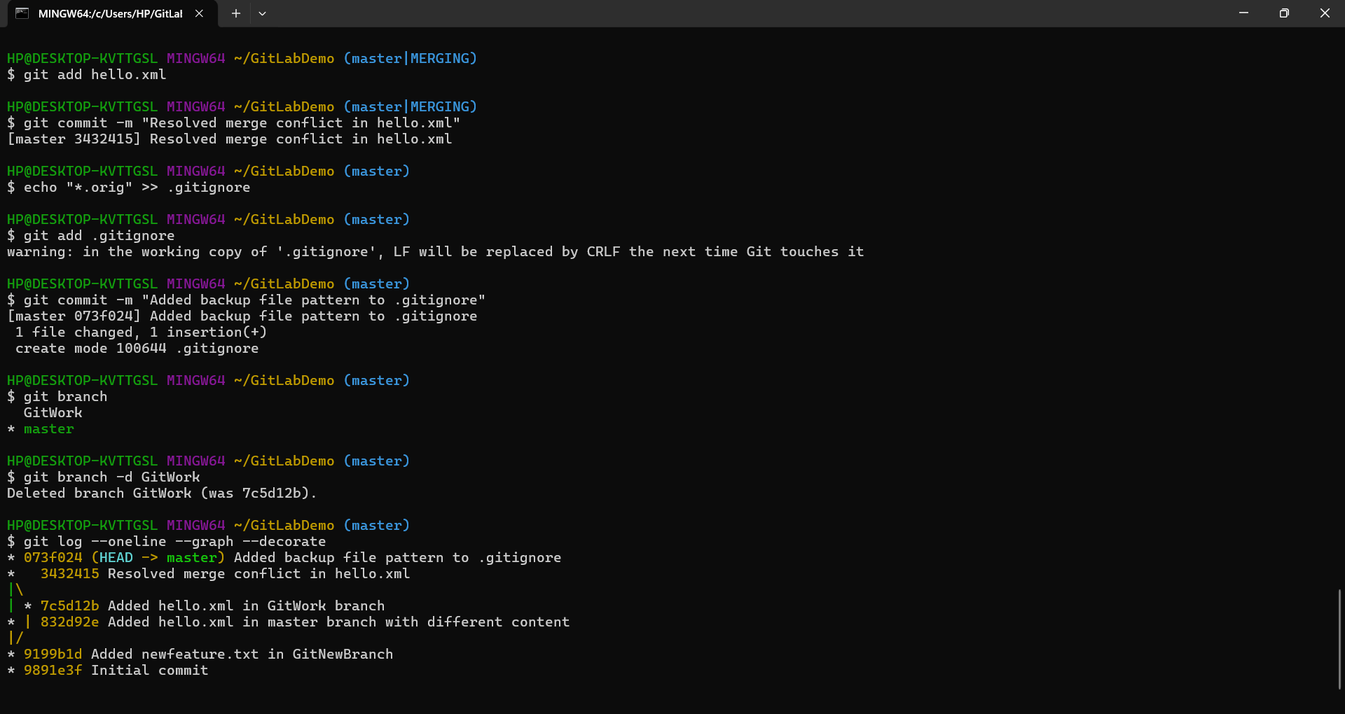

**7.** **Check differences (CLI and GUI)**

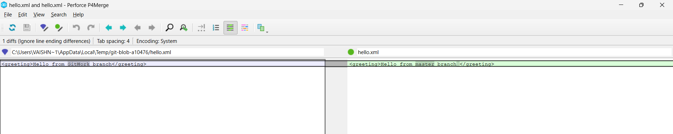

**8. Merge the branch and trigger conflict**

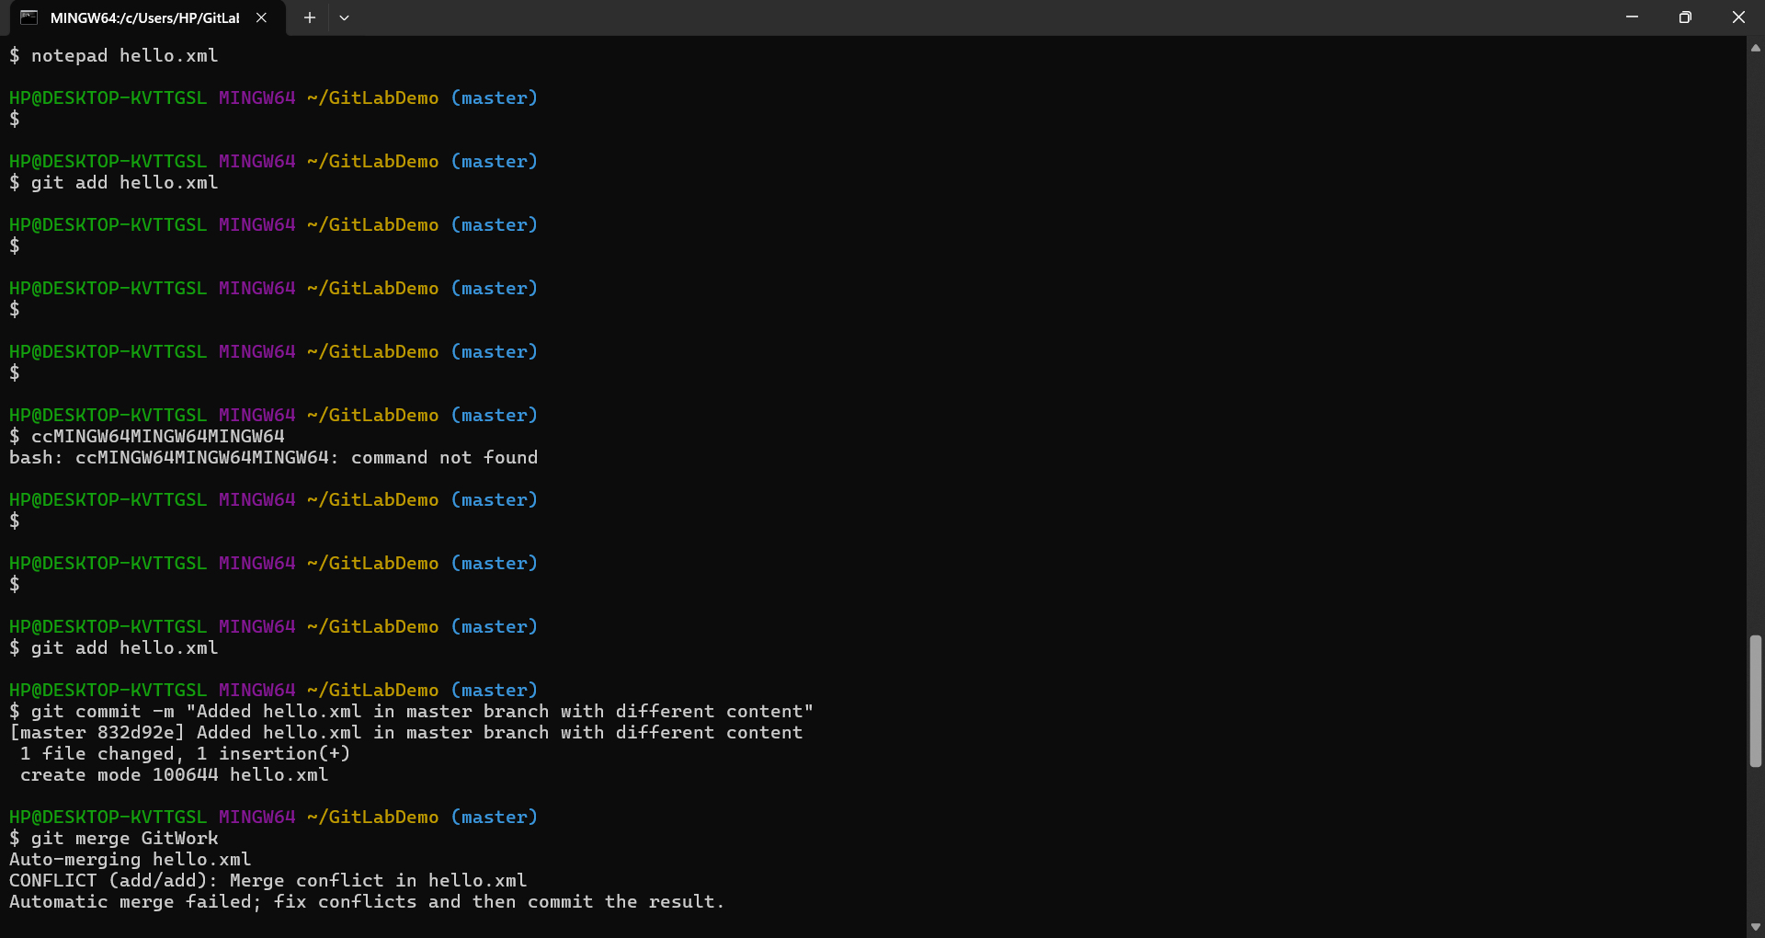

**9. Use 3-way merge with P4Merge**



**10.** **Add backup file to .gitignore**



**11.** **Clean up merged branch**



**12. Final log view**



**5.Git-HOL**

**Objectives**

Explain how to clean up and push back to remote Git

In this hands-on lab, you will learn how to:

🡪Execute steps involving clean up and push back to remote Git.

**Step-by-Step Instructions**

1. **Verify if master is in clean state**

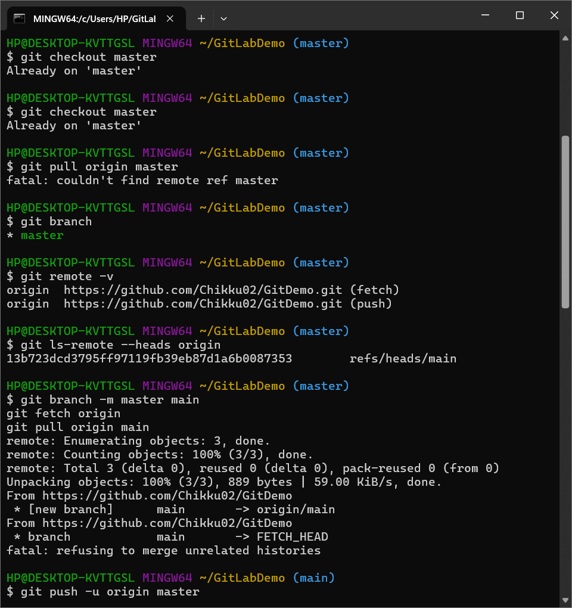

1. **List all available branches**



1. **Pull remote repository**

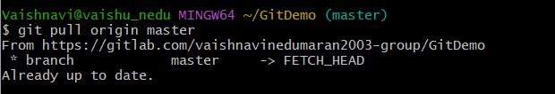

1. **Push all local changes to remote**



1. **Verify changes on GitLab**

