UC 2 GUIDE

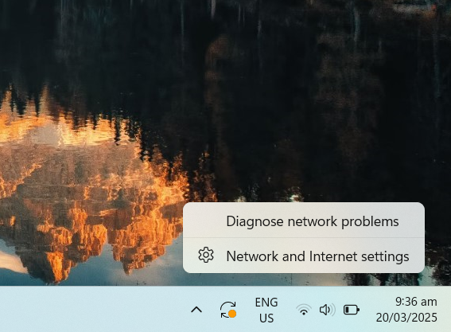
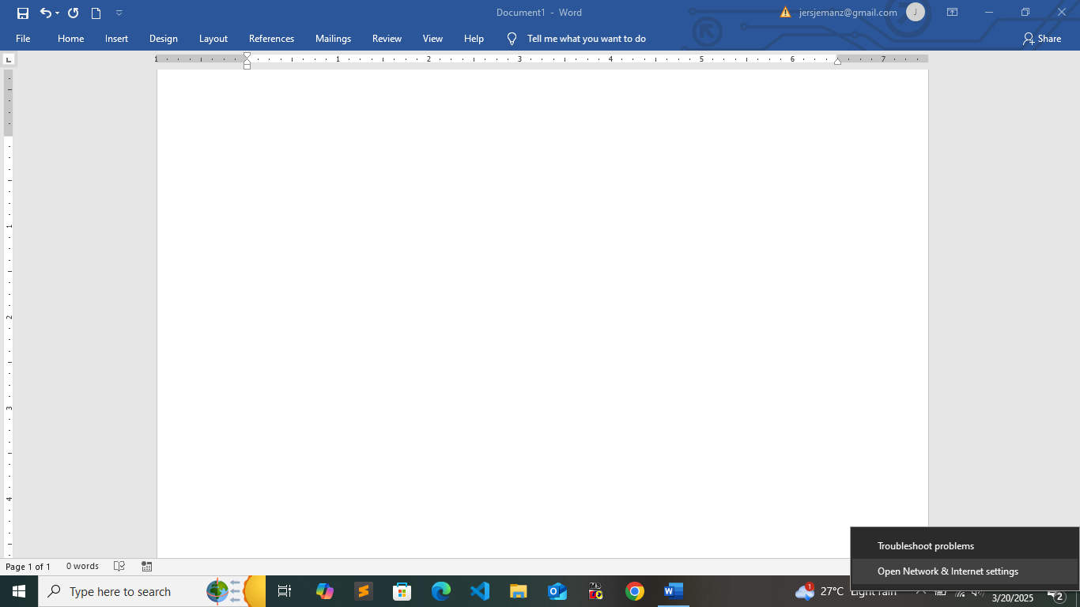
- Go to network and right click, choose Open Network & Internet Settings.

2. Click the Change adapter options.
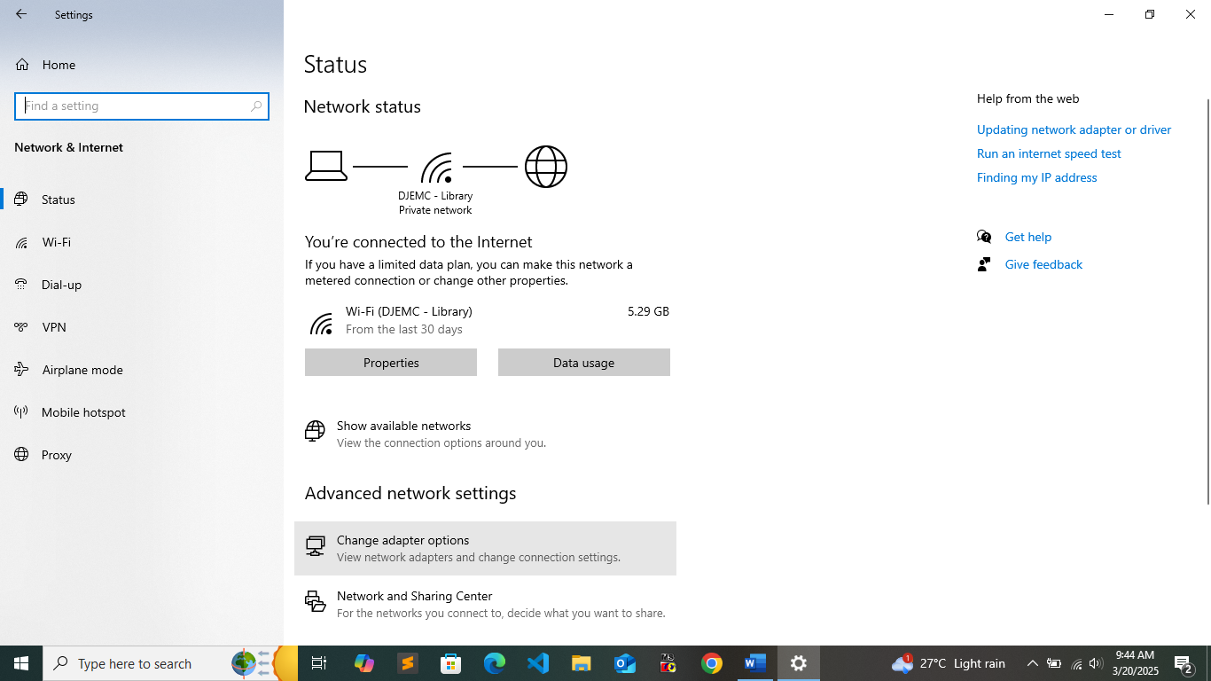

- Go to Ethernet and right click then click the Properties in the menu.
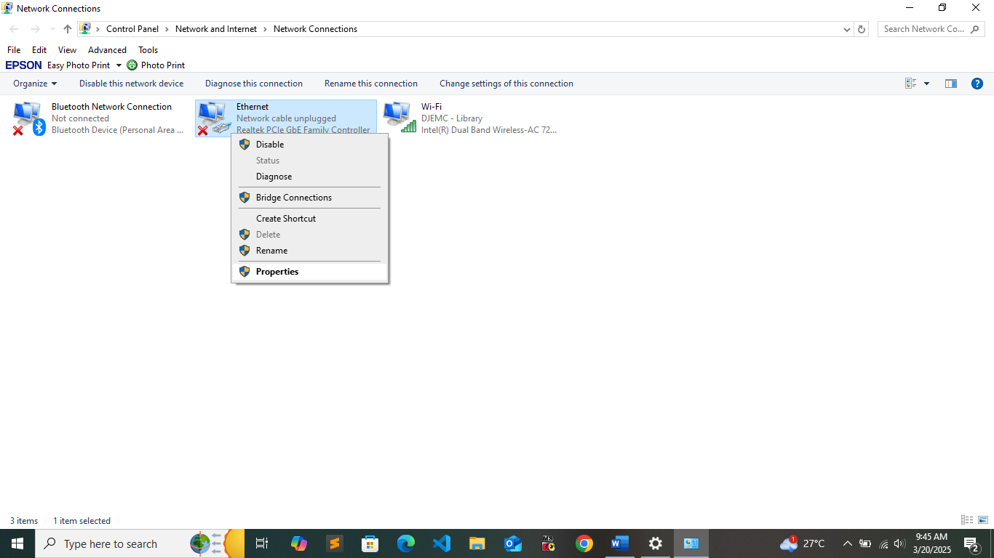

4. In the network menu, click the Internet Protocol Version 4 (TCP/IPv4).
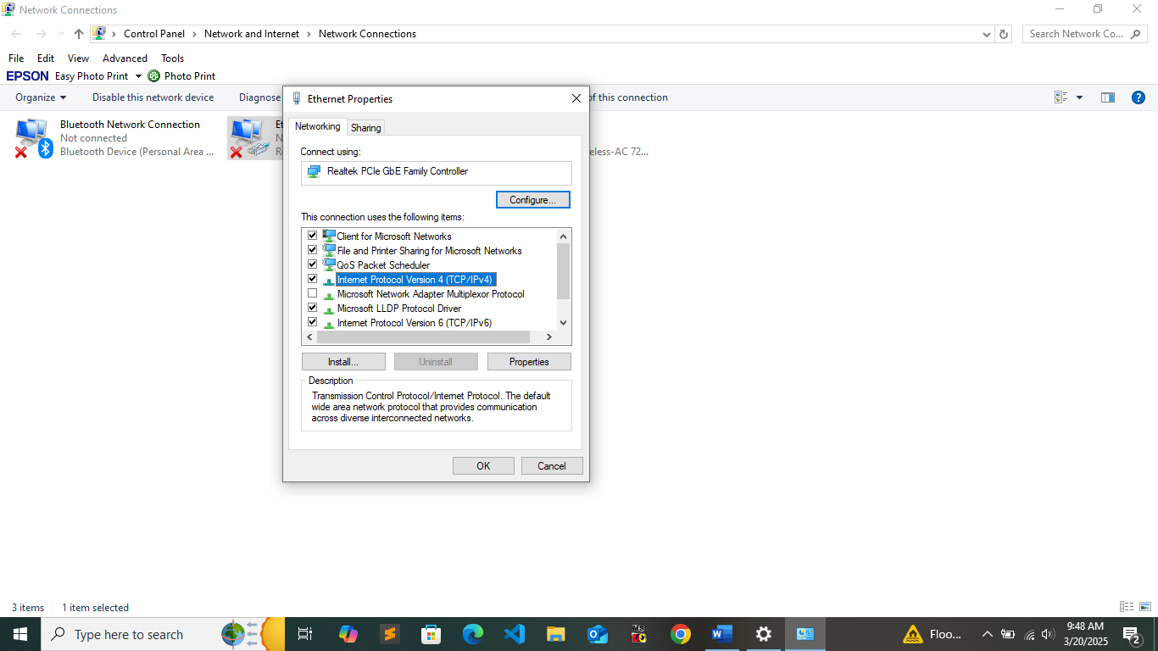

A

5. Then click Properties.


A

6. Click the Obtain an IP address automatically option.
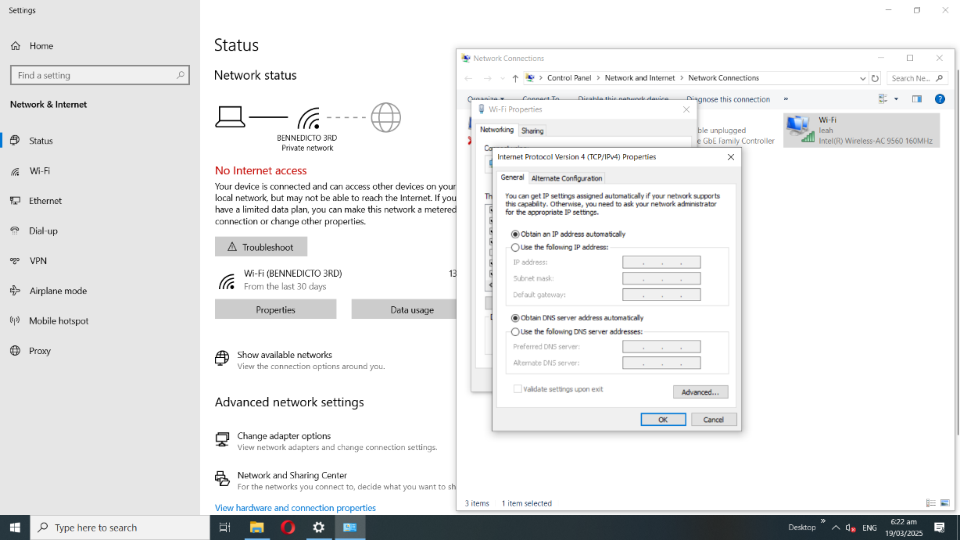

7. Click Windows R and type cmd thend click OK button.
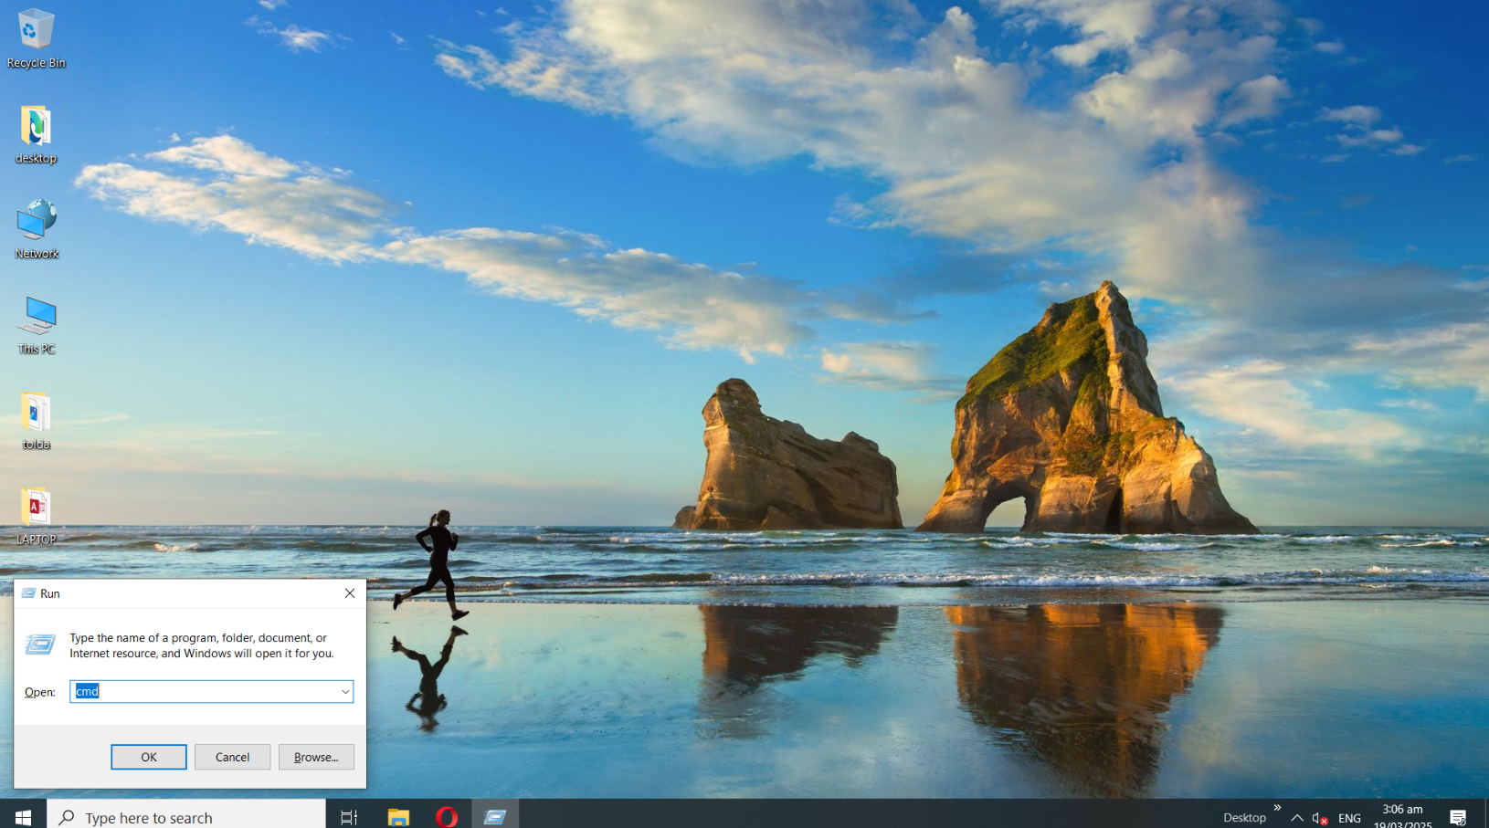

8. Type ipconfig to config your IP Address.
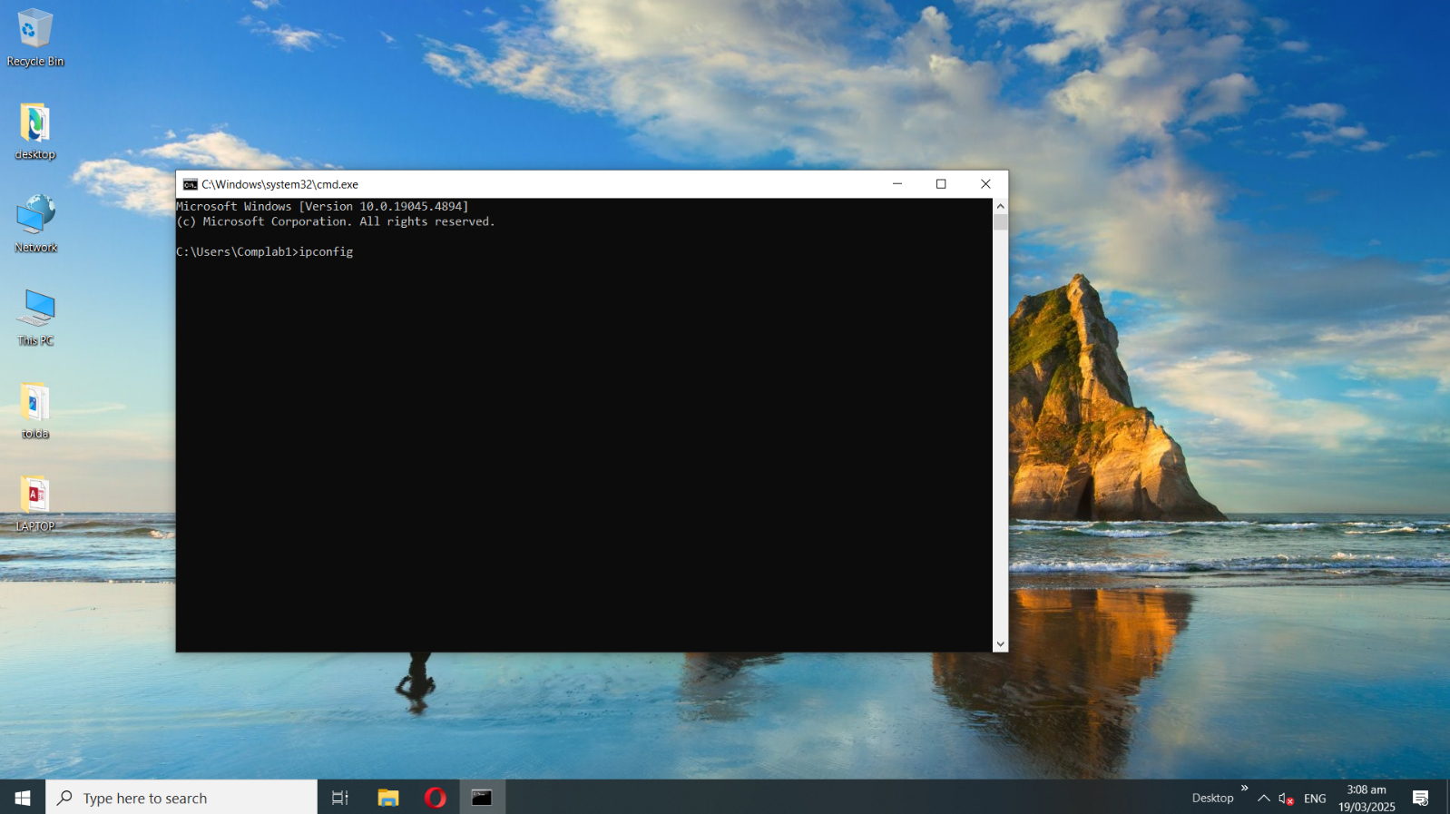

9. Get and copy the IP of Default Gateway.
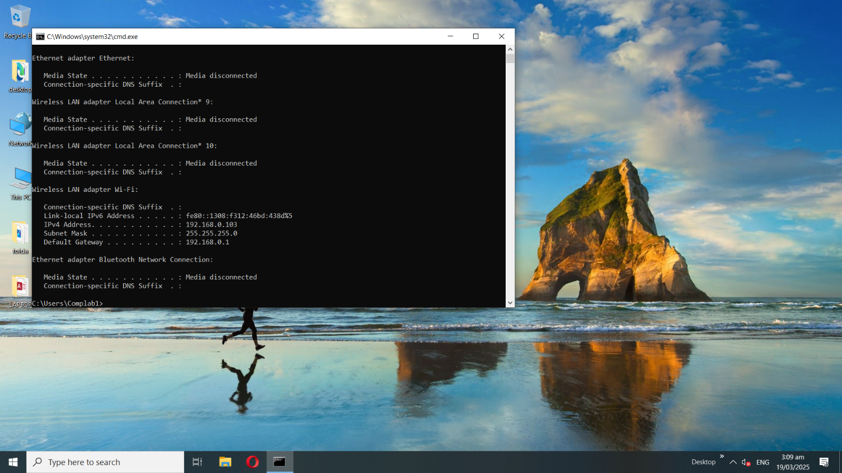

10. Go to internet browser, paste or type the Default Gateway IP Address in the URL search engine then enter. After that click Login.
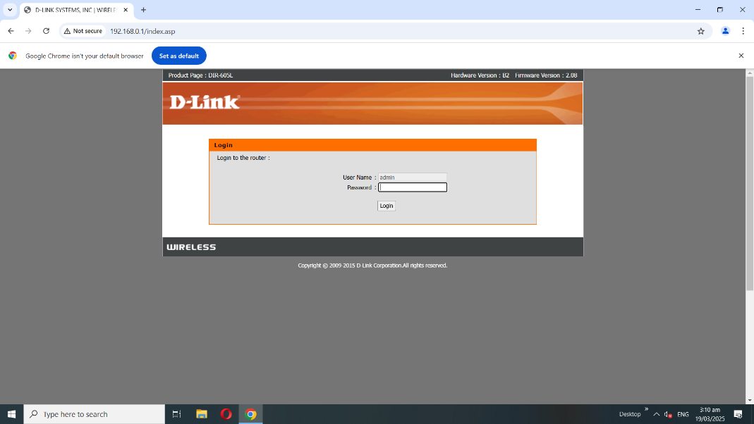

11. Change the Network Name (SSID) based on to the instruction given to your Trainor then click Advance button.
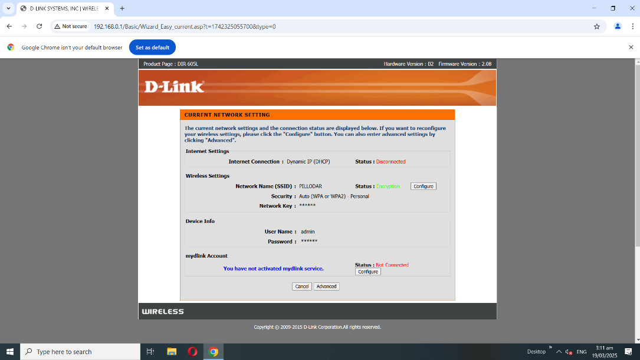

12. Go to the LAN Setup menu and enter your IP address based on the assigned IP class given to you.
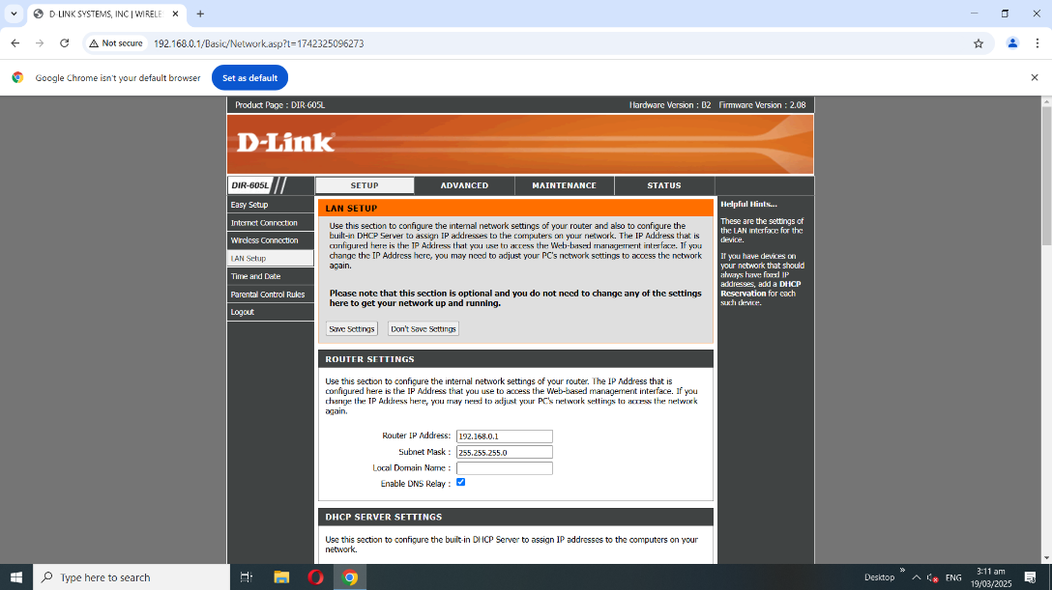

13. Look for the IP address of the WAP in the DHCP client list. You can use that IP address to configure the WAP.
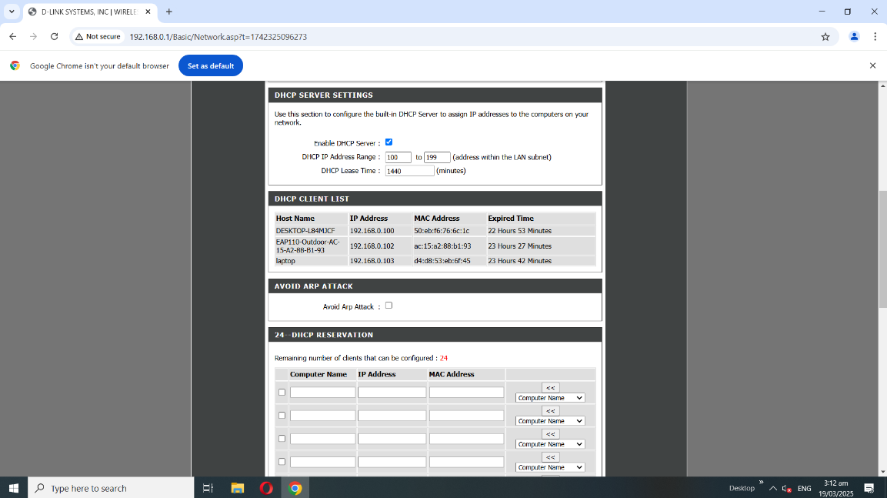

14. Go to the browser and type the IP Address

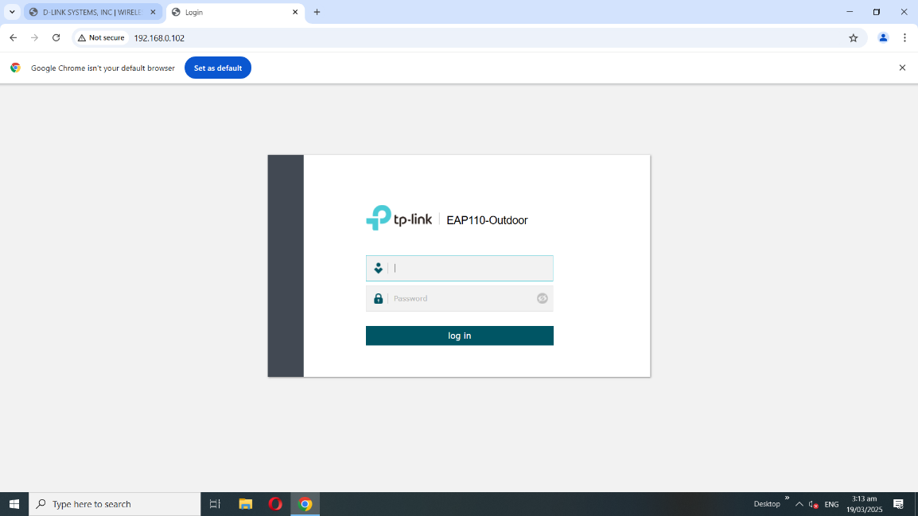

15. Click Windows R and type services.msc then click OK.

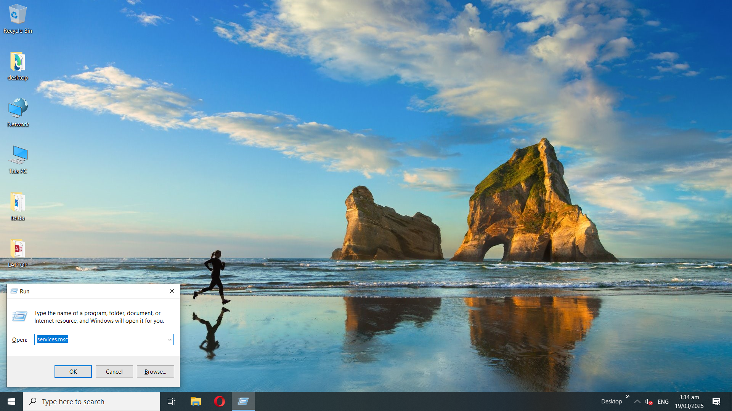

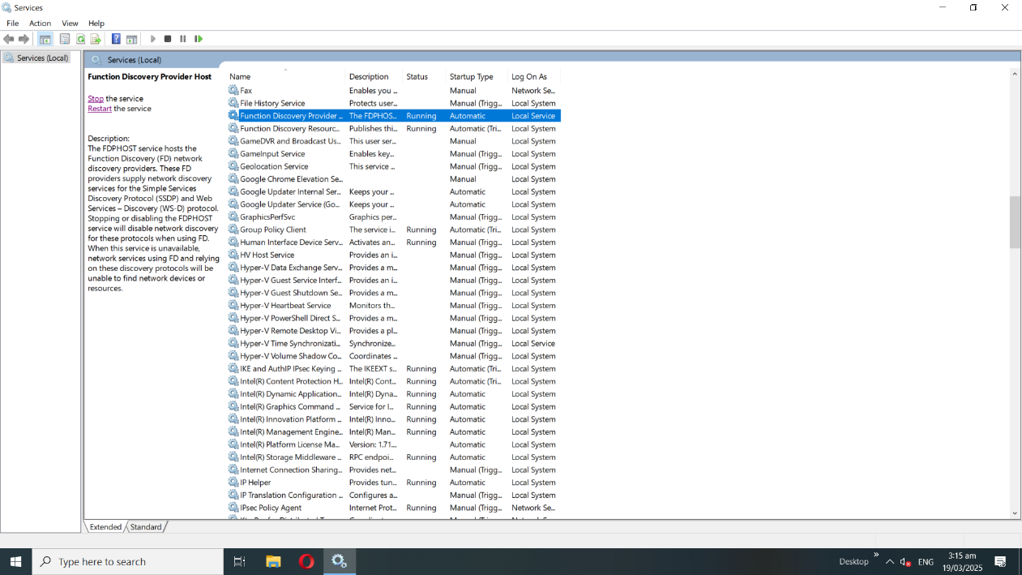
16. Click the Function Discovery Provider and Function Discovery Resources then click Start to run.

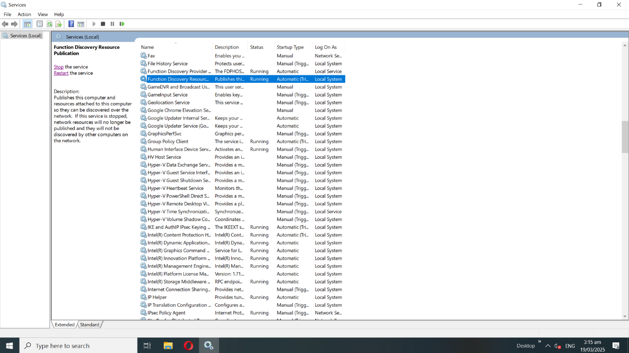

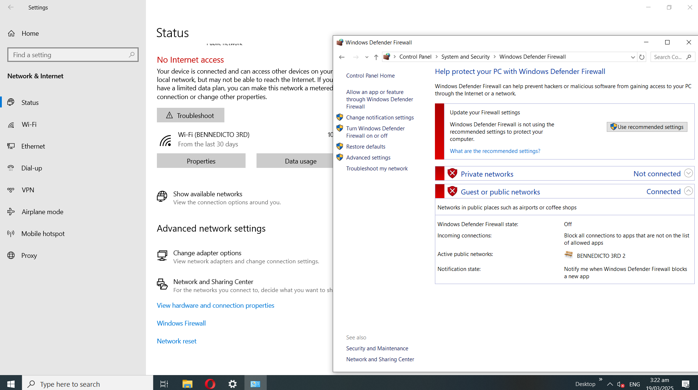
17. Go to settings > Control Panel> System and Security> Windows Defender Firewall.

18. Turn off both public and private network settings Windows Defender Firewall.

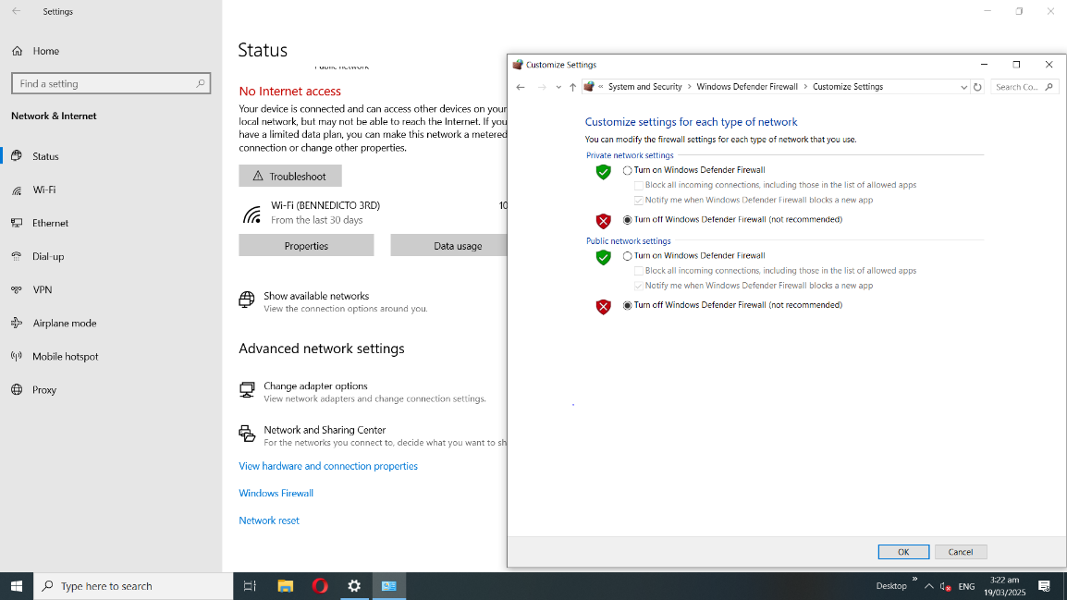

19. Click the Network and Sharing Center and turn on sharing so anyone with network access and write files in the public folders.
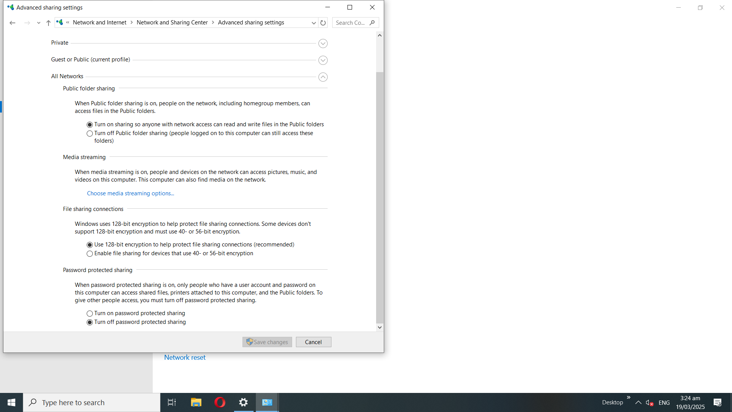
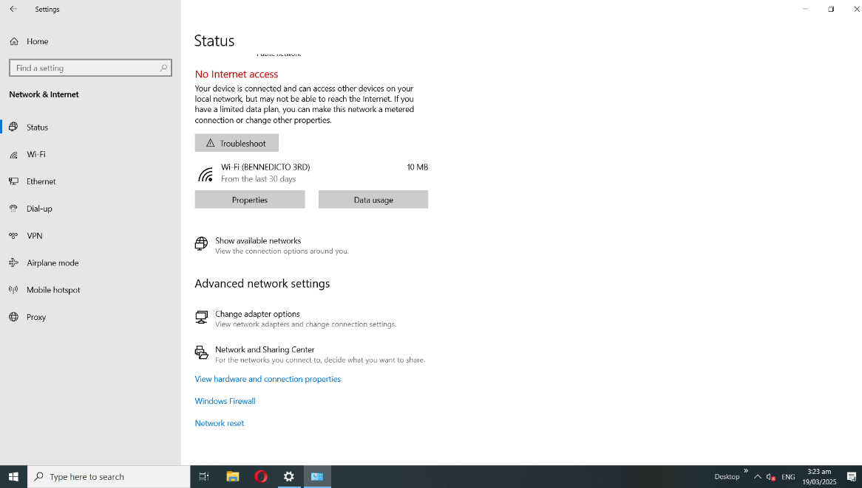

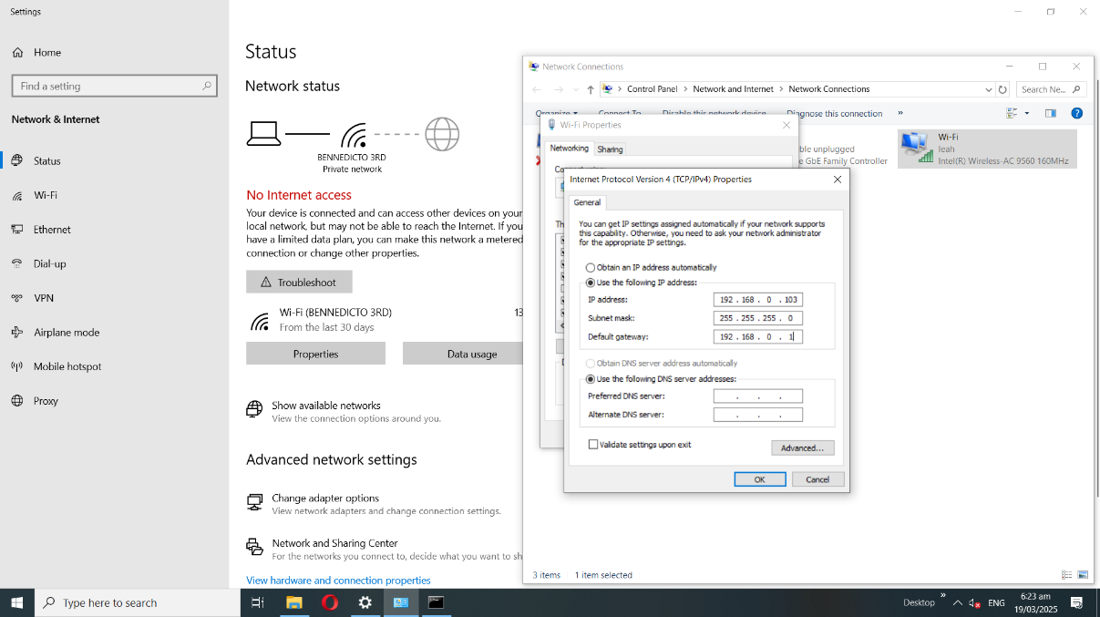
20. Set the IP Address to Static based on the IP Address that you set on the network.

21. Go to This PC and check the network to see if the two clients and the server are connected.
