SET-UP COMPUTER SERVERS

Before starting configuring the server, make sure that the server’s IP address is static, as shown in the figure below.
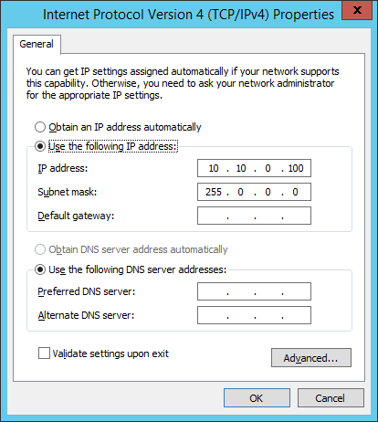
Open Server Manager and click Manage the select Add Roles and Features
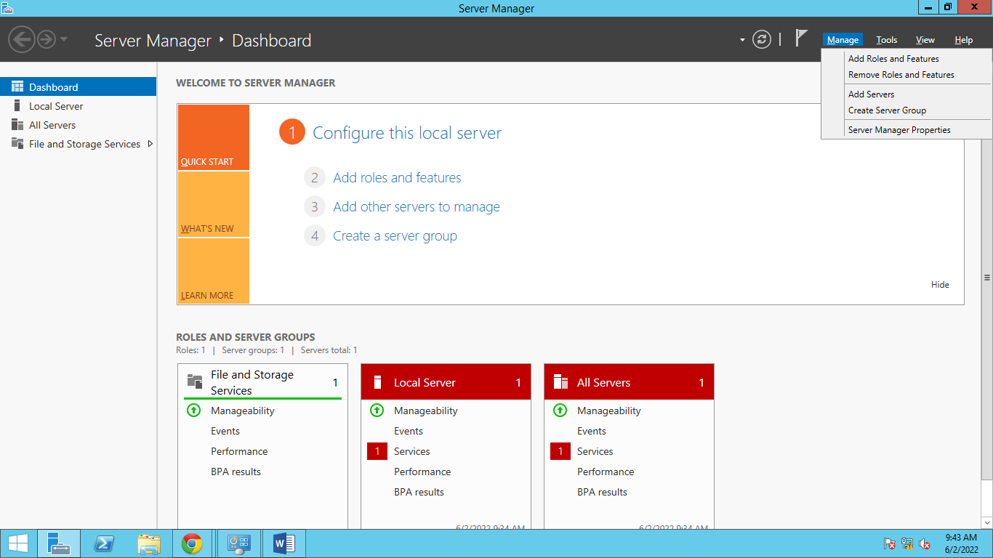
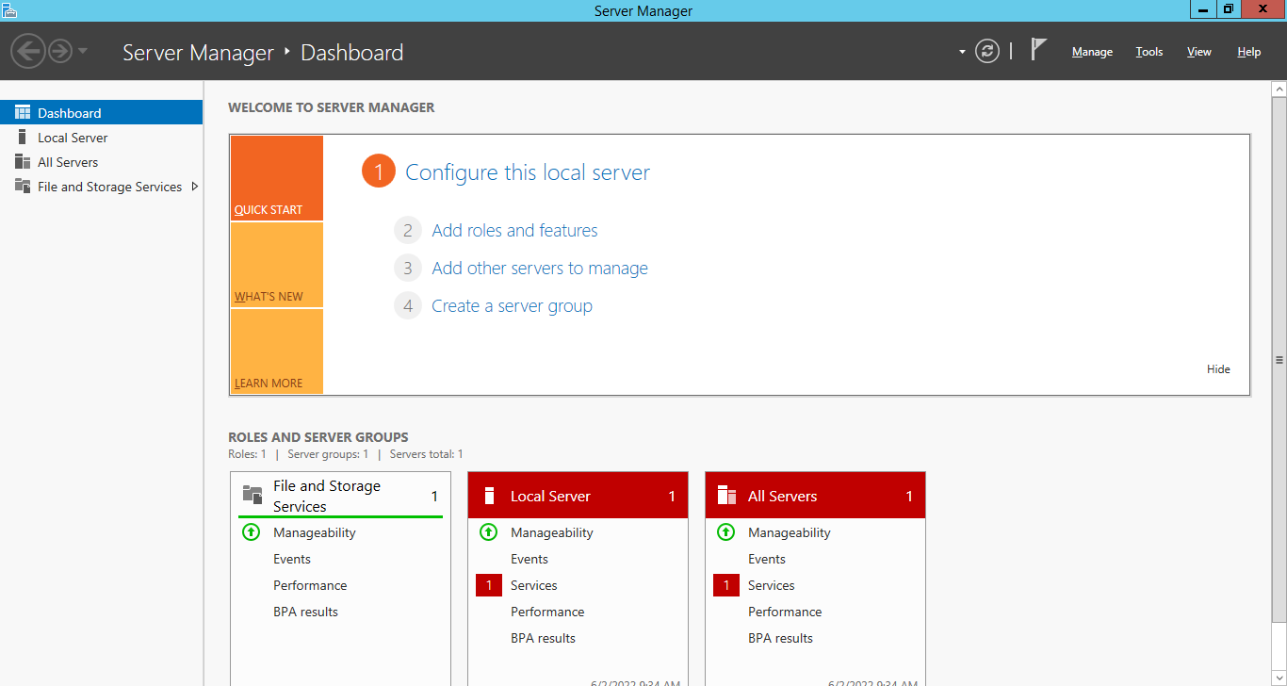

The Add Roles and Features Wizards window will show. Click NEXT after the window appears. Then follow the images show below.
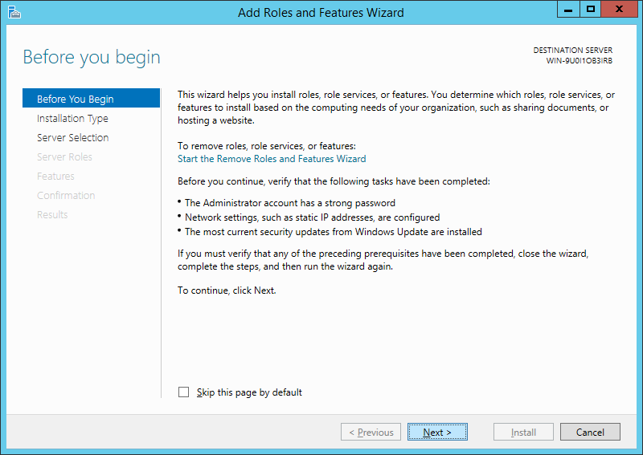

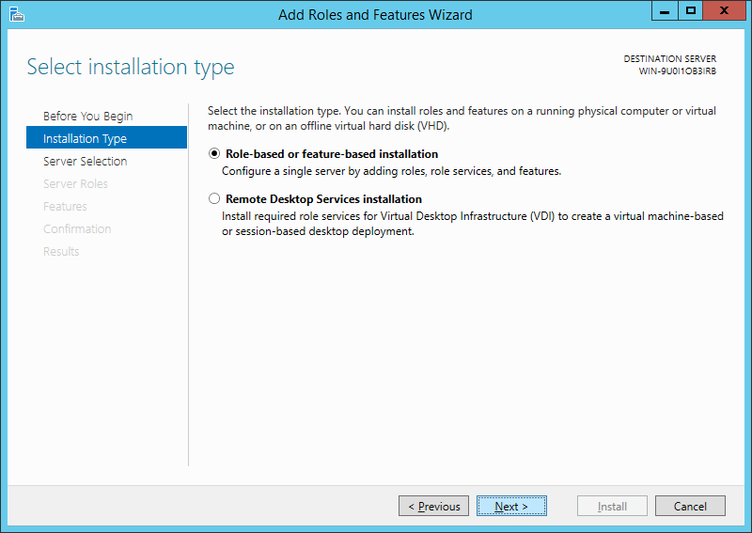

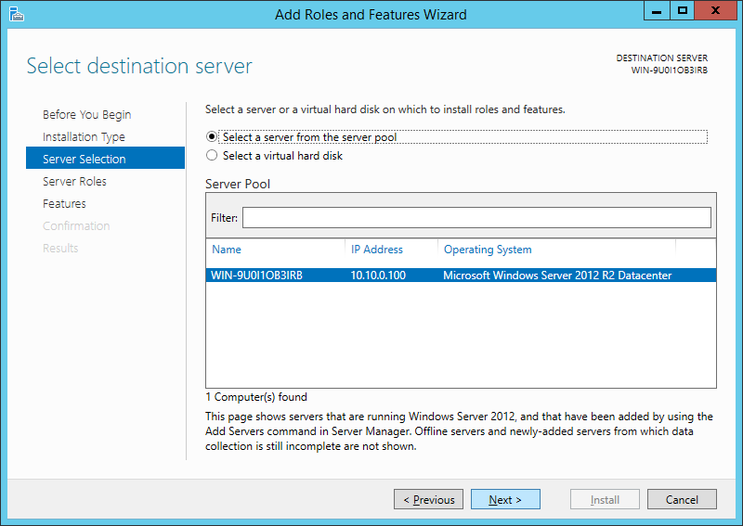

Add the following Roles by checking the check box, Active Directory Domain Services (ADDS), Dynamic Host Configuration Protocol (DHCP) Server, Domain Name System (DNS) Server, and Print and Document Services.
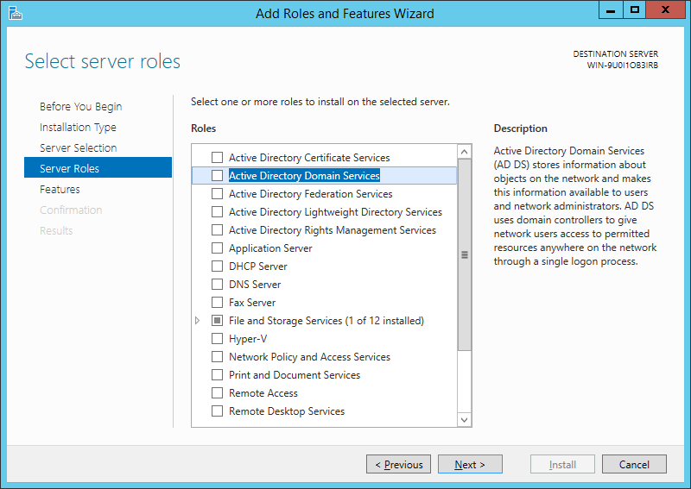

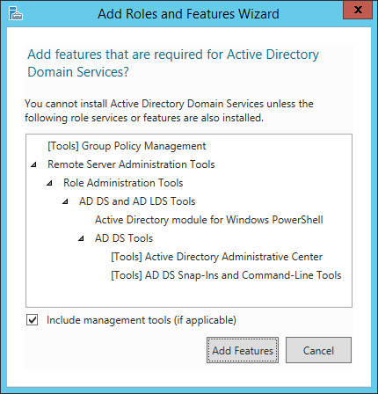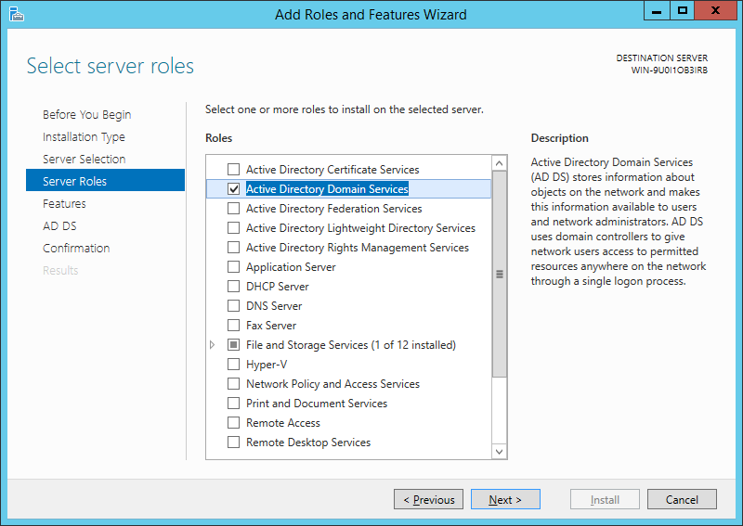
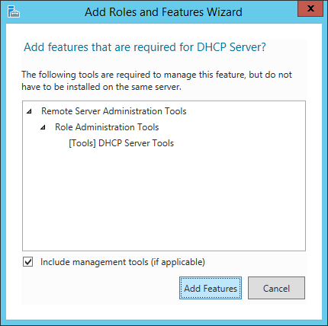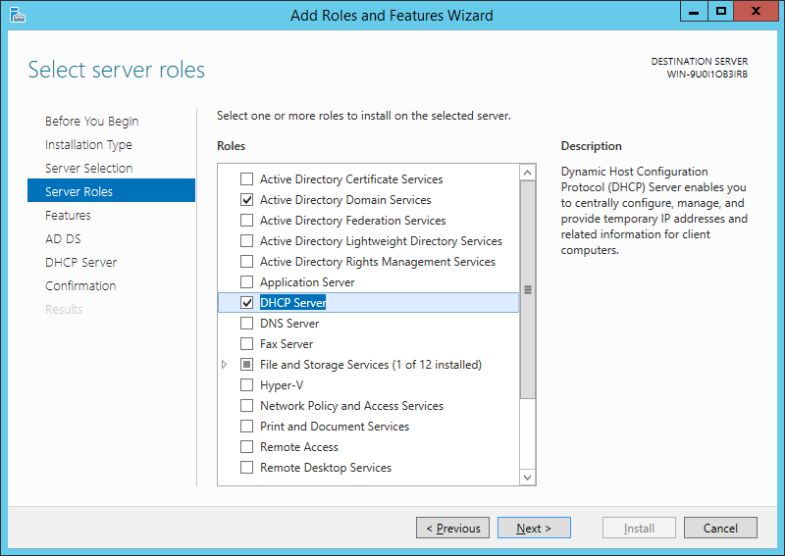
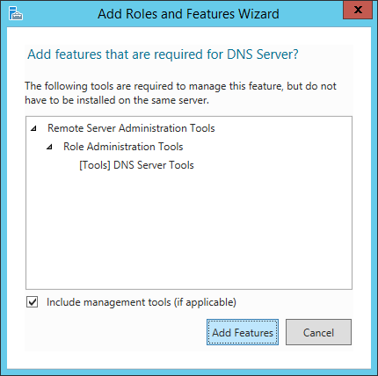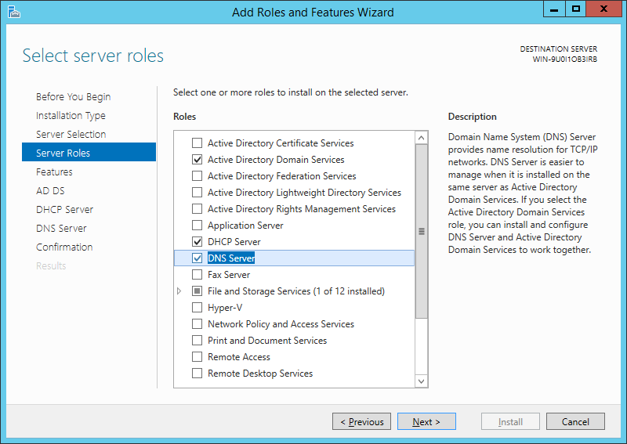

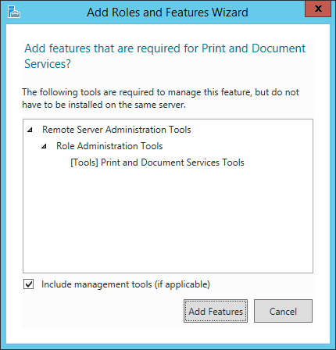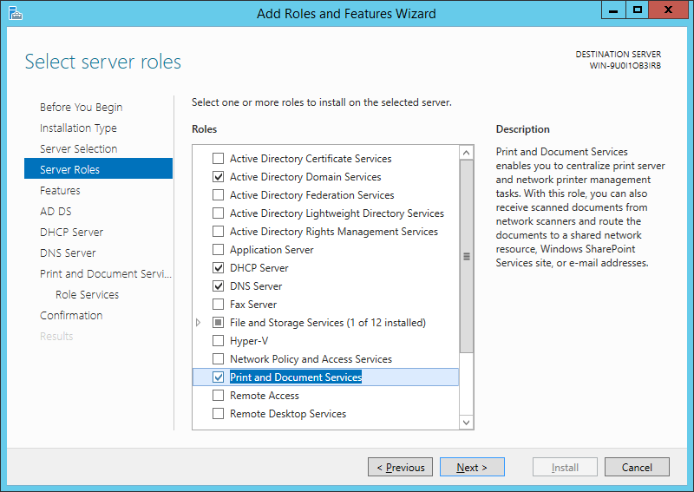

Make sure all the necessary Roles are checked as shown below, Then clicked NEXT.
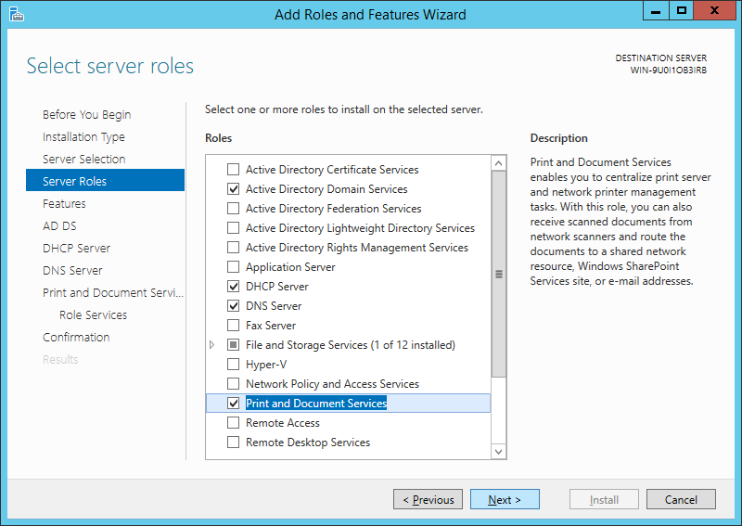

A new window will appear. Just make sure Group Policy Management is checked before clicking next.

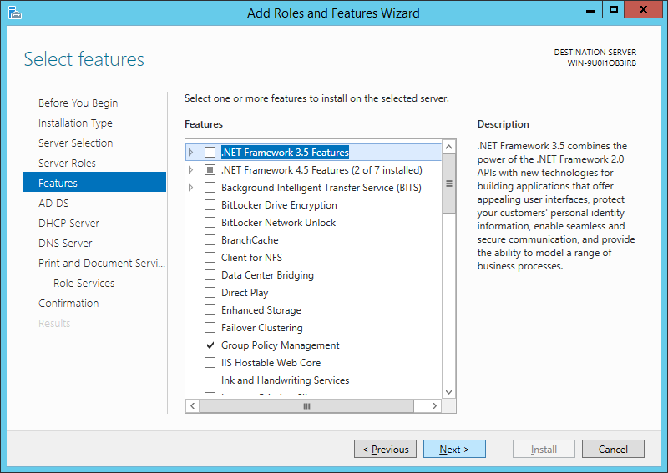

Just follow the installation steps shown in the figure below by clicking the NEXT buttons.
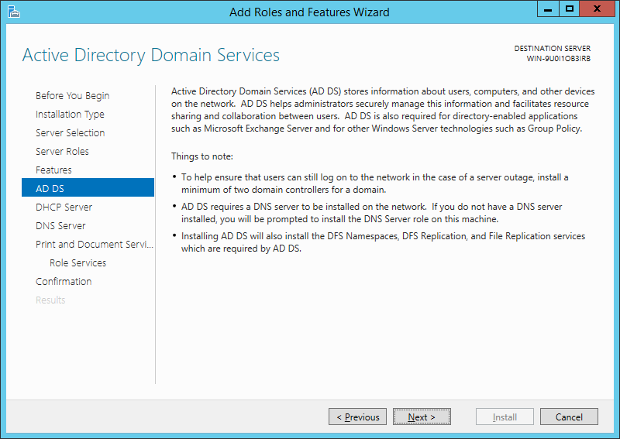
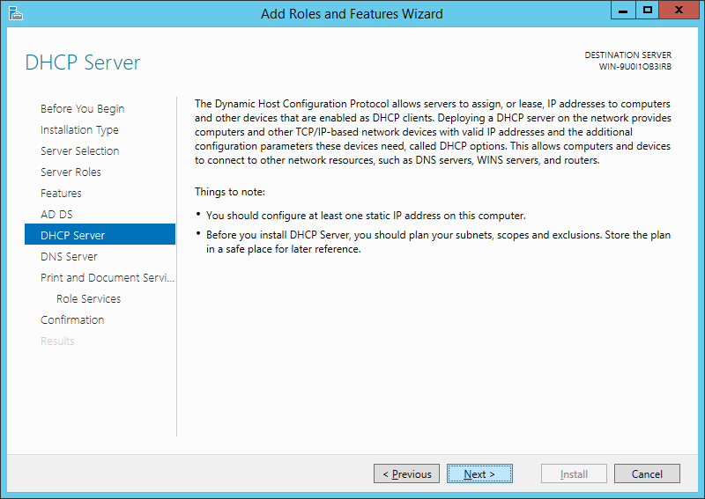
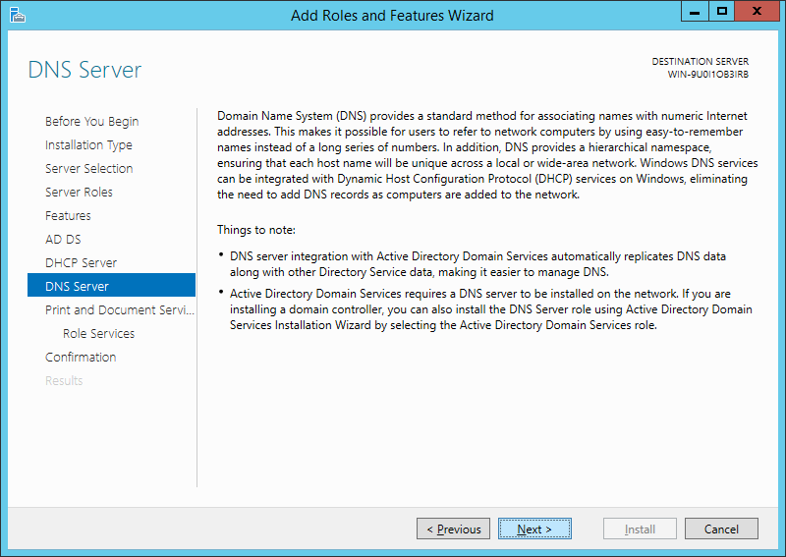
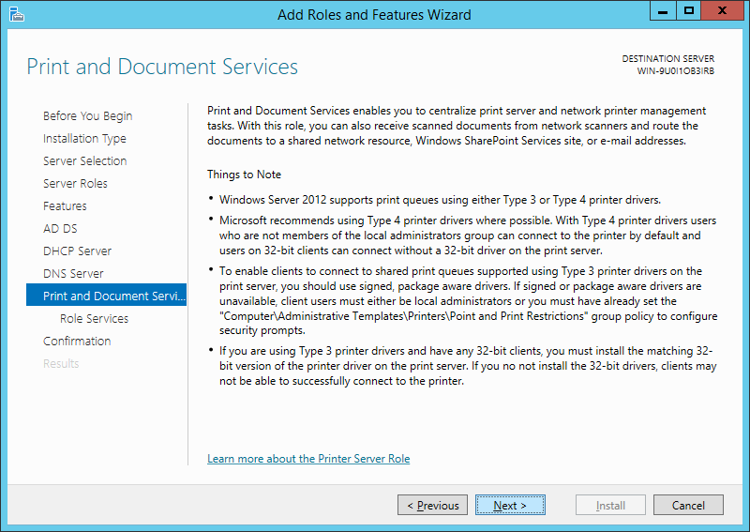
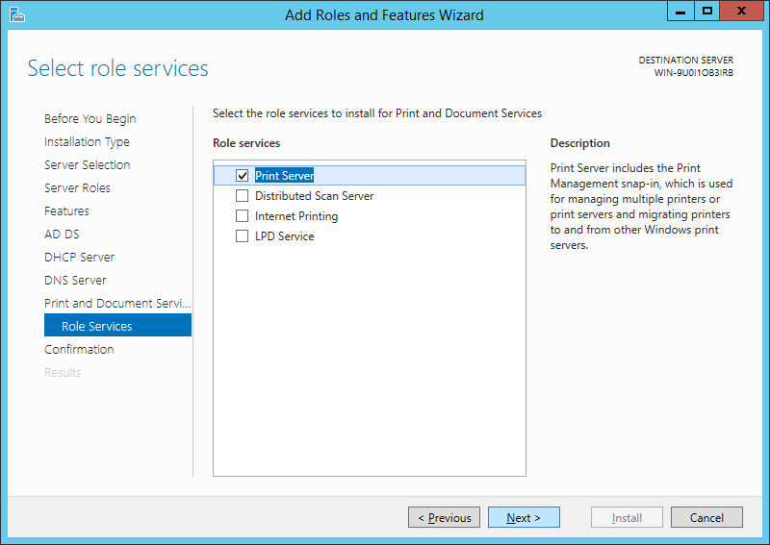
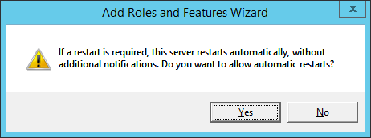
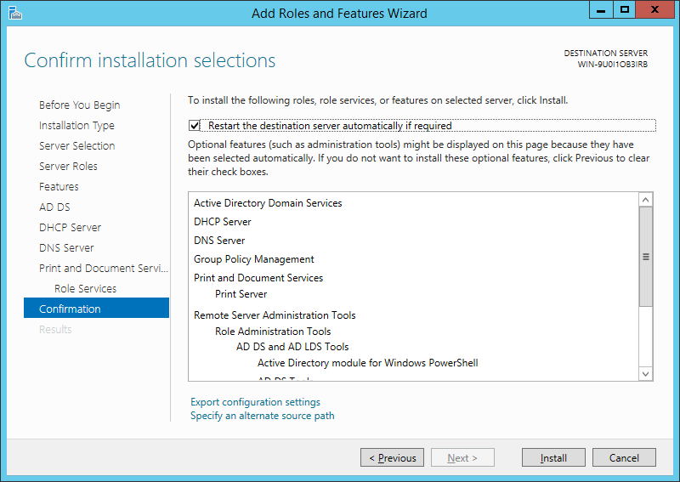
Click INSTALL after clicking the YES button above and wait for the installation to finish as shown below.
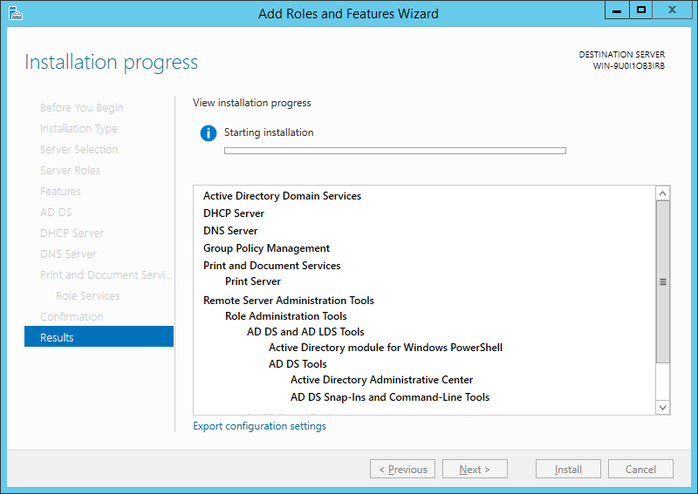

PROMOTING SERVER TO A DOMAIN CONTROLLER
Click the NOTIFICATION of the Server Manager (FLAG ICON), then select PROMOTE THIS SERVER TO A DOMAIN CONTROLLER
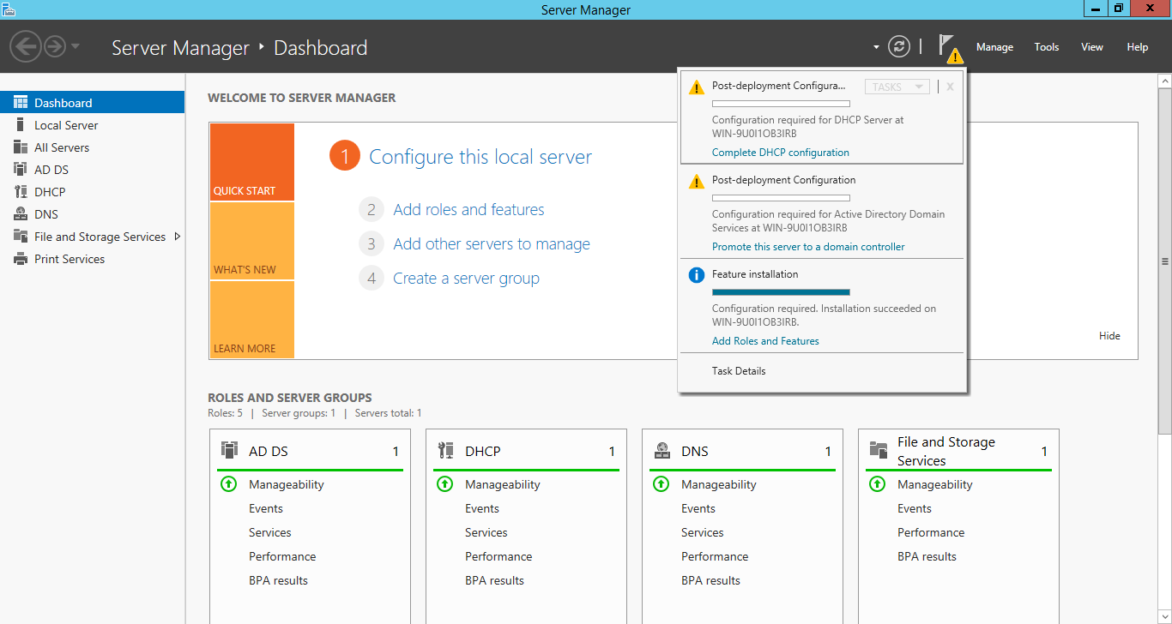

A new window will then appear. Select ADD A NEW FOREST then type css.org as Root domain name then click NEXT.
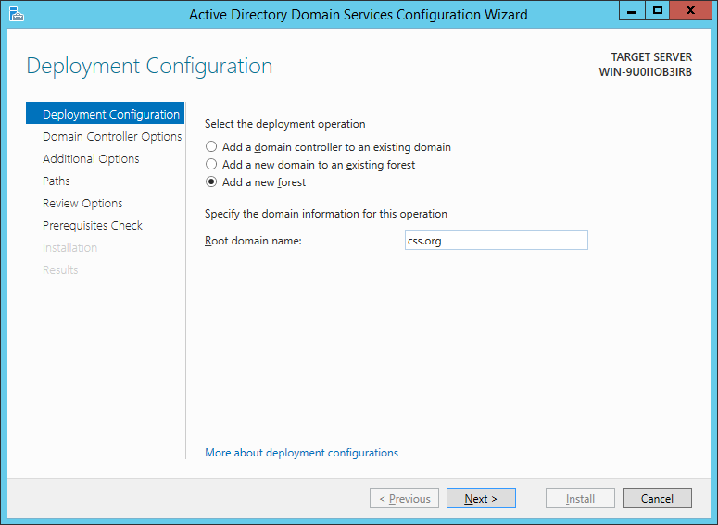
Type your password and confirm,(pass: Css@12345) then click NEXT and continue the installation by clicking the NEXT buttons as shown in the images below.
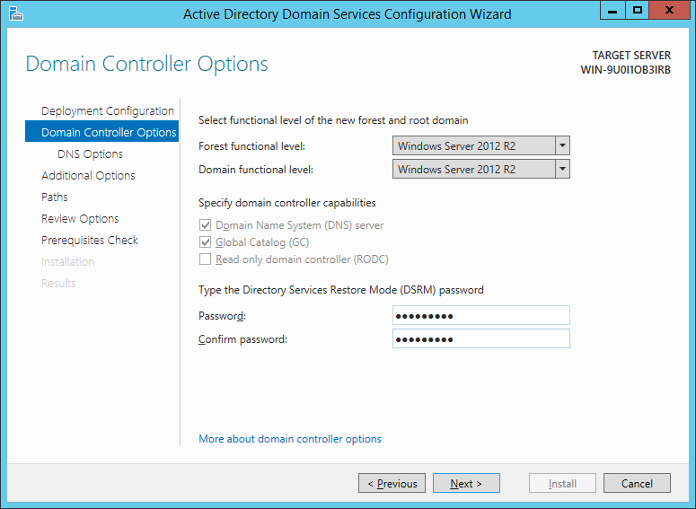
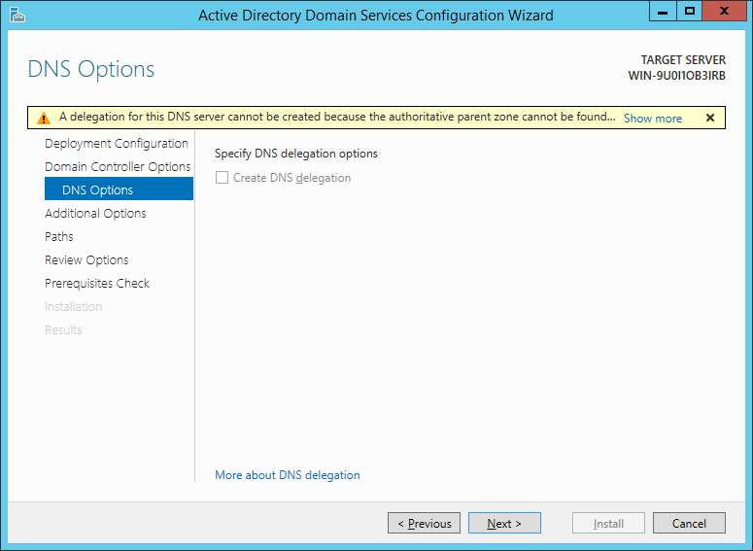

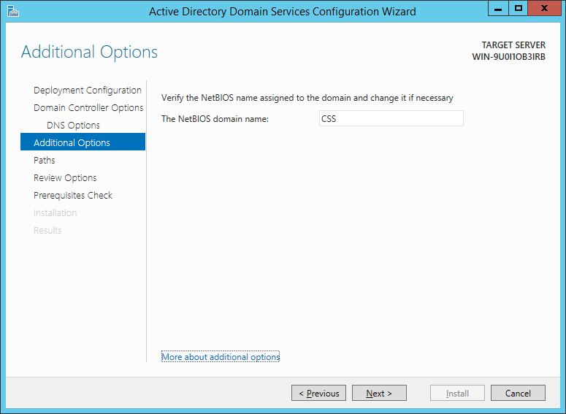
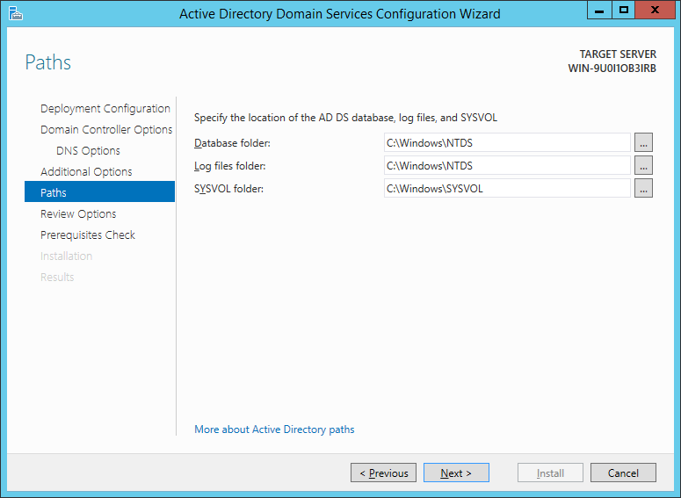
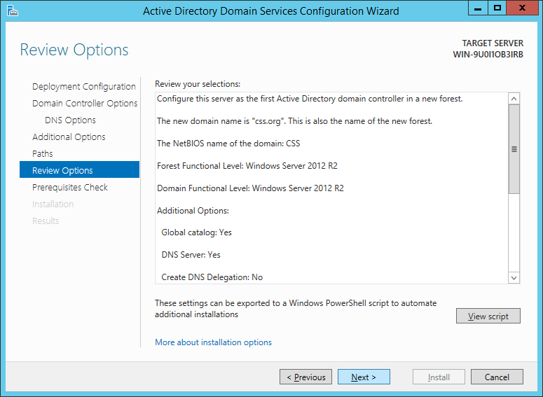
Then click INSTALL. Let the computer install the prerequisites and the computer will restart after successful installation.
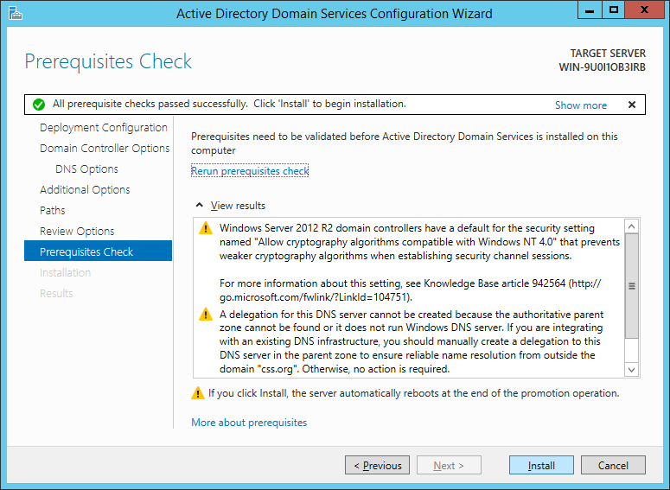
COMPLETING DHCP CONFIGURATION
Go to Server Manager and click the notification icon again. Then Select COMPLETE DHCP CONFIGURATION.
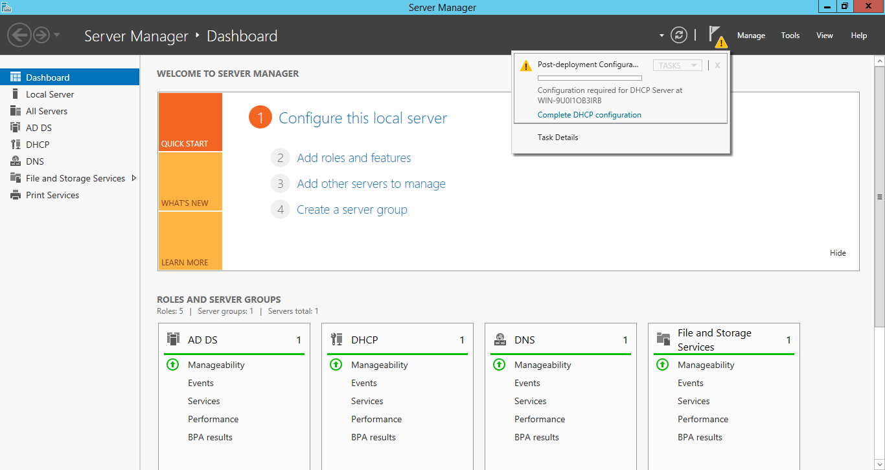
Follow the installation process by just clicking the NEXT button.
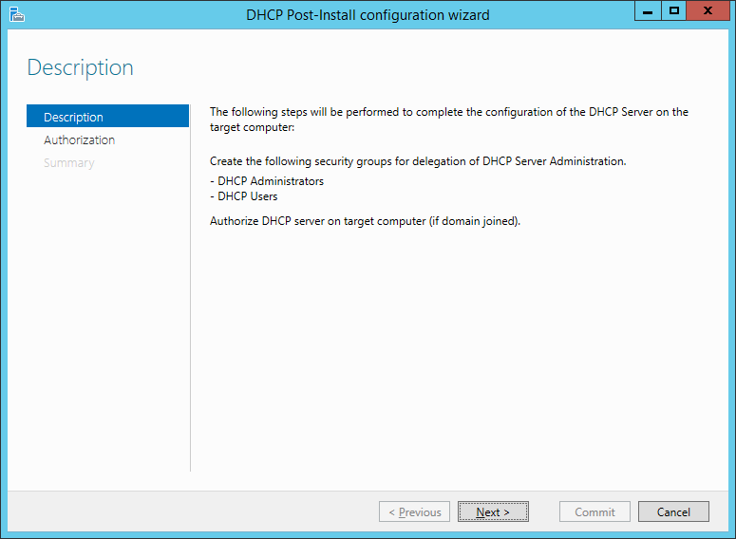
Then click COMMIT.
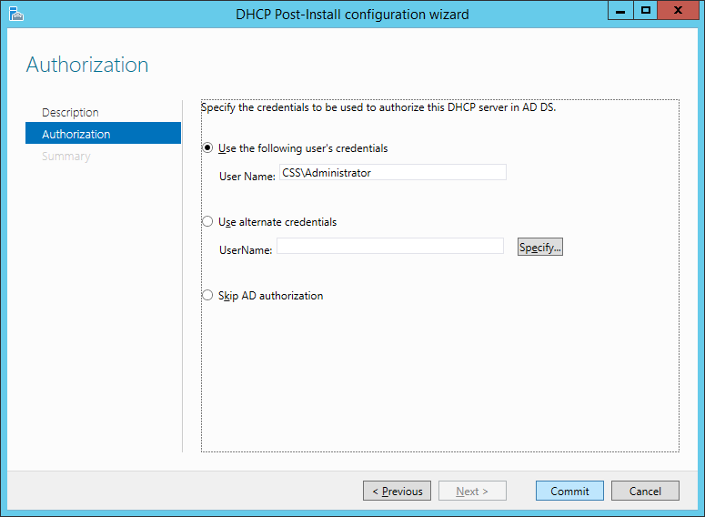
Then click the CLOSE button.
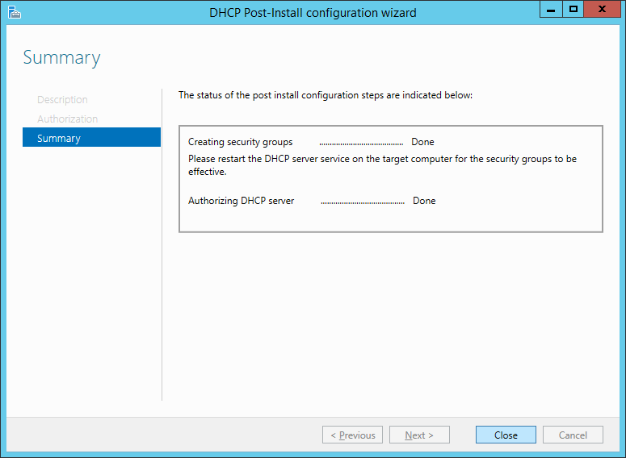
SETTING UP REVERSE LOOK-UP ZONES
Next step is to configure a reverse lookup address of the DNS Server. Go to Tools then select DNS.
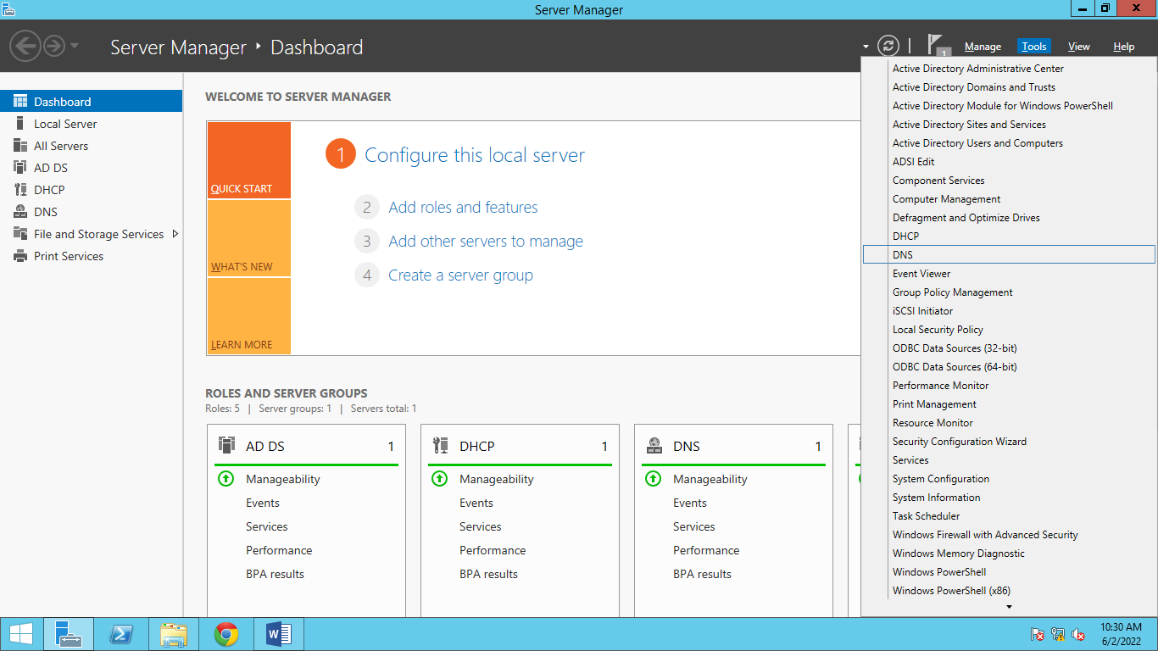
You will see the name of your server on the left side. Click the small triangle icon to expand.
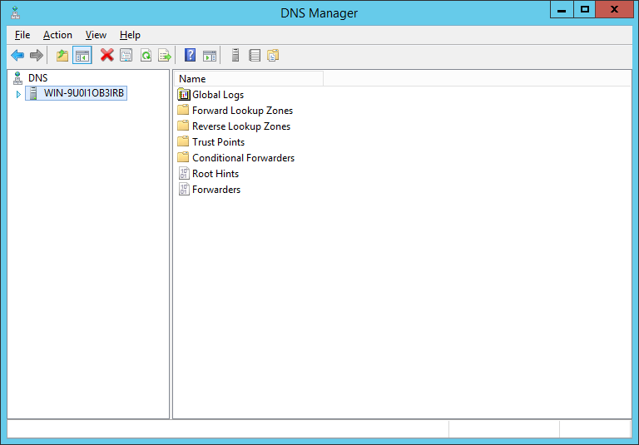
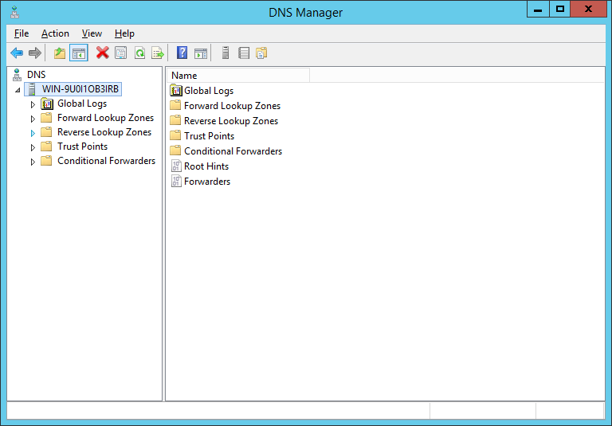
Right click REVERSE LOOK-UP ZONES the select NEW ZONE.
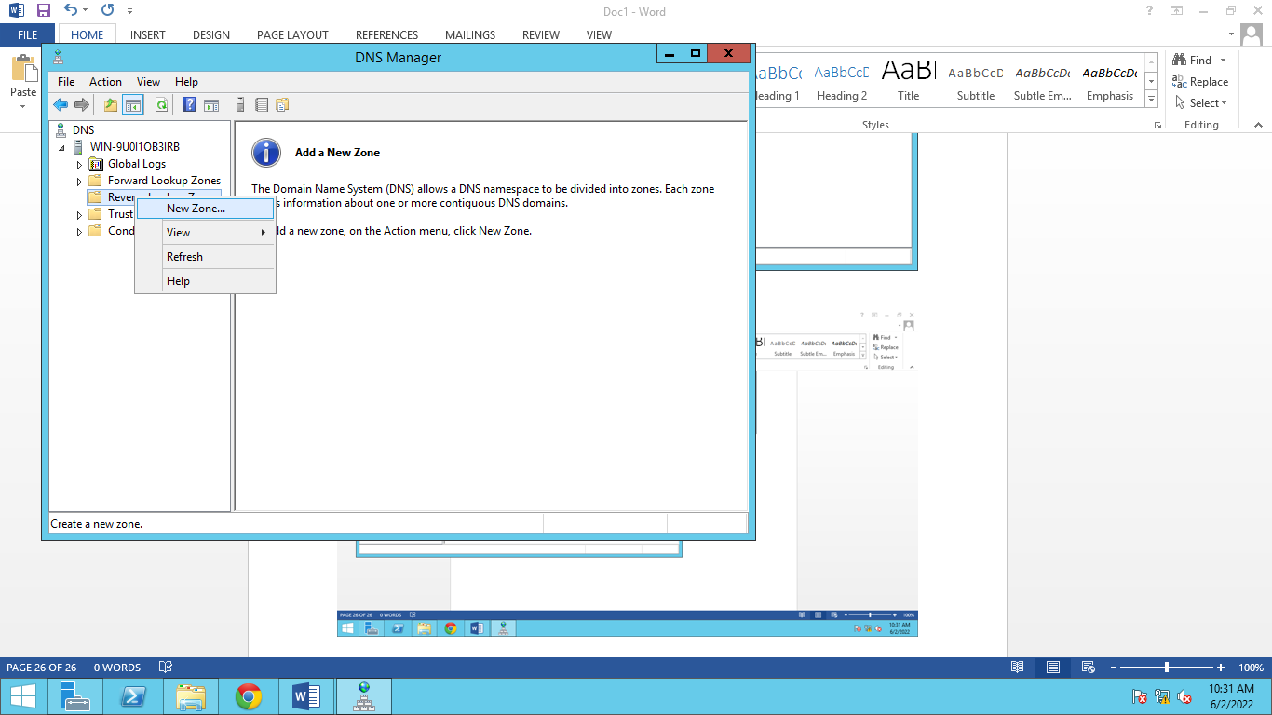
Then the New Zone Wizard will appear. Click NEXT. Make sure primary zone is selected then click NEXT. Then follow the installation wizard by clicking NEXT buttons as shown below.
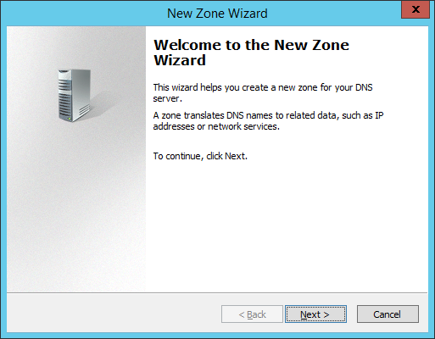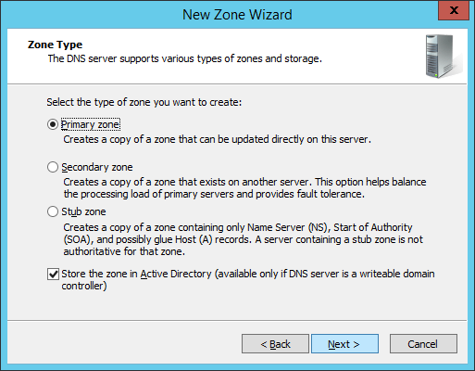
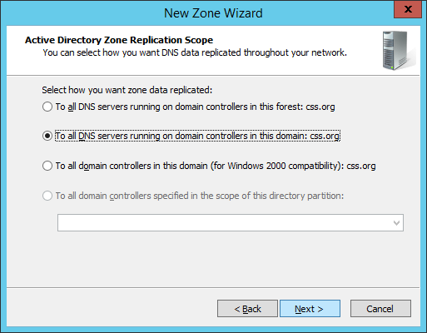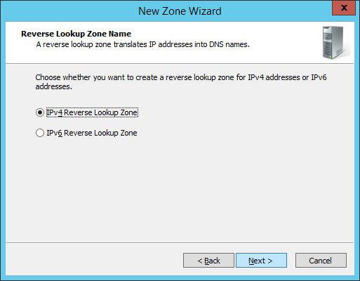
Type the network ID (10.10.0) and click NEXT.
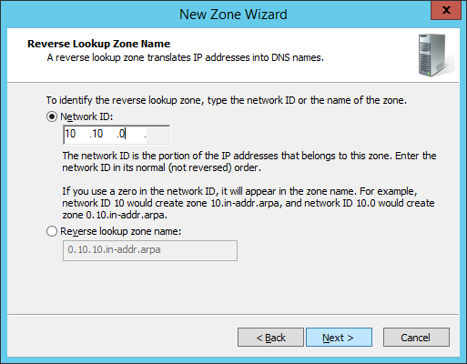
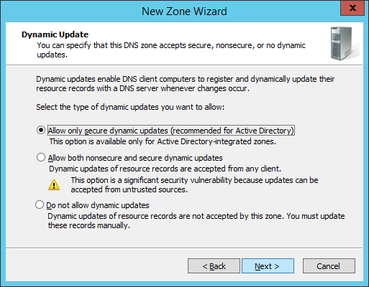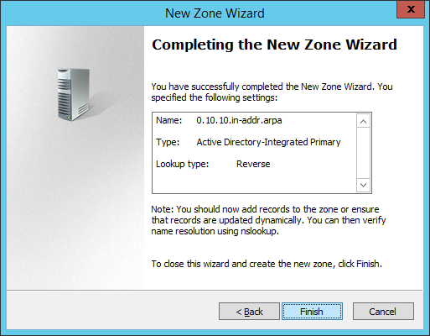
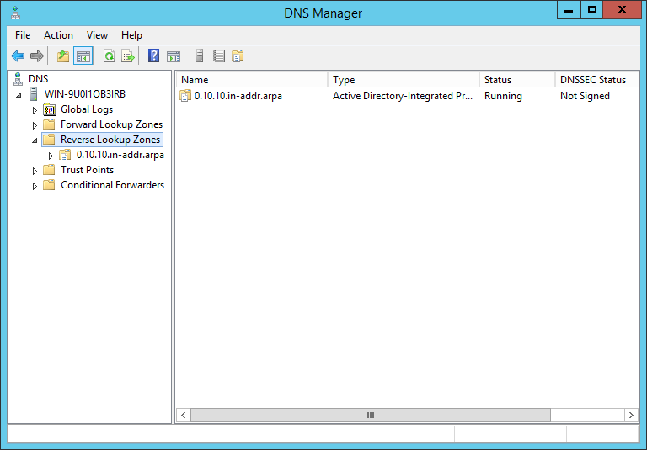
You will then see the reverse lookup zone added below. The server roles are now completely setup. Next section will show how to set-up user accounts.

SETTING-UP USER ACCOUNTS
Next step is to create user Accounts. Go thep Server Manager and click ACTIVE DIRECTORY USERS AND COMPUTERS.
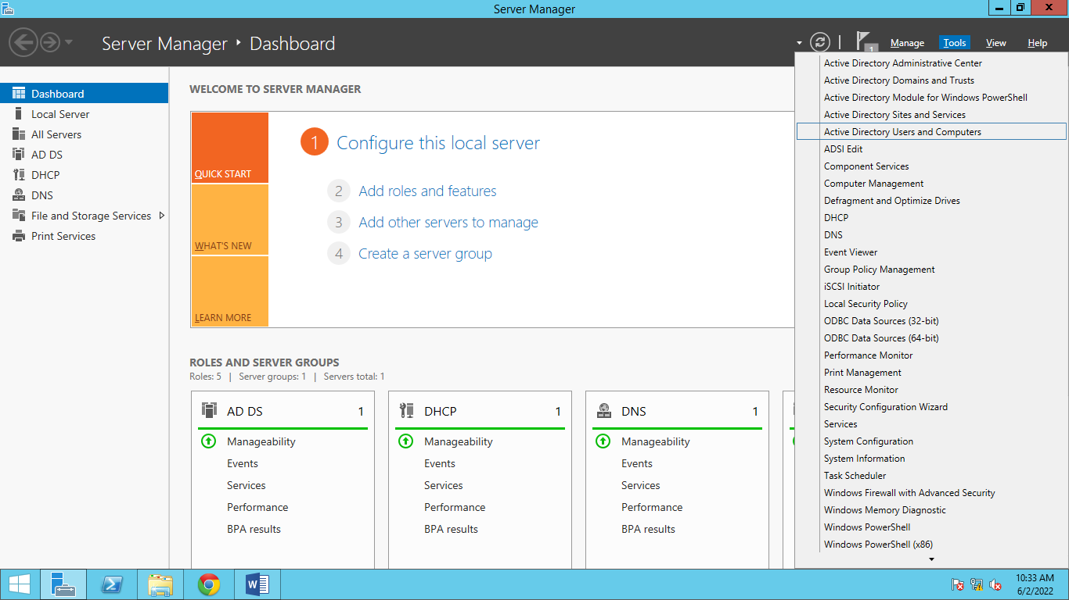
Expand css.org
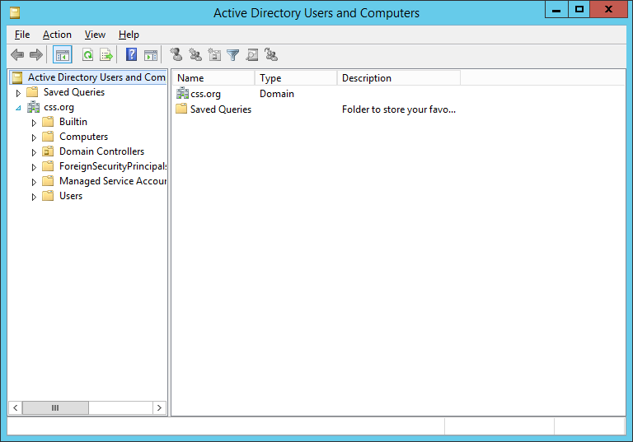

Right click css.org then click NEW the select ORGANIZATIONAL UNIT. A new window will appear then rename your organizational unit into Redirection.
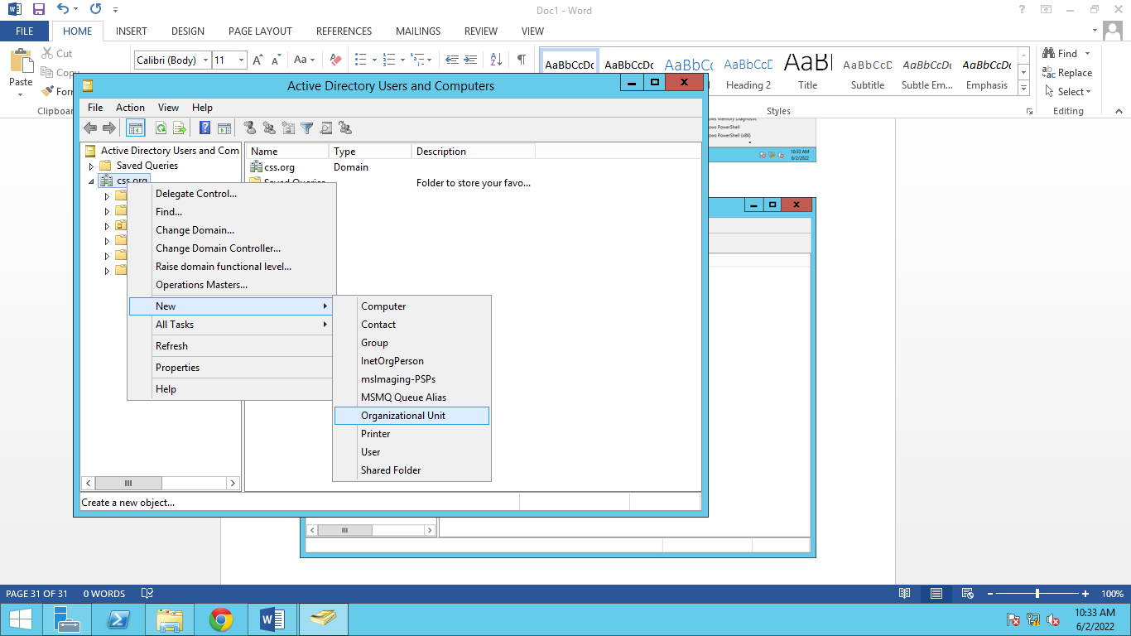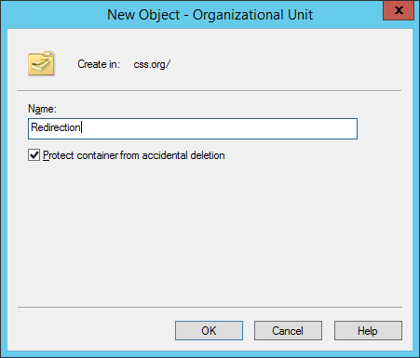
The newly create organization unit will appear below. Create new users under this Organization Unit by right clicking it then select NEW > USER. You need to create TWO (2) users. Follow user creation by following the screen shots below.
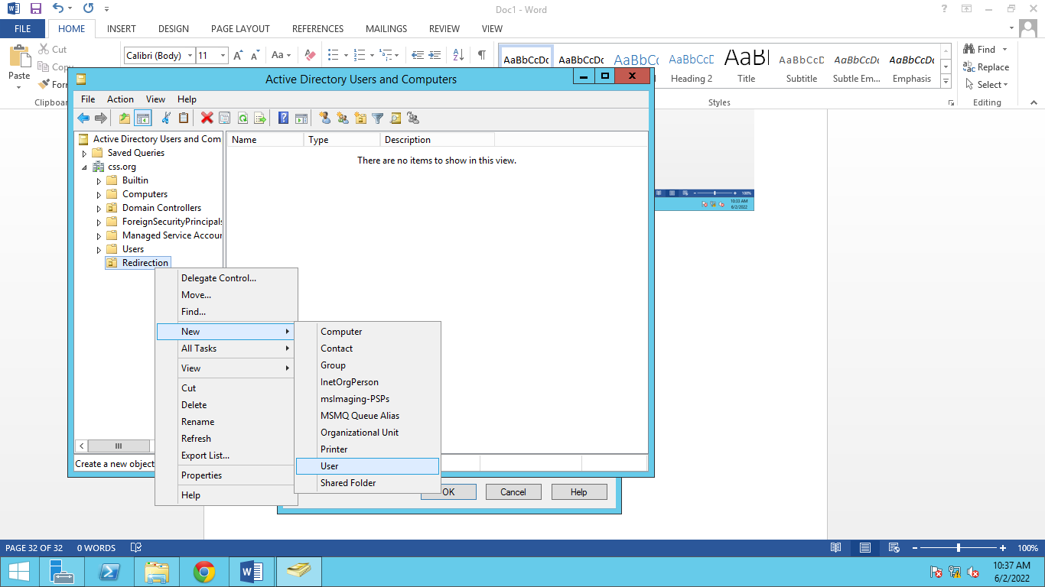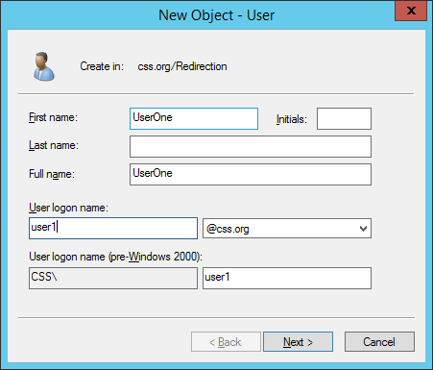

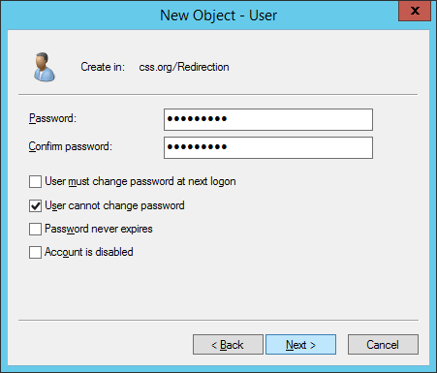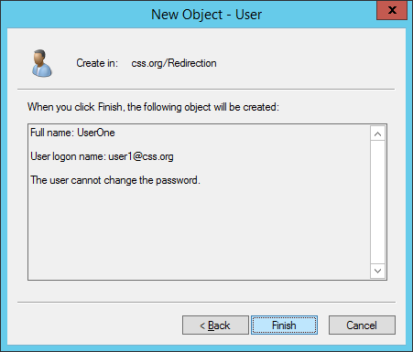
Repeat the process above to create two users as shown below.
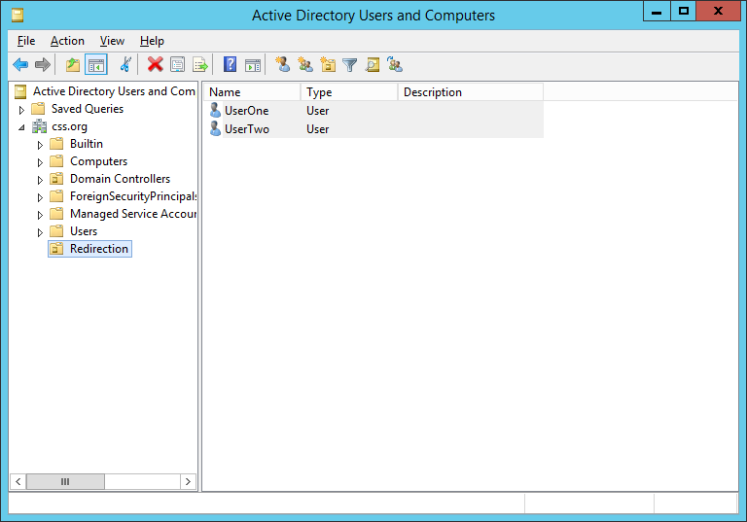
Next step is to configure users’ folder configuration. Go to servers’ Local Disk (D). Then create a new folder and rename it “UserFiles” as shown below.
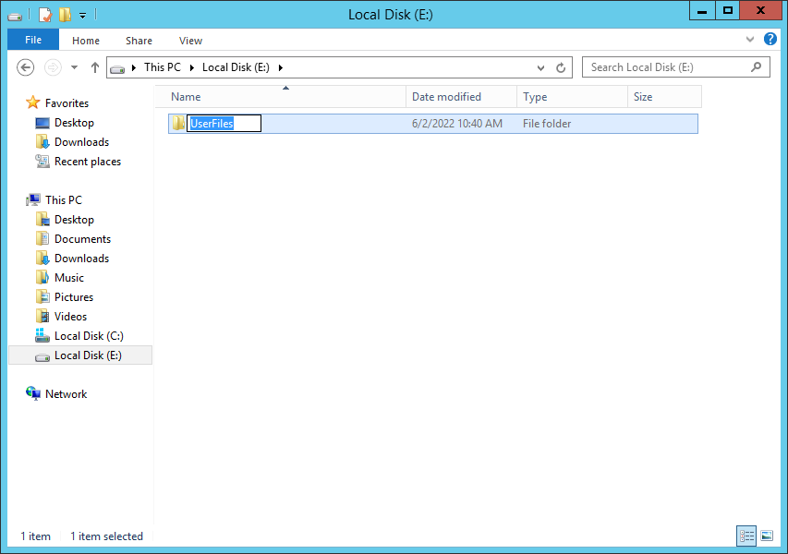
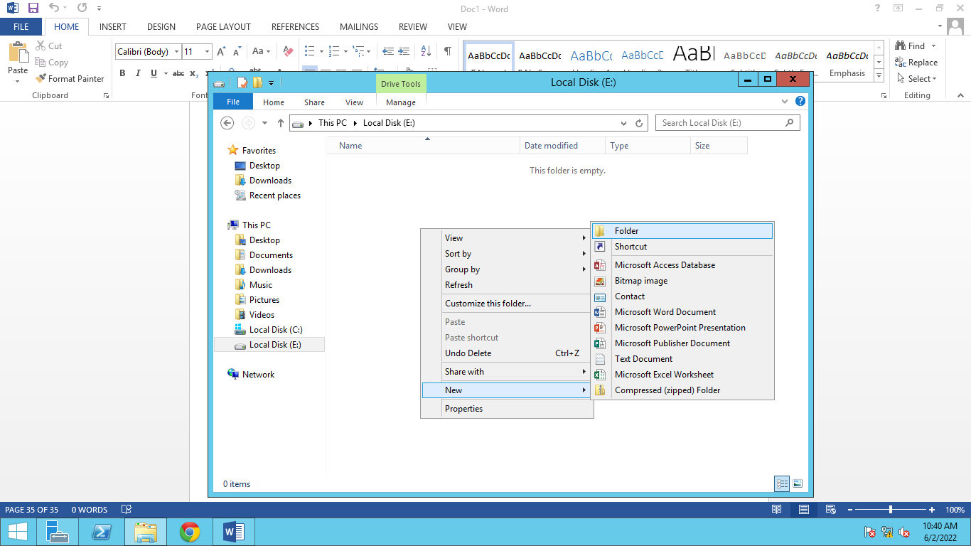
Right click the new created folder then select PROPERTIES, a new window will appear. Configure its sharing properties by clicking SHARE as shown below.
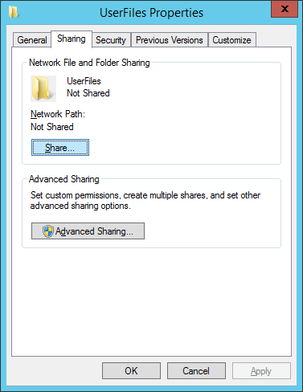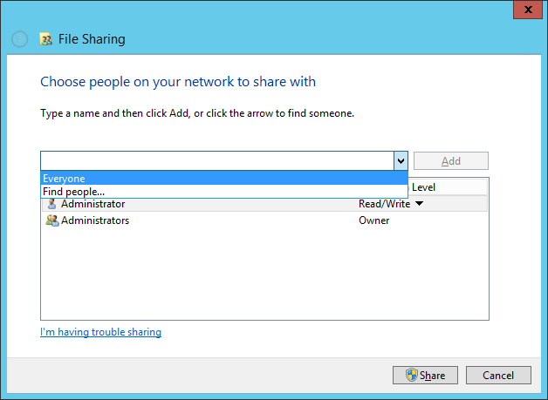
After selecting EVERYONE click ADD then change the Read Permission to READ/WRITE. 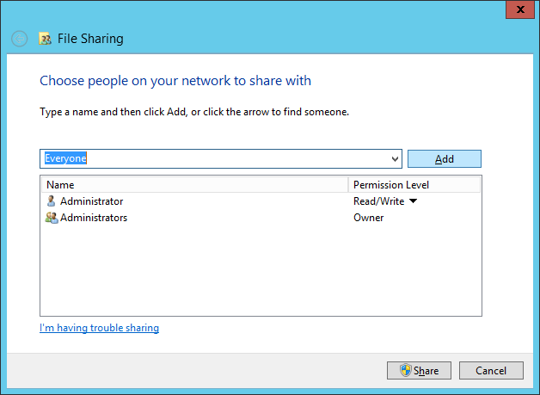 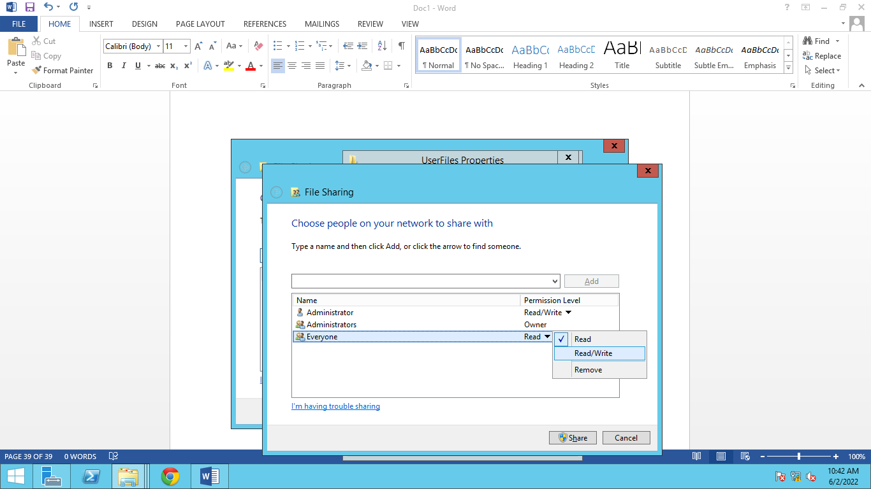
Then click SHARE
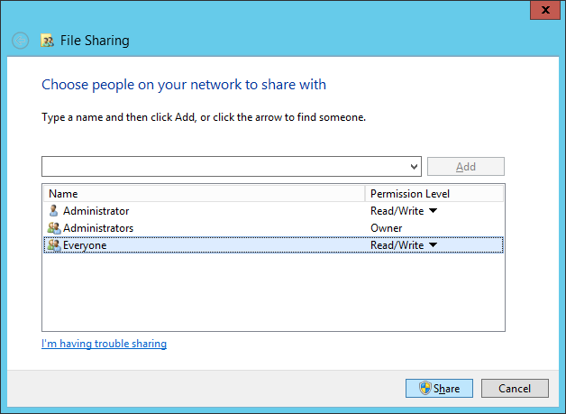
Click Done. Don’t forget to copy the network path as shown below.
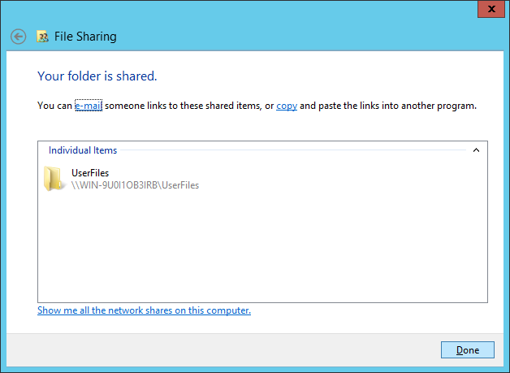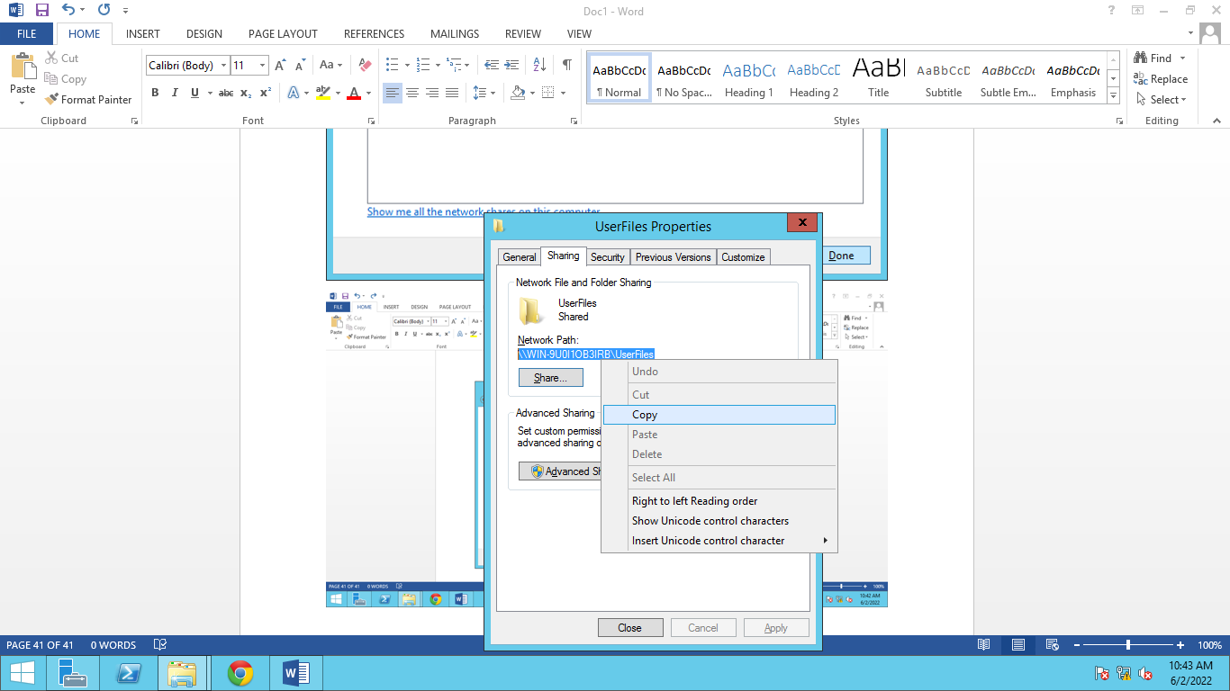

Configure group policy management.
Server Manager > Tools > Group Policy Management
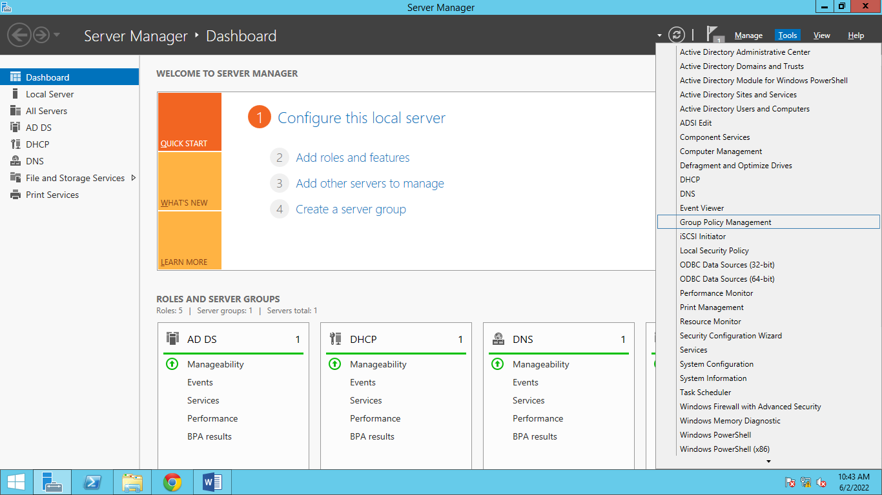
Expand Forest: css.org. > Expand Domains > The Organizational Unit that you have created before ( in Active Directory Users and Computers) can be seen here.
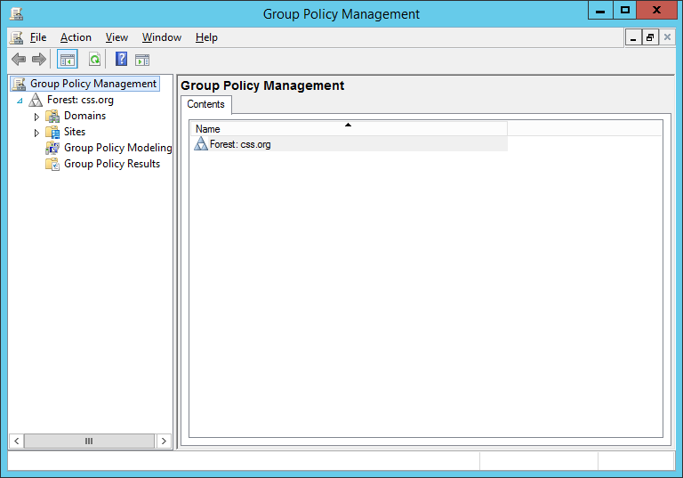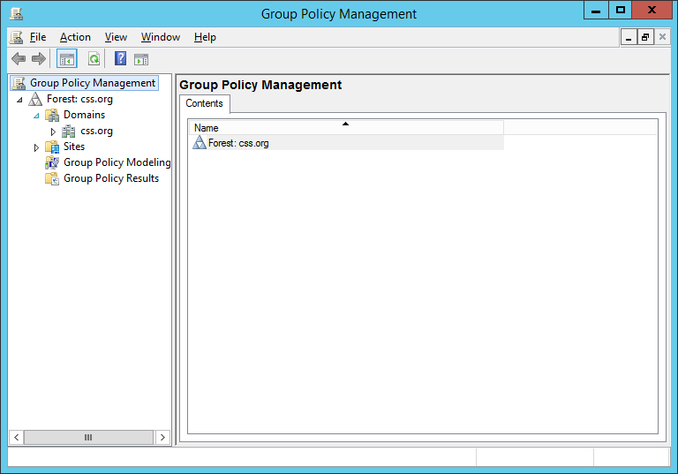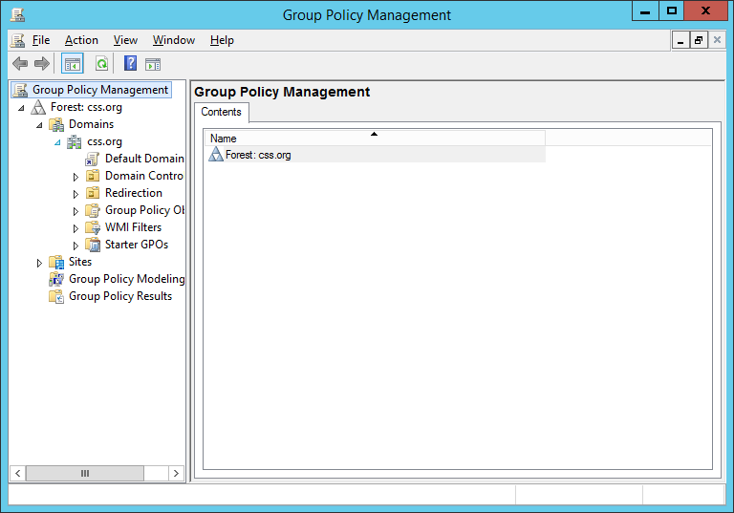

Right click > Create a GPO in this domain and Link it here. A new window will then appear. Name it redirection.
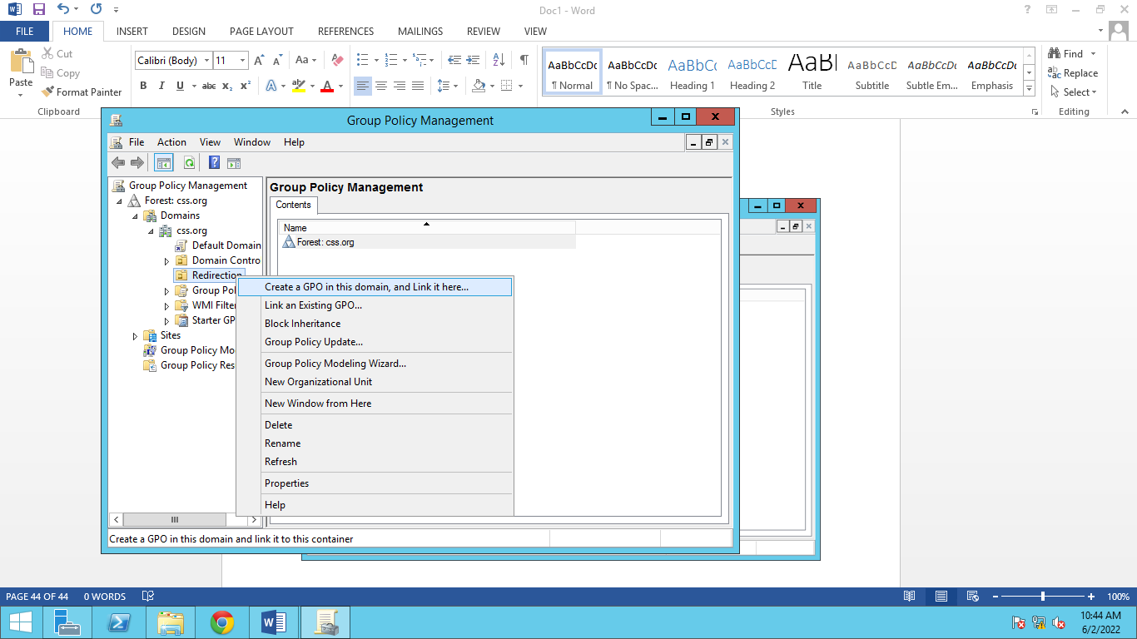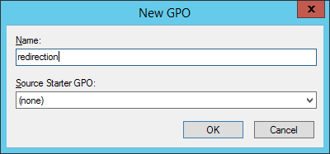
The newly create GPO will appear as shown below. Right click > Edit. If a new window will appear just click OK.
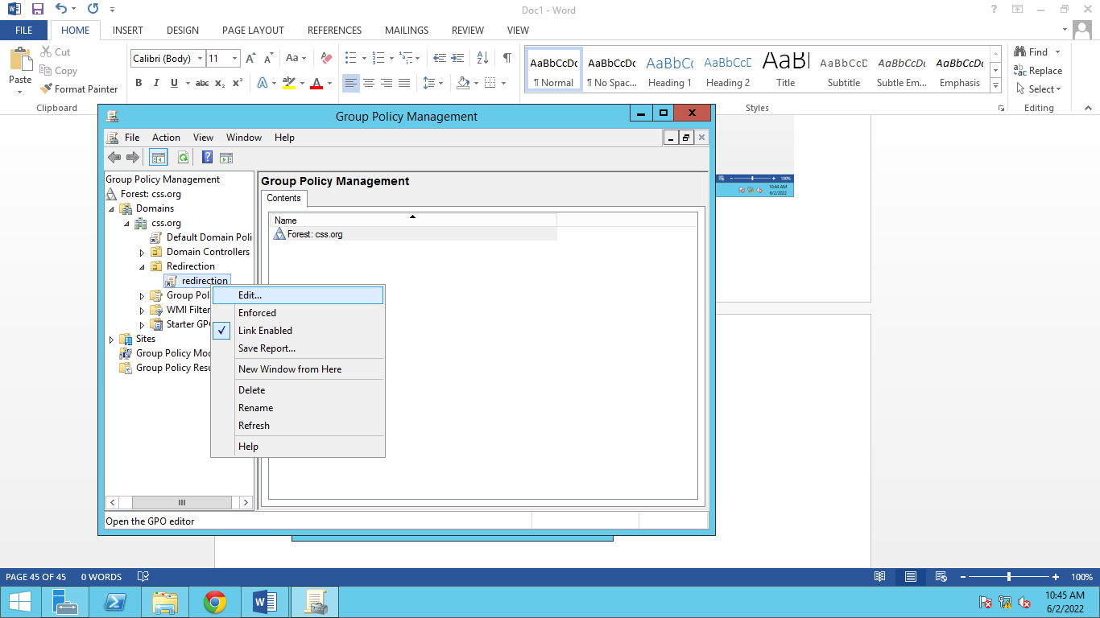
The Group Policy Management Editor will appear. Go to User Configuration > Policies > Windows Settings > Folder Redirection
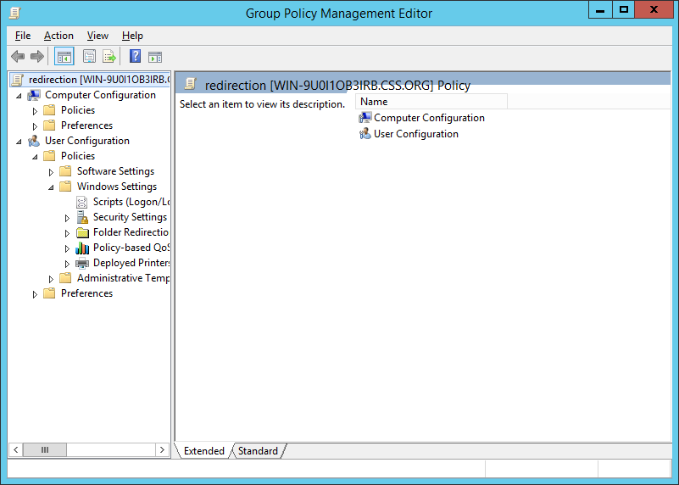
Expand Folder redirection. Right click Desktop > Properties. Then select BASIC
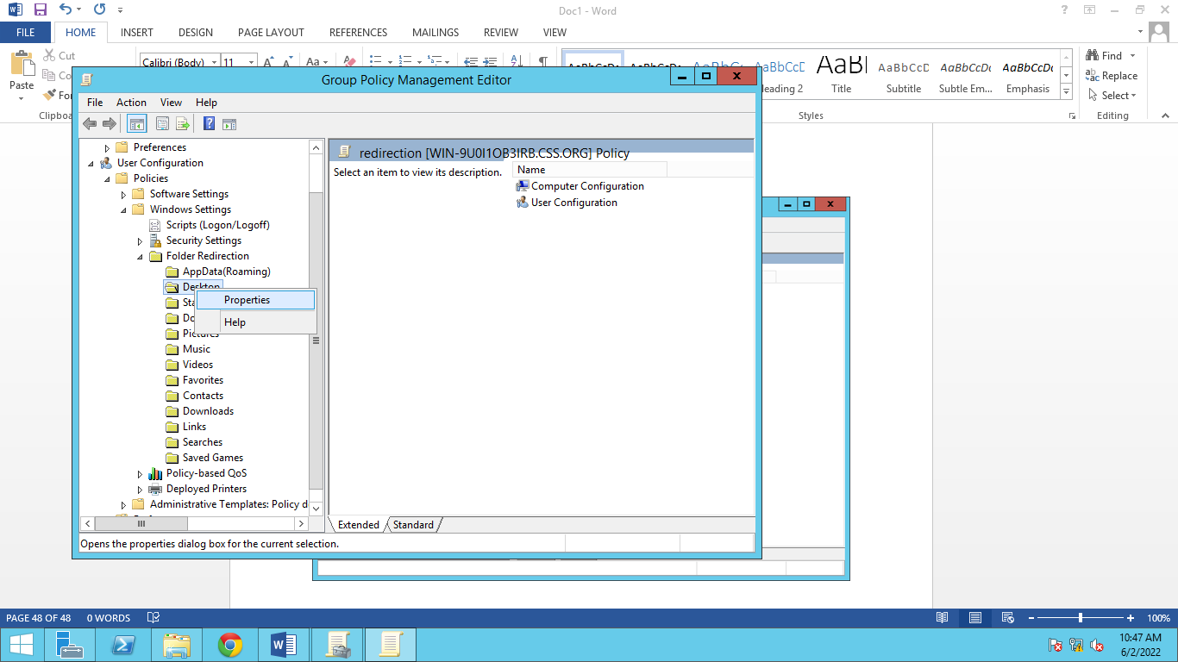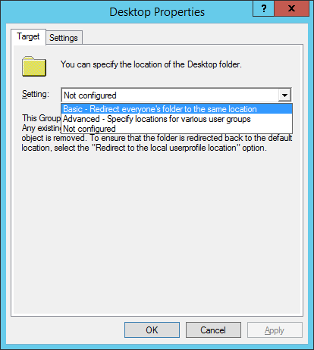
Past the ROOT PATH that was copied before during folder sharing. Apply > Yes > OK
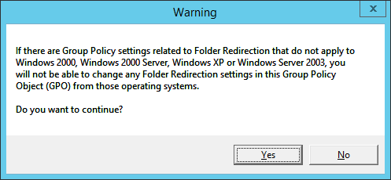
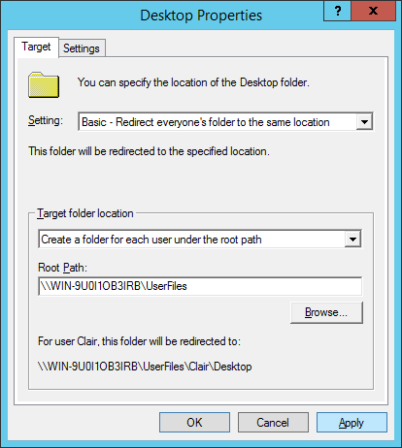
Repeat this process but this time for DOCUMENTS and PICTURES also.
Then Go to your Client PCs and connect it to the domain.

CONNECTING CLIENT PC TO A DOMAIN
Go to client PC adapter settings. Then change the Preferred DNS Server and use the Server’s IP Address. If you are not sure of your server IP Address, you can go to server PC then open CMD then type ipconfig.
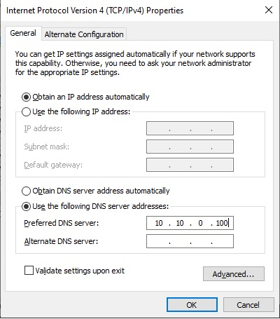

Right click This PC > Properties. A new window will open. Then click Change Settings.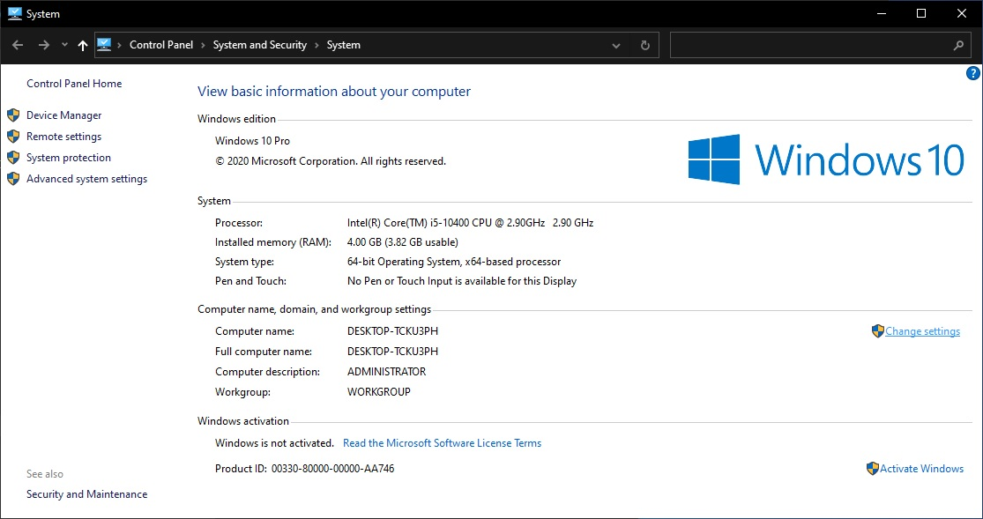

Click Change > then select domain and type the domain in this case css.org
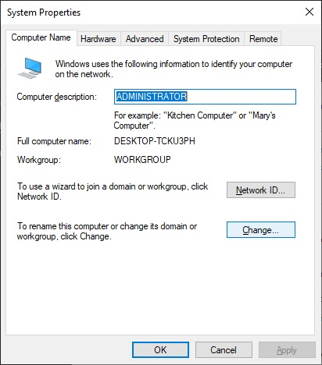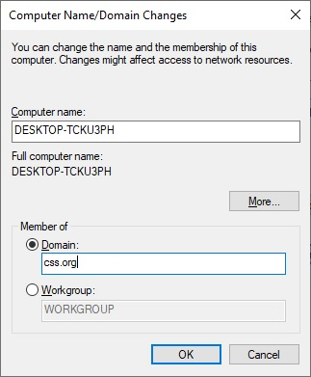
A new window will appear. You can use the account credentials you have created. However, you can also use the administrator account as well. Click OK > OK > Close > Restart Now. The PC will then restart. This time login the accounts you have created both wired and wireless
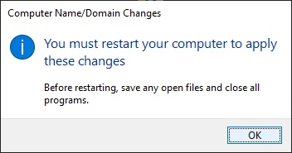
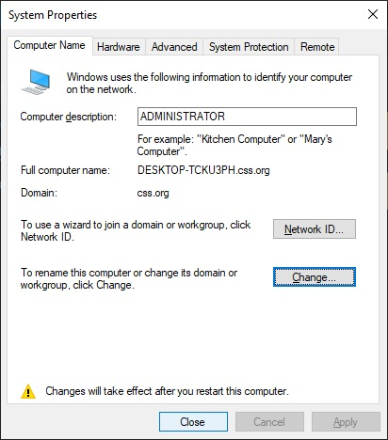
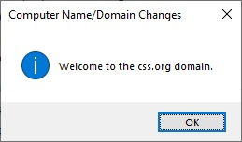
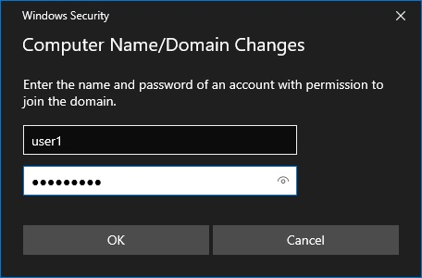

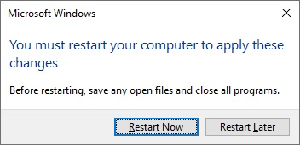
CHECKING FOLDER REDIRECTION
Check folder redirection by going to the folder you have created in the local drive. Open UserFiles, you will then see a new folder created with the user accounts you have logged in from your client PC. If you have logged in the two account you have previously created then two accounts will be visible here.
Open user1 > Desktop
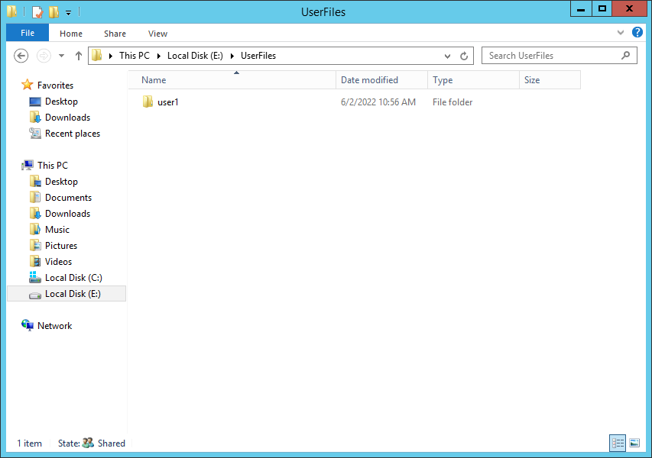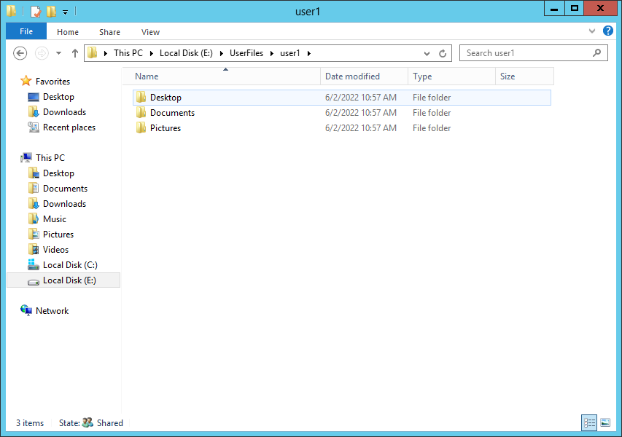
Continue > Security Tab
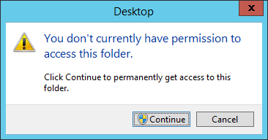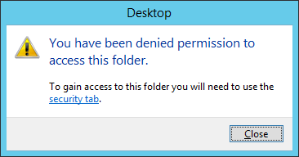
Advanced > Change > type administrators > Check Names > OK
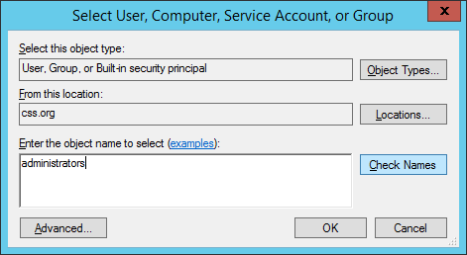
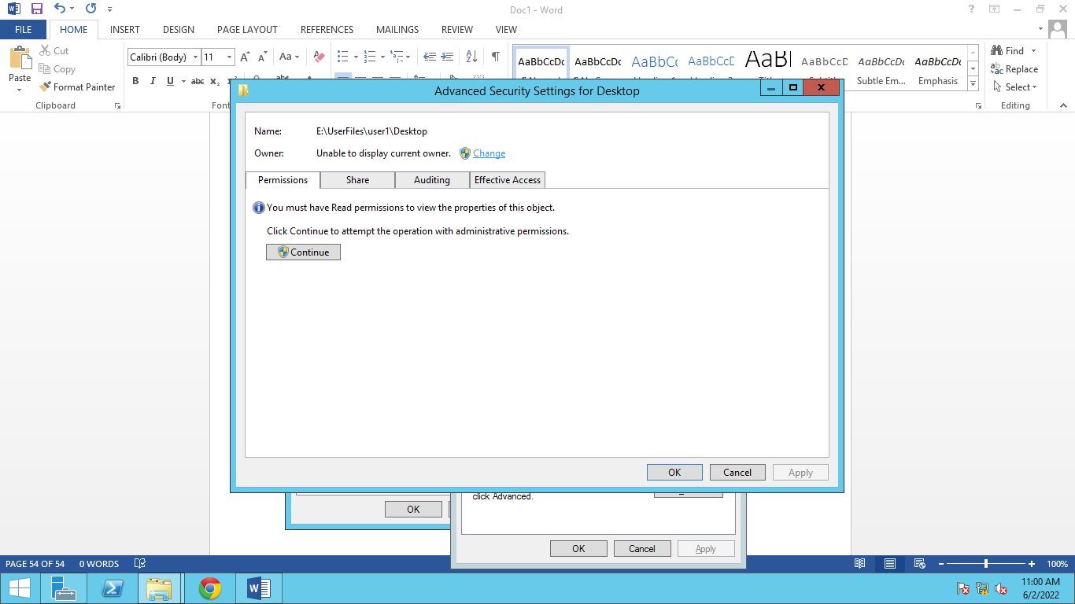
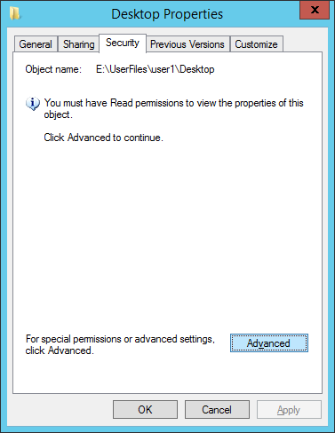
Click Apply > the OK > Close.

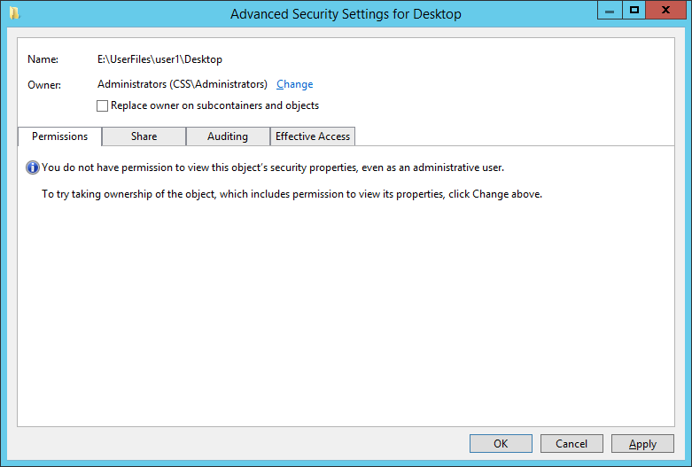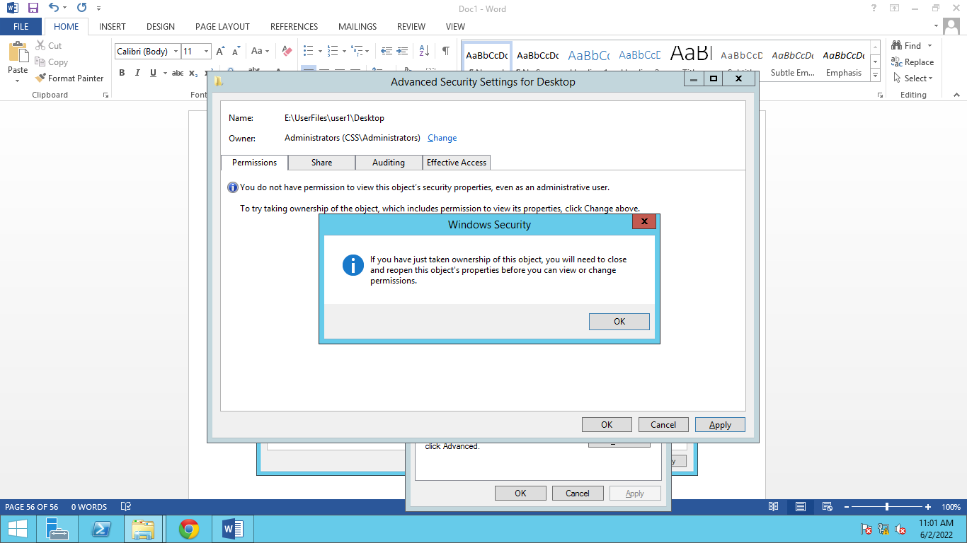

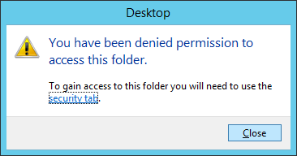
Open the folder again the click continue.
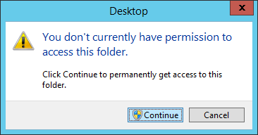
You will then see the file/s created at the client PC.
